Index of project

* Synopsis ………………………………………………………..02
* Form …………………………………………………………45
* Code …………………………………………………………69
* Documentation …………………………………………….401

Indira Gandhi national open university



Synopsis

On

Gift sales & inventory management system

Submitted by amit kumar sah

Guided by

Mukesh kumar jha

Contents

1. **Title of the project……………………………………… 04**
2. **Introduction of the project …………………………… 04**
3. **Introduction of the guide and Bio-data…………….. 06**
4. **Introduction of the client……………………………… 17**
5. **Objective of the project……………………………….. 18**
6. **Project category………………………………………... 20**
7. **Tools / Platform………………………………………… 21**
8. **Hardware and Software requirement and specification…………………………………………….. 23**
9. **Input of the project……………………………………. 24**
10. **Output of the Project………………………………. 24**
11. **Data flow diagram…………………………………... 25**
12. **Entity-Relationship diagram………………………. 29**
13. **Data structure……………………………………….. 30**
14. **Module description…………………………………. 35**
15. **Report generation…………………………………... 42**
16. **Testing to be used…………………………………... 42**
17. **Future scope and further enhancement………….43**
18. **Limitation of the Project……………………………..43**

Title of the Project

The title of the presented project is “Gift Sales & Inventory Management System”.

This software is dedicated for automation of tasks of a gift shop. It will automate the sales and purchase management tasks of the shop by providing facility for data input and report generation through preformatted input forms and report forms.

If the user wants any report he has to enter just few details and click one or more button and the result will be obtained within a second.

Introduction of the Project

The presented projected is just an effort to minimize huge work of the client who get it very difficult to maintain all the records regarding their customers , vendors, products and so on . Earlier the client had to maintain huge notebook for keeping their customers record, Vendors record and products record. They also had to maintain the description of each gift item such as their purchase rate, sale rate, and quantity. In case Customer and Vendor, they had to maintain product order, payment, outstanding amount and many more. These type of work consume more time and decrease the transactions.

With the help of presented system/software, Now the client will be able to manage all these work in more efficient manner. The system will keep all records regarding an item such as cost rate sales rate, profit, quantity, expiry date and consumption of product in the market. The addition of new item, deletion and updating of existing record will be easy now. The software also maintain the records of existing customers such as name, address, contact, orders, payment, dues and full description of that people.

This software will provide facility for addition, deletion, updating and searching of records.

This software will use java in the front end and oracle-10g in the back end.

Introduction of the guide and bio-data

**MUKESH KUMAR JHA**

[mukeshq@gmail.com.in](mailto:mukeshq@gmail.com.in)

[mukesh.kumar@anchorconsultancy.com.in](mailto:mukesh.kumar@anchorconsultancy.com.in)

Mobile: +91-9835242527

**Career Objective**

To work in a dynamic company in the IT industry on development or consulting where my analytical/technical skills, knowledge, and work experience are utilized optimally. To work as Technology consultant harnessing various technologies. Endeavour to excel in the realm of Information Technology, through sincere work and devotion by ensuring improvement of my own growth and realize my vision, which in turn would take my organization to greater heights in team of prosperity and reputation.

***IT Skill Set***

**OS**: Windows 9x/NT 4.0, Win 2000, Win XP

**RDBMS**: SQL Server 2005, SQL Server 2000, Oracle9i

**Programming Languages:** C# 2005, VB.Net 2005, VB 6.0., Java, C, C++, DS

**Web Technologies**: HTML, ASP.Net, XML, Web Services

**Script**: JavaScript

**Others**: OOPS, Software Engineering and MS Office

**Summary of Experience & Skills**

* + - * Currently working with ANCHOR CONSULTANCY SERVICES., Patna.
      * 1 year experience at **Viaedge Softwarevt Technolo Ltd**., Patna.
      * 1 year experience at **DNR InfotrenzSolutions Pvt Ltd**, Patna.
      * 1.5 year experience at **LM Computer Education Pvt Ltd**, Patna
      * Experience in aspects of complete **SDLC** with sound programming skills in **VB,VB.NET & C# .NET, SQL Server** and web technologies like **HTML, Java Script, ASP.NET(with C#) .**

***Qualifications***

## Professional Qualifications

* M.C.A. from IGNOU, in 2007
* A.D.C.A. from IGNOU, in 2006
* B.C.A. from IGNOU, in 2005

# Academic Qualifications

* Intermediate from BIEC, in 2001
* Metric from BSEB, in 1999.

***EXTRA KNOWLEDGE***

ACCOUNTS-Able to Solved Problem Related to Financial Accounting.

Working Experience

1. Organization ANCHOR CONSULTANCY SERVICES., Patna.

Duration: From APRIL.-2009 to till date.

Job Title: Software Engineer.

1. Organization: Viaedge Softwarevt Technolo Ltd.., Patna.

Duration: From Mar.-2008 to Mar.-2009 date.

Job Title: Software Developer.

Project Worked on:

A. Project Title: WP_EMS

Tools used: VB.NET, Oracle(SQL,PL/SQL)

Team SIZE: 02

Project Description:

This project based on N-Tier architecture with .Net framework with strong concept of OOPs, This application fulfils all the requirement of the Railway Workshop Project office Patna for Bill Passing and Accounting Related Work Like bill Receiving ,budget allotment, project wise fund allotment, cheque printing, cash book printing and so

Many types of report generation.

B. Project Title: Yojana Management System .

Tools used: VB.NET, Sql Server2005

Team SIZE: 02

Project Description s: The system stores information about the various type of yojana like INDRA AAWAS,NREGA,JRY etc in this software collect the detail information about the State, District, Subdivision,Block,GramPanchayat,Village,Tola and detail information about the work progress of various Yojana and Also print different type of report.

1. Worked with DNR Infotrenz Solutions Pvt Ltd, Patna.

Duration: Jan 2007 – feb. 2008.

Job Title: Software Developer.

A Project Title: Inventory Management for Pharmaceuticals Products.

Tools used: VB.NET, Oracle (SQL, PL/SQL)

Team SIZE: 02

Project Description: This system is developed for maintaining the sell

& purchase and bill preparations of Retailers as well as dealers.

B. Project Title: YourTourAndTravelCompany for Travel Company.

Tools used: .NET(c#), Oracle (SQL, PL/SQL)

Team SIZE: 02

Project Description: The system stores information about the employees, drivers, and Customers of YourTourAndTravelCompany. The system provides a Windows-based interface for accepting feedback details, assigning a feedback to an employee from the responsible operational department, accepting investigation details, and accepting corrective action details. In addition, it generates the Pending Feedbacks Report and Customer Feedback Investigation Report. The system provides a Web-based interface for accepting feedback details from a customer, displaying the status of the feedback to a customer, and displaying the new services offered by YourTourAndTravelCompany.

D. Project Title : Stock Management System for Construction Company.

Tools used : VB.NET, Oracle (SQL, PL/SQL)

Team SIZE : 02

Project Description : The system stores information about the material purchase, material issue on rent, material retune by the agency in which Condition as like damage, lost or well and then calculate there respective Charges and store hire details print the bill and e.t.c.

E. Project Title: Internal Examination System for SAFETY

Department of Construction Company.

Tools used: SP.NET(c#), Oracle (SQL, PL/SQL)

Time SIZE: 02

Project Description: The system is maintaining an online internal exam of a safety department on there intranet .in this system safety manger compose the question for internal progress test. And theirs employees solved the question and and system produced theirs concerning result to manager and employee.

4.Worked with LM Computer Education Pvt Ltd, Patna.

Duration: Apr 2005 – Dec. 2006.

Job Title: Faculty.

Work Description:-In this period I had worked as a Computer Trainer.

Personal Profile

• A hard-working and dependable

• Able to work well in a team.

• Extensively understand the important of friendliness, open-mindedness and thinking on my feet.

• as the confidence and determination to embark on a career in Information technology.

Core Strengths:

➢ Ability to understand and grasp things quickly and efficiently.

➢ Ability to perform meticulously and deliver timely results independently.

➢ Highly adaptable to all situations.

Personal Information

Name: Mukesh Kumar Jha

Father’s Name: Shri Harishchandra Jha

Birth Date: 4th May 1984

Gender: Male

Marital status: Unmarried

Nationality : Indian

Mobile Phone : +91-9835242527

Email: [mukeshq@gmail.com.in](mailto:bhartendukat@yahoo.co.in)

Present Address: Jagat Narayan Road

Kadam Kuan, Patna-3

Language Known : English & Hindi

Aim to Life : To prove myself as the best Software Professional.

Place:

Signature

Date: (Mukesh Kumar Jha)

Introduction of the client

This software is designed for a gift shop. The name of the shop is Prem Traders. It is a independent and private shop governed by a particular person. This shop does not belongs any organization. This shop has been giving service from 15 years. It contains various type of gift item just like household, toys, Archie and wishes gift. The full address of the software is given below.

* Name :- Prem Traders
* Address :- Churi Market , Nala Road, Patna
* Contact :- 9431457363

Objective of the project

The presented system is attempted to convert of the manual system of Gift Sales & Inventory System into a computer based solution. The main objectives of the project are as follows.

1. Capability :-
2. Increased processing speed :-

Manually calculation of bills in the shop used to take lot of time and was prone to errors. But after automation the software will be able to perform error free calculation within a second due to high speed.

1. Improved volume of work :-

The user will not have to worry about increasing volume of products and customers. All the voluminous details about product and customers will be handled efficiently and easly by this software.

1. Faster retrieval of information :-

In manual system if the user wanted to search a particular record for a product or customer .he had turn over many pages which consumed lot of time.

But with the help of this software to search any record about a product or a customer , the user has to just enter the product or customer Id and click on search button, result will be obtained within second. So this software will greatly increase the information retrieval speed.

1. Control :-

1. Great accuracy and consistency :-

This system will follow the rules of normalization and thus all information about a customer is stored in just one place. So there is no chance of data redundancy, duplicity due to this. There is a consistency in the system.

1. Better security :-

Unlike a manual system, only person who has been permitted to access the date of the system with a password, can access these records. This project provides three level of security namely data level, user level and administrator level.

1. Periodic backup :-

The system will be able to make backup periodically so that in case any loss of data , it can be handled by restoration. There is no need of extra paper work.

1. Graphical user interface :-
2. Enhanced communication :-

This system will provide a beautiful graphical user interface for easy communication so working on this software will always be a fun for its client.

Project category

My software uses feature of Relational Database Management System and Object Oriented Programming Services.

In RDBMS, data is stored on memory in very efficient way. Data is stored in the form of logical tables. It provides structured query language for all operation of the database like storing, retrieving and updating data. It provides high security through it’s access control mechanism.

Now a days, OOPS is most widely used by the programmers in programming fields. It provides very efficient feature like data hiding, encaptulation and polymorphism.

Data hiding is achieved by the use concept of class and object. Data hiding enables hiding the data in a program so that programmer could not accidently perform wrong manipulation on data.

Tools / platform:-

**Front-end:-**

This software uses java in the front end. Java is one of the most widely used front end language today. Java is a fully object oriented programming languages. It provides the feature of inheritance, due to which the existing code can be easily extended include new feature. This will enable the software to be easily expanded. It also provides the feature of data hiding to prevent the programmer from accidently performing wrong manipulation on the data items.

The java compiler compiles the source code into byte code. This byte-code is then run by JVM(Java Virtual Machine) with the help of own instruction set and due to this feature, Java programs are completely virus resistant. Thus, Java also provides very strong security mechanism.

**Feature of Java:-**

There are some features of java which is given below:-

1. Object oriented environment

2. Distributed

3. Interrupted

4. Robust

5. Exception handling

6. Portable

7. High Performance

8. Multithreaded

9. Dynamic

Back-end:-

The software uses oracle 10g in the Back-end. Oracle 10g uses the concept relational DBMS for manipulation and management of data. It uses SQL for storing, updating, retrieving or deleting data records from the database. Oracle 10g is easy and reliable to use, because it’s simpler coding. The data is stored in normalized form in the database which prevents redundancy and data duplicity due to which the system remains consistent, their information stored in the form of logical tables.

Oracle has introduced a large number of new features:-

1. Analysis queries.
2. Scalar sub-queries.
3. Joint.
4. Pivot insert statements and merge statement.
5. Exception handling.
6. Package.
7. Trigger.

Hardware and software specification

**Hardware requirement:-**

* Processor :- Intel pentium4
* RAM :- 256 MB
* Hard-disk :- 40 GB
* Printer :- HP LASER JET

**Software requirement:-**

* Operating System :- Windows Series (Professional, 2000, XP)
* Front-End :- Java
* Back-End :- Oracle 10g

Input of the project

There is some input function which is used to store the record information of the software.

* Product details
* Party details
* Customer details
* Payment details
* Bill generation details

Output of the project

This software also generates output reports on following criteria.

* Monthly sales report
* Generate bill report
* Stock details report
* Outstanding report
* Product details report
* Customer / vendor details report

Bill report request detail

Stock availability report request detail

Monthly sales report detail

Outstanding amount report request detail

Bill report request detail

Stock availability report request detail

Outstanding amount report request detail

Monthly sales report request detail

Bill payment

Issue bill

Invoice detail

Customer code

Customer detail

Party detail

Invoice payment

Product supply order

Supply product

PAR T Y

Party code

CUS TOMER

Ordered product delivery

**FIG: 0-LEVEL DFD**

**FIG: 1-LEVEL DFD**

Party detail

inward

PARTY

Party code

outward

Party

_master

Product supply

order

Party invoice

Valid party code

Party_invoice

Product_

detail

Party payment detail

Bill detail

Generate bill

ordered

product

RETAIL CUSTOMER

payment

Payment detail

Customer detail

Bulk customer

Customer code

Customer_

invoice

invoice detail

Customer invoice detail

billing

Issue bill

bill detail

payment

Payment details

Monthly sales report detail

Monthly sales report request detail

Outstanding amount report detail

Outstanding amount report request detail

Bill report detail

Bill report request detail

**FIG: 2-LEVEL DFD**

Customer invoice detail

Party_invoice

Customer_

invoice

Outstanding amount report detail

Monthly sales report detail

Customer

invoice detail

Party invoice detail

Product code detailail

Product code

bill detail

invoice detail

Issue bill

Retail_

customer

Product_detail

billing

Customer_

invoice

BULK

CUSTOMER

Party

delivers

Product

Inward

to

recieves

recieves

Payment

Bill _payment

To

outward

Customer or invoice

order

places

places

Bulk_customer

Retail_customer

Gift Group

Issue bill

**ER-DIAGRAM**

Data structure

1. Gift Group :-

|  |  |  |  |
| --- | --- | --- | --- |
| FIELDS | TYPE | SIZE | DESCRIPTION |
| group_code | Char | 5 | primary key |
| group_name | char | 20 |  |

1. Product details :-

|  |  |  |  |
| --- | --- | --- | --- |
| FIELDS | TYPE | SIZE | DESCRIPTION |
| Pdcode | Char | 5 | primary key |
| Pdname | Char | 20 | not null |
| group_code | Char | 5 | foreign key |
| Mfd | Date | ------- |  |
| Doe | Date | ------- |  |
| Uprice | Number | 10,2 |  |
| Mrp | Number | 10,2 |  |
| Pricetag | Number | 5 |  |
| Qty | Number | 5 |  |

1. Party master :-

|  |  |  |  |
| --- | --- | --- | --- |
| FIELDS | TYPE | SIZE | DESCRIPTION |
| Pcode | Char | 5 | primary key |
| Pname | Char | 20 |  |
| Organization | Char | 30 |  |
| Address | Char | 50 |  |
| Contact | Char | 12 |  |
| Duesamt | number | 10,2 |  |

1. Inward :-

|  |  |  |  |
| --- | --- | --- | --- |
| FIELDS | TYPE | SIZE | DESCRIPTION |
| Inwno | Char | 5 |  |
| Inwdate | Date | ----- |  |
| group_code | Char | 5 | foreign key |
| Pdcode | Char | 5 | foreign key |
| Qty | Number | 5 |  |
| Mrp | Number | 10,2 |  |
| Inwamt | Number | 10,2 |  |

1. Outward :-

|  |  |  |  |
| --- | --- | --- | --- |
| FIELDS | TYPE | SIZE | DESCRIPTION |
| Outno | Char | 5 |  |
| Outdate | Date | ----- |  |
| group_code | Char | 5 | foreign key |
| Pdcode | Char | 5 | foreign key |
| Qty | Number | 5 |  |
| Mrp | Number | 10,2 |  |
| Outamt | Number | 10,2 |  |

1. Customer_invoice :-

|  |  |  |  |
| --- | --- | --- | --- |
| FIELDS | TYPE | SIZE | DESCRIPTION |
| Invno | Char | 5 |  |
| Invdate | Date | ----- |  |
| Ccode | Char | 5 | foreign key |
| Pdcode | Char | 5 | foreign key |
| Qty | Number | 5 |  |
| Mrp | Number | 10,2 |  |
| Invamt | Number | 10,2 |  |

1. Party_invoice :-

|  |  |  |  |
| --- | --- | --- | --- |
| FIELDS | TYPE | SIZE | DESCRIPTION |
| Invno | Char | 5 |  |
| Invdate | Date | ----- |  |
| pcode | Char | 5 | foreign key |
| Pdcode | Char | 5 | foreign key |
| Qty | Number | 5 |  |
| Mrp | Number | 10,2 |  |
| Invamt | Number | 10,2 |  |
| Osamt | Number | 10,2 |  |

1. Bulk_Customer :-

|  |  |  |  |
| --- | --- | --- | --- |
| FIELDS | TYPE | SIZE | DESCRIPTION |
| Ccode | Char | 5 | primary key |
| Cname | Char | 20 |  |
| Address | Char | 20 |  |
| Contact | Number | 15 |  |
| Osamt | Number | 10,2 |  |

1. Issues_Bill :-

|  |  |  |  |
| --- | --- | --- | --- |
| FIELDS | TYPE | SIZE | DESCRIPTION |
| Ccode | Char | 5 | foreign key |
| Invno | Char | 5 | Primary key |
| Invamt | Number | 10,2 |  |
| Qty | Number | 5 |  |
| Tax | Number | 5 |  |
| Dis | Number | 5 |  |
| Billamt | Number | 10,2 |  |

1. Bill_Payment :-

|  |  |  |  |
| --- | --- | --- | --- |
| FIELDS | TYPE | SIZE | DESCRIPTION |
| Ccode | Char | 5 | foreign key |
| Invno | Char | 5 | foreign key |
| Paidamt | Number | 10,2 |  |
| Osamt | Number | 10,2 |  |
| Billamt | Number | 10,2 |  |

1. Retail_Customer :-

|  |  |  |  |
| --- | --- | --- | --- |
| FIELDS | TYPE | SIZE | DESCRIPTION |
| Transno | Char | 5 | primary key |
| Transdate | Char | 5 |  |
| Pdcode | Char | 5 | foreign key |
| Qty | Number | 5 |  |
| Mrp | number | 10,2 |  |
| Tax | Number | 5 |  |
| Dis | Number | 5 |  |
| Billamt | Number | 10,2 |  |

1. bCustomer_Invoice :-

|  |  |  |  |
| --- | --- | --- | --- |
| FIELDS | TYPE | SIZE | DESCRIPTION |
| Invno | char | 5 |  |
| Pdcode | char | 5 |  |
| Qty | number | 5 |  |
| Month | char | 5 |  |
| Year | number | 5 |  |

1. bRetail_Customer:-

|  |  |  |  |
| --- | --- | --- | --- |
| FIELDS | TYPE | SIZE | DESCRIPTION |
| Transno | char | 5 |  |
| Pdcode | char | 5 |  |
| Qty | number | 5 |  |
| Month | char | 5 |  |
| Year | number | 5 |  |

1. login:-

|  |  |  |  |
| --- | --- | --- | --- |
| FIELDS | TYPE | SIZE | DESCRIPTION |
| Name | Varchar2 | 20 | Part ofcomposite key |
| Pwd | Varchar2 | 10 | Part of composite ke |

Module Description

1. *Gift group :-*

Every product in the gift shop belongs to a particular group of gift and this group detail of gift is stored in gift group table. In other words, gift group table describes the type gifts like house-hold, toys and Archie.

1. *Product Detail :-*

Product detail table holds every kind of details about the products in the gift shop.

In the gift shop different types of products are available each of which belongs to a particular product group. Gift group table holds detail of these product groups.

In product detail table, the primary key is pdcode and the foreign key is group_code which refers to gift group table.

Gift group

Product details

1. *Party master :-*

* Party master tables holds details of all the vendors who supply to the Gift shop.

1. *Inward :-*

* In this module, Inward table holds details about every inward transaction of products from different branches of the gift shop in the city.
* Gift group and product detail table has been described in module 2.
* In inward table the primary key is inwno and the foreign key group_code that refers to gift group table and pdcode refers to product detail table.

Gift group



Product details

1. *Outward :-*

In this module,

* Outward table contains details about every outward transaction or product from the gift shop to different branches in the city.
* Product table has been described in the module 2.
* In outward table, the primary key is outno and the foreign key are group_code and pdcode which refers to the gift group table and product detail table respectably.

Gift Group

Outward

Product Details

1. *Customer_Invoice :-*

In this module,

* Customer invoice table holds details of the invoicegiven by bulk_customer.
* Bulk_customer table holds personal information of the bulk_customer like name and address.
* In customer_invoice table, the primary key is invno. The foreign keys are ccode and pdcode which refers to the bulk_customer table and product details table.

Bulk_customer

Customer_invoice

Product details

1. **Party_invoice :-**

In this module,

* Party invoice table holds detail about inward invoice, outward invoice and party invoice.
* In party invoice table, the primary key invno. The foreign key is pcode and pdcode referencing party master and product details table.

Party master

Product details

Party_invoice

1. ***Bulk_customer :-***

In this module,

* Bulk_custmer table holds personal details of the customer.
* In this table, the primary is ccode.

1. **Issue_bill :-**

In this module,

* Issue_bill table holds detail of the products in the customer invoice given by bulk_customer.
* Bulk_customer has been described in module 8.
* Customer_invoice table has been described in module 6.
* In issue_bill table, foreign keys are ccode, invno and pdcode.

Bulk_customer

Customer_invoice

Issue_bill

**Product details**

1. *Bill_payment:-*

In this module,

* Bill_payment table holds the detail ofpaid amount and outstanding amount of bulk_customer.
* In bill_payment table, the foreign keys are ccode and invno which refers to bulk_customer table and customer_invoice table.

Bulk_customer

Bill_payment

Customer_invoice table

1. *Retail_customer* ***:-***

In this module,

* Retail_customer table holds details of daily user transaction.
* In retail_customer table, transno and the foreign key is pdcode which refers to product details table.

Product details

Retail_customer

Report generation

My software has following reports.

1. Monthly Sales report :-

This report shows the details of all the products sold in a particular month. It contains details like product code, product name, quantity sold, total selling price and profit or loss.

1. Generate bill report :-

This report is used for creating bills for bulk_customer and retail_customer.

1. Stock details report:-

This report is used for showing the details of the stock, i.e it analysis that which product are available in the stock.

1. Outstanding amount report :-

This report is used for showing the outstanding amount of the bulk customers.

testing process to be used

After the development of my software these two testing process will be used to test the software.

**White-box testing**, also known as structural testing is a method of testing software that tests internal structures or workings of an application as opposed to its functionality. This requires through knowledge of the internal structure of the system.

**Black-box testing**, also known as functional testing is a method of testing software that tests the functionality of an application as opposed to its internal structure or workings. This does not require through knowledge of the internal structure of the system.

Future scope & further enhancement

As this software is based on java, the code can be easily extended to add new features. In future if the user of the software requires some new functionality to be added in the software then it can be easily done by extending the existing code of the software to include the new functionalities.

Limitation of the project

My project has following limitations:-

* This software can not be used on the internet.
* This software does not provide any provision for backup and recovery, that is if data gets accidently delete then it can not be recovered.
* There is no provision for data fragmentation in this software. That is, if the value of the data greatly increases then it can not be fragmented and stored on the other hard-disk.

----------------------- Synopsis END -------------------------

Index of form

1. Login ……………………………………………………47
2. Menubar ………………………………………………47
3. Softwar Detail ……………………48
4. Developer Detail ………………48
5. Change_Password …………………49
6. Gift Group …………………………………………49
7. Product_Details ……………………………50
8. Bulk_Customer ……………………………51
9. Party_Master …………………………………51
10. Inward …………………………………………………52
11. deleteInward ……………………52
12. serchInward …………………53
13. updateInward …………………53
14. subUpdateInward………………53
15. Outward ……………………………………………54
16. deleteOutward ……………55
17. searchOutward ……………55
18. updateOutward ……………56
19. subUpdateOutward …………56
20. Customer Invoice …………………………57
21. deleteCustomer_Invoice…58
22. serchCustomer_Invoice …58
23. updateCustomer_Invoice…59
24. subUpdateCustomer_Invoice…59
25. Patry_Invoice …………………………………60
26. deleteParty_Invoice …61
27. serachParty_Invoice …61
28. updateParty_Invoice …62
29. subUpdateParty_Invoice … 62
30. Issue_Bill …………………………………………63
31. Bill_Payment ……………………………………63
32. Retail_Customer …………………………64
33. deleteRetail_Customer ……65
34. updateRetail_Customer ……65
35. subUpdateRetail_Customer65

* **Report**

1. Monthly_Stock_Report …………………66
2. Outstanding_Report ……………………66
3. Monhly_Sales_Report ………………67
4. Invoice_Sales_Report
5. Reail_Customer
6. Bulk_Customer ………………………………68
7. **Login**

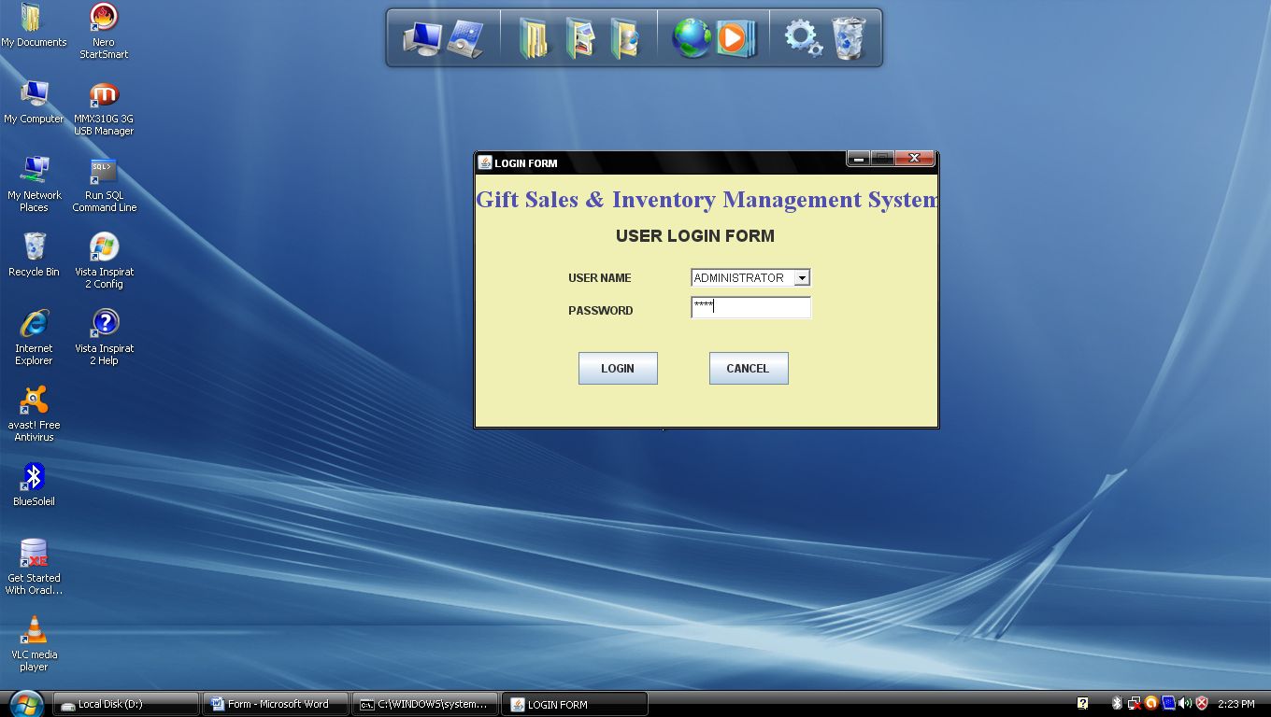

2. Menubar

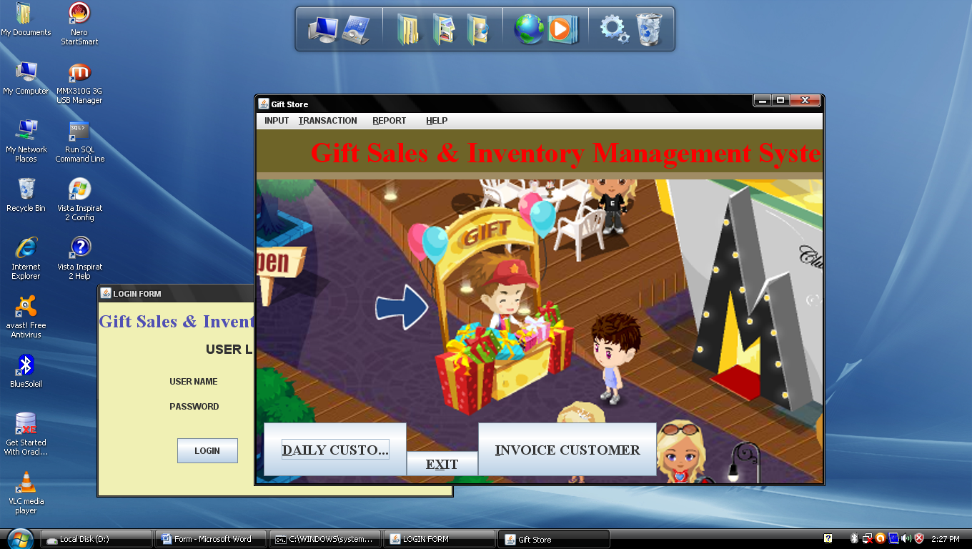

1. Software Detail :-

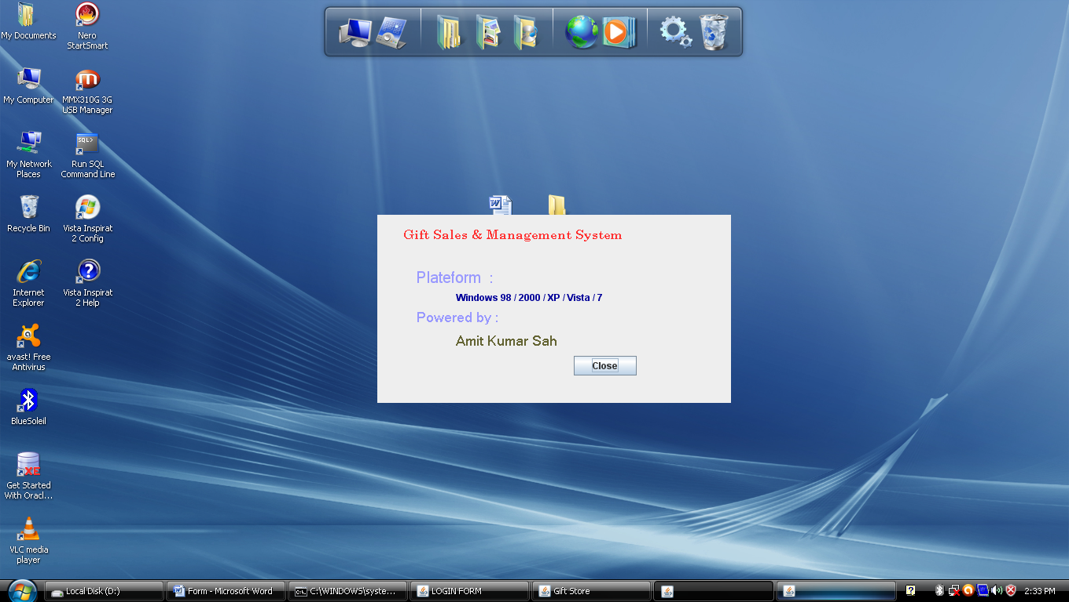

1. Developer Detail :-

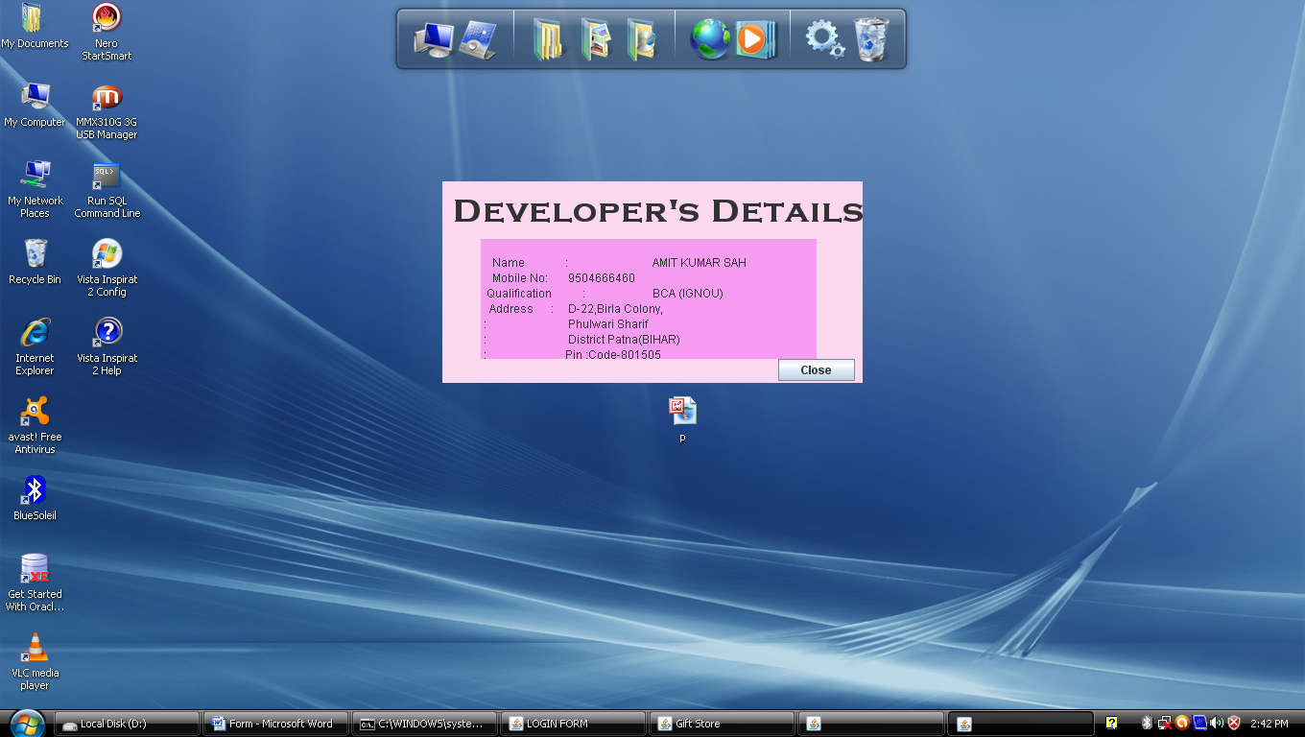

1. Change Password :-

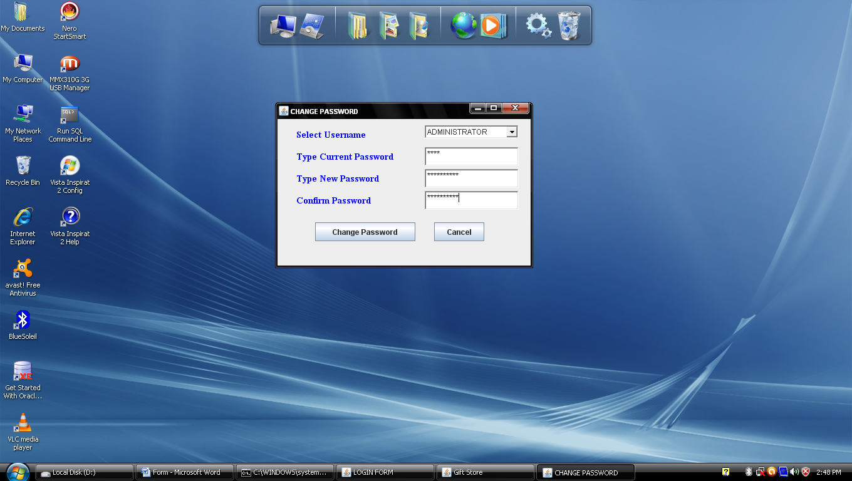

3. Gift_Group:-

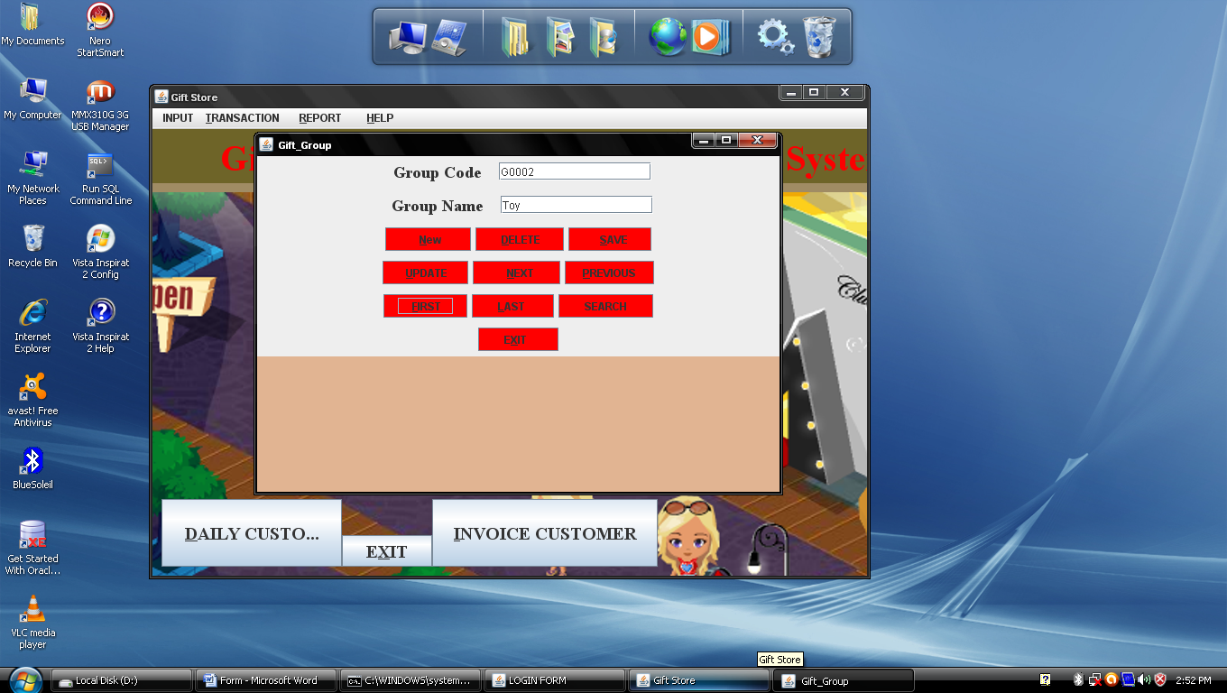

4.Product_Deatils :-

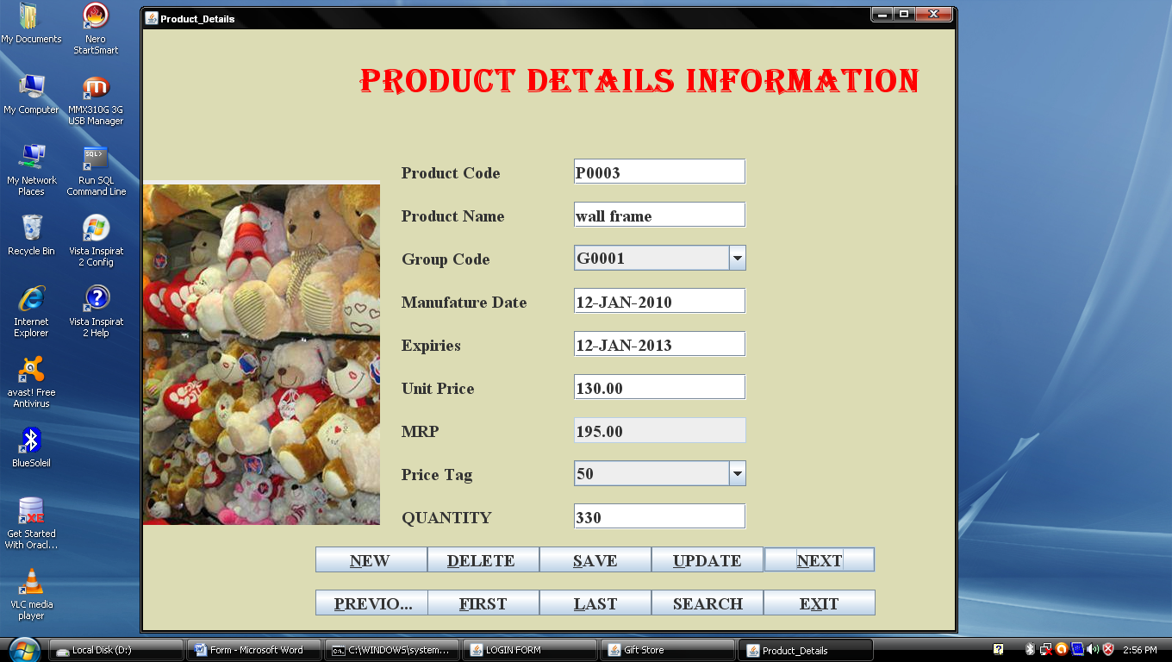

5. Bulk_Customer:-

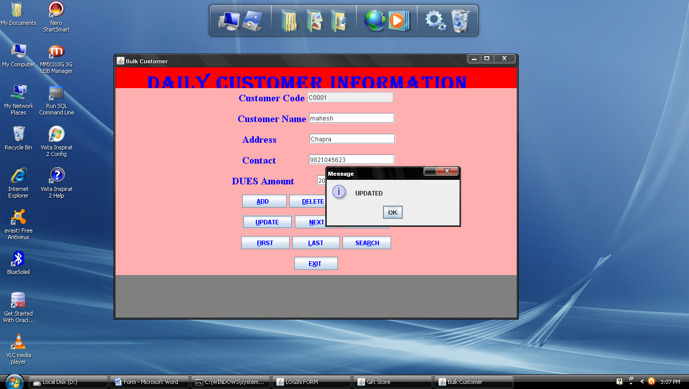

6. Party_Master :-

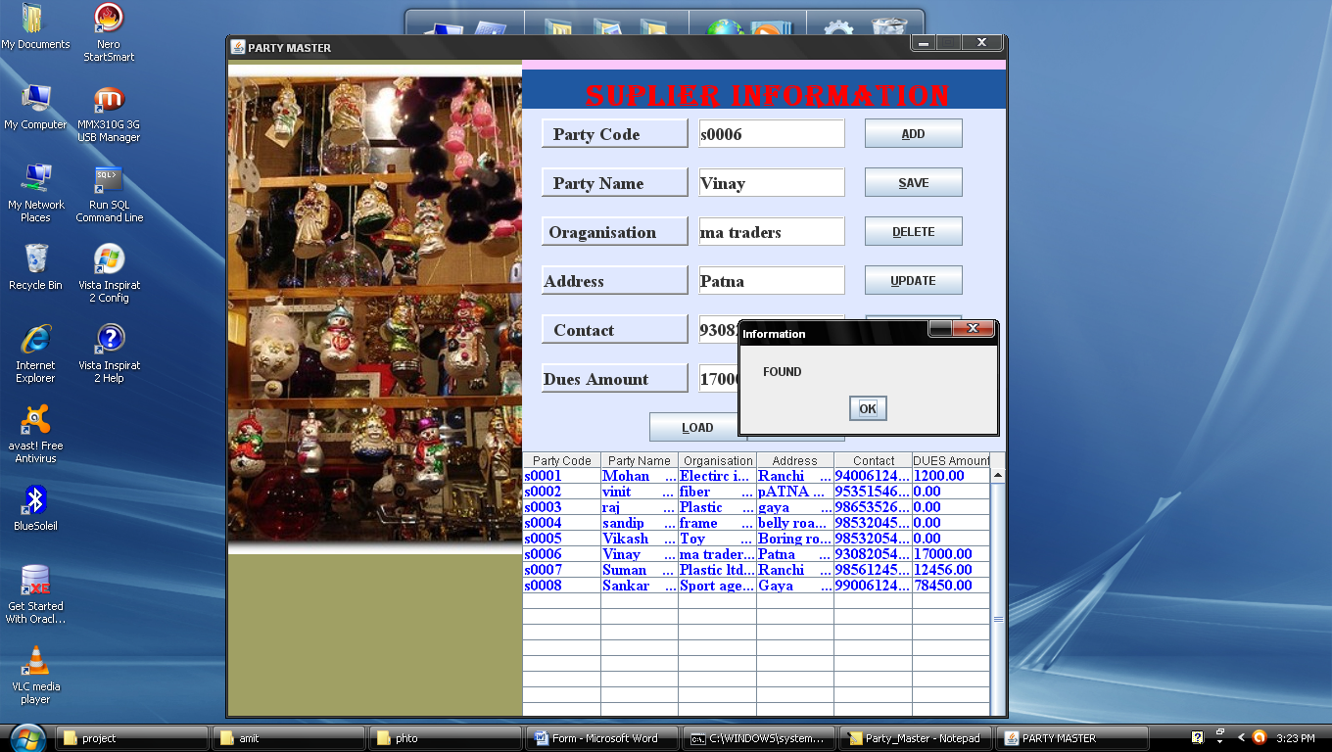

7. ***Inward :-***

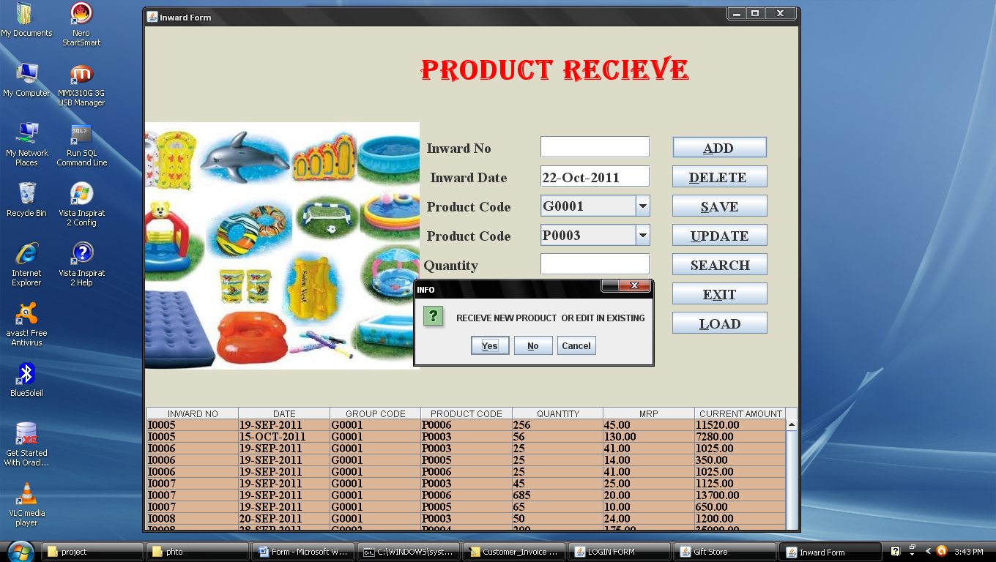

1. deleteInward :-

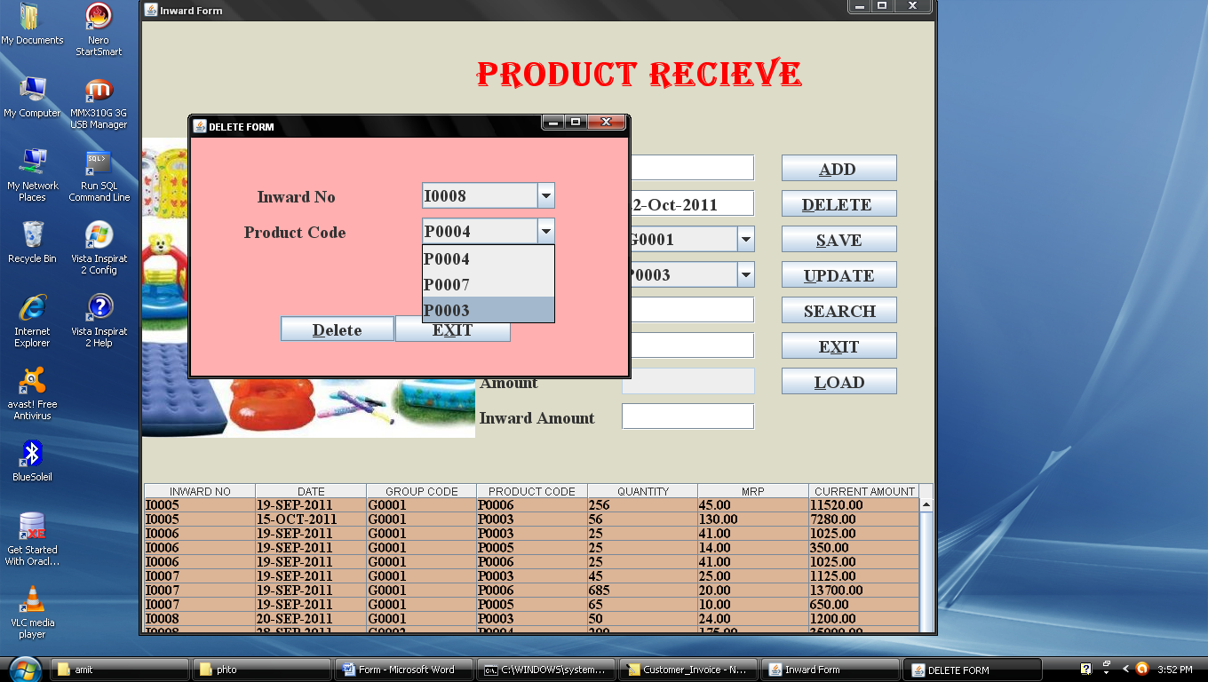

1. searchInward :-

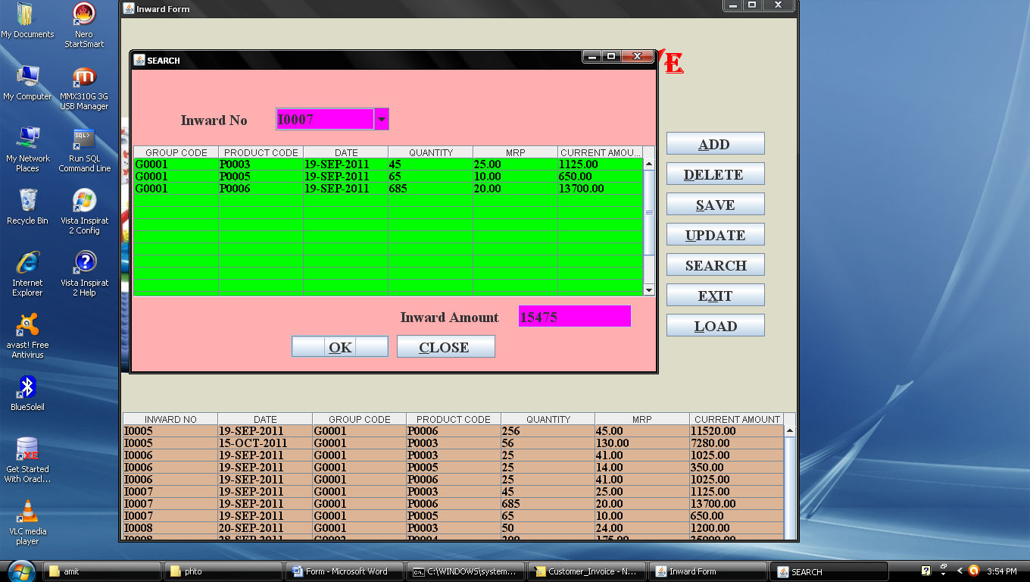

1. update_Inward:-

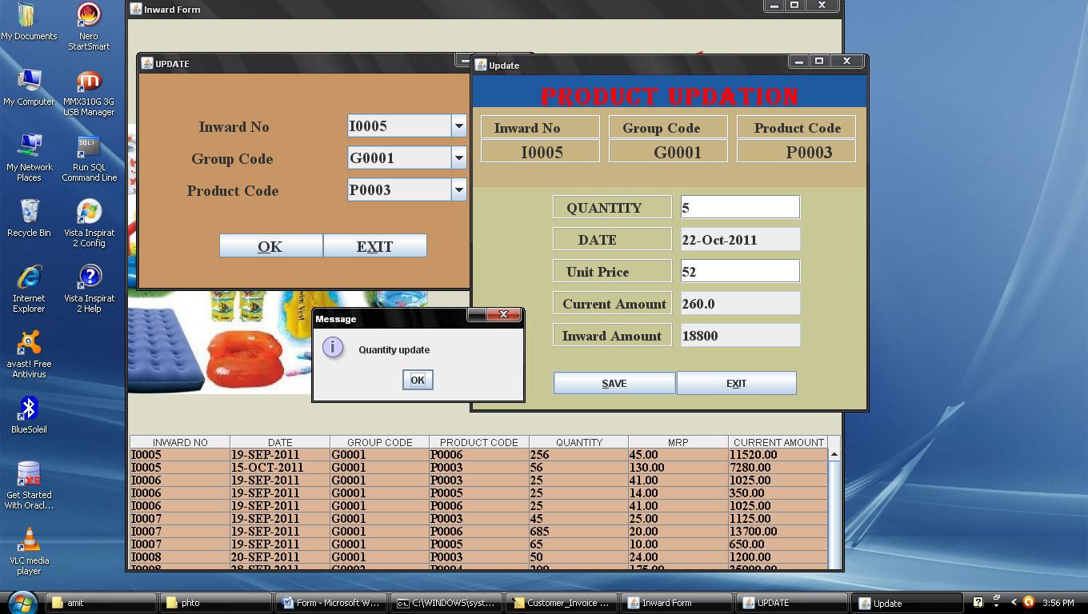

***8.Outward :-***

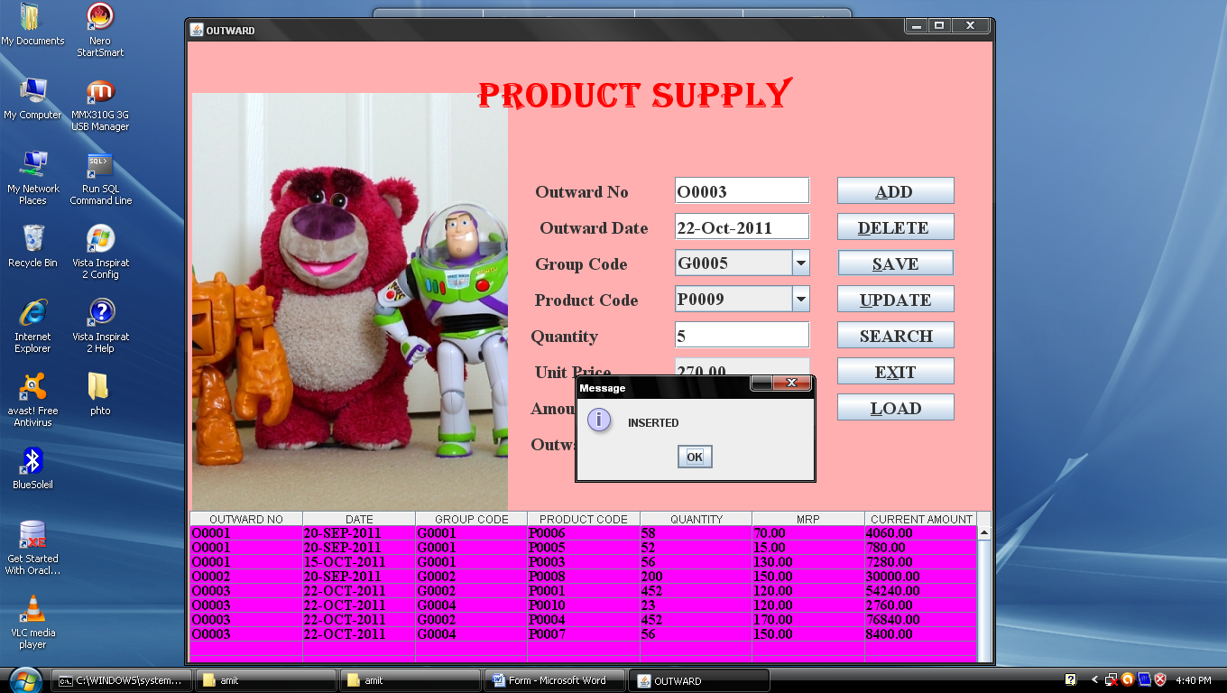

1. deleteOutward:-

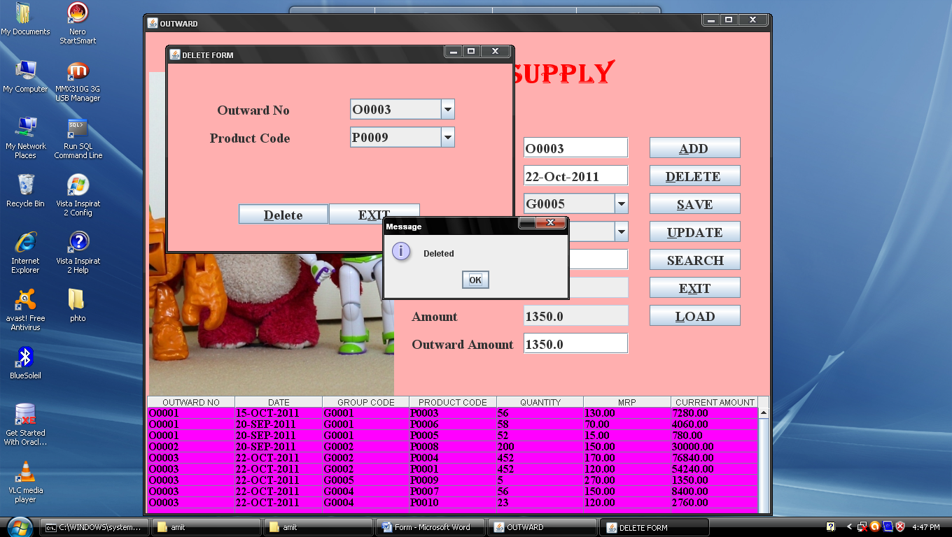

1. searchOutward :-

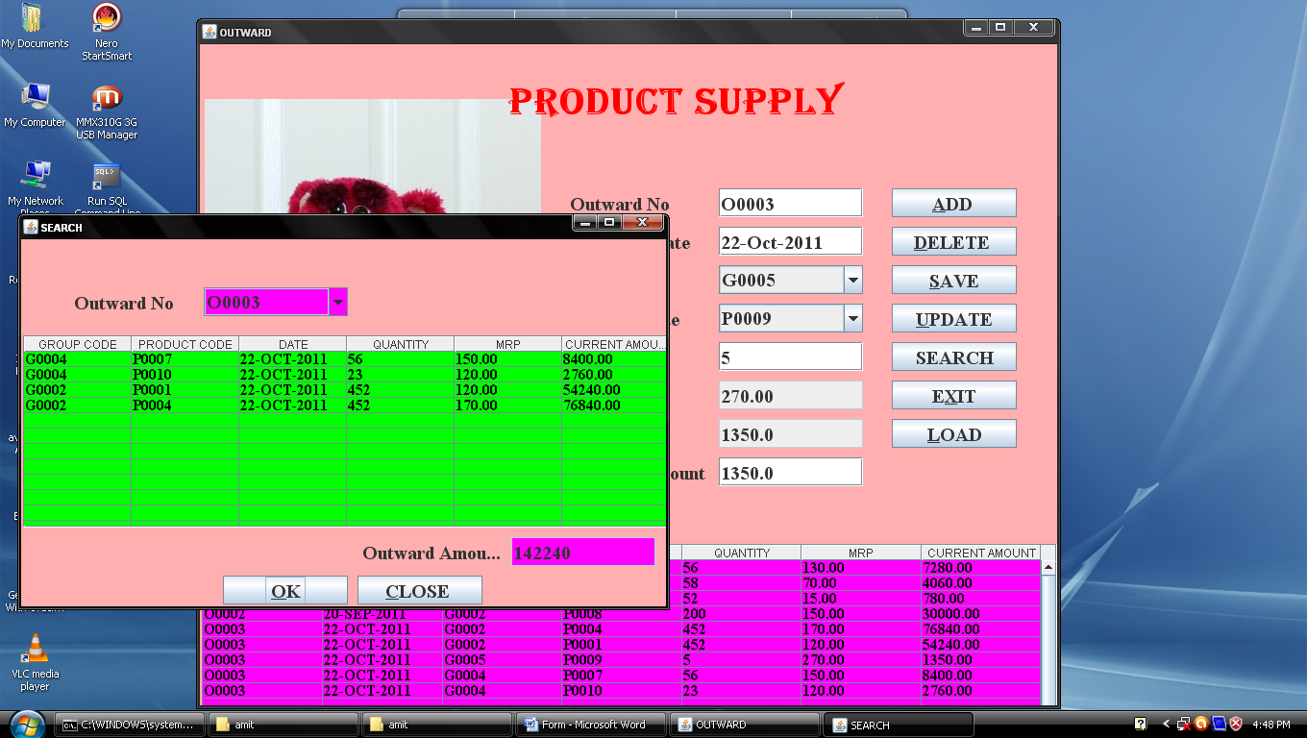

1. updateOutward :-



1. subUpdateOutward:-

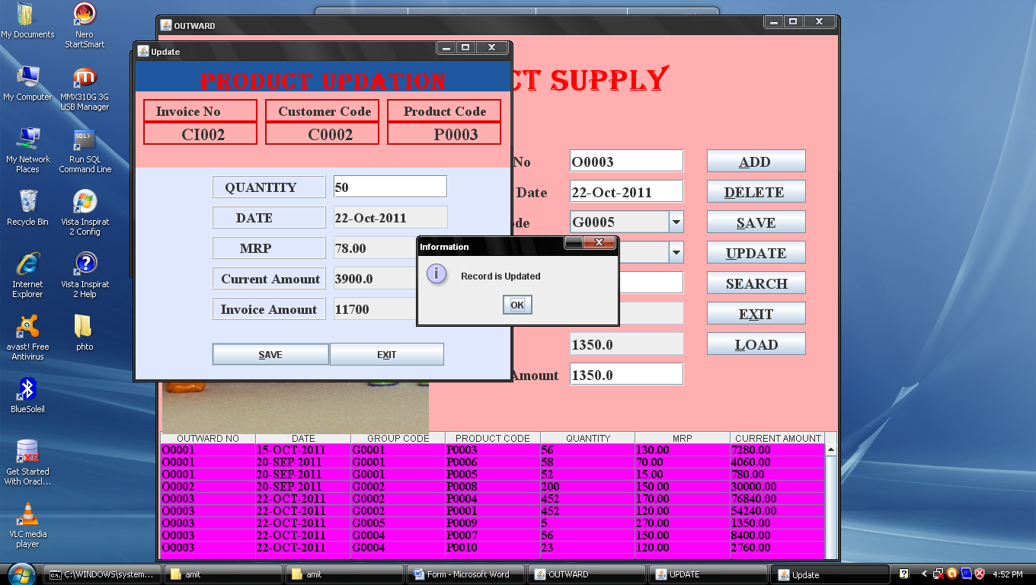

***9. Customer_Invoice:-***

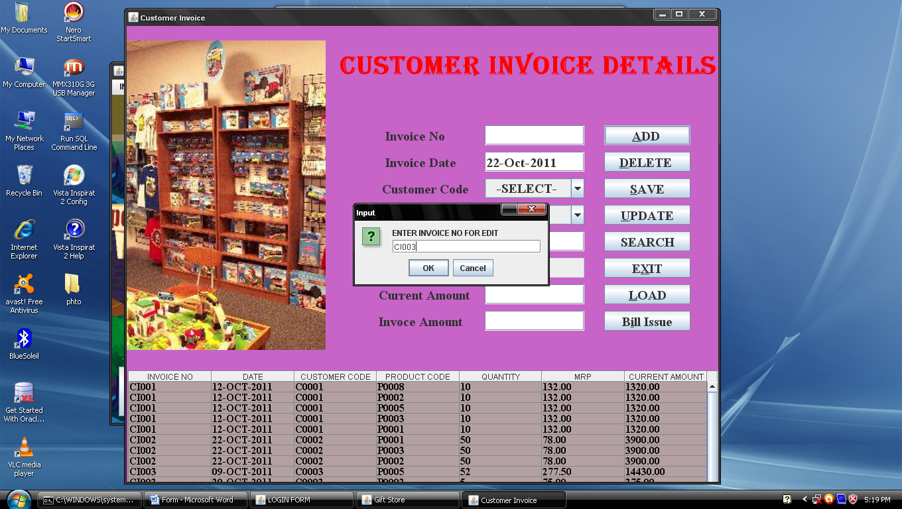

1. deleteCustomer_Invoice :-

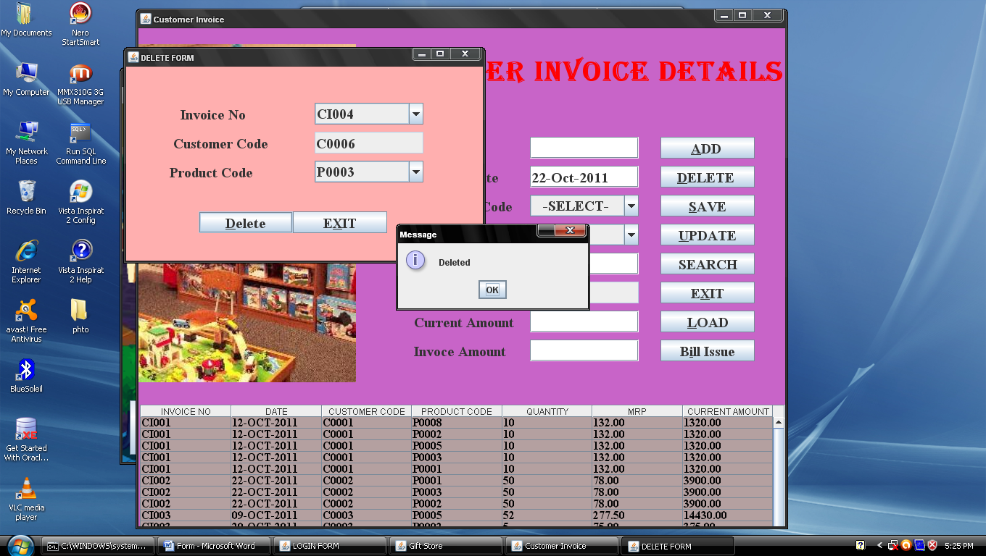

1. searchCustomer_Invoice:-

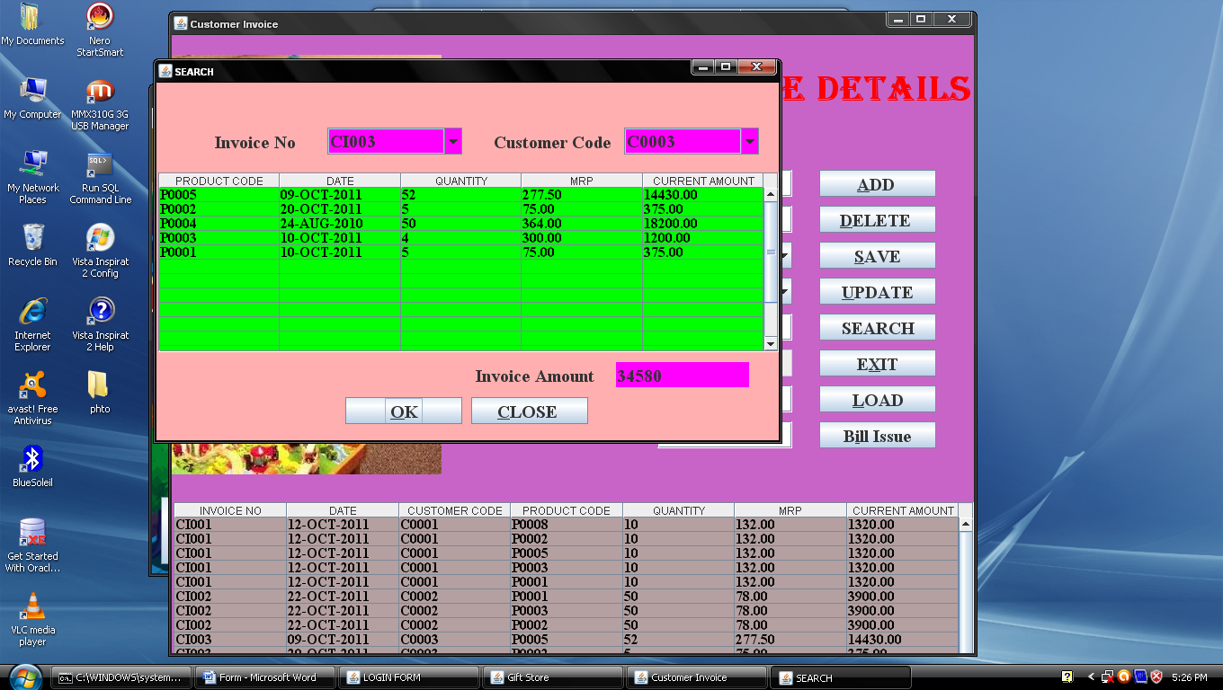

1. updateCustomer_Invoice:-

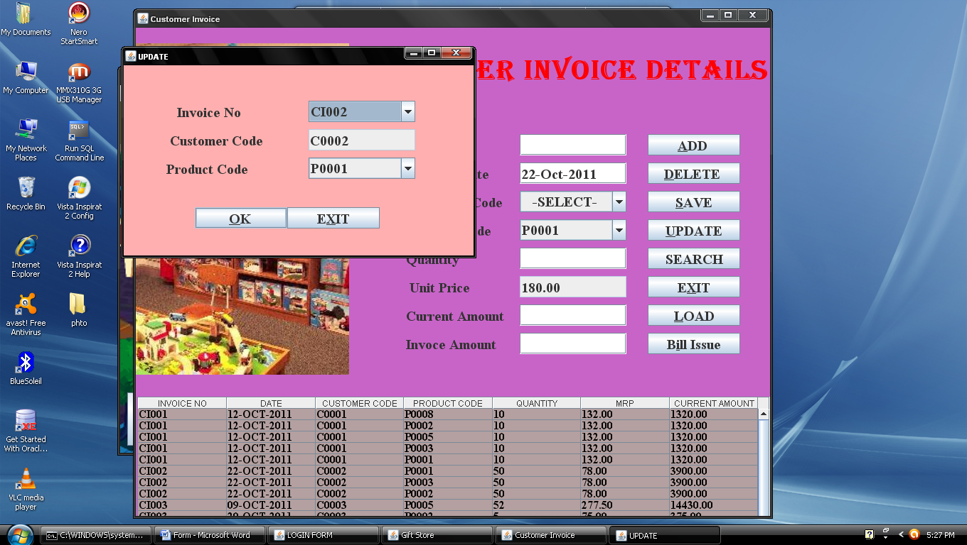

1. subUpdateCustomer_Invoice:-

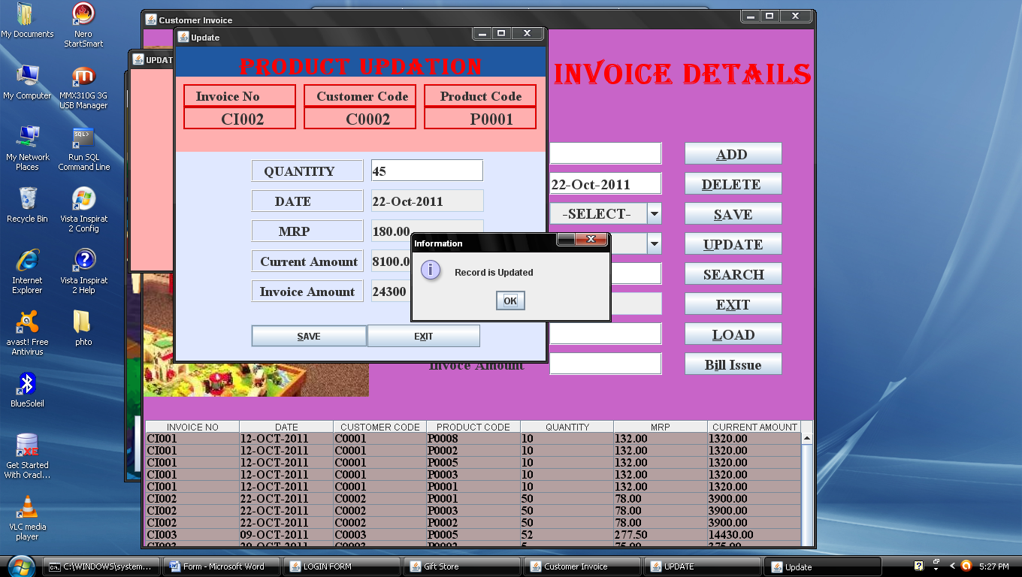

***10. Party_Invoice:-***

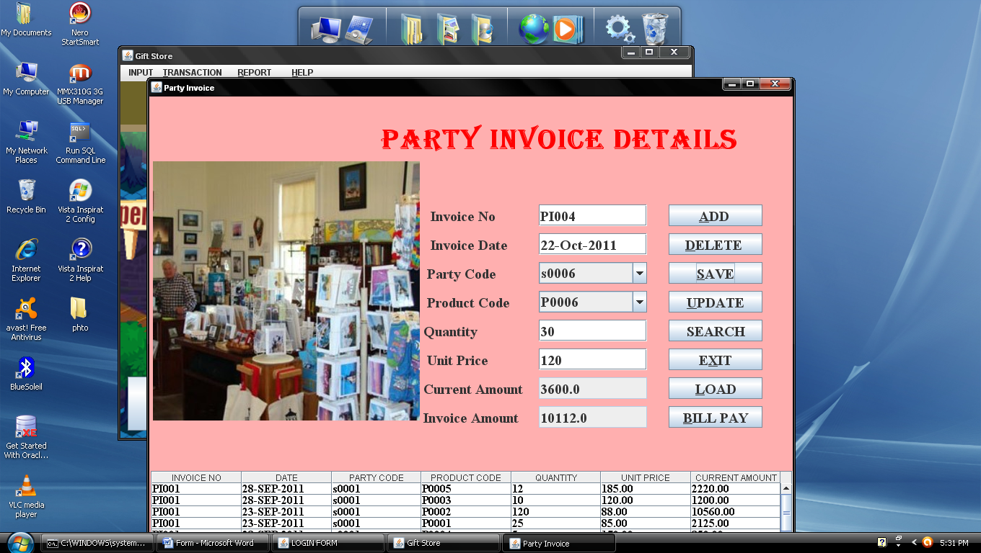

1. deleteParty_Invoice:-

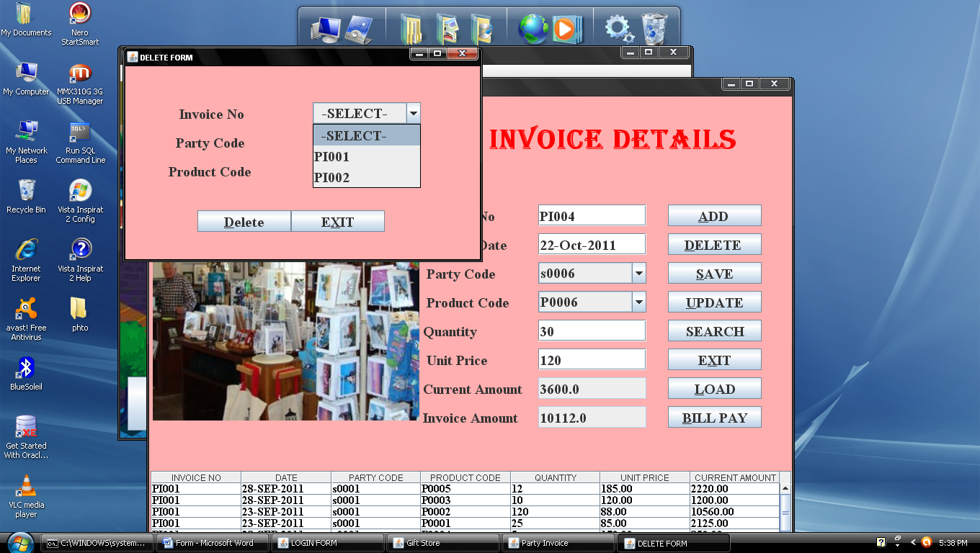

1. searchParty_Invoice:-

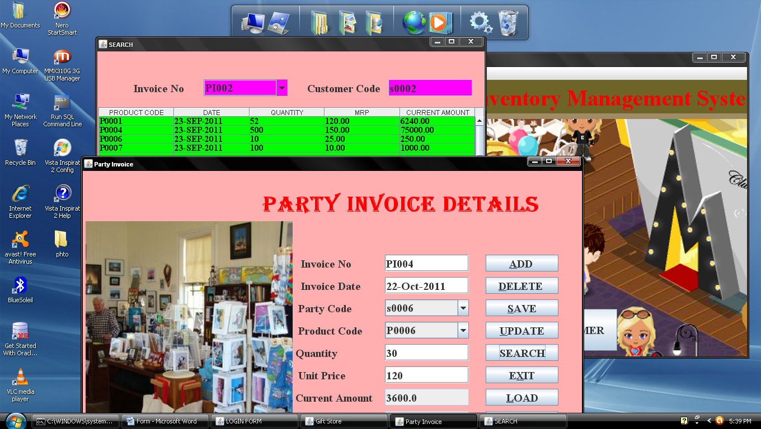

1. updateParty_Invoice :-
2. subUpdateParty_Invoice:-

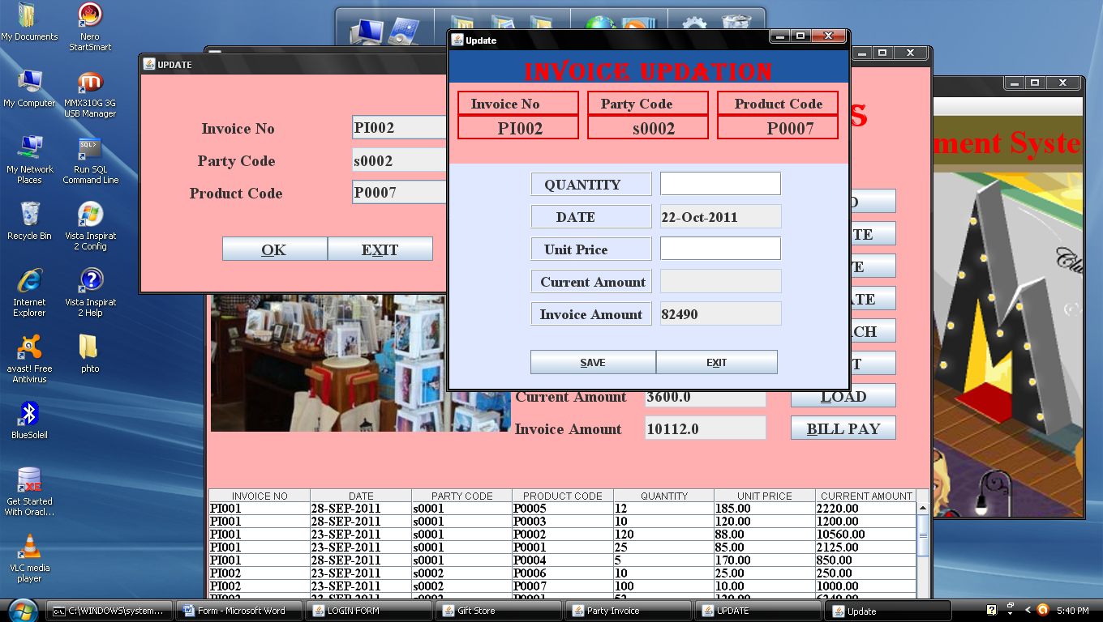

***11.Issue_Bill:-***

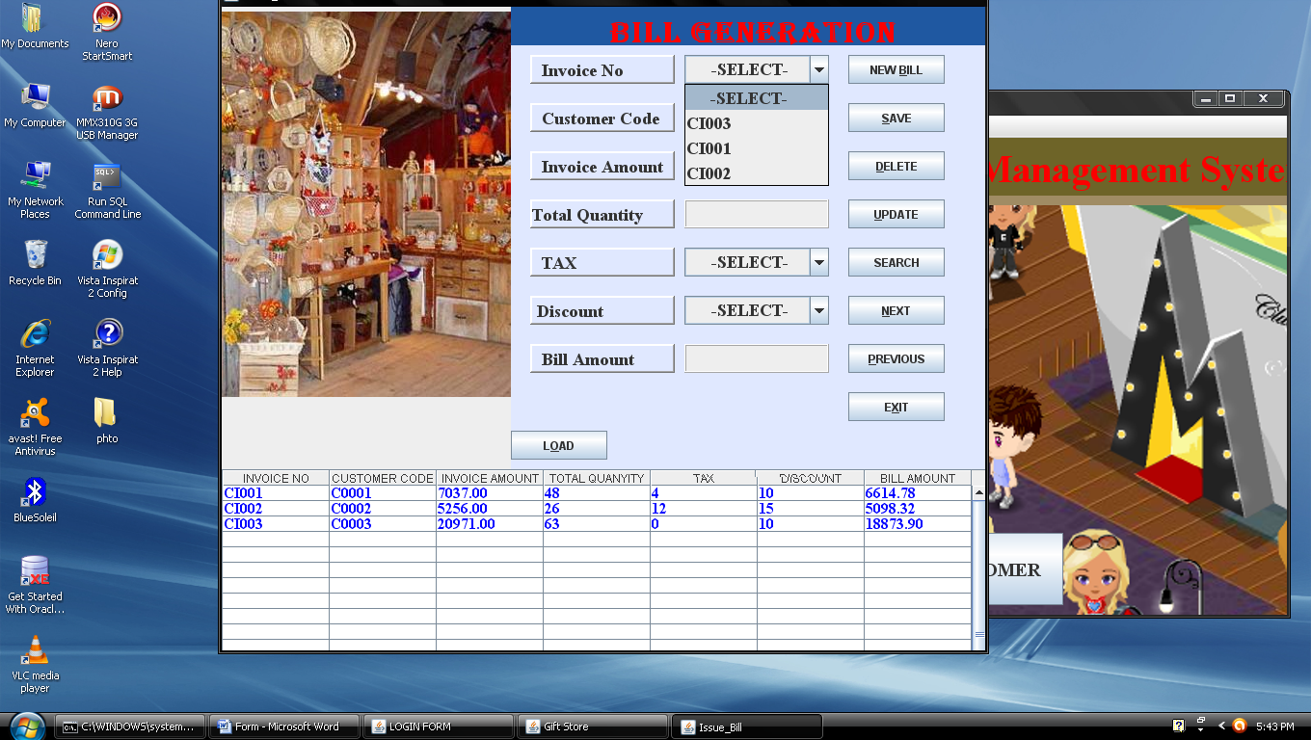

***12.Bill_Payment:-***

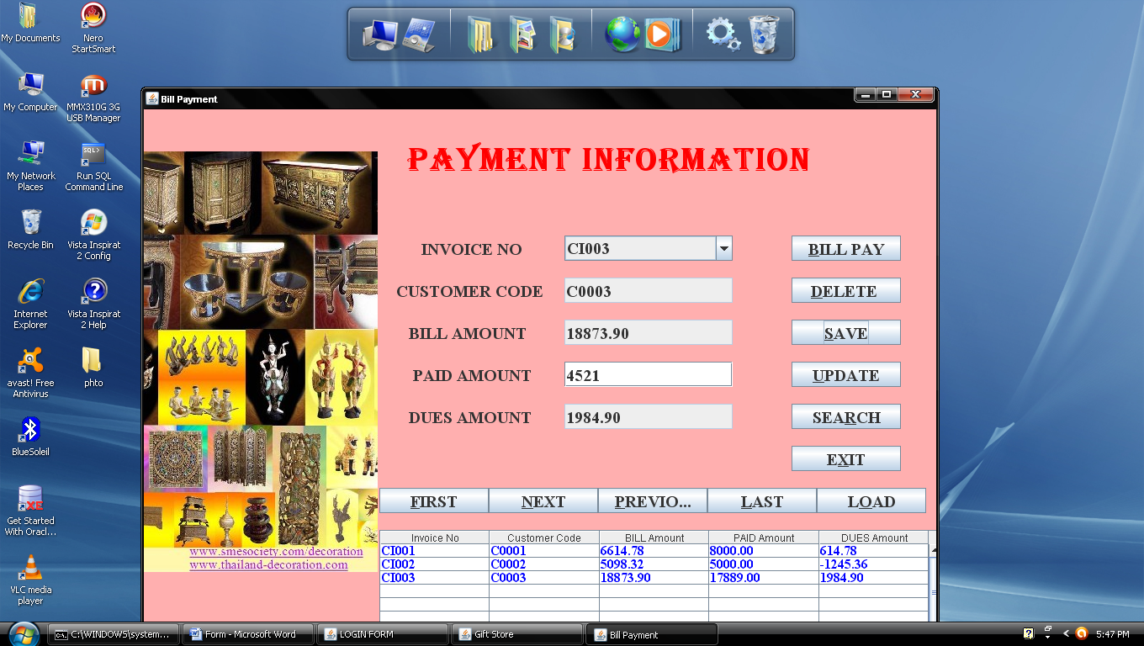

***13. Retail_Customer :-***

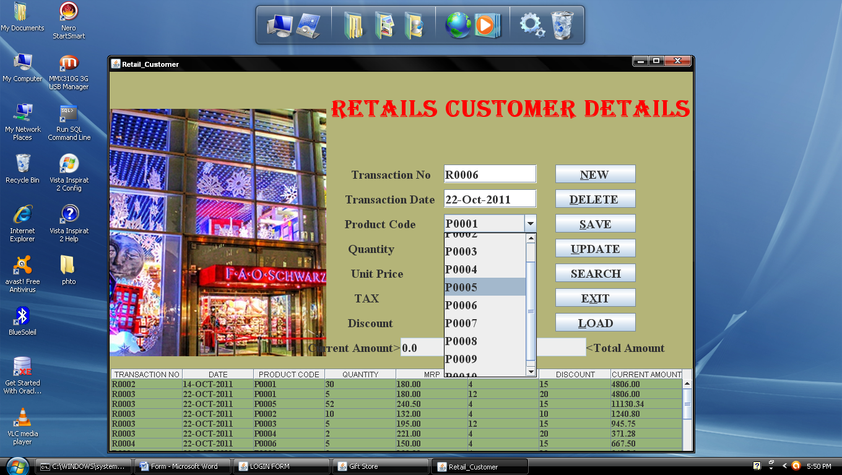

1. deleteRetail_Customer :-

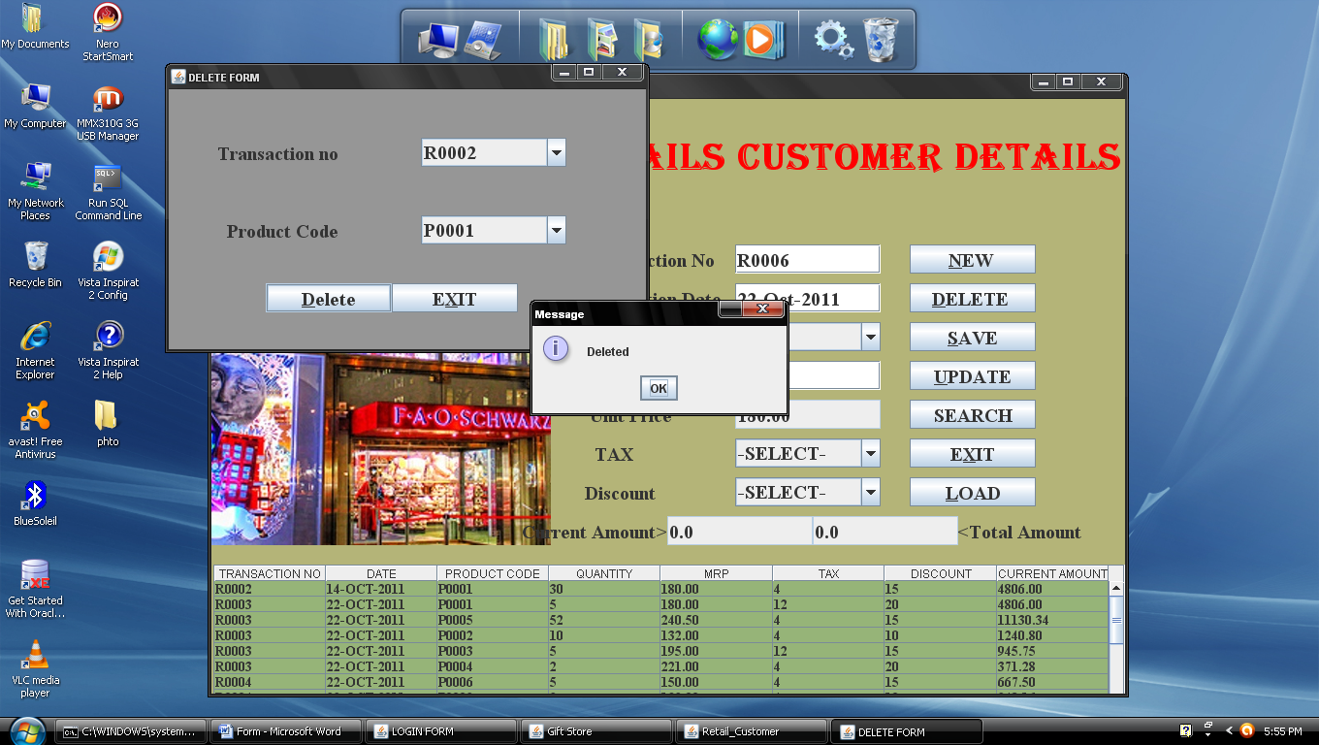

b)updateRetail_Customer:-

c) subupdateRetail_Customer :-

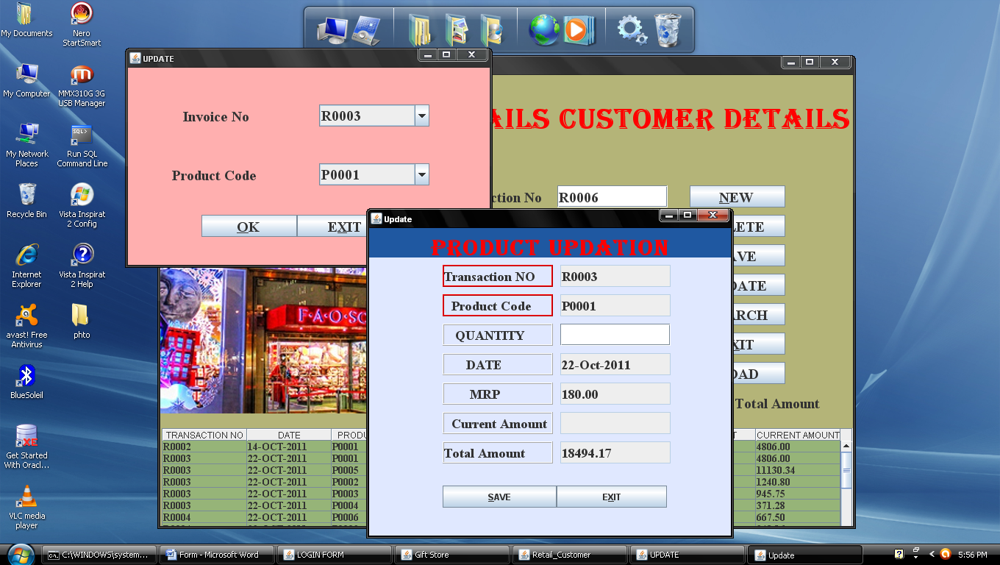

* Report

***14.Stock_Detail_Report:-***

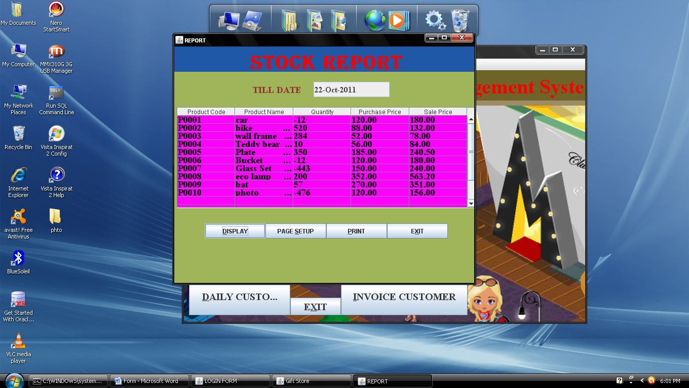

***15.Outstanding_Detail_Report:-***

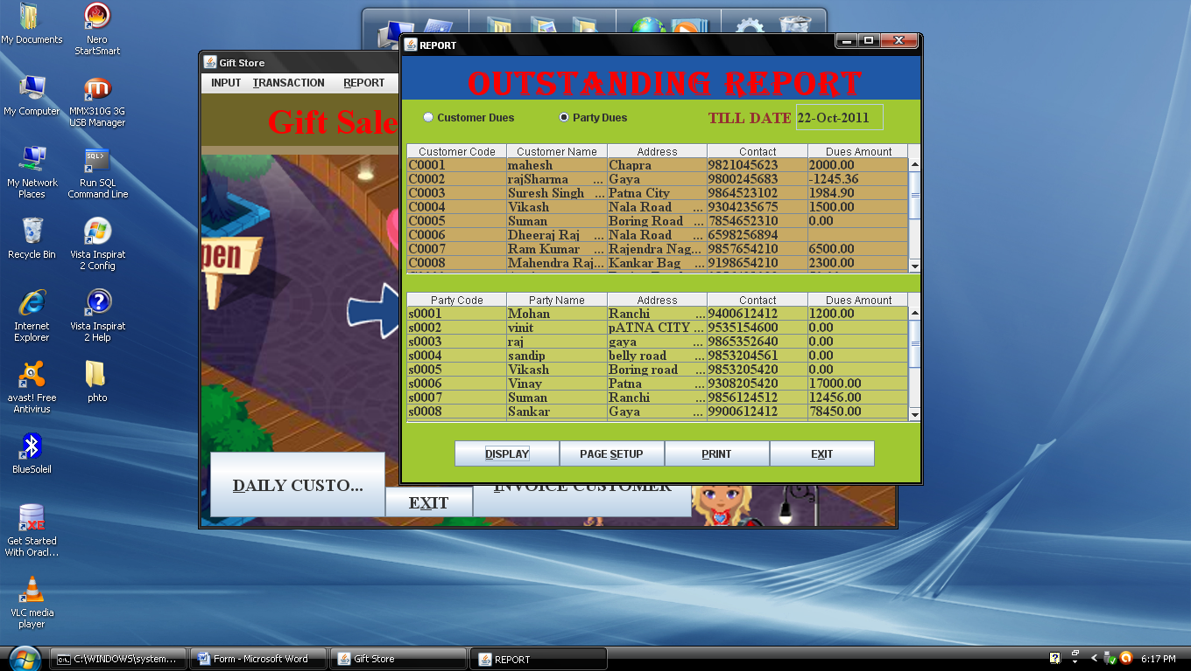

***16. Monthly_Sales_Report:-***

***a) Invoice_Sales_Report***

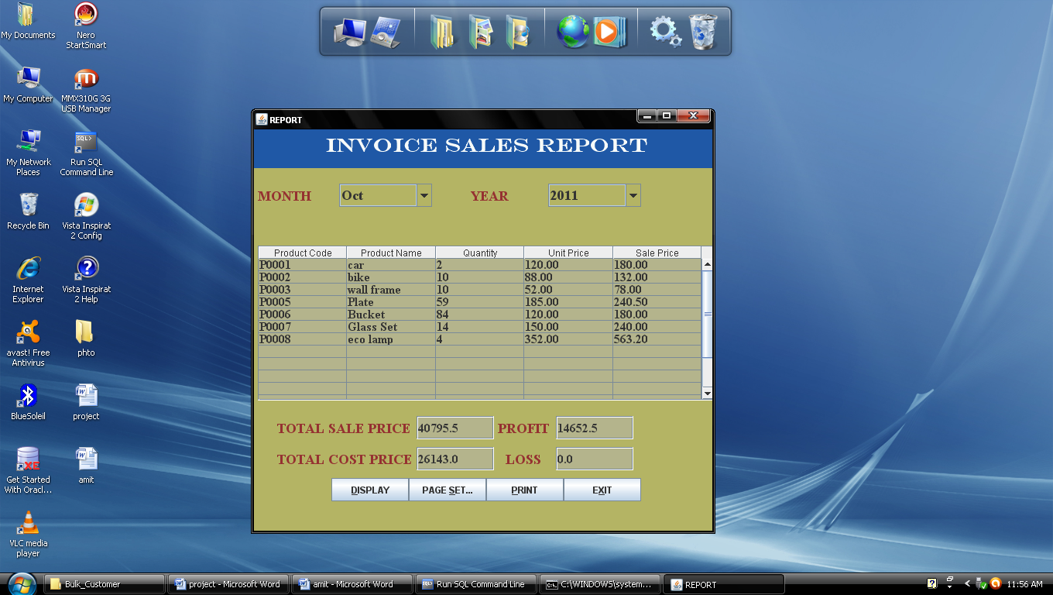

1. Retail_Sales_Report:-

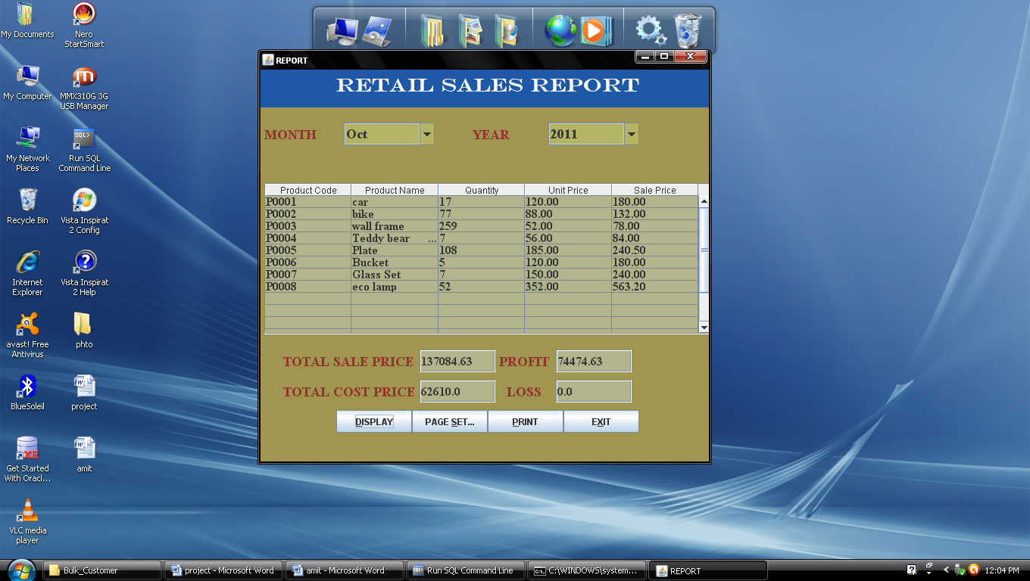

***17.Bulk_Customer_Report:-***

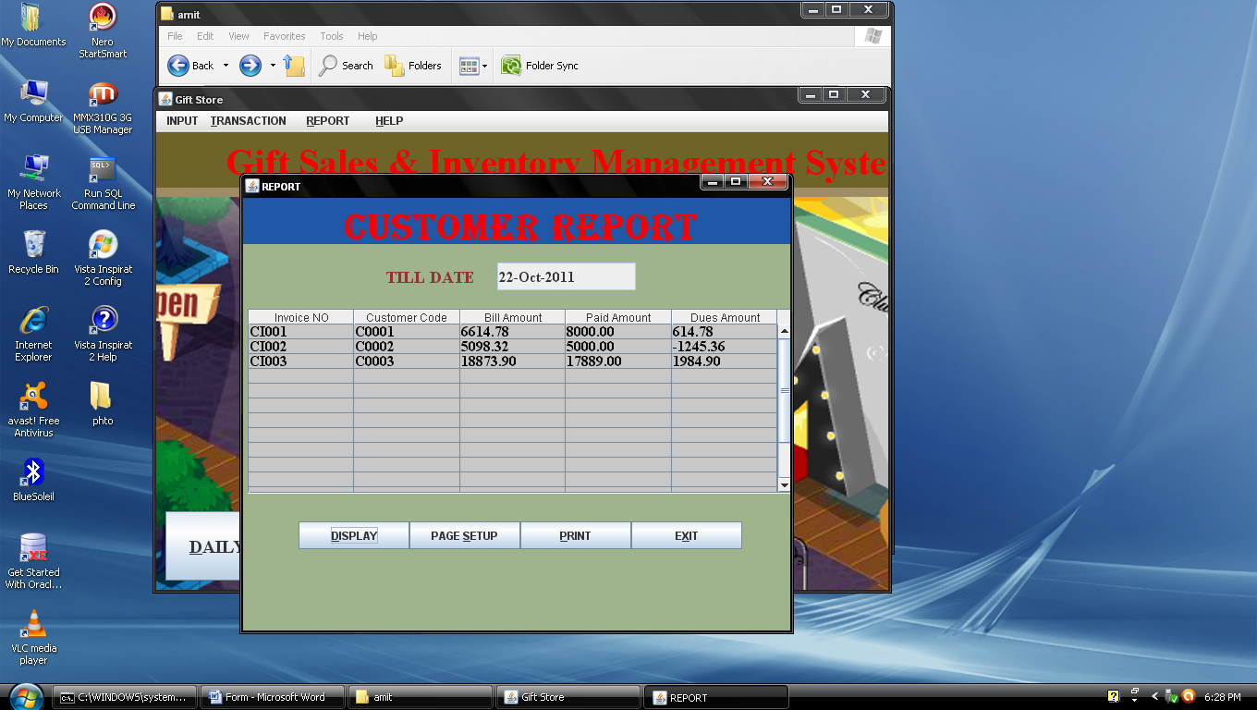

**­--------------------Form End--------------------**

Index of code

* Login ………………………………………………………………………………………71
* Menu
* Menubar ……………………………………………………………75
* Software Detail…………………………………………83
* Developer ………………………………………………………85
* ChangePassword …………………………………………87
* Input

1. Gift_Group ………………………………………………………………91
2. Product_Details ……………………………………………100
3. Party_Master ……………………………………………………114
4. Inward ……………………………………………………………………126

* deleteInward …………………………………140
* searchInward …………………………………145
* updateInward …………………………………150
* subUpdateInward …………………………156

1. Outward …………………………………………………………………163

* deleteOutward …………………………………177
* searchOutward …………………………………182
* updateOutward …………………………………188
* subUpdateOuward ……………………………192

1. Customer_Invoice ……………………………………………200

* deleteCustomer_Invoice ……………214
* searchCustomer_Invoice ……………220
* updateCustomer_Invoice ……………225
* subUpdateCustomer_Invoice ……230

1. Party_Invoice ……………………………………………………239

* deleteParty_Invoice ……………………252
* searchParty_Invoice ……………………258
* updateParty_Invoice ……………………264
* subUpdateParty_Invoice ……………268

8.Bulk_Customer ……………………………………………………277

9.Issue_Bill ……………………………………………………………287

10.Bill_Payment ……………………………………………………304

11.Retail_Customer ………………………………………………320

* deleteRetail_Customer ………………335
* updateRetail_Customer ………………340
* subUpdateRetail_Customer ………344
* Report

1. Stock_Detail_Report ………………………………………353
2. Outstanding_Report ………………………………………359
3. Monthly_Sales_Report …………………………………368

* Invoice_Sales_Repot …………………370
* Retail_Sales_Report …………………380

1. Bulk_Customer_Report …………………………………390

* Primary key Generation

1. Gift_Group………………………………………………………………397
2. Product_Details ………………………………………………398
3. Party_Master ……………………………………………………398
4. Bulk_Customer …………………………………………………399

* Login

import java.awt.*;

import java.sql.*;

import java.net.*;

import javax.swing.*;

import java.awt.event.*;

import java.lang.*;

public class login extends JFrame implements ActionListener

{

JButton b1,b2;

JLabel l1,l2,l3,l4,l;

Choice ch;

TextField t1;

int i;

JPanel jp1,jp2,jp3;

String user="";

ResultSet rs;

Statement statement;

Connection myConnection;

public login()

{

JFrame aWindow = new JFrame("LOGIN FORM");

Toolkit theKit = aWindow.getToolkit();

Dimension wndSize = theKit.getScreenSize();

aWindow.setBounds(wndSize.width/4,wndSize.height/4,wndSize.width/2,wndSize.height/2);

Container cn=aWindow.getContentPane();

aWindow.setDefaultCloseOperation(JFrame.EXIT_ON_CLOSE);

cn.setLayout(null);

cn.setBackground(new Color(240,240,180));

l1=new JLabel("Gift Sales & Inventory Management System");

l1.setFont(new Font("Times New Roman",Font.BOLD,26));

l1.setForeground(new Color(80,80,180));

l1.setBounds(0,1,500,50);

l2=new JLabel("USER LOGIN FORM");

l2.setBounds(150,40,200,50);

l2.setFont(new Font("Corier",Font.BOLD,18));

l3=new JLabel("USER NAME");

l3.setBounds(100,90,70,40);

l4=new JLabel("PASSWORD");

l4.setBounds(100,130,80,30);

b1=new JButton("LOGIN");

b1.setBounds(110,190,85,35);

b2=new JButton("CANCEL");

b2.setBounds(250,190,85,35);

ch=new Choice();

ch.setBounds(230,100,130,35);

ch.add("--SELECT USER--");

ch.add("ADMINISTRATOR ");

ch.add("GUEST");

t1=new TextField(15);

t1.setBounds(230,130,130,25);

t1.setEchoChar('*');

cn.add(l1);cn.add(t1);

cn.add(l2);cn.add(b1);

cn.add(l3);cn.add(b2);

cn.add(l4);cn.add(ch);

b1.addActionListener(this);

b2.addActionListener(this);

aWindow.pack();

aWindow.setSize(500,300);

aWindow.setVisible(true);

aWindow.setResizable(false);

connect();

}

public void actionPerformed(ActionEvent evt)

{

String str,str1="",str2="",str3;

int l,lpw,f;

if(evt.getSource()==b1)

{

try

{

str=(String)ch.getSelectedItem();

l=str.length();

str=str.trim();

str3=t1.getText();

str3=str3.trim();

lpw=str3.length();

if(lpw>10)

{

JOptionPane.showMessageDialog(null,"Max 10 digit accept");

}

else

{

rs=statement.executeQuery("select * from login");

f=0;

while(rs.next())

{

str1=rs.getString(1);

str2=rs.getString(2);

str1=str1.trim();

str2=str2.trim();

if((str.compareTo(str1)==0)&&(str2.compareTo(str3)==0))

{

f=1;

break;

}

}

if(f==1 )

{

new Menubar();

t1.setText("");

}

if(f==0)

{

JOptionPane.showMessageDialog(null,"Invalid Password");

}

}

}

catch(SQLException sqle)

{

JOptionPane.showMessageDialog(null,"Error"+sqle);

}

}

if(evt.getSource()==b2)

{

System.exit(0);

}

}

public void connect()

{

try

{

try

{

Class.forName("sun.jdbc.odbc.JdbcOdbcDriver");

myConnection=DriverManager.getConnection("jdbc:odbc:amit","system","amit");

statement=myConnection.createStatement(ResultSet.TYPE_SCROLL_SENSITIVE,ResultSet.CONCUR_UPDATABLE);

}

catch(SQLException sqle)

{

JOptionPane.showMessageDialog(null,sqle);

}

}

catch(Exception ex)

{

JOptionPane.showMessageDialog(null,ex);

}

}

public static void main(String args[])

{

login lg=new login();

}

}

* Menu
* Menubar

import input.*;

import report.*;

import java.lang.*;

import java.io.*;

import javax.swing.*;

import java.sql.*;

import java.awt.*;

import java.awt.event.*;

import javax.swing.event.*;

import javax.swing.border.*;

import javax.swing.JTable.*;

import java.awt.print.*;

import javax.swing.JMenuBar;

import javax.swing.JMenu;

import javax.swing.JMenuItem;

import javax.swing.KeyStroke;

import static java.awt.event.InputEvent.*;

public class Menubar extends JFrame

{

private JMenuBar menubar=new JMenuBar();

private JMenu m1,m2,m3,m4,mi3,mi4,mi5;

private JMenuItem mi1,mi2,mi6,mi7,mi8,mi9,mi10,mi11,mi12,mi13,mi14,mi15,mi16,sm1,sm2,sm3,sm4,sm5,sm6;

private JLabel l1,l2;

private JButton b1,b2,b3;

private JPanel p1,p2;

private Container cn;

private String str1,str2,str3,str4,str5,str6,str;

private Connection connection;

private Statement statement;

private ResultSet rs;

Cursor cr=new Cursor(Cursor.HAND_CURSOR);

public Menubar()

{

super("Gift Store");

setLayout(null);

Dimension screensize=Toolkit.getDefaultToolkit().getScreenSize();

setBounds((screensize.width-700)/4,(screensize.height-400)/4,700,400);

setSize(800,550);

setDefaultCloseOperation(JFrame.EXIT_ON_CLOSE);

cn=getContentPane();

cn.setBackground(new Color(200,140,100));

l1=new JLabel("Gift Sales & Inventory Management System");

l1.setFont(new Font("ALGERIAN",Font.BOLD, 40));

l1.setForeground(new Color(250,0,0));

p1=new JPanel();

p1.setBounds(0,0,800,62);

p1.setBackground(new Color(31,88,166));

p1.add(l1);

cn.add(p1,BorderLayout.NORTH);

Icon ic=new ImageIcon("9.jpg");

l2=new JLabel(ic);

l2.setForeground(Color.red);

l2.setBounds(180,0,400,350);

p2=new JPanel();

p2.setLayout(null);

p2.setBounds(0,60,800,490);

p2.setBackground(new Color(200,140,100));

cn.add(p2,BorderLayout.CENTER);

setJMenuBar(menubar);

//MENUS

m1=new JMenu(" INPUT");

m2=new JMenu("TRANSACTION");

m3=new JMenu(" REPORT");

m4=new JMenu(" HELP");

//MENU MENUITEMS

// Entry Item

mi1=new JMenuItem("Gift Group");

mi2=new JMenuItem("Product Detail");

mi3=new JMenu("Supplier & cUst");

m1.add(mi1); m1.add(mi2); m1.add(mi3);

//transaction

mi4=new JMenu("Branch");

mi5=new JMenu("Order");

mi6=new JMenuItem("Issue Bill");

mi7=new JMenuItem("Bill Payment");

mi8=new JMenuItem("Retail Customer");

m2.add(mi4); m2.add(mi6);

m2.add(mi7); m2.add(mi8);

m2.add(mi5);

//REPORT MENUITEMS

mi9=new JMenuItem("Monthly Sales");

mi10=new JMenuItem("Product Stock");

mi11=new JMenuItem("Dues Amount");

mi12=new JMenuItem("Bulk Customer");

m3.add(mi9);

m3.add(mi11);

m3.add(mi11);

m3.add(mi12);

//HELP MENUITEMS

mi13=new JMenuItem("Software Deatil");

mi14=new JMenuItem("Developer Detail");

mi15=new JMenuItem("Instruction");

mi16=new JMenuItem("Change Password");

m4.add(mi13);

m4.add(mi14);

m4.add(mi15);

m4.add(mi16);

// Sub Menu Item

sm1=new JMenuItem("Supplier");

sm2=new JMenuItem("Customer");

sm3=new JMenuItem("Inward");

sm4=new JMenuItem("Outward");

sm5=new JMenuItem("Customer Invoice");

sm6=new JMenuItem("Party Invoice");

mi3.add(sm1);

mi3.add(sm2);

mi4.add(sm3);

mi4.add(sm4);

mi5.add(sm5);

mi5.add(sm6);

// Button

b1=new JButton("DAILY CUSTOMER");

b1.setFont(new Font("Serif",Font.BOLD,20));

b1.setMnemonic('D');

b1.setBounds(200,300,250,35);

b1.addActionListener(new transactionlistener());

p2.add(b1);

b2=new JButton("INVOICE CUSTOMER");

b2.setFont(new Font("Serif",Font.BOLD,20));

b2.setMnemonic('I');

b2.setBounds(480,300,250,35);

//b2.setBackground(new Color(150,180,60));

b2.addActionListener(new transactionlistener());

p2.add(b2);

b3=new JButton("EXIT");

b3.setFont(new Font("Serif",Font.BOLD,20));

b3.setMnemonic('X');

b3.setBounds(300,350,100,35);

b3.addActionListener(new exitListener());

p2.add(b3);

p2.add(l2);

//MNEMONICS

m1.setMnemonic('E');

m2.setMnemonic('T');

m3.setMnemonic('R');

m4.setMnemonic('H');

mi1.setAccelerator(KeyStroke.getKeyStroke('G',CTRL_DOWN_MASK));

mi2.setAccelerator(KeyStroke.getKeyStroke('P',CTRL_DOWN_MASK));

mi6.setAccelerator(KeyStroke.getKeyStroke('B',CTRL_DOWN_MASK));

mi7.setAccelerator(KeyStroke.getKeyStroke('D',CTRL_DOWN_MASK));

mi8.setAccelerator(KeyStroke.getKeyStroke('R',CTRL_DOWN_MASK));

mi9.setAccelerator(KeyStroke.getKeyStroke('M',CTRL_DOWN_MASK));

mi10.setAccelerator(KeyStroke.getKeyStroke('U',CTRL_DOWN_MASK));

mi11.setAccelerator(KeyStroke.getKeyStroke('S',CTRL_DOWN_MASK));

mi12.setAccelerator(KeyStroke.getKeyStroke('Y',CTRL_DOWN_MASK));

mi13.setAccelerator(KeyStroke.getKeyStroke('W',CTRL_DOWN_MASK));

mi14.setAccelerator(KeyStroke.getKeyStroke('V',CTRL_DOWN_MASK));

mi15.setAccelerator(KeyStroke.getKeyStroke('M',CTRL_DOWN_MASK));

mi16.setAccelerator(KeyStroke.getKeyStroke('N',CTRL_DOWN_MASK));

sm1.setAccelerator(KeyStroke.getKeyStroke('K',CTRL_DOWN_MASK));

sm2.setAccelerator(KeyStroke.getKeyStroke('T',CTRL_DOWN_MASK));

sm3.setAccelerator(KeyStroke.getKeyStroke('I',CTRL_DOWN_MASK));

sm4.setAccelerator(KeyStroke.getKeyStroke('O',CTRL_DOWN_MASK));

sm5.setAccelerator(KeyStroke.getKeyStroke('C',CTRL_DOWN_MASK));

sm6.setAccelerator(KeyStroke.getKeyStroke('A',CTRL_DOWN_MASK));

menubar.add(m1);

menubar.add(m2);

menubar.add(m3);

menubar.add(m4);

//ACTIONLISTENERS

mi1.addActionListener(new entrylistener());

mi2.addActionListener(new entrylistener());

sm1.addActionListener(new entrylistener());

sm2.addActionListener(new entrylistener());

sm3.addActionListener(new transactionlistener());

sm4.addActionListener(new transactionlistener());

sm5.addActionListener(new transactionlistener());

sm6.addActionListener(new transactionlistener());

mi6.addActionListener(new transactionlistener());

mi7.addActionListener(new transactionlistener());

mi8.addActionListener(new transactionlistener());

mi9.addActionListener(new reportlistener());

mi10.addActionListener(new reportlistener());

mi11.addActionListener(new reportlistener());

mi12.addActionListener(new reportlistener());

mi13.addActionListener(new helplistener());

mi14.addActionListener(new helplistener());

mi15.addActionListener(new helplistener());

mi16.addActionListener(new helplistener());

connect();

setVisible(true);

setResizable(false);

}

private class entrylistener implements ActionListener

{

public void actionPerformed(ActionEvent e)

{

if(e.getSource()==mi1)

{

new Gift_Group();

}

if(e.getSource()==mi2)

{

new Product_Details();

}

if(e.getSource()==sm1)

{

new Bulk_Customer();

}

if(e.getSource()==sm2)

{

new Party_Master();

}

}

}

private class transactionlistener implements ActionListener

{

public void actionPerformed(ActionEvent e)

{

if(e.getSource()==sm3)

{

new Inward();

}

if(e.getSource()==sm4)

{

new Outward();

}

if(e.getSource()==sm5)

{

new Customer_Invoice();

}

if(e.getSource()==sm6)

{

new Party_Invoice();

}

if(e.getSource()==mi6)

{

new Issue_Bill();

}

if(e.getSource()==mi7)

{

new Bill_Payment();

}

if(e.getSource()==mi8)

{

new Retail_Customer();

}

if(e.getSource()==b1)

{

new Retail_Customer();

}

if(e.getSource()==b2)

{

new Customer_Invoice();

}

}

}

private class reportlistener implements ActionListener

{

public void actionPerformed(ActionEvent e)

{

if(e.getSource()==mi9)

{

new Monthly_Sales_Report();

}

if(e.getSource()==mi10)

{

new Outstanding_Report();

}

if(e.getSource()==mi11)

{

new Stock_Detail_Report();

}

if(e.getSource()==mi12)

{

new Bulk_Customer_Report();

}

}

}

private class helplistener implements ActionListener

{

public void actionPerformed(ActionEvent e)

{

if(e.getSource()==mi13)

{

new aboutsw();

}

if(e.getSource()==mi14)

{

new developer();

}

if(e.getSource()==mi15)

{

new instruction();

}

if(e.getSource()==mi16)

{

new ChangePassword();

}

}

}

public class exitListener implements ActionListener

{

int r;

public void actionPerformed(ActionEvent e)

{

r=JOptionPane.showConfirmDialog(null,"EXIT","WARNING",JOptionPane.WARNING_MESSAGE);

if(r==JOptionPane.YES_OPTION)

dispose();

}

}

protected void processWindowEvent(WindowEvent we)

{ int r;

if(we.getID() == we.WINDOW_CLOSING)

{

r=JOptionPane.showConfirmDialog(null,"Do You Want To Exit Now !","Enter Carefully",JOptionPane.WARNING_MESSAGE);

if(r==JOptionPane.YES_OPTION)

dispose();

}

}

public void connect()

{

try

{

try

{

Class.forName("sun.jdbc.odbc.JdbcOdbcDriver");

connection=DriverManager.getConnection("jdbc:odbc:amit","system","amit");

statement=connection.createStatement();

}

catch(SQLException sqle)

{

JOptionPane.showMessageDialog(null,"Exception"+sqle);

}

}

catch(Exception e)

{

JOptionPane.showMessageDialog(null,"NOT CONNECTED");

}

}

public static void main(String args[])

{

Menubar mb=new Menubar();

}

}

* Software Detail:-

Package input;

import java.lang.*;

import java.awt.*;

import java.awt.event.*;

import javax.swing.*;

public class aboutsw extends JFrame

{

private JButton b1;

private JLabel l1,l2,l3,l4,l5;

Dimension screenSize;

public aboutsw()

{

b1=new JButton();

l1=new JLabel();

l2=new JLabel();

l3=new JLabel();

l4=new JLabel();

l5=new JLabel();

getContentPane().setLayout(null);

setDefaultCloseOperation(JFrame.DISPOSE_ON_CLOSE);

setResizable(false);

setUndecorated(true);

getAccessibleContext().setAccessibleName("About");

b1.setText("Close");

getContentPane().add(b1);

b1.setBounds(250, 180, 80, 25);

b1.addActionListener(new closeListener());

l1.setFont(new Font("Microsoft Sans Serif", 0, 20));

l1.setForeground(new java.awt.Color(153,153,255));

l1.setText("Plateform : ");

getContentPane().add(l1);

l1.setBounds(50,70,120, 20);

l2.setText("Gift Sales & Management System");

l2.setFont(new Font("Century Schoolbook", 1, 16));

l2.setForeground(new java.awt.Color(255, 51, 51));

getContentPane().add(l2);

l2.setBounds(34,10,410,30);

l3.setForeground(new Color(0, 0, 153));

l3.setText("Windows 98 / 2000 / XP / Vista / 7");

getContentPane().add(l3);

l3.setBounds(100,95,200,20);

l4.setText("Powered by :");

l4.setFont(new Font("Microsoft Sans Serif", 0, 18));

l4.setForeground(new java.awt.Color(153, 153, 255));

getContentPane().add(l4);

l4.setBounds(50, 120, 130, 20);

l5.setText("Amit Kumar Sah");

l5.setFont(new Font("Microsoft Sans Serif", 0, 18));

getContentPane().add(l5);

l5.setBounds(100, 150, 190, 20);

l5.setForeground(new Color(100,100, 51));

Dimension screenSize = Toolkit.getDefaultToolkit().getScreenSize();

setBounds((screenSize.width-400)/2, (screenSize.height-220)/2,450, 240);

setVisible(true);

}

private class closeListener implements ActionListener

{

public void actionPerformed(ActionEvent e)

{

dispose();

}

}

public static void main (String args[])

{

aboutsw asw = new aboutsw();

}

}

* Developer :-

package input;

import java.lang.*;

import java.awt.*;

import java.awt.event.*;

import javax.swing.*;

public class developer extends JFrame

{

private JButton b1;

private JLabel l1;

private JTextArea t1;

Dimension screenSize;

public developer()

{

l1=new JLabel();

l1.setFont(new Font("Copperplate Gothic Bold", 1, 34));

l1.setText("Developer's Details");

getContentPane().add(l1);

l1.setBounds(10, 10, 510, 40);

t1=new JTextArea();

t1.setBackground(new Color(246, 156, 242));

t1.setText("\n Name\t:\t AMIT KUMAR SAH\n Mobile No:\t 9504666460\t\n Qualification \t :\t BCA (IGNOU)\n Address :\t D-22,Birla Colony,\n :\t Phulwari Sharif \n :\t District Patna(BIHAR) \n :\tPin :Code-801505 \t \n ");

getContentPane().add(t1);

t1.setBounds(40, 60, 350, 125);

t1.setEditable(false);

b1=new JButton();

b1.setText("Close");

getContentPane().add(b1);

b1.setBounds(350, 185, 80, 23);

b1.addActionListener(new closeListener());

getContentPane().setLayout(null);

getContentPane().setBackground(new Color(252,216,240));

setDefaultCloseOperation(JFrame.DISPOSE_ON_CLOSE);

setResizable(false);

setUndecorated(true);

Dimension screenSize = Toolkit.getDefaultToolkit().getScreenSize();

setBounds((screenSize.width-438)/2, (screenSize.height-200)/3, 438, 210);

setVisible(true);

}

private class closeListener implements ActionListener

{

public void actionPerformed(ActionEvent e)

{

dispose();

}

}

/*

public static void main (String args[])

{

developer dv=new developer();

} */

}

* ChangePassword

package input;

import java.awt.*;

import java.sql.*;

import java.net.*;

import javax.swing.*;

import java.awt.event.*;

import java.lang.*;

public class ChangePassword extends JFrame implements ActionListener

{

JButton cgpw,cancel;

JLabel l1,l2,l3,l4;

Choice txtnm;

TextField t1,t2,t3;

int i;

JPanel p1;

ResultSet rs;

Statement statement;

Connection myConnection;

public ChangePassword()

{

super("CHANGE PASSWORD");

Dimension wndSize=Toolkit.getDefaultToolkit().getScreenSize();

Container myContainer=getContentPane();

myContainer.setBackground(Color.cyan);

setDefaultCloseOperation(JFrame.EXIT_ON_CLOSE);

p1=new JPanel();

p1.setLayout(null);

p1.setBounds(0,0,900,400);

l1=new JLabel("Select Username");

l1.setFont(new Font("Times New Roman",Font.BOLD,15));

l1.setForeground(Color.blue);

l1.setBounds(30,10,200,30);

p1.add(l1);

l2=new JLabel("Type Current Password");

l2.setBounds(30,45,200,30);

l2.setFont(new Font("Times New Roman",Font.BOLD,15));

l2.setForeground(Color.blue);

p1.add(l2);

l3=new JLabel("Type New Password");

l3.setBounds(30,80,200,30);

l3.setFont(new Font("Times New Roman",Font.BOLD,15));

l3.setForeground(Color.blue);

p1.add(l3);

l4=new JLabel("Confirm Password");

l4.setBounds(30,115,200,30);

l4.setFont(new Font("Times New Roman",Font.BOLD,15));

l4.setForeground(Color.blue);

p1.add(l4);

txtnm=new Choice();

txtnm.setBounds(235,10,150,30);

txtnm.add("--SELECT USER--");

txtnm.add("ADMINISTRATOR");

txtnm.add("GUEST");

p1.add(txtnm);

t1=new TextField(20);

t1.setBounds(235,45,150,30);

t1.setEchoChar('*');

p1.add(t1);

t2=new TextField(20);

t2.setBounds(235,80,150,30);

t2.setEchoChar('*');

p1.add(t2);

t3=new TextField(20);

t3.setBounds(235,115,150,30);

t3.setEchoChar('*');

p1.add(t3);

cgpw=new JButton("Change Password");

cgpw.setBounds(60,165,160,30);

p1.add(cgpw);

cancel=new JButton("Cancel");

cancel.setBounds(250,165,80,30);

p1.add(cancel);

myContainer.add(p1);

cgpw.addActionListener(this);

cancel.addActionListener(this);

pack();

setVisible(true);

setBounds((wndSize.width-410)/4,(wndSize.height-250)/4,900,235);

setSize(410,235);

setResizable(false);

connect();

}

public void actionPerformed(ActionEvent evt)

{

String strun,strpw,strnpw,strcfpw,pw="";

int l,f,f1;

if(evt.getSource()==cgpw)

{

try

{

strun=(String)txtnm.getSelectedItem();

strun=strun.trim();

strpw=t1.getText();

strpw=strpw.trim();

if(strpw.equals(""))

{

JOptionPane.showMessageDialog(null,"TextBox:Blanck");

t1.requestFocus();

}

rs=statement.executeQuery("select pwd from login where name='"+strun+"'");

rs.next();

pw=rs.getString(1);

pw=pw.trim();

if(strpw.compareTo(pw)==0)

{

strnpw=t2.getText();

strcfpw=t3.getText();

if(strnpw==""||strcfpw=="")

{

JOptionPane.showMessageDialog(null,"Type New Password and Confirm Password");

t2.requestFocus();

}

strnpw=strnpw.trim();

strcfpw=strcfpw.trim();

if(strnpw.compareTo(strcfpw)==0)

{

statement.executeUpdate("update login set pwd='"+strnpw+"' where name='"+strun+"'");

statement.executeUpdate("commit");

JOptionPane.showMessageDialog(null,"Password Changed");

t1.setText("");

t2.setText("");

t3.setText("");

t1.requestFocus();

}

else

{

JOptionPane.showMessageDialog(null,"New Password Incorrectly Confirmed.Retype New Password");

t2.setText("");

t3.setText("");

t2.requestFocus();

}

}

else

{

JOptionPane.showMessageDialog(null,"Incorrect Current Password");

t1.setText("");

t1.requestFocus();

}

}

catch(SQLException sqle)

{

JOptionPane.showMessageDialog(null,"aamessage"+sqle);

}

}

if(evt.getSource()==cancel)

{

dispose();

}

}

public void connect()

{

try

{

try

{

Class.forName("sun.jdbc.odbc.JdbcOdbcDriver");

myConnection=DriverManager.getConnection("jdbc:odbc:amit","system","amit");

statement=myConnection.createStatement();

}

catch(SQLException sqle)

{

JOptionPane.showMessageDialog(null,sqle);

}

}

catch(Exception ex)

{

JOptionPane.showMessageDialog(null,ex);

}

}

/*

public static void main(String args[])

{

ChangePassword cpw=new ChangePassword();

*/

}

* Input

1.Gift_Group

package input;

import java.net.*;

import java.awt.*;

import javax.swing.*;

import java.sql.*;

import java.awt.event.*;

public class Gift_Group extends JFrame

{

private JPanel p1,p2,p3,p4,p5,p6;

private JTextField t1,t2;

private JLabel l1,l2,l3;

private JButton b1,b2,b3,b4,b5,b6,b7,b8,b9,b10;

private Container cn;

String str,str1,str2,str3;

Connection connection;

Statement statement;

Dimension screensize;

ResultSet rs;

int f,k,c;

public Gift_Group()

{

super(" Gift_Group ");

setSize(1000,700);

getContentPane().setLayout(null);

setDefaultCloseOperation(JFrame.EXIT_ON_CLOSE);

cn=getContentPane();

cn.setLayout(new GridLayout(10,12));

cn.setBackground(new Color(225,180,146));

l1=new JLabel(" Group Code ");

l1.setFont(new Font("Serif",Font.BOLD,18));

l2=new JLabel(" Group Name ");

l2.setFont(new Font("Serif",Font.BOLD,18));

p1=new JPanel();

p2=new JPanel();

p3=new JPanel();

p4=new JPanel();

p5=new JPanel();

p6=new JPanel();

t1=new JTextField(15);

t2=new JTextField(15);

b1=new JButton(" New ");

b1.addActionListener(new newListener());

b1.setToolTipText("Add new Record");

b1.setMnemonic('N');

b1.setBackground(Color.red);

b2=new JButton(" DELETE ");

b2.addActionListener(new deleteListener());

b2.setToolTipText("Delete a record");

b2.setMnemonic('D');

b2.setBackground(Color.red);

b3=new JButton(" SAVE ");

b3.addActionListener(new saveListener());

b3.setToolTipText("Save the Record");

b3.setMnemonic('S');

b3.setBackground(Color.red);

b4=new JButton(" UPDATE ");

b4.addActionListener(new updateListener());

b4.setToolTipText("Update the Record");

b4.setMnemonic('U');

b4.setBackground(Color.red);

b5=new JButton(" NEXT ");

b5.addActionListener(new nextListener());

b5.setToolTipText("next Record");

b5.setMnemonic('N');

b5.setBackground(Color.red);

b6=new JButton(" PREVIOUS ");

b6.addActionListener(new previousListener());

b6.setToolTipText("previous Record");

b6.setMnemonic('P');

b6.setBackground(Color.red);

b7=new JButton(" FIRST ");

b7.addActionListener(new firstListener());

b7.setToolTipText("First Record");

b7.setMnemonic('F');

b7.setBackground(Color.red);

b8=new JButton(" LAST ");

b8.addActionListener(new lastListener());

b8.setToolTipText("last Record");

b8.setMnemonic('L');

b8.setBackground(Color.red);

b9=new JButton(" SEARCH ");

b9.addActionListener(new searchListener());

b9.setToolTipText("Find the Record");

b9.setMnemonic('F');

b9.setBackground(Color.red);

b10=new JButton(" EXIT ");

b10.addActionListener(new exitListener());

b10.setToolTipText("Close");

b10.setMnemonic('X');

b10.setBackground(Color.red);

p1.add(l1);p1.add(t1);

p2.add(l2);p2.add(t2);

p3.add(b1);p3.add(b2);p3.add(b3);

p4.add(b4);p4.add(b5);p4.add(b6);

p5.add(b7);p5.add(b8);p5.add(b9);

p6.add(b10);

cn.add(p1);cn.add(p2);

cn.add(p3);cn.add(p4);

cn.add(p5);cn.add(p6);

pack();

setVisible(true);

screensize=Toolkit.getDefaultToolkit().getScreenSize();

setBounds((screensize.width-900)/2,(screensize.height-700)/2,500,450);

connect();

}

public void connect()

{

try

{

try

{

Class.forName("sun.jdbc.odbc.JdbcOdbcDriver");

connection=DriverManager.getConnection("jdbc:odbc:amit","system","amit");

statement=connection.createStatement();

}

catch(SQLException sqle)

{

JOptionPane.showMessageDialog(null,"Exception"+sqle);

}

}

catch(Exception e)

{

JOptionPane.showMessageDialog(null,"NOT CONNECTED");

}

}

private class newListener implements ActionListener

{

public void actionPerformed(ActionEvent e)

{

try

{

rs=statement.executeQuery("select group_code from lGift_Group");

rs.next();

str=rs.getString(1);

t1.setText(str);

t1.setEditable(false);

t2.setText("");

}

catch(SQLException sqle)

{

JOptionPane.showMessageDialog(null,"Value does not exist");

}

}

}

private class deleteListener implements ActionListener

{

public void actionPerformed(ActionEvent e)

{

try

{

str3=JOptionPane.showInputDialog("Enter group_code to be delete");

statement.executeUpdate("delete from Gift_Group where group_code='"+str3+"'");

statement.executeUpdate("commit");

JOptionPane.showMessageDialog(null,"Deleted");

}

catch(SQLException sqle)

{

JOptionPane.showMessageDialog(null,"Falure to Delete");

}

}

}

private class saveListener implements ActionListener

{

public void actionPerformed(ActionEvent e)

{

try

{

str1=t1.getText();

str2=t2.getText();

statement.executeUpdate("insert into Gift_Group values('"+str1+"','"+str2+"')");

statement.executeUpdate("commit");

JOptionPane.showMessageDialog(null,"Successfully insert");

}

catch(SQLException sqle)

{

JOptionPane.showMessageDialog(null,"Insertion Falure");

}

}

}

private class updateListener implements ActionListener

{

public void actionPerformed(ActionEvent e)

{

try

{

str1=t1.getText();

str2=t2.getText();

statement.executeUpdate("Update Gift_Group set group_name='"+str2+"' where group_code='"+str1+"'");

statement.executeUpdate("commit");

JOptionPane.showMessageDialog(null,"Updated");

}

catch(SQLException sqle)

{

JOptionPane.showMessageDialog(null,"Could not Update"+sqle);

}

}

}

private class nextListener implements ActionListener

{

public void actionPerformed(ActionEvent e)

{

try

{

str=t1.getText();

if(t1.getText().equals(""))

JOptionPane.showMessageDialog(null,"Click on Next button");

else

{

rs=statement.executeQuery("select * from Gift_Group");

while(rs.next())

{

str3=rs.getString(1);

if(str.compareTo(str3)==0)

break;

}

rs.next();

t1.setText(rs.getString(1));

t2.setText(rs.getString(2));

}

}

catch(SQLException sqle)

{

JOptionPane.showMessageDialog(null,"This is last record");

}

}

}

public class previousListener implements ActionListener

{

public void actionPerformed(ActionEvent e)

{

str=t1.getText();

try

{

rs=statement.executeQuery("select * from Gift_Group");

c=0;

while(rs.next())

{

str3=rs.getString(1);

if(str.compareTo(str3)==0)

break;

c++;

}

rs=statement.executeQuery("select * from Gift_Group");

k=0;

while(rs.next())

{

k++;

if(k==c)

break;

}

t1.setText(rs.getString(1));

t2.setText(rs.getString(2));

}

catch(SQLException sqle)

{

JOptionPane.showMessageDialog(null,"This is First Record");

}

}

}

private class firstListener implements ActionListener

{

public void actionPerformed(ActionEvent e)

{

try

{

rs=statement.executeQuery("select * from Gift_Group");

rs.next();

t1.setText(rs.getString(1));

t2.setText(rs.getString(2));

}

catch(SQLException sqle)

{

JOptionPane.showMessageDialog(null,"First Record");

}

}

}

private class lastListener implements ActionListener

{

public void actionPerformed(ActionEvent e)

{

try

{

c=0;

rs=statement.executeQuery("select * from Gift_Group");

while(rs.next())

c=c+1;

rs=statement.executeQuery("select * from Gift_Group");

while(c!=0)

{

rs.next();

c=c-1;

}

t1.setText(rs.getString(1));

t2.setText(rs.getString(2));

}

catch(SQLException sqle)

{

JOptionPane.showMessageDialog(null," Last Record");

}

}

}

private class searchListener implements ActionListener

{

public void actionPerformed(ActionEvent e)

{

try

{

str3=JOptionPane.showInputDialog("Enter the Group_code to be search");

rs=statement.executeQuery("select * from Gift_Group where group_code='"+str3+"'");

rs.next();

t1.setText(rs.getString(1));

t2.setText(rs.getString(2));

JOptionPane.showMessageDialog(null,"Searched");

}

catch(SQLException sqle)

{

JOptionPane.showMessageDialog(null,"Not Exist");

}

}

}

private class exitListener implements ActionListener

{

public void actionPerformed(ActionEvent e)

{

dispose();

}

}

/* public static void main(String args[])

{

Gift_Group gf=new Gift_Group();

} */

}

2.product_Details

package input;

import java.net.*;

import java.sql.*;

import java.awt.*;

import java.awt.event.*;

import javax.swing.*;

import javax.swing.plaf.*;

public class Product_Details extends JFrame

{

private JTextField t1,t2,t3,t4,t5,t6,t7,t8,t9;

private JLabel l,l1,l2,l3,l4,l5,l6,l7,l8,l9,l10;

private JButton b1,b2,b3,b4,b5,b6,b7,b8,b9,b10;

String st,str,str1,str2,str3,str4,str5,str6,str7,str8,str9;

JComboBox cb,cbtx;

JPanel p1;

Connection connection;

Statement statement;

private Icon icn;

ResultSet rs;

String[] strcb={"30","50","60","70","80","100"};

int c,k;

float pt,up,mrp;

public Product_Details()

{

JFrame fr = new JFrame("Product_Details");

Toolkit tkt = fr.getToolkit();

Dimension frsize = tkt.getScreenSize();

fr.setBounds(frsize.width/8,frsize.height/8,frsize.width/4,frsize.height/2);

fr.setDefaultCloseOperation(JFrame.DISPOSE_ON_CLOSE);

Container cn=fr.getContentPane();

cn.setLayout(null);

icn=new ImageIcon("1.jpg");

l=new JLabel(icn);

l.setBounds(0,0,275,400);

p1=new JPanel();

p1.setBounds(0,175,275,400);

p1.add(l);

cn.add(p1);

l10 = new JLabel("PRODUCT DETAILS INFORMATION ");

l10.setForeground(Color.red);

l10.setFont(new Font("Algerian",Font.BOLD,40));

l10.setBounds(250,20,700,80);

l1 = new JLabel("Product Code");

l1.setFont(new Font("Serif",Font.BOLD,20));

l1.setBounds(300,150,180,30);

t1 = new JTextField(20);

t1.setFont(new Font("Serif",Font.BOLD,20));

t1.setBounds(500,150,200,30);

l2 = new JLabel("Product Name");

l2.setFont(new Font("Serif",Font.BOLD,20));

l2.setBounds(300,200,200,30);

t2 = new JTextField(20);

t2.setFont(new Font("Serif",Font.BOLD,20));

t2.setBounds(500,200,200,30);

l3 = new JLabel("Group Code");

l3.setFont(new Font("Serif",Font.BOLD,20));

l3.setBounds(300,250,200,30);

cb=new JComboBox();

cb.setFont(new Font("Serif",Font.BOLD,20));

cb.setBounds(500,250,200,30);

l4 = new JLabel("Manufature Date");

l4.setFont(new Font("Serif",Font.BOLD,20));

l4.setBounds(300,300,200,30);

t4= new JTextField(20);

t4.setFont(new Font("Serif",Font.BOLD,20));

t4.setBounds(500,300,200,30);

l5= new JLabel( "Expiries ");

l5.setFont(new Font("Serif",Font.BOLD,20));

l5.setBounds(300,350,200,30);

t5 = new JTextField(20);

t5.setFont(new Font("Serif",Font.BOLD,20));

t5.setBounds(500,350,200,30);

l6= new JLabel( "Unit Price ");

l6.setFont(new Font("Serif",Font.BOLD,20));

l6.setBounds(300,400,200,30);

t6= new JTextField(20);

t6.setFont(new Font("Serif",Font.BOLD,20));

t6.setBounds(500,400,200,30);

l7= new JLabel( "MRP ");

l7.setFont(new Font("Serif",Font.BOLD,20));

l7.setBounds(300,450,200,30);

t7= new JTextField(20);

t7.setFont(new Font("Serif",Font.BOLD,20));

t7.setBounds(500,450,200,30);

t7.setEditable(false);

l8= new JLabel( "Price Tag ");

l8.setFont(new Font("Serif",Font.BOLD,20));

l8.setBounds(300,500,200,30);

cbtx=new JComboBox(strcb);

cbtx.setFont(new Font("Serif",Font.BOLD,20));

cbtx.setBounds(500,500,200,30);

l9= new JLabel( "QUANTITY ");

l9.setFont(new Font("Serif",Font.BOLD,20));

l9.setBounds(300,550,200,30);

t9= new JTextField(20);

t9.setFont(new Font("Serif",Font.BOLD,20));

t9.setBounds(500,550,200,30);

b1=new JButton(" NEW ");

b1.setFont(new Font("Serif",Font.BOLD,20));

b1.setBounds(200,600,130,30);

b1.setMnemonic('N');

b1.addActionListener(new newListener());

b2=new JButton( "DELETE ");

b2.setFont(new Font("Serif",Font.BOLD,20));

b2.setBounds(330,600,130,30);

b2.setMnemonic('D');

b2.addActionListener(new deleteListener());

b3=new JButton("SAVE");

b3.setFont(new Font("Serif",Font.BOLD,20));

b3.setBounds(460,600,130,30);

b3.setMnemonic('S');

b3.addActionListener(new saveListener());

b4=new JButton("UPDATE");

b4.setFont(new Font("Serif",Font.BOLD,20));

b4.setBounds(590,600,130,30);

b4.setMnemonic('U');

b4.addActionListener(new updateListener());

b5=new JButton("NEXT");

b5.setFont(new Font("Serif",Font.BOLD,20));

b5.setBounds(720,600,130,30);

b5.setMnemonic('N');

b5.addActionListener(new nextListener());

b6=new JButton("PREVIOUS ");

b6.setFont(new Font("Serif",Font.BOLD,20));

b6.setBounds(200,650,135,30);

b6.setMnemonic('P');

b6.addActionListener(new previousListener());

b7=new JButton("FIRST");

b7.setFont(new Font("Serif",Font.BOLD,20));

b7.setBounds(330,650,130,30);

b7.setMnemonic('F');

b7.addActionListener(new firstListener());

b8=new JButton("LAST");

b8.setFont(new Font("Serif",Font.BOLD,20));

b8.setBounds(460,650,130,30);

b8.setMnemonic('L');

b8.addActionListener(new lastListener());

b9=new JButton("SEARCH");

b9.setFont(new Font("Serif",Font.BOLD,20));

b9.setMnemonic('F');

b9.setBounds(590,650,130,30);

b9.addActionListener(new searchListener());

b10=new JButton("EXIT");

b10.setFont(new Font("Serif",Font.BOLD,20));

b10.setMnemonic('X');

b10.setBounds(720,650,130,30);

b10.addActionListener(new exitListener(fr));

cn.add(l10);cn.add(l1);cn.add(t1);

cn.add(l2);cn.add(t2);cn.add(l3);

cn.add(cb); cn.add(l4);cn.add(t4);

cn.add(l5);cn.add(t5);cn.add(l6);cn.add(t6);

cn.add(l7);cn.add(t7);

cn.add(l8);cn.add(cbtx); cn.add(l9);cn.add(t9);

cn.add(b1);cn.add(b2);

cn.add(b3);cn.add(b4);cn.add(b5);

cn.add(b6);cn.add(b7);

cn.add(b8);cn.add(b9);

cn.add(b10);

cn.setBackground(new Color(220,220,180));

fr.pack();

fr.setSize(950,750);

fr.setVisible(true);

connect();

addComboItem();

}

public void addComboItem()

{

try

{

rs=statement.executeQuery("select group_code from Gift_Group order by group_code");

while(rs.next())

{

cb.addItem((String)rs.getString(1));

}

rs.close();

cb.setSelectedIndex(0);

}

catch(SQLException sqle)

{

JOptionPane.showMessageDialog(null,"No Record In Primary Table");

}

}

public void taxCal()

{

pt=Float.parseFloat(str8);

up=Float.parseFloat(str6);

pt=up*pt/100;

mrp=up+pt;

t7.setText(String.valueOf(mrp));

str7=t7.getText();

}

public void clear()

{

t2.setText(" ");

t4.setText(" ");

t5.setText(" ");

t6.setText(" ");

t7.setText(" ");

t9.setText(" ");

t2.requestFocus();

cbtx.setSelectedIndex(0);

cb.setSelectedIndex(0);

}

private class saveListener implements ActionListener

{

public void actionPerformed(ActionEvent e)

{

try

{

str2=t2.getText();

str3=(String)cb.getSelectedItem();

str4=t4.getText();

str5=t5.getText();

str6=t6.getText();

str8=(String)cbtx.getSelectedItem();

str9=t9.getText();

taxCal();

statement.executeUpdate("insert into Product_Details(pdname,group_code,mfd,doe,uprice,mrp,pctag,qty) values('"+str2.trim()+"','"+str3.trim()+"','"+str4.trim()+"','"+str5.trim()+"','"+str6.trim()+"','"+str7.trim()+"','"+str8.trim()+"','"+str9.trim()+"')");

statement.executeUpdate("commit");

JOptionPane.showMessageDialog(null,"Inserted");

}

catch(SQLException sqle)

{

JOptionPane.showMessageDialog(null,"could not Inserted"+sqle);

}

}

}

private class newListener implements ActionListener

{

public void actionPerformed(ActionEvent e)

{

try

{

rs=statement.executeQuery("select pdcode from lProduct_Details");

rs.next();

st=rs.getString(1);

t1.setText(st);

t1.setEditable(false);

clear();

}

catch(SQLException sqle)

{

JOptionPane.showMessageDialog(null,"Value does not exist");

}

}

}

private class deleteListener implements ActionListener

{

public void actionPerformed(ActionEvent e)

{

try

{

str=JOptionPane.showInputDialog("Enter Product_Code to be delete");

rs=statement.executeQuery("select pdcode,pdname,group_code,TO_CHAR(mfd,'DD-MON-YYYY'),TO_CHAR(doe,'DD-MON-YYYY'),uprice,mrp,pctag,qty from Product_Details where pdcode='"+str+"'");

rs.next();

t1.setText(rs.getString(1));

t2.setText(rs.getString(2));

cb.setSelectedItem(rs.getString(3));

t4.setText(rs.getString(4));

t5.setText(rs.getString(5));

t6.setText(rs.getString(6));

t7.setText(rs.getString(7));

cbtx.setSelectedItem(rs.getString(8));

t9.setText(rs.getString(9));

statement.executeUpdate("delete from Product_Details where pdcode='"+str+"'");

statement.executeUpdate("Commit");

JOptionPane.showMessageDialog(null,"Deleted");

clear();

}

catch(SQLException sqle)

{

JOptionPane.showMessageDialog(null,"Failure to Delete");

}

}

}

private class updateListener implements ActionListener

{

public void actionPerformed(ActionEvent e)

{

try

{

str1=t1.getText();

str2=t2.getText();

str3=(String)cb.getSelectedItem();

str4=t4.getText();

str5=t5.getText();

str6=t6.getText();

str8=(String)cbtx.getSelectedItem();

str9=t9.getText();

taxCal();

statement.executeUpdate("Update Product_Details set pdname='"+str2+"',group_code='"+str3+"',mfd='"+str4+"',doe='"+str5+"',uprice='"+str6+"',mrp='"+str7+"',pctag='"+str8+"',qty='"+str9+"' where pdcode='"+str1+"'");

statement.executeUpdate("commit");

JOptionPane.showMessageDialog(null,"updated");

}

catch(SQLException sqle)

{

System.out.println("Could not update"+sqle);

}

}

}

private class nextListener implements ActionListener

{

public void actionPerformed(ActionEvent e)

{

try

{

str=t1.getText();

if(str.equals(""))

JOptionPane.showMessageDialog(null,"No Record Select");

else

{

rs=statement.executeQuery("select pdcode,pdname,group_code,TO_CHAR(mfd,'DD-MON-YYYY'),TO_CHAR(doe,'DD-MON-YYYY'),uprice,mrp,pctag,qty from Product_Details");

while(rs.next())

{

st=rs.getString(1);

if(str.compareTo(st)==0)

break;

}

rs.next();

t1.setText(rs.getString(1));

t2.setText(rs.getString(2));

t4.setText(rs.getString(4));

t5.setText(rs.getString(5));

t6.setText(rs.getString(6));

t7.setText(rs.getString(7));

t9.setText(rs.getString(9));

cb.setSelectedItem(rs.getString(3));

String tmp=rs.getString(8);

cbtx.setSelectedItem(tmp.substring(0,2));

}

}

catch(SQLException sqle)

{

JOptionPane.showMessageDialog(null,"This is last record");

}

}

}

public class previousListener implements ActionListener

{

public void actionPerformed(ActionEvent e)

{

str=t1.getText();

try

{

rs=statement.executeQuery("select pdcode,pdname,group_code,TO_CHAR(mfd,'DD-MON-YYYY'),TO_CHAR(doe,'DD-MON-YYYY'),uprice,mrp,pctag,qty from Product_Details");

c=0;

while(rs.next())

{

st=rs.getString(1);

if(str.compareTo(st)==0)

break;

c++;

}

rs=statement.executeQuery("select pdcode,pdname,group_code,TO_CHAR(mfd,'DD-MON-YYYY'),TO_CHAR(doe,'DD-MON-YYYY'),uprice,mrp,tax,qty from Product_Details");

k=0;

while(rs.next())

{

k++;

if(k==c)

break;

}

t1.setText(rs.getString(1));

t2.setText(rs.getString(2));

cb.setSelectedItem(rs.getString(3));

t4.setText(rs.getString(4));

t5.setText(rs.getString(5));

t6.setText(rs.getString(6));

t7.setText(rs.getString(7));

String stx=rs.getString(8);

cbtx.setSelectedItem(stx.substring(0,2));

t9.setText(rs.getString(9));

}

catch(SQLException sqle)

{

JOptionPane.showMessageDialog(null,"This is First Record");

}

}

}

private class firstListener implements ActionListener

{

public void actionPerformed(ActionEvent e)

{

try

{

rs=statement.executeQuery("select pdcode,pdname,group_code,TO_CHAR(mfd,'DD-MON-YYYY'),TO_CHAR(doe,'DD-MON-YYYY'),uprice,mrp,pctag,qty from Product_Details");

rs.next();

t1.setText(rs.getString(1));

t2.setText(rs.getString(2));

t4.setText(rs.getString(4));

t5.setText(rs.getString(5));

t6.setText(rs.getString(6));

t7.setText(rs.getString(7));

t9.setText(rs.getString(9));

cb.setSelectedItem(rs.getString(3));

String tmp=rs.getString(8);

cbtx.setSelectedItem(tmp.substring(0,2));

}

catch(SQLException sqle)

{

JOptionPane.showMessageDialog(null,"First Record");

}

}

}

private class lastListener implements ActionListener

{

public void actionPerformed(ActionEvent e)

{

try

{

c=0;

rs=statement.executeQuery("select pdcode,pdname,group_code,TO_CHAR(mfd,'DD-MON-YYYY'),TO_CHAR(doe,'DD-MON-YYYY'),uprice,mrp,pctag,qty from Product_Details");

while(rs.next())

c=c+1;

rs=statement.executeQuery("select pdcode,pdname,group_code,TO_CHAR(mfd,'DD-MON-YYYY'),TO_CHAR(doe,'DD-MON-YYYY'),uprice,mrp,pctag,qty from Product_Details");

while(c!=0)

{

rs.next();

c=c-1;

}

t1.setText(rs.getString(1));

t2.setText(rs.getString(2));

cb.setSelectedItem(rs.getString(3));

t4.setText(rs.getString(4));

t5.setText(rs.getString(5));

t6.setText(rs.getString(6));

t7.setText(rs.getString(7));

String tmp=rs.getString(8);

cbtx.setSelectedItem(tmp.substring(0,2));

t9.setText(rs.getString(9));

}

catch(SQLException sqle)

{

JOptionPane.showMessageDialog(null," Last Record");

}

}

}

private class searchListener implements ActionListener

{

public void actionPerformed(ActionEvent e)

{

try

{

st=JOptionPane.showInputDialog("Enter the Product Code to be search");

rs=statement.executeQuery("select pdcode,pdname,group_code,TO_CHAR(mfd,'DD-MON-YYYY'),TO_CHAR(doe,'DD-MON-YYYY'),uprice,mrp,pctag,qty from Product_Details where pdcode='"+st+"'");

rs.next();

t1.setText(rs.getString(1));

t2.setText(rs.getString(2));

cb.setSelectedItem(rs.getString(3));

t4.setText(rs.getString(4));

t5.setText(rs.getString(5));

t6.setText(rs.getString(6));

t7.setText(rs.getString(7));

String tmp=rs.getString(8);

t9.setText(rs.getString(9));

cbtx.setSelectedItem(tmp.substring(0,2));

JOptionPane.showMessageDialog(null,"Searched");

}

catch(SQLException sqle)

{

JOptionPane.showMessageDialog(null,"Not Exist");

}

}

}

private class exitListener implements ActionListener

{

JFrame aw;

public exitListener(JFrame aWindow)

{

aw=aWindow;

}

public void actionPerformed(ActionEvent e)

{

aw.dispose();

}

}

public void connect()

{

try

{

try

{

Class.forName("sun.jdbc.odbc.JdbcOdbcDriver");

connection=DriverManager.getConnection( "jdbc:odbc:amit","system","amit");

statement=connection.createStatement();//ResultSet.TYPE_SCROLL_INSENSITIVE,ResultSet.CONCUR_UPDATABLE);

}

catch(SQLException sqle)

{

JOptionPane.showMessageDialog(null,"EXCEPTION"+sqle);

}

}

catch(Exception e)

{

JOptionPane.showMessageDialog(null,"NOT CONNECTED");

}

}

/*

public static void main (String args[])

{

Product_Details pd = new Product_Details();

}*/

}

3.Party_Master

package input;

import java.lang.*;

import java.io.*;

import javax.swing.*;

import java.sql.*;

import java.awt.*;

import java.awt.event.*;

import javax.swing.event.*;

import javax.swing.border.*;

import javax.swing.JTable.*;

public class Party_Master extends JFrame

{

private JLabel ttl,lpc,l1,l2,l3,l4,l5,l6;

private JTextField t1,t2,t3,t4,t5,t6;

private JButton b1,b2,b3,b4,b5,b6,b7;

private JPanel p1,p2,p3,p4;

private Container cn;

String str1,str2,str3,str4,str5,str6,str,st,s;

int f,r;

String[] fieldhead={"Party Code","Party Name","Organisation","Address","Contact","DUES Amount"};

Object cord[][]=new Object[30][6];

JTable table=new JTable(cord,fieldhead);

Connection connection;

Statement statement;

Dimension screensize;

ResultSet rs;

Cursor cr=new Cursor(Cursor.HAND_CURSOR);

public Party_Master()

{

super("PARTY MASTER");

setDefaultCloseOperation(JFrame.DISPOSE_ON_CLOSE);

setLayout(null);

cn=getContentPane();

cn.setBackground(new Color(180,180,120));

cn.setBackground(new Color(252,200,250));

BevelBorder edge=new BevelBorder(BevelBorder.RAISED);

EtchedBorder edge1=new EtchedBorder(EtchedBorder.RAISED);

p1=new JPanel();

p2=new JPanel();

p3=new JPanel();

lpc=new JLabel();

Icon img=new ImageIcon("4.jpg");

lpc.setIcon(img);

p2.add(lpc);

p2.setBounds(0,0,300,800);

cn.add(p2);

ttl=new JLabel("SUPLIER INFORMATION");

ttl.setFont(new Font("Algerian",Font.BOLD,32));

ttl.setForeground(Color.RED);

p1.add(ttl);

p1.setBackground(new Color(31,88,161));

p1.setBounds(300,10,500,40);

p3.setLayout(null);

p3.setBackground(new Color(224,232,255));

p3.setBounds(300,50,500,750);

cn.add(p3);

l1=new JLabel(" Party Code");

l1.setFont(new Font("Serif",1,18));

l1.setBounds(20,10,150,30);

p3.add(l1);

t1=new JTextField(20);

t1.setFont(new Font("Serif",1,18));

t1.setBounds(180,10,150,30);

t1.addActionListener(new enterListener());

p3.add(t1);

t1.setEditable(false);

b1=new JButton("ADD");

b1.setToolTipText("Add New Record");

b1.setBounds(350,10,100,30);

b1.setCursor(cr);

b1.addActionListener(new newListener());

b1.setMnemonic('A');

p3.add(b1);

l2=new JLabel(" Party Name");

l2.setFont(new Font("Serif",1,18));

l2.setBounds(20,60,150,30);

p3.add(l2);

t2=new JTextField(20);

t2.setFont(new Font("Serif",1,18));

t2.setBounds(180,60,150,30);

t2.addActionListener(new enterListener());

p3.add(t2);

t1.setEditable(true);

b2=new JButton("SAVE");

b2.setToolTipText("Save Record");

b2.setMnemonic('S');

b2.addActionListener(new saveListener());

b2.setCursor(cr);

b2.setBounds(350,60,100,30);

p3.add(b2);

l3=new JLabel(" Oraganisation");

l3.setFont(new Font("Serif",1,18));

l3.setBounds(20,110,150,30);

p3.add(l3);

t3=new JTextField(30);

t3.setFont(new Font("Serif",1,18));

t3.setBounds(180,110,150,30);

t3.addActionListener(new enterListener());

p3.add(t3);

b3=new JButton("DELETE");

b3.setBounds(350,110,100,30);

b3.setToolTipText("Delete Record");

b3.setMnemonic('D');

b3.addActionListener(new deleteListener());

b3.setCursor(cr);

p3.add(b3);

l4=new JLabel("Address");

l4.setFont(new Font("Serif",1,18));

l4.setBounds(20,160,150,30);

p3.add(l4);

t4=new JTextField(50);

t4.setFont(new Font("Serif",1,18));

t4.setBounds(180,160,150,30);

t4.addActionListener(new enterListener());

p3.add(t4);

b4=new JButton("UPDATE");

b4.setBounds(350,160,100,30);

b4.setToolTipText("Update Record");

b4.setMnemonic('U');

b4.addActionListener(new updateListener());

b4.setCursor(cr);

p3.add(b4);

l5=new JLabel(" Contact");

l5.setFont(new Font("Serif",1,18));

l5.setBounds(20,210,150,30);

p3.add(l5);

t5=new JTextField(20);

t5.setFont(new Font("Serif",1,18));

t5.setBounds(180,210,150,30);

t5.addActionListener(new enterListener());

p3.add(t5);

l6=new JLabel("Dues Amount");

l6.setFont(new Font("Serif",1,18));

l6.setBounds(20,260,150,30);

p3.add(l6);

t6=new JTextField(20);

t6.setFont(new Font("Serif",1,18));

t6.setBounds(180,260,150,30);

t6.addActionListener(new enterListener());

p3.add(t6);

b5=new JButton("SEARCH");

b5.setBounds(350,210,100,30);

b5.setToolTipText("Search Record");

b5.setMnemonic('R');

b5.addActionListener(new searchListener());

b5.setCursor(cr);

p3.add(b5);

b6=new JButton("LOAD");

b6.setBounds(130,310,100,30);

b6.setToolTipText("Insert in Table");

b6.setMnemonic('L');

b6.addActionListener(new loadListener());

b6.setCursor(cr);

p3.add(b6);

b7=new JButton("EXIT");

b7.setBounds(230,310,100,30);

b7.setToolTipText("Exit");

b7.setMnemonic('X');

b7.addActionListener(new exitListener());

b7.setCursor(cr);

p3.add(b7);

b1.setCursor(cr);

l1.setBorder(edge);

l2.setBorder(edge);

l3.setBorder(edge);

l4.setBorder(edge);

l5.setBorder(edge);

l6.setBorder(edge);

t1.setBorder(edge1);

t2.setBorder(edge1);

t3.setBorder(edge1);

t4.setBorder(edge1);

t5.setBorder(edge1);

t6.setBorder(edge1);

JTable table=new JTable(cord,fieldhead);

table.setFont(new Font("Serif",Font.BOLD,16));

table.setForeground(Color.white);

table.setBackground(new Color(200,160,160));

JScrollPane jsp=new JScrollPane(table);

jsp.setHorizontalScrollBarPolicy(JScrollPane.HORIZONTAL_SCROLLBAR_NEVER);

p3.add(jsp);

jsp.setBounds(0,350,495,400);

cn.add(p1);

cn.add(p2);

cn.add(p3);

pack();

setSize(900,1000);

screensize=Toolkit.getDefaultToolkit().getScreenSize();

setBounds((screensize.width-900)/2,(screensize.height-700)/2,800,700);

setVisible(true);

setResizable(false);

connect();

}

protected void processWindowEvent(WindowEvent we)

{

if(we.getID() == we.WINDOW_CLOSING)

{

r=JOptionPane.showConfirmDialog(null,"WANT TO EXIT !","WARNING",JOptionPane.WARNING_MESSAGE);

if(r==JOptionPane.YES_OPTION)

dispose();

}

}

public void clear()

{

t2.setEditable(true);

t3.setEditable(true);

t4.setEditable(true);

t5.setEditable(true);

t6.setEditable(true);

t1.setText("");

t2.setText("");

t3.setText("");

t4.setText("");

t5.setText("");

t6.setText("");

}

private class enterListener implements ActionListener

{

public void actionPerformed(ActionEvent e)

{

if(e.getSource()==t1)

t2.requestFocus();

if(e.getSource()==t2)

t3.requestFocus();

if(e.getSource()==t3)

t4.requestFocus();

if(e.getSource()==t4)

t5.requestFocus();

if(e.getSource()==t5)

t6.requestFocus();

if(e.getSource()==t6)

b1.requestFocus();

}

}

private class newListener implements ActionListener

{

public void actionPerformed(ActionEvent e)

{

try

{

clear();

rs=statement.executeQuery("select pcode from lParty_Master");

rs.next();

st=rs.getString(1);

t1.setText(st);

t1.setEditable(false);

}

catch(SQLException sqle)

{

JOptionPane.showMessageDialog(null,"Value does not exist");

}

}

}

public void connect()

{

try

{

try

{

Class.forName("sun.jdbc.odbc.JdbcOdbcDriver");

connection=DriverManager.getConnection("jdbc:odbc:amit","system","amit");

statement=connection.createStatement();

}

catch(SQLException sqle)

{

JOptionPane.showMessageDialog(null,sqle,"DataBase Error",JOptionPane.ERROR_MESSAGE,new ImageIcon("oracle.gif"));

}

}

catch(Exception e)

{

JOptionPane.showMessageDialog(null,e,"DataBase Error",JOptionPane.ERROR_MESSAGE,new ImageIcon("pic001.jpg"));

}

}

private class exitListener implements ActionListener

{

public void actionPerformed(ActionEvent e)

{

r=JOptionPane.showConfirmDialog(null,"WANT TO EXIT","WARNING",JOptionPane.WARNING_MESSAGE);

if(r==JOptionPane.YES_OPTION)

dispose();

}

}

private class saveListener implements ActionListener

{

public void actionPerformed(ActionEvent e)

{

try

{

str1=t1.getText();

rs=statement.executeQuery("select * from Party_Master");

f=0;

while(rs.next())

{

st=rs.getString(2);

if(str1.compareTo(st)==0)

{

f=1;

break;

}

}

if(f==1)

JOptionPane.showMessageDialog(null,"Record Exist","INFO:",JOptionPane.INFORMATION_MESSAGE,new ImageIcon("BELLRING.gif"));

else

{

str2=t2.getText();

str3=t3.getText();

str4=t4.getText();

str5=t5.getText();

str6=t6.getText();

statement.executeUpdate("insert into Party_Master values('','"+str2+"','"+str3+"','"+str4+"','"+str5+"','"+str6+"')");

statement.executeUpdate("commit");

JOptionPane.showMessageDialog(null,"Record is Saved","INFO:",JOptionPane.INFORMATION_MESSAGE,new ImageIcon("b1.gif"));

load();

}

}

catch(SQLException sqle)

{

JOptionPane.showMessageDialog(null,sqle,"DataBase Error",JOptionPane.ERROR_MESSAGE,new ImageIcon("oracle.gif"));

}

}

}

private class deleteListener implements ActionListener

{

int r;

public void actionPerformed(ActionEvent e)

{

try

{

str=JOptionPane.showInputDialog("Enter Product Code to Delete" );

if(str.compareTo("")!=0)

{

r=JOptionPane.showConfirmDialog(null,"Are you to Delete","INFORMATION",JOptionPane.WARNING_MESSAGE);

if(r==JOptionPane.YES_OPTION)

{

statement.executeUpdate("delete from Party_Master where pcode='"+str+"'");

statement.executeUpdate("commit");

load();

t1.setText("");

t2.setText("");

t3.setText("");

t4.setText("");

t5.setText("");

t6.setText("");

JOptionPane.showMessageDialog(null,"DELETED","INFORMATION",JOptionPane.INFORMATION_MESSAGE,new ImageIcon("SendChat.gif"));

statement.executeUpdate("commit");

}

}

}

catch(SQLException sqle)

{

JOptionPane.showMessageDialog(null,"CanNot be DELETED","Information",JOptionPane.ERROR_MESSAGE,new ImageIcon("error.gif"));

}

}

}

private class searchListener implements ActionListener

{

public void actionPerformed(ActionEvent e)

{

try

{

str=JOptionPane.showInputDialog("Enter the Product Code to Search");

rs=statement.executeQuery("select * from Party_Master where pcode='"+str+"'");

rs.next();

t1.setText(rs.getString(1));

t2.setText(rs.getString(2));

t3.setText(rs.getString(3));

t4.setText(rs.getString(4));

t5.setText(rs.getString(5));

t6.setText(rs.getString(6));

JOptionPane.showMessageDialog(null,"FOUND","Information",JOptionPane.INFORMATION_MESSAGE,new ImageIcon("search.gif"));

}

catch(SQLException sqle)

{

JOptionPane.showMessageDialog(null,"NOT FOUND","Information",JOptionPane.INFORMATION_MESSAGE,new ImageIcon("BELLRING.gif"));

}

}

}

private class updateListener implements ActionListener

{

public void actionPerformed(ActionEvent e)

{

try

{

if(t1.getText().compareTo("")==0)

JOptionPane.showMessageDialog(null,"NO Entry","Information",JOptionPane.INFORMATION_MESSAGE,new ImageIcon("BELLRING.gif"));

else

{

str1=t1.getText();

str2=t2.getText();

str3=t3.getText();

str4=t4.getText();

str5=t5.getText();

str6=t6.getText();

statement.executeUpdate("update Party_Master set pcode='"+str1+"',pname='"+str2+"',organisation='"+str3+"',address='"+str4+"',contact='"+str5+"',duesamt='"+str6+"' where pcode='"+str1+"'");

statement.executeUpdate("commit");

JOptionPane.showMessageDialog(null,"Record is Updated","Information",JOptionPane.INFORMATION_MESSAGE,new ImageIcon("SendChat.gif"));

load();

}

}

catch(SQLException sqle)

{

JOptionPane.showMessageDialog(null,sqle,"Information",JOptionPane.INFORMATION_MESSAGE,new ImageIcon("BELLRING.gif"));

}

}

}

private class loadListener implements ActionListener

{

public void actionPerformed(ActionEvent e)

{

load();

}

}

public void load()

{

int k=0;

try

{

statement.executeUpdate("commit");

rs=statement.executeQuery("select * from Party_Master order by pcode");

while(rs.next())

{

str1=rs.getString(1);

str2=rs.getString(2);

str3=rs.getString(3);

str4=rs.getString(4);

str5=rs.getString(5);

str6=rs.getString(6);

cord[k][0]=str1;

cord[k][1]=str2;

cord[k][2]=str3;

cord[k][3]=str4;

cord[k][4]=str5;

cord[k][5]=str6;

k++;

}

cord[k][0]=" ";

cord[k][1]=" ";

cord[k][2]=" ";

cord[k][3]=" ";

cord[k][4]=" ";

cord[k][5]=" ";

JTable table=new JTable(cord,fieldhead);

table.setFont(new Font("Serif",Font.BOLD,16));

table.setForeground(Color.blue);

JScrollPane jsp=new JScrollPane(table);

jsp.setHorizontalScrollBarPolicy(JScrollPane.HORIZONTAL_SCROLLBAR_NEVER);

p3.add(jsp);

jsp.setBounds(0,350,495,400);

p3.add(jsp);

}

catch(SQLException sqle)

{

JOptionPane.showMessageDialog(null,"Record not transfer");

}

}

/*

public static void main(String args[])

{

Party_Master pm= new Party_Master();

}*/

}

4.Inward

package input;

import java.net.*;

import java.lang.*;

import java.io.*;

import java.sql.*;

import java.awt.*;

import java.awt.event.*;

import javax.swing.*;

import javax.swing.plaf.*;

import javax.swing.JTable.*;

import java.text.*;

import javax.swing.border.*;

public class Inward extends JFrame

{

private JTextField t1,t2,t3,t4,t5,t6,t7,t8;

private JLabel l1,l2,l3,l4,l5,l6,l7,l8,l9,l10;

private JButton b1,b2,b3,b4,b5,b6,b7;

String s,st,st1,st2,st3,str,str1,str2,str3,str4,str5,str6,str7,str8;

JComboBox cb1,cb2;

float invamt,up,qty,cramt;

Connection connection;

Statement statement;

private Icon icn;

ResultSet rs,rs1;

int c,k,f,r;

Container cn=new Container();

String[] fieldhead={"INWARD NO","DATE","GROUP CODE","PRODUCT CODE","QUANTITY"," MRP ","CURRENT AMOUNT"};

Object cord[][]=new Object[30][7];

JTable table=new JTable(cord,fieldhead);

public Inward()

{

JFrame fr = new JFrame("Inward Form");

Toolkit tkt = fr.getToolkit();

Dimension frsize = tkt.getScreenSize();

fr.setBounds(frsize.width/8,frsize.height/12,frsize.width/2,frsize.height/8);

fr.setDefaultCloseOperation(JFrame.DISPOSE_ON_CLOSE);

cn=fr.getContentPane();

cn.setLayout(null);

icn=new ImageIcon("5.jpg");

l9=new JLabel(icn);

l9.setBounds(0,0,375,600);

l8 = new JLabel("Product Recieve ");

l8.setForeground(Color.red);

l8.setFont(new Font("Algerian",Font.BOLD,40));

l8.setBounds(375,20,380,80);

l1 = new JLabel(" Inward No");

l1.setFont(new Font("Serif",Font.BOLD,20));

l1.setBounds(380,150,150,30);

t1 = new JTextField(20);

t1.setFont(new Font("Serif",Font.BOLD,20));

t1.setBounds(540,150,150,30);

b1=new JButton(" ADD ");

b1.setFont(new Font("Serif",Font.BOLD,20));

b1.setBounds(720,150,130,30);

b1.setMnemonic('A');

b1.addActionListener(new newListener());

l2 = new JLabel(" Inward Date");

l2.setFont(new Font("Serif",Font.BOLD,20));

l2.setBounds(380,190,150,30);

t2 = new JTextField(20);

t2.setFont(new Font("Serif",Font.BOLD,20));

t2.setBounds(540,190,150,30);

b2=new JButton( "DELETE ");

b2.setFont(new Font("Serif",Font.BOLD,20));

b2.setBounds(720,190,130,30);

b2.setMnemonic('D');

b2.addActionListener(new deleteListener());

l3 = new JLabel(" Product Code");

l3.setFont(new Font("Serif",Font.BOLD,20));

l3.setBounds(380,230,150,30);

cb1=new JComboBox();

cb1.setFont(new Font("Serif",Font.BOLD,20));

cb1.setBounds(540,230,150,30);

b3=new JButton("SAVE");

b3.setFont(new Font("Serif",Font.BOLD,20));

b3.setBounds(720,230,130,30);

b3.setMnemonic('S');

b3.addActionListener(new saveListener());

l4 = new JLabel(" Product Code");

l4.setFont(new Font("Serif",Font.BOLD,20));

l4.setBounds(380,270,150,30);

cb2=new JComboBox();

cb2.setFont(new Font("Serif",Font.BOLD,20));

cb2.setBounds(540,270,150,30);

b4=new JButton("UPDATE");

b4.setFont(new Font("Serif",Font.BOLD,20));

b4.setBounds(720,270,130,30);

b4.setMnemonic('U');

b4.addActionListener(new updateListener());

l5= new JLabel( "Quantity");

l5.setFont(new Font("Serif",Font.BOLD,20));

l5.setBounds(380,310,150,30);

t5 = new JTextField(20);

t5.setFont(new Font("Serif",Font.BOLD,20));

t5.setBounds(540,310,150,30);

l6= new JLabel(" Unit Price");

l6.setFont(new Font("Serif",Font.BOLD,20));

l6.setBounds(380,350,150,30);

t6= new JTextField(20);

t6.setFont(new Font("Serif",Font.BOLD,20));

t6.setBounds(540,350,150,30);

l7= new JLabel("Amount");

l7.setFont(new Font("Serif",Font.BOLD,20));

l7.setBounds(380,390,150,30);

t7= new JTextField(20);

t7.setFont(new Font("Serif",Font.BOLD,20));

t7.setBounds(540,390,150,30);

t7.setEditable(false);

l10= new JLabel("Inward Amount");

l10.setFont(new Font("Serif",Font.BOLD,20));

l10.setBounds(380,430,150,30);

t8= new JTextField(20);

t8.setFont(new Font("Serif",Font.BOLD,20));

t8.setBounds(540,430,150,30);

b5=new JButton("SEARCH");

b5.setFont(new Font("Serif",Font.BOLD,20));

b5.setMnemonic('F');

b5.setBounds(720,310,130,30);

b5.addActionListener(new searchListener());

b6=new JButton("EXIT");

b6.setFont(new Font("Serif",Font.BOLD,20));

b6.setMnemonic('X');

b6.setBounds(720,350,130,30);

b6.addActionListener(new exitListener(fr));

b7=new JButton("LOAD");

b7.setFont(new Font("Serif",Font.BOLD,20));

b7.setMnemonic('L');

b7.setBounds(720,390,130,30);

b7.addActionListener(new loadListener());

JTable table=new JTable(cord,fieldhead);

table.setFont(new Font("Serif",Font.BOLD,16));

table.setForeground(Color.black);

table.setBackground(new Color(220,180,150));

JScrollPane jsp=new JScrollPane(table);

jsp.setHorizontalScrollBarPolicy(JScrollPane.HORIZONTAL_SCROLLBAR_NEVER);

jsp.setBounds(2,520,890,400);

cn.add(l1);cn.add(t1);

cn.add(l2);cn.add(t2);

cn.add(l3);cn.add(cb1);

cn.add(l4);cn.add(cb2);

cn.add(l5);cn.add(t5);

cn.add(l6);cn.add(t6);

cn.add(l7);cn.add(t7);

cn.add(l10);cn.add(t8);

cn.add(l8);cn.add(l9);

cn.add(b1);cn.add(b2);

cn.add(b3);cn.add(b4);

cn.add(b5);

cn.add(b6);

cn.add(b7);

cn.add(jsp);

cn.setBackground(new Color(220,220,200));

fr.pack();

fr.setSize(900,720);

fr.setVisible(true);

connect();

date_create();

productCodeCombo();

groupCodeCombo();

}

private void date_create()

{

java.util.Date dt=new java.util.Date();

DateFormat dft= DateFormat.getDateInstance(DateFormat.MEDIUM,java.util.Locale.UK);

t2.setText((String)dft.format(dt));

}

public void groupCodeCombo()

{

try

{

rs=statement.executeQuery("select group_code from Gift_Group order by group_code");

while(rs.next())

{

cb1.addItem((String)rs.getString(1));

}

rs.close();

cb2.setEnabled(false);

cb1.addActionListener(new cbListener());

cb1.setSelectedIndex(0);

}

catch(SQLException sqle)

{

JOptionPane.showMessageDialog(null,"No Record In Primary Table");

}

}

private class cbListener implements ActionListener

{

public void actionPerformed(ActionEvent e)

{

cb2.removeActionListener(this);

cb2.setEnabled(true);

cb2.removeAllItems();

try

{

rs=statement.executeQuery("select pdcode from product_details where group_code='"+String.valueOf(cb1.getSelectedItem()).trim()+"'");

while(rs.next())

cb2.addItem(rs.getString(1));

}

catch(SQLException sqle)

{

JOptionPane.showMessageDialog(null,sqle,"Database Error on Fetchin",JOptionPane.ERROR_MESSAGE);

}

}

}

public void amountCal(Float invamt)

{

qty=Float.parseFloat(str5);

up=Float.parseFloat(str6);

cramt=up*qty;

t7.setText(String.valueOf(cramt));

str7=t7.getText();

invamt=invamt+cramt;

t8.setText(String.valueOf(invamt));

str8=t8.getText();

}

public void amountFind(String str1)

{

try

{

rs=statement.executeQuery("select inwno,sum(inwamt) from Inward group by inwno having inwno='"+str1+"'");

rs.next();

str=rs.getString(2);

t8.setText(str);

rs.close();

}

catch(SQLException sqle)

{

JOptionPane.showMessageDialog(null,"Error to Calculate"+sqle);

}

}

public void clear()

{

try

{

rs=statement.executeQuery("select * from lInward");

rs.next();

String st=rs.getString(1);

t1.setText(st);

rs.close();

date_create();

t5.setText("");

t6.setText("");

t7.setText("");

invamt=0;

t8.setText(String.valueOf(invamt));

cb1.setSelectedItem(0);

}

catch(SQLException sqle)

{

JOptionPane.showMessageDialog(null,"Error");

}

}

public void updateProduct(String st4,String str5,String str6)

{

float a,b,c;

int q1,q,tq;

try

{

q=Integer.parseInt(str5);

b=Float.parseFloat(str6);

rs=statement.executeQuery("select qty,pctag from Product_Details");

rs.next();

st=rs.getString(1);

s=rs.getString(2);

q1=Integer.parseInt(st);

a=Float.parseFloat(s);

tq=q+q1;

str=String.valueOf(tq);

c=b+b*a/100;

st1=String.valueOf(c);

statement.executeUpdate("update Product_Details set qty='"+str+"',mrp='"+st1+"',uprice='"+str6+"' where pdcode='"+str4+"'");

statement.executeUpdate("commit");

}

catch(SQLException sqle)

{

JOptionPane.showMessageDialog(null,"Qauntity does not update");

}

}

private class saveListener implements ActionListener

{

public void actionPerformed(ActionEvent e)

{

int flg=0;

try

{

str1=t1.getText();

str3=(String)cb1.getSelectedItem();

str4=(String)cb2.getSelectedItem();

rs=statement.executeQuery("select pdcode from Inward where inwno='"+str1+"' and group_code='"+str3+"'");

while(rs.next())

{

str=rs.getString(1);

if(str4.compareTo(str)==0)

{

flg=1;

break;

}

}

if(flg==1)

{

JOptionPane.showMessageDialog(null,"product code already exists ");

}

else

{

str1=t1.getText();

str2=t2.getText();

str3=(String)cb1.getSelectedItem();

str4=(String)cb2.getSelectedItem();

str5=t5.getText();

str6=t6.getText();

str8=t8.getText();

invamt=Float.parseFloat(str8);

amountCal(invamt);

statement.executeUpdate("insert into Inward values('"+str1.trim()+"','"+str2.trim()+"','"+str3.trim()+"','"+str4.trim()+"','"+str5.trim()+"','"+str6.trim()+"','"+str7.trim()+"')");

statement.executeUpdate("commit");

JOptionPane.showMessageDialog(null,"INSERTED");

load();

updateProduct(str4,str5,str6);

r=JOptionPane.showConfirmDialog(null,"Add More Product","INFO",JOptionPane.INFORMATION_MESSAGE);

if(r==JOptionPane.YES_OPTION)

{

t1.setEditable(false);

cb1.setSelectedIndex(0);

t5.setText("");

t6.setText("");

t7.setText("");

}

if(r==JOptionPane.NO_OPTION)

{

int a,b;

str1=t1.getText();

rs=statement.executeQuery("select inwno from lInward");

rs.next();

st2=rs.getString(1);

st=st2.substring(2);

a=Integer.parseInt(st);

str=str1.substring(2);

b=Integer.parseInt(str);

if(a==b)

{

try

{

rs=statement.executeQuery("select inwno from lInward");

rs.next();

str1=rs.getString(1);

rs=statement.executeQuery("select lpad(to_char(to_number(substr('"+str1+"',2))+1),4,'0') from dual");

rs.next();

str1="I"+rs.getString(1);

statement.executeUpdate("Update lInward set inwno='"+str1+"'");

statement.executeUpdate("commit");

JOptionPane.showMessageDialog(null,"Cmt");

clear();

t1.setEditable(true);

cb1.setEnabled(true);

cb1.setSelectedIndex(0);

}

catch(SQLException sqle)

{

JOptionPane.showMessageDialog(null,"not cancati"+sqle);

}

}

else

clear();

JOptionPane.showMessageDialog(null," not cancat");

}

}

}

catch(SQLException sqle)

{

JOptionPane.showMessageDialog(null,"CAN'T INSERT"+sqle);

}

}

}

private class newListener implements ActionListener

{

public void actionPerformed(ActionEvent e)

{

k=JOptionPane.showConfirmDialog(null,"RECIEVE NEW PRODUCT OR EDIT IN EXISTING","INFO",JOptionPane.INFORMATION_MESSAGE);

if(k==JOptionPane.YES_OPTION)

{

clear();

}

else

{

try

{

str1=JOptionPane.showInputDialog("ENTER INWARD NO FOR EDIT");

rs=statement.executeQuery("select * from Inward where inwno='"+str1+"'");

rs.next();

t1.setText(rs.getString(1));

t5.setText("");

t6.setText("");

t7.setText("");

str3=rs.getString(3);

cb1.setSelectedItem(str3.trim());

cb2.setSelectedIndex(0);

rs.close();

amountFind(str1);

}

catch(SQLException sqle)

{

JOptionPane.showMessageDialog(null,"NOT EXIST");

}

}

}

}

private class deleteListener implements ActionListener

{

public void actionPerformed(ActionEvent e)

{

new deleteInward();

}

}

private class updateListener implements ActionListener

{

public void actionPerformed(ActionEvent e)

{

new updateInward();

}

}

private class searchListener implements ActionListener

{

public void actionPerformed(ActionEvent e)

{

new searchInward();

}

}

private class exitListener implements ActionListener

{

JFrame aw;

public exitListener(JFrame aWindow)

{

aw=aWindow;

}

public void actionPerformed(ActionEvent e)

{

aw.dispose();

}

}

public void connect()

{

try

{

try

{

Class.forName("sun.jdbc.odbc.JdbcOdbcDriver");

connection=DriverManager.getConnection( "jdbc:odbc:amit","system","amit");

statement=connection.createStatement();

}

catch(SQLException sqle)

{

JOptionPane.showMessageDialog(null,"EXCEPTION"+sqle);

}

}

catch(Exception e)

{

JOptionPane.showMessageDialog(null,"NOT CONNECTED");

}

}

private class loadListener implements ActionListener

{

public void actionPerformed(ActionEvent e)

{

load();

}

}

public void load()

{

int k=0;

String s1,s2;

try

{

statement.executeUpdate("commit");

rs=statement.executeQuery("select inwno,TO_CHAR(inwdate,'DD-MON-YYYY'),group_code,pdcode,qty,mrp,inwamt from Inward order by inwno");

while(rs.next())

{

str1=rs.getString(1);

str2=rs.getString(2);

str3=rs.getString(3);

str4=rs.getString(4);

str5=rs.getString(5);

str6=rs.getString(6);

str7=rs.getString(7);

cord[k][0]=str1;

cord[k][1]=str2;

cord[k][2]=str3;

cord[k][3]=str4;

cord[k][4]=str5;

cord[k][5]=str6;

cord[k][6]=str7;

k++;

}

cord[k][0]=" ";

cord[k][1]=" ";

cord[k][2]=" ";

cord[k][3]=" ";

cord[k][4]=" ";

cord[k][5]=" ";

cord[k][6]=" ";

JTable table=new JTable(cord,fieldhead);

table.setFont(new Font("Serif",Font.BOLD,16));

table.setForeground(Color.black);

table.setBackground(new Color(220,180,150));

JScrollPane jsp=new JScrollPane(table);

jsp.setHorizontalScrollBarPolicy(JScrollPane.HORIZONTAL_SCROLLBAR_NEVER);

cn.add(jsp);

jsp.setBounds(2,520,890,400);

}

catch(SQLException sqle)

{

JOptionPane.showMessageDialog(null,"Record not transfer");

}

}

/*

public static void main (String args[])

{

Inward in = new Inward();

} */

}

* deleteInward

package input;

import java.net.*;

import java.lang.*;

import java.io.*;

import java.sql.*;

import java.awt.*;

import java.awt.event.*;

import javax.swing.*;

import javax.swing.plaf.*;

import java.text.*;

import javax.swing.border.*;

public class deleteInward extends JFrame

{

private JLabel l1,l2,l3;

private JButton b1,b3;

JComboBox cb1,cb2;

private Container cn;

String str1,str2,str3;

int f;

Connection connection;

Statement statement;

Dimension screensize;

ResultSet rs;

public deleteInward()

{

JFrame fr = new JFrame("DELETE FORM");

Toolkit tkt = fr.getToolkit();

Dimension frsize = tkt.getScreenSize();

fr.setBounds(frsize.width/8,frsize.height/12,frsize.width/2,frsize.height/8);

fr.setDefaultCloseOperation(JFrame.DISPOSE_ON_CLOSE);

cn=fr.getContentPane();

cn.setLayout(null);

l1 = new JLabel(" Inward No");

l1.setFont(new Font("Serif",Font.BOLD,20));

l1.setBounds(50,50,150,30);

cb1=new JComboBox();

cb1.setFont(new Font("Serif",Font.BOLD,20));

cb1.setBounds(260,50,150,30);

l3 = new JLabel(" Product Code");

l3.setFont(new Font("Serif",Font.BOLD,20));

l3.setBounds(50,90,150,30);

cb2=new JComboBox();

cb2.setFont(new Font("Serif",Font.BOLD,20));

cb2.setBounds(260,90,150,30);

b1=new JButton("Delete");

b1.setFont(new Font("Serif",Font.BOLD,20));

b1.setBounds(100,200,130,30);

b1.setMnemonic('D');

b1.addActionListener(new deleteListener());

b3=new JButton( "EXIT");

b3.setFont(new Font("Serif",Font.BOLD,20));

b3.setBounds(230,200,130,30);

b3.setMnemonic('X');

b3.addActionListener(new exitListener(fr));

cn.add(l1);cn.add(cb1);

cn.add(l3);cn.add(cb2);

cn.add(b1);cn.add(b3);

fr.pack();

fr.setSize(500,300);

fr.setVisible(true);

cn.setBackground(Color.pink);

connect();

productCodeCombo();

}

public void productCodeCombo()

{

try

{

cb1.addItem("Select Inward");

rs=statement.executeQuery("select distinct(inwno) from Inward order by inwno");

while(rs.next())

{

cb1.addItem((String)rs.getString(1));

}

cb1.setSelectedIndex(0);

cb1.addActionListener(new cbListener());

cb2.setEnabled(false);

}

catch(SQLException sqle)

{

JOptionPane.showMessageDialog(null,"No Record In Primary Table");

}

}

private class cbListener implements ActionListener

{

public void actionPerformed(ActionEvent e)

{

str1=String.valueOf(cb1.getSelectedItem()).trim();

cb2.removeActionListener(this);

cb2.setEnabled(true);

cb2.removeAllItems();

try

{

rs=statement.executeQuery("select pdcode from Inward where inwno='"+str1+"'");

while(rs.next())

{

cb2.addItem(rs.getString(1));

}

}

catch(SQLException sqle)

{

JOptionPane.showMessageDialog(null,sqle);

}

}

}

private class deleteListener implements ActionListener

{

public void actionPerformed(ActionEvent e)

{

try

{

str1=(String)cb1.getSelectedItem();

str3=(String)cb2.getSelectedItem();

updateProduct(str1,str3);

statement.executeUpdate("delete from Inward where inwno='"+str1+"' and pdcode='"+str3+"'");

statement.executeUpdate("Commit");

JOptionPane.showMessageDialog(null,"Deleted");

}

catch(SQLException sqle)

{

JOptionPane.showMessageDialog(null,"Failure to Delete");

}

}

}

public void updateProduct(String str1,String str3)

{

String s,st;

int q1,q,tq;

try

{

rs=statement.executeQuery("select qty from Inward where inwno='"+str1+"' and pdcode='"+str3+"'");

rs.next();

s=rs.getString(1);

q1=Integer.parseInt(s);

rs=statement.executeQuery("select qty from Product_Details where pdcode='"+str3+"'");

rs.next();

st=rs.getString(1);

q=Integer.parseInt(st);

tq=q-q1;

st=String.valueOf(tq);

statement.executeUpdate("update Product_Details set qty='"+st+"' where pdcode='"+str3+"'");

statement.executeUpdate("commit");

JOptionPane.showMessageDialog(null,"Quantity update");

}

catch(SQLException sqle)

{

JOptionPane.showMessageDialog(null,"Qauntity does not update");

}

}

public void connect()

{

try

{

try

{

Class.forName("sun.jdbc.odbc.JdbcOdbcDriver");

connection=DriverManager.getConnection( "jdbc:odbc:amit","system","amit");

statement=connection.createStatement();

}

catch(SQLException sqle)

{

JOptionPane.showMessageDialog(null,"EXCEPTION"+sqle);

}

}

catch(Exception e)

{

JOptionPane.showMessageDialog(null,"NOT CONNECTED");

}

}

private class exitListener implements ActionListener

{

JFrame aw;

public exitListener(JFrame aWindow)

{

aw=aWindow;

}

public void actionPerformed(ActionEvent e)

{

aw.dispose();

}

}

*/

public static void main(String args[])

{

deleteInward di= new deleteInward();

} */

}

* searchInward

package input;

import java.net.*;

import java.lang.*;

import java.io.*;

import java.sql.*;

import java.awt.*;

import java.awt.event.*;

import javax.swing.*;

import javax.swing.plaf.*;

import javax.swing.JTable.*;

import java.text.*;

import javax.swing.border.*;

public class searchInward extends JFrame

{

private JLabel l1,l2,l3;

private JTextField t3;

private JButton b1,b2;

private JComboBox cb1,cb2;

private Container cn;

String st,str1,str2,str3,str4,str5,str6,str7;

int f,r,k;

Connection connection;

Statement statement;

Dimension screensize;

ResultSet rs;

String[] fieldhead={"GROUP CODE","PRODUCT CODE","DATE","QUANTITY"," MRP ","CURRENT AMOUNT"};

Object cord[][]=new Object[15][6];

JTable table=new JTable(cord,fieldhead);

public searchInward()

{

JFrame fr = new JFrame("SEARCH");

Toolkit tkt = fr.getToolkit();

Dimension frsize = tkt.getScreenSize();

fr.setBounds(frsize.width/8,frsize.height/12,frsize.width/2,frsize.height/8);

fr.setDefaultCloseOperation(JFrame.DISPOSE_ON_CLOSE);

cn=fr.getContentPane();

cn.setLayout(null);

l1 = new JLabel(" Inward No");

l1.setFont(new Font("Serif",Font.BOLD,20));

l1.setBounds(30,50,150,30);

cb1=new JComboBox();

cb1.setFont(new Font("Serif",Font.BOLD,20));

cb1.setBounds(190,50,150,30);

cb1.setBackground(Color.magenta);

l3 = new JLabel(" Inward Amount");

l3.setFont(new Font("Serif",Font.BOLD,20));

l3.setBounds( 350,310,150,30);

t3=new JTextField(20);

t3.setFont(new Font("Serif",Font.BOLD,20));

t3.setBounds(510,310,150,30);

t3.setEditable(false);

t3.setBackground(Color.magenta);

b1=new JButton(" OK ");

b1.setFont(new Font("Serif",Font.BOLD,20));

b1.setBounds(210,350,130,30);

b1.setMnemonic('O');

b1.addActionListener(new loadListener());

b2=new JButton(" CLOSE ");

b2.setFont(new Font("Serif",Font.BOLD,20));

b2.setBounds(350,350,130,30);

b2.setMnemonic('C');

b2.addActionListener(new closeListener(fr));

JTable table=new JTable(cord,fieldhead);

table.setFont(new Font("Serif",Font.BOLD,16));

table.setForeground(Color.black);

table.setBackground(Color.green);

JScrollPane jsp=new JScrollPane(table);

jsp.setHorizontalScrollBarPolicy(JScrollPane.HORIZONTAL_SCROLLBAR_NEVER);

jsp.setBounds(2,100,690,200);

cn.add(l1);cn.add(cb1);

cn.add(l3);cn.add(t3);

cn.add(jsp);

cn.add(b1);cn.add(b2);

fr.pack();

fr.setSize(700,430);

fr.setVisible(true);

cn.setBackground(Color.pink);

connect();

inwardCombo();

}

public void inwardCombo()

{

try

{

cb1.addItem(" -SELECT-");

rs=statement.executeQuery("select distinct(inwno) from Inward order by inwno");

while(rs.next())

{

cb1.addItem((String)rs.getString(1));

}

}

catch(SQLException sqle)

{

JOptionPane.showMessageDialog(null,"No Record in INVOICE TABLE");

}

}

private class loadListener implements ActionListener

{

public void actionPerformed(ActionEvent e)

{ try

{

str6=(String)cb1.getSelectedItem();

load(str6);

rs=statement.executeQuery("select inwno,sum(inwamt) from Inward group by inwno having inwno='"+str6+"'");

rs.next();

st=rs.getString(2);

t3.setText(st);

}

catch(SQLException sqle)

{

JOptionPane.showMessageDialog(null,"Can't Calculate"+sqle);

}

}

}

public void load(String str6)

{

k=0;

try

{

statement.executeUpdate("commit");

rs=statement.executeQuery("select group_code,pdcode,TO_CHAR(inwdate,'DD-MON-YYYY'),qty,mrp,inwamt from Inward where inwno='"+str6+"'");

while(rs.next())

{

str1=rs.getString(1);

str2=rs.getString(2);

str3=rs.getString(3);

str4=rs.getString(4);

str5=rs.getString(5);

str7=rs.getString(6);

cord[k][0]=str1;

cord[k][1]=str2;

cord[k][2]=str3;

cord[k][3]=str4;

cord[k][4]=str5;

cord[k][5]=str7;

k++;

}

cord[k][0]=" ";

cord[k][1]=" ";

cord[k][2]=" ";

cord[k][3]=" ";

cord[k][4]=" ";

cord[k][5]=" ";

JTable table=new JTable(cord,fieldhead);

table.setFont(new Font("Serif",Font.BOLD,16));

table.setForeground(Color.black);

table.setBackground(Color.green);

JScrollPane jsp=new JScrollPane(table);

jsp.setHorizontalScrollBarPolicy(JScrollPane.HORIZONTAL_SCROLLBAR_NEVER);

cn.add(jsp);

jsp.setBounds(2,100,690,200);

}

catch(SQLException sqle)

{

JOptionPane.showMessageDialog(null,"Record not transfer");

}

}

public void connect()

{

try

{

try

{

Class.forName("sun.jdbc.odbc.JdbcOdbcDriver");

connection=DriverManager.getConnection( "jdbc:odbc:amit","system","amit");

statement=connection.createStatement();

}

catch(SQLException sqle)

{

JOptionPane.showMessageDialog(null,"EXCEPTION"+sqle);

}

}

catch(Exception e)

{

JOptionPane.showMessageDialog(null,"NOT CONNECTED");

}

}

private class closeListener implements ActionListener

{

JFrame aw;

public closeListener(JFrame aWindow)

{

aw=aWindow;

}

public void actionPerformed(ActionEvent e)

{

aw.dispose();

}

}

/*

public static void main(String args[])

{

searchInward si= new searchInward();

}*/

}

* updateInward

package input;

import java.net.*;

import java.lang.*;

import java.io.*;

import java.sql.*;

import java.awt.*;

import java.awt.event.*;

import javax.swing.*;

import javax.swing.plaf.*;

import javax.swing.JTable.*;

import java.text.*;

import javax.swing.border.*;

public class updateInward extends JFrame

{

private JLabel l1,l2,l3;

private JButton b1,b3;

JComboBox cb1,cb2,cb3;

JPanel p1=new JPanel();

private Container cn;

String str1,str2,str3;

int f;

Connection connection;

Statement statement;

Dimension screensize;

ResultSet rs,rs1;

public updateInward()

{

JFrame fr = new JFrame("UPDATE");

Toolkit tkt = fr.getToolkit();

Dimension frsize = tkt.getScreenSize();

fr.setBounds(frsize.width/8,frsize.height/12,frsize.width/2,frsize.height/8);

fr.setDefaultCloseOperation(JFrame.DISPOSE_ON_CLOSE);

cn=fr.getContentPane();

cn.setLayout(null);

l1 = new JLabel(" Inward No");

l1.setFont(new Font("Serif",Font.BOLD,20));

l1.setBounds(50,50,150,30);

cb1=new JComboBox();

cb1.setFont(new Font("Serif",Font.BOLD,20));

cb1.setBounds(260,50,150,30);

l2 = new JLabel(" Group Code");

l2.setFont(new Font("Serif",Font.BOLD,20));

l2.setBounds(50,90,150,30);

cb2=new JComboBox();

cb2.setFont(new Font("Serif",Font.BOLD,20));

cb2.setBounds(260,90,150,30);

l3 = new JLabel(" Product Code");

l3.setFont(new Font("Serif",Font.BOLD,20));

l3.setBounds(50,130,150,30);

cb3=new JComboBox();

cb3.setFont(new Font("Serif",Font.BOLD,20));

cb3.setBounds(260,130,150,30);

b1=new JButton(" OK ");

b1.setFont(new Font("Serif",Font.BOLD,20));

b1.setBounds(100,200,130,30);

b1.setMnemonic('O');

b1.addActionListener(new okListener());

b3=new JButton("EXIT");

b3.setFont(new Font("Serif",Font.BOLD,20));

b3.setBounds(230,200,130,30);

b3.setMnemonic('X');

b3.addActionListener(new exitListener(fr));

cn.add(l1);cn.add(cb1);

cn.add(l2);cn.add(cb2);

cn.add(l3);cn.add(cb3);

cn.add(b1);cn.add(b3);

fr.pack();

fr.setSize(500,300);

fr.setVisible(true);

cn.setBackground(new Color(200,150,100));

connect();

inwardCombo();

}

public void inwardCombo()

{

try

{

rs=statement.executeQuery("select distinct(inwno) from Inward order by inwno");

while(rs.next())

{

cb1.addItem((String)rs.getString(1));

}

cb2.setEnabled(false);

cb3.setEnabled(false);

cb1.addActionListener(new cbListener());

cb1.setSelectedIndex(0);

}

catch(SQLException sqle)

{

JOptionPane.showMessageDialog(null,"No Record In Primary Table");

}

}

private class cbListener implements ActionListener

{

public void actionPerformed(ActionEvent e)

{

if(e.getSource()==cb1)

{

str1=String.valueOf(cb1.getSelectedItem()).trim();

cb2.removeActionListener(this);

cb2.setEnabled(true);

cb2.removeAllItems();

try

{

rs=statement.executeQuery("select distinct(group_code) from Inward where inwno='"+str1+"' order by group_code");

while(rs.next())

{

cb2.addItem(rs.getString(1));

}

cb2.addActionListener(this);

cb2.setSelectedIndex(0);

}

catch(SQLException sqle)

{

JOptionPane.showMessageDialog(null,"Can't Load Group Code"+sqle);

}

}

if(e.getSource()==cb2)

{

cb3.setEnabled(true);

cb3.removeActionListener(this);

cb3.removeAllItems();

try

{

str1=String.valueOf(cb1.getSelectedItem()).trim();

str2=String.valueOf(cb2.getSelectedItem()).trim();

rs=statement.executeQuery("select distinct(pdcode) from Inward where inwno='"+str1+"'and group_code='"+str2+"' order by pdcode");

while(rs.next())

{

cb3.addItem(rs.getString(1));

}

}

catch(SQLException sqle)

{

JOptionPane.showMessageDialog(null,"Can't Load Group Code"+sqle);

}

}

}

}

public void connect()

{

try

{

try

{

Class.forName("sun.jdbc.odbc.JdbcOdbcDriver");

connection=DriverManager.getConnection( "jdbc:odbc:amit","system","amit");

statement=connection.createStatement();

}

catch(SQLException sqle)

{

JOptionPane.showMessageDialog(null,"EXCEPTION"+sqle);

}

}

catch(Exception e)

{

JOptionPane.showMessageDialog(null,"NOT CONNECTED");

}

}

private class okListener implements ActionListener

{

public void actionPerformed(ActionEvent e)

{

str1=(String)cb1.getSelectedItem();

str2=(String)cb2.getSelectedItem();

str3=(String)cb3.getSelectedItem();

new subUpdateInward(str1,str2,str3);

}

}

private class exitListener implements ActionListener

{

JFrame aw;

public exitListener(JFrame aWindow)

{

aw=aWindow;

}

public void actionPerformed(ActionEvent e)

{

aw.dispose();

}

}

/*

public static void main(String args[])

{

updateInward ui= new updateInward();

}*/

}

* subUpdateInward

package input;

import java.lang.*;

import java.io.*;

import javax.swing.*;

import java.sql.*;

import java.awt.*;

import java.awt.event.*;

import javax.swing.event.*;

import javax.swing.border.*;

import java.text.*;

public class subUpdateInward extends JFrame

{

private JLabel ttl,lpc,l1,l2,l3,l4,l5,l6,l7,l8,l9,l10,l11;

private JTextField t1,t2,t3,t4,t5,t6,t7,t8;

private JButton b1,b2;

private JPanel p1,p2,p3,p4;

private Container cn;

String str1,str2,str3,str4,str5,str6,str7,str8,str,st,s;

int k,f,r,c;

float up,cramt,invamt,qty;

Connection connection;

Statement statement;

Dimension screensize;

ResultSet rs;

Cursor cr=new Cursor(Cursor.HAND_CURSOR);

public subUpdateInward(String s1,String s2,String s3)

{

super("Update");

setDefaultCloseOperation(JFrame.DISPOSE_ON_CLOSE);

setLayout(null);

cn=getContentPane();

cn.setBackground(new Color(200,200,150));

BevelBorder edge=new BevelBorder(BevelBorder.RAISED);

EtchedBorder edge1=new EtchedBorder(EtchedBorder.RAISED);

str6=s1.trim();

str7=s2.trim();

str8=s3.trim();

p1=new JPanel();

p2=new JPanel();

p3=new JPanel();

ttl=new JLabel("PRODUCT UPDATION ");

ttl.setFont(new Font("Algerian",Font.BOLD,32));

ttl.setForeground(Color.RED);

p1.add(ttl);

p1.setBackground(new Color(30,90,161));

p1.setBounds(0,0,500,40);

p2.setLayout(null);

p2.setBackground(new Color(200,180,130));

p2.setBounds(0,40,500,100);

p3.setLayout(null);

p3.setBackground(new Color(200,200,150));

p3.setBounds(0,140,500,420);

l1=new JLabel(" QUANTITY");

l1.setFont(new Font("Serif",1,18));

l1.setBounds(100,10,150,30);

p3.add(l1);

t1=new JTextField(20);

t1.setFont(new Font("Serif",1,18));

t1.setBounds(260,10,150,30);

p3.add(t1);

l2=new JLabel(" DATE ");

l2.setFont(new Font("Serif",1,18));

l2.setBounds(100,50,150,30);

p3.add(l2);

t2=new JTextField(20);

t2.setFont(new Font("Serif",1,18));

t2.setBounds(260,50,150,30);

p3.add(t2);

l3=new JLabel(" Unit Price");

l3.setFont(new Font("Serif",1,18));

l3.setBounds(100,90,150,30);

p3.add(l3);

t3=new JTextField(20);

t3.setFont(new Font("Serif",1,18));

t3.setBounds(260,90,150,30);

p3.add(t3);

l4=new JLabel(" Current Amount");

l4.setFont(new Font("Serif",1,18));

l4.setBounds(100,130,150,30);

p3.add(l4);

t4=new JTextField(20);

t4.setFont(new Font("Serif",1,18));

t4.setBounds(260,130,150,30);

t4.setEditable(false);

p3.add(t4);

l5=new JLabel(" Inward Amount");

l5.setFont(new Font("Serif",1,18));

l5.setBounds(100,170,150,30);

p3.add(l5);

t5=new JTextField(20);

t5.setFont(new Font("Serif",1,18));

t5.setBounds(260,170,150,30);

t5.setEditable(false);

p3.add(t5);

l6=new JLabel(" Inward No");

l6.setFont(new Font("Serif",1,18));

l6.setBounds(10,10,150,30);

p2.add(l6);

l7=new JLabel(" Group Code");

l7.setFont(new Font("Serif",1,18));

l7.setBounds(170,10,150,30);

p2.add(l7);

l8=new JLabel(" Product Code");

l8.setFont(new Font("Serif",1,18));

l8.setBounds(330,10,150,30);

p2.add(l8);

l9=new JLabel(" "+str6);

l9.setFont(new Font("Serif",1,22));

l9.setBounds(10,40,150,30);

p2.add(l9);

l10=new JLabel(" "+str7);

l10.setFont(new Font("Serif",1,22));

l10.setBounds(170,40,150,30);

p2.add(l10);

l11=new JLabel(" "+str8);

l11.setFont(new Font("Serif",1,22));

l11.setBounds(330,40,150,30);

p2.add(l11);

b1=new JButton("SAVE");

b1.setToolTipText("Change in Records");

b1.setBounds(100,230,155,30);

b1.setCursor(cr);

b1.addActionListener(new saveListener());

b1.setMnemonic('S');

p3.add(b1);

b2=new JButton("EXIT");

b2.setToolTipText("EXIT");

b2.setMnemonic('X');

b2.addActionListener(new exitListener());

b2.setBounds(255,230,150,30);

p3.add(b2);

l1.setBorder(edge1);

l2.setBorder(edge1);

l3.setBorder(edge1);

l4.setBorder(edge1);

l5.setBorder(edge1);

l6.setBorder(edge1);

l7.setBorder(edge1);

l8.setBorder(edge1);

l9.setBorder(edge1);

l10.setBorder(edge1);

l11.setBorder(edge1);

cn.add(p1);

cn.add(p2);

cn.add(p3);

pack();

setSize(500,450);

screensize=Toolkit.getDefaultToolkit().getScreenSize();

setBounds((screensize.width-900)/2,(screensize.height-700)/2,500,450);

setVisible(true);

setResizable(true);

connect();

date_enter();

findInv();

}

protected void processWindowEvent(WindowEvent we)

{

if(we.getID() == we.WINDOW_CLOSING)

{

r=JOptionPane.showConfirmDialog(null,"EXIT","WARNING",JOptionPane.WARNING_MESSAGE);

if(r==JOptionPane.YES_OPTION)

dispose();

}

}

public void findInv()

{

try

{

rs=statement.executeQuery("select inwno,sum(inwamt) from Inward group by inwno having inwno='"+str6+"'");

rs.next();

st=rs.getString(2);

t5.setText(st);

}

catch(SQLException sqle)

{

JOptionPane.showMessageDialog(null,"Can't Calculate"+sqle);

}

}

public void amountCal()

{

qty=Float.parseFloat(str1);

up=Float.parseFloat(str3);

cramt=up*qty;

t4.setText(String.valueOf(cramt));

str4=t4.getText();

}

private void date_enter()

{

java.util.Date dt=new java.util.Date();

DateFormat dft= DateFormat.getDateInstance(DateFormat.MEDIUM,java.util.Locale.UK);

t2.setText((String)dft.format(dt));

t2.setEditable(false);

}

public void connect()

{

try

{

try

{

Class.forName("sun.jdbc.odbc.JdbcOdbcDriver");

connection=DriverManager.getConnection("jdbc:odbc:amit","system","amit");

statement=connection.createStatement();

}

catch(SQLException sqle)

{

JOptionPane.showMessageDialog(null,sqle,"DataBase Error",JOptionPane.ERROR_MESSAGE,new ImageIcon("bb.jpg"));

}

}

catch(Exception e)

{

JOptionPane.showMessageDialog(null,e,"DataBase Error",JOptionPane.ERROR_MESSAGE,new ImageIcon("cc.jpg"));

}

}

private class exitListener implements ActionListener

{

public void actionPerformed(ActionEvent e)

{

r=JOptionPane.showConfirmDialog(null,"EXIT","WARNING",JOptionPane.WARNING_MESSAGE);

if(r==JOptionPane.YES_OPTION)

dispose();

}

}

private class saveListener implements ActionListener

{

public void actionPerformed(ActionEvent e)

{

try

{

str1=t1.getText();

if(str1.equals(""))

JOptionPane.showConfirmDialog(null,"Please Enter Quantity","WARNING",JOptionPane.WARNING_MESSAGE);

else

{

str1=t1.getText();

str2=t2.getText();

str3=t3.getText();

amountCal();

updateProduct();

statement.executeUpdate("update Inward set inwdate='"+str2+"',qty='"+str1+"',mrp='"+str3+"',inwamt='"+str4+"' where inwno='"+str6+"' and group_code='"+str7+"' and pdcode='"+str8+"'");

statement.executeUpdate("commit");

findInv();

JOptionPane.showMessageDialog(null,"Record is Updated","Information",JOptionPane.INFORMATION_MESSAGE);

}

}

catch(SQLException sqle)

{

JOptionPane.showMessageDialog(null,sqle,"Information",JOptionPane.INFORMATION_MESSAGE);

}

}

}

public void updateProduct()

{

String s1,st,s2,st1,str;

int q1,q2,q,tq;

float a,b,c;

try

{

rs=statement.executeQuery("select qty,pctag from Product_Details where pdcode='"+str8+"'");

rs.next();

q=Integer.parseInt(rs.getString(1));

a=Float.parseFloat(rs.getString(2));

rs=statement.executeQuery("select qty from Inward where inwno='"+str6+"' and pdcode='"+str8+"'");

rs.next();

q1=Integer.parseInt(rs.getString(1));

q2=Integer.parseInt(t1.getText());

tq=q+q2-q1;

st=String.valueOf(tq);

b=Float.parseFloat(t3.getText());

c=b+b*a/100;

st1=String.valueOf(c);

statement.executeUpdate("update Product_Details set qty='"+st+"',uprice='"+str3+"',mrp='"+st1+"' where pdcode='"+str8+"'");

statement.executeUpdate("commit");

JOptionPane.showMessageDialog(null,"Quantity update");

}

catch(SQLException sqle)

{

JOptionPane.showMessageDialog(null,"Qauntity does not update");

}

}

/*

public static void main(String args[])

{

subUpdateInward sui= new subUpdateInward("I0005","G0001","P0003");

}*/

}

5.outward

package input;

import java.net.*;

import java.lang.*;

import java.io.*;

import java.sql.*;

import java.awt.*;

import java.awt.event.*;

import javax.swing.*;

import javax.swing.plaf.*;

import javax.swing.JTable.*;

import java.text.*;

import javax.swing.border.*;

public class Outward extends JFrame

{

private JTextField t1,t2,t3,t4,t5,t6,t7,t8;

private JLabel l1,l2,l3,l4,l5,l6,l7,l8,l9,l10;

private JButton b1,b2,b3,b4,b5,b6,b7;

String s,st,st1,st2,st3,str,str1,str2,str3,str4,str5,str6,str7,str8;

JComboBox cb1,cb2;

float invamt,up,qty,cramt;

Connection connection;

Statement statement;

private Icon icn;

ResultSet rs,rs1;

int c,k,f,r;

Container cn=new Container();

String[] fieldhead={"OUTWARD NO","DATE","GROUP CODE","PRODUCT CODE","QUANTITY"," MRP ","CURRENT AMOUNT"};

Object cord[][]=new Object[30][7];

JTable table=new JTable(cord,fieldhead);

public Outward()

{

JFrame fr = new JFrame("OUTWARD");

Toolkit tkt = fr.getToolkit();

Dimension frsize = tkt.getScreenSize();

fr.setBounds(frsize.width/8,frsize.height/12,frsize.width/2,frsize.height/8);

fr.setDefaultCloseOperation(JFrame.DISPOSE_ON_CLOSE);

cn=fr.getContentPane();

cn.setLayout(null);

icn=new ImageIcon("pic001.jpg");

l9=new JLabel(icn);

l9.setBounds(0,0,300,510);

l8 = new JLabel("Product Supply");

l8.setForeground(Color.red);

l8.setFont(new Font("Algerian",Font.BOLD,40));

l8.setBounds(320,20,600,80);

l1=new JLabel(" Outward No");

l1.setFont(new Font("Serif",Font.BOLD,20));

l1.setBounds(380,150,150,30);

t1 = new JTextField(20);

t1.setFont(new Font("Serif",Font.BOLD,20));

t1.setBounds(540,150,150,30);

b1=new JButton(" ADD ");

b1.setFont(new Font("Serif",Font.BOLD,20));

b1.setBounds(720,150,130,30);

b1.setMnemonic('A');

b1.addActionListener(new newListener());

l2 = new JLabel(" Outward Date");

l2.setFont(new Font("Serif",Font.BOLD,20));

l2.setBounds(380,190,150,30);

t2 = new JTextField(20);

t2.setFont(new Font("Serif",Font.BOLD,20));

t2.setBounds(540,190,150,30);

b2=new JButton( "DELETE ");

b2.setFont(new Font("Serif",Font.BOLD,20));

b2.setBounds(720,190,130,30);

b2.setMnemonic('D');

b2.addActionListener(new deleteListener());

l3 = new JLabel(" Group Code");

l3.setFont(new Font("Serif",Font.BOLD,20));

l3.setBounds(380,230,150,30);

cb1=new JComboBox();

cb1.setFont(new Font("Serif",Font.BOLD,20));

cb1.setBounds(540,230,150,30);

b3=new JButton("SAVE");

b3.setFont(new Font("Serif",Font.BOLD,20));

b3.setBounds(720,230,130,30);

b3.setMnemonic('S');

b3.addActionListener(new saveListener());

l4 = new JLabel(" Product Code");

l4.setFont(new Font("Serif",Font.BOLD,20));

l4.setBounds(380,270,150,30);

cb2=new JComboBox();

cb2.setFont(new Font("Serif",Font.BOLD,20));

cb2.setBounds(540,270,150,30);

cb2.addActionListener(new cbListener());

b4=new JButton("UPDATE");

b4.setFont(new Font("Serif",Font.BOLD,20));

b4.setBounds(720,270,130,30);

b4.setMnemonic('U');

b4.addActionListener(new updateListener());

l5= new JLabel( "Quantity");

l5.setFont(new Font("Serif",Font.BOLD,20));

l5.setBounds(380,310,150,30);

t5 = new JTextField(20);

t5.setFont(new Font("Serif",Font.BOLD,20));

t5.setBounds(540,310,150,30);

l6= new JLabel(" Unit Price");

l6.setFont(new Font("Serif",Font.BOLD,20));

l6.setBounds(380,350,150,30);

t6= new JTextField(20);

t6.setFont(new Font("Serif",Font.BOLD,20));

t6.setBounds(540,350,150,30);

t6.setEditable(false);

l7= new JLabel("Amount");

l7.setFont(new Font("Serif",Font.BOLD,20));

l7.setBounds(380,390,150,30);

t7= new JTextField(20);

t7.setFont(new Font("Serif",Font.BOLD,20));

t7.setBounds(540,390,150,30);

t7.setEditable(false);

l10= new JLabel("Outward Amount");

l10.setFont(new Font("Serif",Font.BOLD,20));

l10.setBounds(380,430,150,30);

t8= new JTextField(20);

t8.setFont(new Font("Serif",Font.BOLD,20));

t8.setBounds(540,430,150,30);

b5=new JButton("SEARCH");

b5.setFont(new Font("Serif",Font.BOLD,20));

b5.setMnemonic('F');

b5.setBounds(720,310,130,30);

b5.addActionListener(new searchListener());

b6=new JButton("EXIT");

b6.setFont(new Font("Serif",Font.BOLD,20));

b6.setMnemonic('X');

b6.setBounds(720,350,130,30);

b6.addActionListener(new exitListener(fr));

b7=new JButton("LOAD");

b7.setFont(new Font("Serif",Font.BOLD,20));

b7.setMnemonic('L');

b7.setBounds(720,390,130,30);

b7.addActionListener(new loadListener());

JTable table=new JTable(cord,fieldhead);

table.setFont(new Font("Serif",Font.BOLD,16));

table.setForeground(Color.black);

table.setBackground(Color.magenta);

JScrollPane jsp=new JScrollPane(table);

jsp.setHorizontalScrollBarPolicy(JScrollPane.HORIZONTAL_SCROLLBAR_NEVER);

jsp.setBounds(2,520,890,400);

cn.add(l1);cn.add(t1);

cn.add(l2);cn.add(t2);

cn.add(l3);cn.add(cb1);

cn.add(l4);cn.add(cb2);

cn.add(l5);cn.add(t5);

cn.add(l6);cn.add(t6);

cn.add(l7);cn.add(t7);

cn.add(l10);cn.add(t8);

cn.add(l8);cn.add(l9);

cn.add(b1);cn.add(b2);

cn.add(b3);cn.add(b4);

cn.add(b5);

cn.add(b6);

cn.add(b7);

cn.add(jsp);

cn.setBackground(Color.PINK);

fr.pack();

fr.setSize(900,720);

fr.setVisible(true);

connect();

date_create();

groupCodeCombo();

t5.requestFocus();

}

private void date_create()

{

java.util.Date dt=new java.util.Date();

DateFormat dft= DateFormat.getDateInstance(DateFormat.MEDIUM,java.util.Locale.UK);

t2.setText((String)dft.format(dt));

}

public void groupCodeCombo()

{

try

{

rs=statement.executeQuery("select distinct(group_code) from Product_Details order by group_code");

while(rs.next())

{

cb1.addItem(rs.getString(1));

}

rs.close();

cb2.setEnabled(false);

cb1.setSelectedIndex(0);

cb1.addActionListener(new cbListener());

}

catch(SQLException sqle)

{

JOptionPane.showMessageDialog(null,"No Record In Primary Table");

}

}

private class cbListener implements ActionListener

{

public void actionPerformed(ActionEvent e)

{

If(e.getSource()==cb1)

{

cb2.removeActionListener(this);

cb2.setEnabled(true);

cb2.removeAllItems();

try

{

rs=statement.executeQuery("select pdcode from product_details where group_code='"+String.valueOf(cb1.getSelectedItem()).trim()+"'");

while(rs.next())

{

cb2.addItem(rs.getString(1));

}

cb2.addActionListener(this);

}

catch(SQLException sqle)

{

JOptionPane.showMessageDialog(null,sqle,"Database Error on Fetchin",JOptionPane.ERROR_MESSAGE);

}

}

If(e.getSource()==cb2)

{

try

{

rs=statement.executeQuery("select uprice from product_details where pdcode='"+String.valueOf(cb2.getSelectedItem()).trim()+"'");

rs.next();

t6.setText(rs.getString(1));

}

catch(SQLException sqle)

{

JOptionPane.showMessageDialog(null,sqle,"Database Error on Fetchin",JOptionPane.ERROR_MESSAGE);

}

}

}

}

public void amountCal(Float invamt)

{

qty=Float.parseFloat(str5);

up=Float.parseFloat(str6);

cramt=up*qty;

t7.setText(String.valueOf(cramt));

str7=t7.getText();

invamt=invamt+cramt;

t8.setText(String.valueOf(invamt));

str8=t8.getText();

}

public void amountFind(String str1)

{

try

{

rs=statement.executeQuery("select outno,sum(outamt) from Outward group by outno having outno='"+str1+"'");

rs.next();

str=rs.getString(2);

t8.setText(str);

}

catch(SQLException sqle)

{

JOptionPane.showMessageDialog(null,"Error to Calculate"+sqle);

}

}

public void clear()

{

try

{

rs=statement.executeQuery("select * from lOutward");

rs.next();

String st=rs.getString(1);

t1.setText(st);

rs.close();

date_create();

t5.setText("");

t6.setText("");

t7.setText("");

invamt=0;

t8.setText(String.valueOf(invamt));

cb1.setSelectedItem(0);

}

catch(SQLException sqle)

{

JOptionPane.showMessageDialog(null,"Error");

}

}

public void updateProduct(String str4,String str5)

{

int q1,q,tq;

try

{

q=Integer.parseInt(str5);

rs=statement.executeQuery("select qty from Product_Details");

rs.next();

st=rs.getString(1);

q1=Integer.parseInt(st);

tq=q-q1;

str=String.valueOf(tq);

statement.executeUpdate("update Product_Details set qty='"+str+"' where pdcode='"+str4+"'");

statement.executeUpdate("commit");

}

catch(SQLException sqle)

{

JOptionPane.showMessageDialog(null,"Qauntity does not update");

}

}

private class saveListener implements ActionListener

{

public void actionPerformed(ActionEvent e)

{

int flg=0;

try

{

str1=t1.getText();

str3=(String)cb1.getSelectedItem();

str4=(String)cb2.getSelectedItem();

rs=statement.executeQuery("select pdcode from Outward where outno='"+str1+"' and group_code='"+str3+"'");

while(rs.next())

{

str=rs.getString(1);

if(str4.compareTo(str)==0)

{

flg=1;

break;

}

}

if(flg==1)

{

JOptionPane.showMessageDialog(null,"product code already exists ");

}

else

{

str1=t1.getText();

str2=t2.getText();

str3=(String)cb1.getSelectedItem();

str4=(String)cb2.getSelectedItem();

str5=t5.getText();

str6=t6.getText();

str8=t8.getText();

invamt=Float.parseFloat(str8);

amountCal(invamt);

updateProduct(str4,str5);

statement.executeUpdate("insert into Outward values('"+str1.trim()+"','"+str2.trim()+"','"+str3.trim()+"','"+str4.trim()+"','"+str5.trim()+"','"+str6.trim()+"','"+str7.trim()+"')");

statement.executeUpdate("commit");

JOptionPane.showMessageDialog(null,"INSERTED");

load();

r=JOptionPane.showConfirmDialog(null,"Add More Product","INFO",JOptionPane.INFORMATION_MESSAGE);

if(r==JOptionPane.YES_OPTION)

{

t1.setEditable(false);

cb1.setSelectedIndex(0);

t5.setText("");

t6.setText("");

t7.setText("");

}

if(r==JOptionPane.NO_OPTION)

{

int a,b;

str1=t1.getText();

rs=statement.executeQuery("select outno from lOutward");

rs.next();

st2=rs.getString(1);

st=st2.substring(2);

a=Integer.parseInt(st);

str=str1.substring(2);

b=Integer.parseInt(str);

if(a==b)

{

try

{

rs=statement.executeQuery("select outno from lOutward");

rs.next();

str1=rs.getString(1);

rs=statement.executeQuery("select lpad(to_char(to_number(substr('"+str1+"',2))+1),4,'0') from dual");

rs.next();

str1="O"+rs.getString(1);

statement.executeUpdate("Update lOutward set outno='"+str1+"'");

statement.executeUpdate("commit");

clear();

t1.setEditable(true);

cb1.setEnabled(true);

cb1.setSelectedIndex(0);

}

catch(SQLException sqle)

{

JOptionPane.showMessageDialog(null,"not cancati"+sqle);

}

}

else

clear();

}

}

}

catch(SQLException sqle)

{

JOptionPane.showMessageDialog(null,"CAN'T INSERT"+sqle);

}

}

}

private class newListener implements ActionListener

{

public void actionPerformed(ActionEvent e)

{

k=JOptionPane.showConfirmDialog(null,"OK=New Record AND NO=EDIT IN EXISTING","INFO",JOptionPane.INFORMATION_MESSAGE);

if(k==JOptionPane.YES_OPTION)

{

clear();

}

else

{

try

{

str1=JOptionPane.showInputDialog("Enter Outward No For Edit");

rs=statement.executeQuery("select * from Outward where outno='"+str1+"'");

rs.next();

t1.setText(rs.getString(1));

t5.setText("");

t6.setText("");

t7.setText("");

str3=rs.getString(3);

cb1.setSelectedItem(str3.trim());

cb2.setSelectedIndex(0);

amountFind(str1);

}

catch(SQLException sqle)

{

JOptionPane.showMessageDialog(null,"NOT EXIST");

}

}

}

}

private class deleteListener implements ActionListener

{

public void actionPerformed(ActionEvent e)

{

new deleteOutward();

}

}

private class updateListener implements ActionListener

{

public void actionPerformed(ActionEvent e)

{

new updateOutward();

}

}

private class searchListener implements ActionListener

{

public void actionPerformed(ActionEvent e)

{

new searchOutward();

}

}

private class exitListener implements ActionListener

{

JFrame aw;

public exitListener(JFrame aWindow)

{

aw=aWindow;

}

public void actionPerformed(ActionEvent e)

{

aw.dispose();

}

}

public void connect()

{

try

{

try

{

Class.forName("sun.jdbc.odbc.JdbcOdbcDriver");

connection=DriverManager.getConnection( "jdbc:odbc:amit","system","amit");

statement=connection.createStatement();

}

catch(SQLException sqle)

{

JOptionPane.showMessageDialog(null,"EXCEPTION"+sqle);

}

}

catch(Exception e)

{

JOptionPane.showMessageDialog(null,"NOT CONNECTED");

}

}

private class loadListener implements ActionListener

{

public void actionPerformed(ActionEvent e)

{

load();

}

}

public void load()

{

int k=0;

String s1,s2;

try

{

statement.executeUpdate("commit");

rs=statement.executeQuery("select outno,TO_CHAR(outdate,'DD-MON-YYYY'),group_code,pdcode,qty,mrp,outamt from Outward order by outno");

while(rs.next())

{

str1=rs.getString(1);

str2=rs.getString(2);

str3=rs.getString(3);

str4=rs.getString(4);

str5=rs.getString(5);

str6=rs.getString(6);

str7=rs.getString(7);

cord[k][0]=str1;

cord[k][1]=str2;

cord[k][2]=str3;

cord[k][3]=str4;

cord[k][4]=str5;

cord[k][5]=str6;

cord[k][6]=str7;

k++;

}

cord[k][0]=" ";

cord[k][1]=" ";

cord[k][2]=" ";

cord[k][3]=" ";

cord[k][4]=" ";

cord[k][5]=" ";

cord[k][6]=" ";

JTable table=new JTable(cord,fieldhead);

table.setFont(new Font("Serif",Font.BOLD,16));

table.setForeground(Color.black);

table.setBackground(Color.magenta);

JScrollPane jsp=new JScrollPane(table);

jsp.setHorizontalScrollBarPolicy(JScrollPane.HORIZONTAL_SCROLLBAR_NEVER);

cn.add(jsp);

jsp.setBounds(2,520,890,400);

}

catch(SQLException sqle)

{

JOptionPane.showMessageDialog(null,"Record not transfer");

}

}

/*

public static void main (String args[])

{

Outward ot = new Outward();

} */

}

* deleteOutward

package input;

import java.net.*;

import java.lang.*;

import java.io.*;

import java.sql.*;

import java.awt.*;

import java.awt.event.*;

import javax.swing.*;

import javax.swing.plaf.*;

import java.text.*;

import javax.swing.border.*;

public class deleteOutward extends JFrame

{

private JLabel l1,l2,l3;

private JButton b1,b3;

JComboBox cb1,cb2;

private Container cn;

String str1,str2,str3;

int f;

Connection connection;

Statement statement;

Dimension screensize;

ResultSet rs;

public deleteOutward()

{

JFrame fr = new JFrame("DELETE FORM");

Toolkit tkt = fr.getToolkit();

Dimension frsize = tkt.getScreenSize();

fr.setBounds(frsize.width/8,frsize.height/12,frsize.width/2,frsize.height/8);

fr.setDefaultCloseOperation(JFrame.DISPOSE_ON_CLOSE);

cn=fr.getContentPane();

cn.setLayout(null);

l1 = new JLabel(" Outward No");

l1.setFont(new Font("Serif",Font.BOLD,20));

l1.setBounds(50,50,150,30);

cb1=new JComboBox();

cb1.setFont(new Font("Serif",Font.BOLD,20));

cb1.setBounds(260,50,150,30);

l3 = new JLabel(" Product Code");

l3.setFont(new Font("Serif",Font.BOLD,20));

l3.setBounds(50,90,150,30);

cb2=new JComboBox();

cb2.setFont(new Font("Serif",Font.BOLD,20));

cb2.setBounds(260,90,150,30);

b1=new JButton("Delete");

b1.setFont(new Font("Serif",Font.BOLD,20));

b1.setBounds(100,200,130,30);

b1.setMnemonic('D');

b1.addActionListener(new deleteListener());

b3=new JButton( "EXIT");

b3.setFont(new Font("Serif",Font.BOLD,20));

b3.setBounds(230,200,130,30);

b3.setMnemonic('X');

b3.addActionListener(new exitListener(fr));

cn.add(l1);cn.add(cb1);

cn.add(l3);cn.add(cb2);

cn.add(b1);cn.add(b3);

fr.pack();

fr.setSize(500,300);

fr.setVisible(true);

cn.setBackground(Color.pink);

connect();

productCodeCombo();

}

public void productCodeCombo()

{

try

{

cb1.addItem("Select Outward");

rs=statement.executeQuery("select distinct(outno) from Outward order by outno");

while(rs.next())

{

cb1.addItem((String)rs.getString(1));

}

cb1.setSelectedIndex(0);

cb1.addActionListener(new cbListener());

cb2.setEnabled(false);

}

catch(SQLException sqle)

{

JOptionPane.showMessageDialog(null,"No Record In Primary Table");

}

}

private class cbListener implements ActionListener

{

public void actionPerformed(ActionEvent e)

{

str1=String.valueOf(cb1.getSelectedItem()).trim();

cb2.removeActionListener(this);

cb2.setEnabled(true);

cb2.removeAllItems();

try

{

rs=statement.executeQuery("select pdcode from Outward where outno='"+str1+"'");

while(rs.next())

{

cb2.addItem(rs.getString(1));

}

}

catch(SQLException sqle)

{

JOptionPane.showMessageDialog(null,sqle);

}

}

}

private class deleteListener implements ActionListener

{

public void actionPerformed(ActionEvent e)

{

try

{

str1=(String)cb1.getSelectedItem();

str3=(String)cb2.getSelectedItem();

if(str3.equals(""))

JOptionPane.showMessageDialog(null,"Doesnot exist");

else

{

updateProduct(str1,str3);

statement.executeUpdate("delete from Outward where outno='"+str1+"' and pdcode='"+str3+"'");

statement.executeUpdate("Commit");

JOptionPane.showMessageDialog(null,"Deleted");

}

}

catch(SQLException sqle)

{

JOptionPane.showMessageDialog(null,"Failure to Delete");

}

}

}

public void updateProduct(String str1,String str3)

{

String s,st;

int q1,q,tq;

try

{

rs=statement.executeQuery("select qty from Outward where outno='"+str1+"' and pdcode='"+str3+"'");

rs.next();

s=rs.getString(1);

q1=Integer.parseInt(s);

rs=statement.executeQuery("select qty from Product_Details where pdcode='"+str3+"'");

rs.next();

st=rs.getString(1);

q=Integer.parseInt(st);

tq=q1+q;

st=String.valueOf(tq);

statement.executeUpdate("update Product_Details set qty='"+st+"' where pdcode='"+str3+"'");

statement.executeUpdate("commit");

JOptionPane.showMessageDialog(null,"Quantity update");

}

catch(SQLException sqle)

{

JOptionPane.showMessageDialog(null,"Qauntity does not update");

}

}

public void connect()

{

try

{

try

{

Class.forName("sun.jdbc.odbc.JdbcOdbcDriver");

connection=DriverManager.getConnection( "jdbc:odbc:amit","system","amit");

statement=connection.createStatement();

}

catch(SQLException sqle)

{

JOptionPane.showMessageDialog(null,"EXCEPTION"+sqle);

}

}

catch(Exception e)

{

JOptionPane.showMessageDialog(null,"NOT CONNECTED");

}

}

private class exitListener implements ActionListener

{

JFrame aw;

public exitListener(JFrame aWindow)

{

aw=aWindow;

}

public void actionPerformed(ActionEvent e)

{

aw.dispose();

}

}

/*

public static void main(String args[])

{

deleteOutward dof= new deleteOutward();

} */

}

* searchOutward

package input;

import java.net.*;

import java.lang.*;

import java.io.*;

import java.sql.*;

import java.awt.*;

import java.awt.event.*;

import javax.swing.*;

import javax.swing.plaf.*;

import javax.swing.JTable.*;

import java.text.*;

import javax.swing.border.*;

public class searchOutward extends JFrame

{

private JLabel l1,l3;

private JTextField t3;

private JButton b1,b2;

private JComboBox cb1;

private Container cn;

String st,str1,str2,str3,str4,str5,str6,str7;

int f,r,k;

Connection connection;

Statement statement;

Dimension screensize;

ResultSet rs;

String[] fieldhead={"GROUP CODE","PRODUCT CODE","DATE","QUANTITY"," MRP ","CURRENT AMOUNT"};

Object cord[][]=new Object[15][6];

JTable table=new JTable(cord,fieldhead);

public searchOutward()

{

JFrame fr = new JFrame("SEARCH");

Toolkit tkt = fr.getToolkit();

Dimension frsize = tkt.getScreenSize();

fr.setBounds(frsize.width/8,frsize.height/12,frsize.width/2,frsize.height/8);

fr.setDefaultCloseOperation(JFrame.DISPOSE_ON_CLOSE);

cn=fr.getContentPane();

cn.setLayout(null);

l1 = new JLabel(" Outward No");

l1.setFont(new Font("Serif",Font.BOLD,20));

l1.setBounds(30,50,150,30);

cb1=new JComboBox();

cb1.setFont(new Font("Serif",Font.BOLD,20));

cb1.setBounds(190,50,150,30);

cb1.setBackground(Color.magenta);

l3 = new JLabel(" Outward Amount");

l3.setFont(new Font("Serif",Font.BOLD,20));

l3.setBounds( 350,310,150,30);

t3=new JTextField(20);

t3.setFont(new Font("Serif",Font.BOLD,20));

t3.setBounds(510,310,150,30);

t3.setEditable(false);

t3.setBackground(Color.magenta);

b1=new JButton(" OK ");

b1.setFont(new Font("Serif",Font.BOLD,20));

b1.setBounds(210,350,130,30);

b1.setMnemonic('O');

b1.addActionListener(new loadListener());

b2=new JButton(" CLOSE ");

b2.setFont(new Font("Serif",Font.BOLD,20));

b2.setBounds(350,350,130,30);

b2.setMnemonic('C');

b2.addActionListener(new closeListener(fr));

JTable table=new JTable(cord,fieldhead);

table.setFont(new Font("Serif",Font.BOLD,16));

table.setForeground(Color.black);

table.setBackground(Color.green);

JScrollPane jsp=new JScrollPane(table);

jsp.setHorizontalScrollBarPolicy(JScrollPane.HORIZONTAL_SCROLLBAR_NEVER);

jsp.setBounds(2,100,690,200);

cn.add(l1);cn.add(cb1);

cn.add(l3);cn.add(t3);

cn.add(jsp);

cn.add(b1);cn.add(b2);

fr.pack();

fr.setSize(700,430);

fr.setVisible(true);

cn.setBackground(Color.pink);

connect();

outwardCombo();

}

public void outwardCombo()

{

try

{

cb1.addItem(" -SELECT-");

rs=statement.executeQuery("select distinct(outno) from Outward order by outno");

while(rs.next())

{

cb1.addItem((String)rs.getString(1));

}

rs.close();

}

catch(SQLException sqle)

{

JOptionPane.showMessageDialog(null,"No Record in Outawrd Table");

}

}

private class loadListener implements ActionListener

{

public void actionPerformed(ActionEvent e)

{ try

{

str6=(String)cb1.getSelectedItem();

load(str6);

rs=statement.executeQuery("select outno,sum(outamt) from Outward group by outno having outno='"+str6+"'");

rs.next();

st=rs.getString(2);

t3.setText(st);

}

catch(SQLException sqle)

{

JOptionPane.showMessageDialog(null,"Can't Calculate"+sqle);

}

}

}

public void load(String str6)

{

k=0;

try

{

statement.executeUpdate("commit");

rs=statement.executeQuery("select group_code,pdcode,TO_CHAR(outdate,'DD-MON-YYYY'),qty,mrp,outamt from Outward where outno='"+str6+"'");

while(rs.next())

{

str1=rs.getString(1);

str2=rs.getString(2);

str3=rs.getString(3);

str4=rs.getString(4);

str5=rs.getString(5);

str7=rs.getString(6);

cord[k][0]=str1;

cord[k][1]=str2;

cord[k][2]=str3;

cord[k][3]=str4;

cord[k][4]=str5;

cord[k][5]=str7;

k++;

}

cord[k][0]=" ";

cord[k][1]=" ";

cord[k][2]=" ";

cord[k][3]=" ";

cord[k][4]=" ";

cord[k][5]=" ";

JTable table=new JTable(cord,fieldhead);

table.setFont(new Font("Serif",Font.BOLD,16));

table.setForeground(Color.black);

table.setBackground(Color.green);

JScrollPane jsp=new JScrollPane(table);

jsp.setHorizontalScrollBarPolicy(JScrollPane.HORIZONTAL_SCROLLBAR_NEVER);

cn.add(jsp);

jsp.setBounds(2,100,690,200);

}

catch(SQLException sqle)

{

JOptionPane.showMessageDialog(null,"Record not transfer");

}

}

public void connect()

{

try

{

try

{

Class.forName("sun.jdbc.odbc.JdbcOdbcDriver");

connection=DriverManager.getConnection( "jdbc:odbc:amit","system","amit");

statement=connection.createStatement();

}

catch(SQLException sqle)

{

JOptionPane.showMessageDialog(null,"EXCEPTION"+sqle);

}

}

catch(Exception e)

{

JOptionPane.showMessageDialog(null,"NOT CONNECTED");

}

}

private class closeListener implements ActionListener

{

JFrame aw;

public closeListener(JFrame aWindow)

{

aw=aWindow;

}

public void actionPerformed(ActionEvent e)

{

aw.dispose();

}

}

/*

public static void main(String args[])

{

searchOutward so= new searchOutward();

}*/

}

* updateOutward

package input;

import java.net.*;

import java.lang.*;

import java.io.*;

import java.sql.*;

import java.awt.*;

import java.awt.event.*;

import javax.swing.*;

import javax.swing.plaf.*;

import javax.swing.JTable.*;

import java.text.*;

import javax.swing.border.*;

public class updateOutward extends JFrame

{

private JLabel l1,l2,l3;

private JButton b1,b3;

JComboBox cb1,cb2,cb3;

JPanel p1=new JPanel();

private Container cn;

String str1,str2,str3;

int f;

Connection connection;

Statement statement;

Dimension screensize;

ResultSet rs,rs1;

public updateOutward()

{

JFrame fr = new JFrame("UPDATE");

Toolkit tkt = fr.getToolkit();

Dimension frsize = tkt.getScreenSize();

fr.setBounds(frsize.width/8,frsize.height/12,frsize.width/2,frsize.height/8);

fr.setDefaultCloseOperation(JFrame.DISPOSE_ON_CLOSE);

cn=fr.getContentPane();

cn.setLayout(null);

l1 = new JLabel(" Outward No");

l1.setFont(new Font("Serif",Font.BOLD,20));

l1.setBounds(50,50,150,30);

cb1=new JComboBox();

cb1.setFont(new Font("Serif",Font.BOLD,20));

cb1.setBounds(260,50,150,30);

l2 = new JLabel(" Group Code");

l2.setFont(new Font("Serif",Font.BOLD,20));

l2.setBounds(50,90,150,30);

cb2=new JComboBox();

cb2.setFont(new Font("Serif",Font.BOLD,20));

cb2.setBounds(260,90,150,30);

l3 = new JLabel(" Product Code");

l3.setFont(new Font("Serif",Font.BOLD,20));

l3.setBounds(50,130,150,30);

cb3=new JComboBox();

cb3.setFont(new Font("Serif",Font.BOLD,20));

cb3.setBounds(260,130,150,30);

b1=new JButton(" OK ");

b1.setFont(new Font("Serif",Font.BOLD,20));

b1.setBounds(100,200,130,30);

b1.setMnemonic('O');

b1.addActionListener(new okListener());

b3=new JButton("EXIT");

b3.setFont(new Font("Serif",Font.BOLD,20));

b3.setBounds(230,200,130,30);

b3.setMnemonic('X');

b3.addActionListener(new exitListener(fr));

cn.add(l1);cn.add(cb1);

cn.add(l2);cn.add(cb2);

cn.add(l3);cn.add(cb3);

cn.add(b1);cn.add(b3);

fr.pack();

fr.setSize(500,300);

fr.setVisible(true);

cn.setBackground(new Color(150,150,100));

connect();

OutwardCombo();

}

public void OutwardCombo()

{

try

{

rs=statement.executeQuery("select distinct(outno) from Outward order by outno");

while(rs.next())

{

cb1.addItem((String)rs.getString(1));

}

cb2.setEnabled(false);

cb3.setEnabled(false);

cb1.addActionListener(new cbListener());

cb1.setSelectedIndex(0);

}

catch(SQLException sqle)

{

JOptionPane.showMessageDialog(null,"No Record In Primary Table");

}

}

private class cbListener implements ActionListener

{

public void actionPerformed(ActionEvent e)

{

if(e.getSource()==cb1)

{

str1=String.valueOf(cb1.getSelectedItem()).trim();

cb2.removeActionListener(this);

cb2.setEnabled(true);

cb2.removeAllItems();

try

{

rs=statement.executeQuery("select distinct(group_code) from Outward where outno='"+str1+"' order by group_code");

while(rs.next())

{

cb2.addItem(rs.getString(1));

}

cb2.addActionListener(this);

cb2.setSelectedIndex(0);

}

catch(SQLException sqle)

{

JOptionPane.showMessageDialog(null,"Can't Load Group Code"+sqle);

}

}

if(e.getSource()==cb2)

{

cb3.setEnabled(true);

cb3.removeActionListener(this);

cb3.removeAllItems();

try

{

str1=String.valueOf(cb1.getSelectedItem()).trim();

str2=String.valueOf(cb2.getSelectedItem()).trim();

rs=statement.executeQuery("select distinct(pdcode) from Outward where outno='"+str1+"'and group_code='"+str2+"' order by pdcode");

while(rs.next())

{

cb3.addItem(rs.getString(1));

}

}

catch(SQLException sqle)

{

JOptionPane.showMessageDialog(null,"Can't Load Group Code"+sqle);

}

}

}

}

public void connect()

{

try

{

try

{

Class.forName("sun.jdbc.odbc.JdbcOdbcDriver");

connection=DriverManager.getConnection( "jdbc:odbc:amit","system","amit");

statement=connection.createStatement();

}

catch(SQLException sqle)

{

JOptionPane.showMessageDialog(null,"EXCEPTION"+sqle);

}

}

catch(Exception e)

{

JOptionPane.showMessageDialog(null,"NOT CONNECTED");

}

}

private class okListener implements ActionListener

{

public void actionPerformed(ActionEvent e)

{

str1=(String)cb1.getSelectedItem();

str2=(String)cb2.getSelectedItem();

str3=(String)cb3.getSelectedItem();

new subUpdateOutward(str1,str2,str3);

}

}

private class exitListener implements ActionListener

{

JFrame aw;

public exitListener(JFrame aWindow)

{

aw=aWindow;

}

public void actionPerformed(ActionEvent e)

{

aw.dispose();

}

}

/*

public static void main(String args[])

{

updateOutward uo= new updateOutward();

}*/

}

* subUpdateOutward

package input;

import java.lang.*;

import java.io.*;

import javax.swing.*;

import java.sql.*;

import java.awt.*;

import java.awt.event.*;

import javax.swing.event.*;

import javax.swing.border.*;

import java.text.*;

public class subUpdateOutward extends JFrame

{

private JLabel ttl,lpc,l1,l2,l3,l4,l5,l6,l7,l8,l9,l10,l11;

private JTextField t1,t2,t3,t4,t5,t6,t7,t8;

private JButton b1,b2;

private JPanel p1,p2,p3,p4;

private Container cn;

String str1,str2,str3,str4,str5,str6,str7,str8,str,st,s;

int k,f,r,c;

float up,cramt,invamt,qty;

Connection connection;

Statement statement;

Dimension screensize;

ResultSet rs;

Cursor cr=new Cursor(Cursor.HAND_CURSOR);

public subUpdateOutward(String s1,String s2,String s3)

{

super("Update");

setDefaultCloseOperation(JFrame.DISPOSE_ON_CLOSE);

setLayout(null);

cn=getContentPane();

cn.setBackground(new Color(200,200,150));

BevelBorder edge=new BevelBorder(BevelBorder.RAISED);

EtchedBorder edge1=new EtchedBorder(EtchedBorder.RAISED);

str6=s1.trim();

str7=s2.trim();

str8=s3.trim();

p1=new JPanel();

p2=new JPanel();

p3=new JPanel();

ttl=new JLabel("PRODUCT UPDATION ");

ttl.setFont(new Font("Algerian",Font.BOLD,32));

ttl.setForeground(Color.RED);

p1.add(ttl);

p1.setBackground(new Color(30,90,161));

p1.setBounds(0,0,500,40);

p2.setLayout(null);

p2.setBackground(new Color(200,180,130));

p2.setBounds(0,40,500,100);

p3.setLayout(null);

p3.setBackground(new Color(200,200,150));

p3.setBounds(0,140,500,420);

l1=new JLabel(" QUANTITY");

l1.setFont(new Font("Serif",1,18));

l1.setBounds(100,10,150,30);

p3.add(l1);

t1=new JTextField(20);

t1.setFont(new Font("Serif",1,18));

t1.setBounds(260,10,150,30);

p3.add(t1);

l2=new JLabel(" DATE ");

l2.setFont(new Font("Serif",1,18));

l2.setBounds(100,50,150,30);

p3.add(l2);

t2=new JTextField(20);

t2.setFont(new Font("Serif",1,18));

t2.setBounds(260,50,150,30);

p3.add(t2);

l3=new JLabel(" Unit Price");

l3.setFont(new Font("Serif",1,18));

l3.setBounds(100,90,150,30);

p3.add(l3);

t3=new JTextField(20);

t3.setFont(new Font("Serif",1,18));

t3.setBounds(260,90,150,30);

p3.add(t3);

l4=new JLabel(" Current Amount");

l4.setFont(new Font("Serif",1,18));

l4.setBounds(100,130,150,30);

p3.add(l4);

t4=new JTextField(20);

t4.setFont(new Font("Serif",1,18));

t4.setBounds(260,130,150,30);

t4.setEditable(false);

p3.add(t4);

l5=new JLabel(" Outward Amount");

l5.setFont(new Font("Serif",1,18));

l5.setBounds(100,170,150,30);

p3.add(l5);

t5=new JTextField(20);

t5.setFont(new Font("Serif",1,18));

t5.setBounds(260,170,150,30);

t5.setEditable(false);

p3.add(t5);

l6=new JLabel(" Outward No");

l6.setFont(new Font("Serif",1,18));

l6.setBounds(10,10,150,30);

p2.add(l6);

l7=new JLabel(" Group Code");

l7.setFont(new Font("Serif",1,18));

l7.setBounds(170,10,150,30);

p2.add(l7);

l8=new JLabel(" Product Code");

l8.setFont(new Font("Serif",1,18));

l8.setBounds(330,10,150,30);

p2.add(l8);

l9=new JLabel(" "+str6);

l9.setFont(new Font("Serif",1,22));

l9.setBounds(10,40,150,30);

p2.add(l9);

l10=new JLabel(" "+str7);

l10.setFont(new Font("Serif",1,22));

l10.setBounds(170,40,150,30);

p2.add(l10);

l11=new JLabel(" "+str8);

l11.setFont(new Font("Serif",1,22));

l11.setBounds(330,40,150,30);

p2.add(l11);

b1=new JButton("SAVE");

b1.setToolTipText("Change in Records");

b1.setBounds(100,230,155,30);

b1.setCursor(cr);

b1.addActionListener(new saveListener());

b1.setMnemonic('S');

p3.add(b1);

b2=new JButton("EXIT");

b2.setToolTipText("EXIT");

b2.setMnemonic('X');

b2.addActionListener(new exitListener());

b2.setBounds(255,230,150,30);

p3.add(b2);

l1.setBorder(edge1);

l2.setBorder(edge1);

l3.setBorder(edge1);

l4.setBorder(edge1);

l5.setBorder(edge1);

l6.setBorder(edge1);

l7.setBorder(edge1);

l8.setBorder(edge1);

l9.setBorder(edge1);

l10.setBorder(edge1);

l11.setBorder(edge1);

cn.add(p1);

cn.add(p2);

cn.add(p3);

pack();

setSize(500,450);

screensize=Toolkit.getDefaultToolkit().getScreenSize();

setBounds((screensize.width-900)/2,(screensize.height 700)/2,500,450);

setVisible(true);

setResizable(true);

connect();

date_enter();

findMrp();

findInv();

}

protected void processWindowEvent(WindowEvent we)

{

if(we.getID() == we.WINDOW_CLOSING)

{

r=JOptionPane.showConfirmDialog(null,"EXIT","WARNING",JOptionPane.WARNING_MESSAGE);

if(r==JOptionPane.YES_OPTION)

dispose();

}

}

private void date_enter()

{

java.util.Date dt=new java.util.Date();

DateFormat dft= DateFormat.getDateInstance(DateFormat.MEDIUM,java.util.Locale.UK);

t2.setText((String)dft.format(dt));

t2.setEditable(false);

}

public void connect()

{

try

{

try

{

Class.forName("sun.jdbc.odbc.JdbcOdbcDriver");

connection=DriverManager.getConnection("jdbc:odbc:amit","system","amit");

statement=connection.createStatement();

}

catch(SQLException sqle)

{

JOptionPane.showMessageDialog(null,sqle,"DataBase Error",JOptionPane.ERROR_MESSAGE,new ImageIcon("bb.jpg"));

}

}

catch(Exception e)

{

JOptionPane.showMessageDialog(null,e,"DataBase Error",JOptionPane.ERROR_MESSAGE,new ImageIcon("cc.jpg"));

}

}

private class exitListener implements ActionListener

{

public void actionPerformed(ActionEvent e)

{

r=JOptionPane.showConfirmDialog(null,"EXIT","WARNING",JOptionPane.WARNING_MESSAGE);

if(r==JOptionPane.YES_OPTION)

dispose();

}

}

public void findMrp()

{

try

{

rs=statement.executeQuery("select uprice from product_details where pdcode='"+str8+"'");

rs.next();

t3.setText(rs.getString(1));

t3.setEditable(false);

}

catch(SQLException sqle)

{

JOptionPane.showMessageDialog(null,sqle);

}

}

public void findInv()

{

try

{

rs=statement.executeQuery("select outno,sum(outamt) from Outward group by outno having outno='"+str6+"'");

rs.next();

st=rs.getString(2);

t5.setText(st);

}

catch(SQLException sqle)

{

JOptionPane.showMessageDialog(null,"Can't Calculate"+sqle);

}

}

public void amountCal()

{

qty=Float.parseFloat(str1);

up=Float.parseFloat(str3);

cramt=up*qty;

t4.setText(String.valueOf(cramt));

str4=t4.getText();

}

private class saveListener implements ActionListener

{

public void actionPerformed(ActionEvent e)

{

try

{

str1=t1.getText();

if(str1.equals(""))

JOptionPane.showConfirmDialog(null,"Please Enter Quantity ","WARNING",JOptionPane.WARNING_MESSAGE);

else

{

str1=t1.getText();

str2=t2.getText();

str3=t3.getText();

amountCal();

updateProduct();

statement.executeUpdate("update Outward set outdate='"+str2+"',qty='"+str1+"',mrp='"+str3+"',outamt='"+str4+"' where outno='"+str6+"' and group_code='"+str7+"' and pdcode='"+str8+"'");

statement.executeUpdate("commit");

findInv();

JOptionPane.showMessageDialog(null,"Record is Updated","Information",JOptionPane.INFORMATION_MESSAGE);

}

}

catch(SQLException sqle)

{

JOptionPane.showMessageDialog(null,sqle,"Information",JOptionPane.INFORMATION_MESSAGE);

}

}

}

public void updateProduct()

{

String st;

int q1,q2,q,tq;

try

{

rs=statement.executeQuery("select qty from Product_Details where pdcode='"+str8+"'");

rs.next();

q=Integer.parseInt(rs.getString(1));

rs=statement.executeQuery("select qty from Outward where outno='"+str6+"' and pdcode='"+str8+"'");

rs.next();

q1=Integer.parseInt(rs.getString(1));

q2=Integer.parseInt(t1.getText());

tq=q+q1-q2;

st=String.valueOf(tq);

statement.executeUpdate("update Product_Details set qty='"+st+"' where pdcode='"+str8+"'");

statement.executeUpdate("commit");

JOptionPane.showMessageDialog(null,"Quantity update");

}

catch(SQLException sqle)

{

JOptionPane.showMessageDialog(null,"Qauntity does not update");

}

}

/*

public static void main(String args[])

{

subUpdateOutward suo= new subUpdateOutward("O0005","G0001","P0003");

}*/

}

6.Customer_Invoice

package input;

import java.net.*;

import java.lang.*;

import java.io.*;

import java.sql.*;

import java.awt.*;

import java.awt.event.*;

import javax.swing.*;

import javax.swing.plaf.*;

import javax.swing.JTable.*;

import java.text.*;

import javax.swing.border.*;

public class Customer_Invoice extends JFrame

{

private JTextField t1,t2,t3,t4,t5,t6,t7,t8;

private JLabel l1,l2,l3,l4,l5,l6,l7,l8,l9,l10;

private JButton b1,b2,b3,b4,b5,b6,b7,b8;

String s,st,st1,str,str1,str2,str3,str4,str5,str6,str7,str8;

JComboBox cb1,cb2;

float invamt,up,qty,cramt;

Connection connection;

Statement statement;

private Icon icn;

ResultSet rs,rs1;

int c,k,f,r;

Container cn=new Container();

String[] fieldhead={"INVOICE NO","DATE","CUSTOMER CODE","PRODUCT CODE","QUANTITY"," MRP ","CURRENT AMOUNT"};

Object cord[][]=new Object[30][7];

JTable table=new JTable(cord,fieldhead);

public Customer_Invoice()

{

JFrame fr = new JFrame("Customer Invoice");

Toolkit tkt = fr.getToolkit();

Dimension frsize = tkt.getScreenSize();

fr.setBounds(frsize.width/8,frsize.height/12,frsize.width/2,frsize.height/8);

fr.setDefaultCloseOperation(JFrame.DISPOSE_ON_CLOSE);

cn=fr.getContentPane();

cn.setLayout(null);

icn=new ImageIcon("e.jpg");

l9=new JLabel(icn);

l9.setBounds(0,0,300,510);

l8 = new JLabel("CUSTOMER INVOICE DETAILS ");

l8.setForeground(Color.red);

l8.setFont(new Font("Algerian",Font.BOLD,40));

l8.setBounds(320,20,600,80);

l1 = new JLabel(" Invoice No");

l1.setFont(new Font("Serif",Font.BOLD,20));

l1.setBounds(380,150,150,30);

t1 = new JTextField(20);

t1.setFont(new Font("Serif",Font.BOLD,20));

t1.setBounds(540,150,150,30);

b1=new JButton(" ADD ");

b1.setFont(new Font("Serif",Font.BOLD,20));

b1.setBounds(720,150,130,30);

b1.setMnemonic('A');

b1.addActionListener(new newListener());

l2 = new JLabel(" Invoice Date");

l2.setFont(new Font("Serif",Font.BOLD,20));

l2.setBounds(380,190,150,30);

t2 = new JTextField(20);

t2.setFont(new Font("Serif",Font.BOLD,20));

t2.setBounds(540,190,150,30);

b2=new JButton( "DELETE ");

b2.setFont(new Font("Serif",Font.BOLD,20));

b2.setBounds(720,190,130,30);

b2.setMnemonic('D');

b2.addActionListener(new deleteListener());

l3 = new JLabel(" Customer Code");

l3.setFont(new Font("Serif",Font.BOLD,20));

l3.setBounds(380,230,150,30);

cb1=new JComboBox();

cb1.setFont(new Font("Serif",Font.BOLD,20));

cb1.setBounds(540,230,150,30);

b3=new JButton("SAVE");

b3.setFont(new Font("Serif",Font.BOLD,20));

b3.setBounds(720,230,130,30);

b3.setMnemonic('S');

b3.addActionListener(new saveListener());

l4 = new JLabel(" Product Code");

l4.setFont(new Font("Serif",Font.BOLD,20));

l4.setBounds(380,270,150,30);

cb2=new JComboBox();

cb2.setFont(new Font("Serif",Font.BOLD,20));

cb2.setBounds(540,270,150,30);

b4=new JButton("UPDATE");

b4.setFont(new Font("Serif",Font.BOLD,20));

b4.setBounds(720,270,130,30);

b4.setMnemonic('U');

b4.addActionListener(new updateListener());

l5= new JLabel( "Quantity");

l5.setFont(new Font("Serif",Font.BOLD,20));

l5.setBounds(380,310,150,30);

t5 = new JTextField(20);

t5.setFont(new Font("Serif",Font.BOLD,20));

t5.setBounds(540,310,150,30);

l6= new JLabel(" Unit Price");

l6.setFont(new Font("Serif",Font.BOLD,20));

l6.setBounds(380,350,150,30);

t6= new JTextField(20);

t6.setFont(new Font("Serif",Font.BOLD,20));

t6.setBounds(540,350,150,30);

l7= new JLabel("Current Amount");

l7.setFont(new Font("Serif",Font.BOLD,20));

l7.setBounds(380,390,150,30);

t7= new JTextField(20);

t7.setFont(new Font("Serif",Font.BOLD,20));

t7.setBounds(540,390,150,30);

t7.setEditable(false);

l10= new JLabel("Invoce Amount");

l10.setFont(new Font("Serif",Font.BOLD,20));

l10.setBounds(380,430,150,30);

t8= new JTextField(20);

t8.setFont(new Font("Serif",Font.BOLD,20));

t8.setBounds(540,430,150,30);

t8.setEditable(false);

b5=new JButton("SEARCH");

b5.setFont(new Font("Serif",Font.BOLD,20));

b5.setMnemonic('F');

b5.setBounds(720,310,130,30);

b5.addActionListener(new searchListener());

b6=new JButton("EXIT");

b6.setFont(new Font("Serif",Font.BOLD,20));

b6.setMnemonic('X');

b6.setBounds(720,350,130,30);

b6.addActionListener(new exitListener(fr));

b7=new JButton("LOAD");

b7.setFont(new Font("Serif",Font.BOLD,20));

b7.setMnemonic('L');

b7.setBounds(720,390,130,30);

b7.addActionListener(new loadListener());

b8=new JButton("Bill Issue");

b8.setFont(new Font("Serif",Font.BOLD,20));

b8.setMnemonic('I');

b8.setBounds(720,430,130,30);

b8.addActionListener(new issueListener());

JTable table=new JTable(cord,fieldhead);

table.setFont(new Font("Serif",Font.BOLD,16));

table.setForeground(Color.black);

table.setBackground(new Color(180,160,160));

JScrollPane jsp=new JScrollPane(table);

jsp.setHorizontalScrollBarPolicy(JScrollPane.HORIZONTAL_SCROLLBAR_NEVER);

jsp.setBounds(2,520,890,400);

cn.add(jsp);

cn.add(l1);cn.add(t1);cn.add(b1);cn.add(b2);

cn.add(l2);cn.add(t2);cn.add(b3);cn.add(b4);

cn.add(l3);cn.add(cb1);cn.add(b5);cn.add(b6);

cn.add(l4);cn.add(cb2);cn.add(b7);cn.add(b8);

cn.add(l5);cn.add(t5);cn.add(l6);cn.add(t6);

cn.add(l7);cn.add(t7); cn.add(l10);cn.add(t8);

cn.add(l8);cn.add(l9);

cn.setBackground(new Color(200,100,200));

fr.pack();

fr.setSize(900,720);

fr.setVisible(true);

connect();

date_create();

productCodeCombo();

customerCodeCombo();

}

private void date_create()

{

java.util.Date dt=new java.util.Date();

DateFormat dft=

DateFormat.getDateInstance(DateFormat.MEDIUM,java.util.Locale.UK);

t2.setText((String)dft.format(dt));

}

public void customerCodeCombo()

{

try

{

cb1.addItem(" -SELECT-");

rs=statement.executeQuery("select ccode from Bulk_Customer");

while(rs.next())

{

cb1.addItem((String)rs.getString(1));

}

rs.close();

cb1.setSelectedIndex(0);

}

catch(SQLException sqle)

{

JOptionPane.showMessageDialog(null,"No Record In Primary Table");

}

}

public void productCodeCombo()

{

try

{

rs=statement.executeQuery("select pdcode from Product_Details");

while(rs.next())

{

cb2.addItem((String)rs.getString(1));

}

rs.close();

cb2.addActionListener(new cbListener());

cb2.setSelectedIndex(0);

}

catch(SQLException sqle)

{

JOptionPane.showMessageDialog(null,"No Record In Primary Table");

}

}

private class cbListener implements ActionListener

{

public void actionPerformed(ActionEvent e)

{

String st;

st=String.valueOf(cb2.getSelectedItem()).trim();

try

{

rs=statement.executeQuery("select mrp from product_details where pdcode='"+st+"'");

rs.next();

t6.setText(rs.getString(1));

t6.setEditable(false);

}

catch(SQLException sqle)

{

JOptionPane.showMessageDialog(null,sqle);

}

}

}

public void amountCal(Float invamt)

{

qty=Float.parseFloat(str5);

up=Float.parseFloat(str6);

cramt=up*qty;

t7.setText(String.valueOf(cramt));

str7=t7.getText();

invamt=invamt+cramt;

t8.setText(String.valueOf(invamt));

str8=t8.getText();

}

public void invoiceFind(String str1)

{

try

{

rs=statement.executeQuery("select invno,sum(invamt) from Customer_Invoice group by invno having invno='"+str1+"'");

rs.next();

str=rs.getString(2);

t8.setText(str);

rs.close();

}

catch(SQLException sqle)

{

JOptionPane.showMessageDialog(null,"Error to Calculate"+sqle);

}

}

public void clear()

{

try

{

rs=statement.executeQuery("select * from c_invoice");

rs.next();

String st=rs.getString(1);

t1.setText(st);

rs.close();

date_create();

t5.setText(" ");

t6.setText(" ");

t7.setText(" ");

cb1.setEnabled(true);

cb1.setSelectedItem(0);

cb2.setSelectedItem(0);

}

catch(SQLException sqle)

{

JOptionPane.showMessageDialog(null,"Error");

}

}

private class saveListener implements ActionListener

{

public void actionPerformed(ActionEvent e)

{

int flg=0;

try

{

str1=t1.getText();

str3=(String)cb1.getSelectedItem();

str4=(String)cb2.getSelectedItem();

rs=statement.executeQuery("select pdcode from Customer_Invoice where invno='"+str1+"' and ccode='"+str3+"'");

while(rs.next())

{

str=rs.getString(1);

if(str4.compareTo(str)==0)

{

flg=1;

break;

}

}

if(flg==1)

{

JOptionPane.showMessageDialog(null,"product code already exists ");

}

else

{

str1=t1.getText();

str2=t2.getText();

str3=(String)cb1.getSelectedItem();

str4=(String)cb2.getSelectedItem();

str5=t5.getText();

str6=t6.getText();

str8=t8.getText();

invamt=Float.parseFloat(str8);

amountCal(invamt);

statement.executeUpdate("insert into Customer_Invoice values('"+str1+"','"+str2+"','"+str3+"','"+str4+"','"+str5+"','"+str6+"','"+str7+"')");

statement.executeUpdate("commit");

JOptionPane.showMessageDialog(null,"INSERTED");

backup();

load();

r=JOptionPane.showConfirmDialog(null,"Add More Product","INFO",JOptionPane.INFORMATION_MESSAGE);

if(r==JOptionPane.YES_OPTION)

{

t1.setEditable(false);

cb1.setEnabled(false);

cb2.setSelectedIndex(0);

t5.setText("");

t6.setText("");

t7.setText("");

}

if(r==JOptionPane.NO_OPTION)

{

int a,b;

rs=statement.executeQuery("select invno from c_invoice");

rs.next();

st1=rs.getString(1);

s=st1.substring(2);

a=Integer.parseInt(s);

str1=t1.getText();

str=str1.substring(2);

b=Integer.parseInt(str);

if(a==b)

{

try

{

rs=statement.executeQuery("select lpad(to_char(to_number(substr('"+str1+"',3))+1),3,'0') from dual");

rs.next();

str1="CI"+rs.getString(1);

statement.executeUpdate("update c_invoice set invno='"+str1+"'");

clear();

t1.setEditable(true);

cb1.setEnabled(true);

cb1.setSelectedIndex(0);

}

catch(SQLException sqle)

{

JOptionPane.showMessageDialog(null,"not cancati"+sqle);

}

}

else

clear();

}

}

}

catch(SQLException sqle)

{

JOptionPane.showMessageDialog(null,"CAN'T INSERT"+sqle);

}

}

}

public void backup()

{

try

{

s=str2.substring(3,6);

st=str2.substring(9,11);

statement.executeUpdate("insert into bCustomer_Invoice

values('"+str1+"','"+str4+"','"+str5+"','"+s+"','"+st+"')");

statement.executeUpdate("commit");

JOptionPane.showMessageDialog(null,"BACKUP updated");

}

catch(SQLException sqle)

{

JOptionPane.showMessageDialog(null,"NOT update bck"+sqle);

}

}

private class newListener implements ActionListener

{

public void actionPerformed(ActionEvent e)

{

k=JOptionPane.showConfirmDialog(null,"ADD NEW INVOICE OR ADD IN EXISTING","INFO",JOptionPane.INFORMATION_MESSAGE);

if(k==JOptionPane.YES_OPTION)

{

clear();

}

else

{

try

{

str1=JOptionPane.showInputDialog("ENTER INVOICE NO FOR EDIT");

rs=statement.executeQuery("select * from Customer_Invoice where invno='"+str1+"'");

rs.next();

t1.setText(rs.getString(1));

t5.setText("");

t6.setText("");

t7.setText("");

str3=rs.getString(3);

cb1.setSelectedItem(str3.trim());

cb1.setEnabled(false);

cb2.setSelectedIndex(0);

rs.close();

invoiceFind(str1);

}

catch(SQLException sqle)

{

JOptionPane.showMessageDialog(null,"NOT EXIST");

}

}

}

}

private class deleteListener implements ActionListener

{

public void actionPerformed(ActionEvent e)

{

new deleteCustomer_Invoice();

}

}

private class updateListener implements ActionListener

{

public void actionPerformed(ActionEvent e)

{

new updateCustomer_Invoice();

}

}

private class searchListener implements ActionListener

{

public void actionPerformed(ActionEvent e)

{

new searchCustomer_Invoice();

}

}

private class issueListener implements ActionListener

{

public void actionPerformed(ActionEvent e)

{

new Issue_Bill();

}

}

private class exitListener implements ActionListener

{

JFrame aw;

public exitListener(JFrame aWindow)

{

aw=aWindow;

}

public void actionPerformed(ActionEvent e)

{

aw.dispose();

}

}

public void connect()

{

try

{

try

{

Class.forName("sun.jdbc.odbc.JdbcOdbcDriver");

connection=DriverManager.getConnection( "jdbc:odbc:amit","system","amit");

statement=connection.createStatement();

}

catch(SQLException sqle)

{

JOptionPane.showMessageDialog(null,"EXCEPTION"+sqle);

}

}

catch(Exception e)

{

JOptionPane.showMessageDialog(null,"NOT CONNECTED");

}

}

private class loadListener implements ActionListener

{

public void actionPerformed(ActionEvent e)

{

load();

}

}

public void load()

{

int k=0;

String s1,s2;

try

{

statement.executeUpdate("commit");

rs=statement.executeQuery("select invno,TO_CHAR(invdate,'DD-MON-YYYY'),ccode,pdcode,qty,mrp,invamt from Customer_Invoice order by invno");

while(rs.next())

{

str1=rs.getString(1);

str2=rs.getString(2);

str3=rs.getString(3);

str4=rs.getString(4);

str5=rs.getString(5);

str6=rs.getString(6);

str7=rs.getString(7);

cord[k][0]=str1;

cord[k][1]=str2;

cord[k][2]=str3;

cord[k][3]=str4;

cord[k][4]=str5;

cord[k][5]=str6;

cord[k][6]=str7;

k++;

}

cord[k][0]=" ";

cord[k][1]=" ";

cord[k][2]=" ";

cord[k][3]=" ";

cord[k][4]=" ";

cord[k][5]=" ";

cord[k][6]=" ";

JTable table=new JTable(cord,fieldhead);

table.setFont(new Font("Serif",Font.BOLD,16));

table.setForeground(Color.black);

table.setBackground(new Color(180,160,160));

JScrollPane jsp=new JScrollPane(table);

jsp.setHorizontalScrollBarPolicy(JScrollPane.HORIZONTAL_SCROLLBAR_NEVER);

cn.add(jsp);

jsp.setBounds(2,520,890,400);

}

catch(SQLException sqle)

{

JOptionPane.showMessageDialog(null,"Record not transfer");

}

}

/*

public static void main (String args[])

{

Customer_Invoice ci = new Customer_Invoice();

} */

}

* deleteCustomer_Invoice

package input;

import java.net.*;

import java.lang.*;

import java.io.*;

import java.sql.*;

import java.awt.*;

import java.awt.event.*;

import javax.swing.*;

import javax.swing.plaf.*;

import java.text.*;

import javax.swing.border.*;

public class deleteCustomer_Invoice extends JFrame

{

private JLabel l1,l2,l3;

private JTextField t1;

private JButton b1,b3;

JComboBox cb1,cb2;

private Container cn;

String st,str,str1,str2,str3;

int f;

Connection connection;

Statement statement;

Dimension screensize;

ResultSet rs;

public deleteCustomer_Invoice()

{

JFrame fr = new JFrame("DELETE FORM");

Toolkit tkt = fr.getToolkit();

Dimension frsize = tkt.getScreenSize();

fr.setBounds(frsize.width/8,frsize.height/12,frsize.width/2,frsize.height/8);

fr.setDefaultCloseOperation(JFrame.DISPOSE_ON_CLOSE);

cn=fr.getContentPane();

cn.setLayout(null);

l1 = new JLabel(" Invoice No");

l1.setFont(new Font("Serif",Font.BOLD,20));

l1.setBounds(50,50,150,30);

cb1=new JComboBox();

cb1.setFont(new Font("Serif",Font.BOLD,20));

cb1.setBounds(260,50,150,30);

l2 = new JLabel(" Customer Code");

l2.setFont(new Font("Serif",Font.BOLD,20));

l2.setBounds(50,90,150,30);

t1 = new JTextField(20);

t1.setFont(new Font("Serif",Font.BOLD,20));

t1.setBounds(260,90,150,30);

l3 = new JLabel(" Product Code");

l3.setFont(new Font("Serif",Font.BOLD,20));

l3.setBounds(50,130,150,30);

cb2=new JComboBox();

cb2.setFont(new Font("Serif",Font.BOLD,20));

cb2.setBounds(260,130,150,30);

b1=new JButton("Delete");

b1.setFont(new Font("Serif",Font.BOLD,20));

b1.setBounds(100,200,130,30);

b1.setMnemonic('D');

b1.addActionListener(new deleteListener());

b3=new JButton( "EXIT");

b3.setFont(new Font("Serif",Font.BOLD,20));

b3.setBounds(230,200,130,30);

b3.setMnemonic('X');

b3.addActionListener(new exitListener(fr));

cn.add(l1);cn.add(cb1);cn.add(l3);cn.add(cb2);

cn.add(l2);cn.add(t1);cn.add(b1);cn.add(b3);

fr.pack();

fr.setSize(500,300);

fr.setVisible(true);

cn.setBackground(Color.pink);

connect();

invoiceCombo();

}

public void invoiceCombo()

{

try

{

cb1.addItem("Select Invoice");

rs=statement.executeQuery("select distinct(invno) from Customer_Invoice order by invno");

while(rs.next())

{

cb1.addItem((String)rs.getString(1));

}

cb1.setSelectedIndex(0);

cb1.addActionListener(new cbListener());

}

catch(SQLException sqle)

{

JOptionPane.showMessageDialog(null,"No Record In Primary Table");

}

}

private class cbListener implements ActionListener

{

public void actionPerformed(ActionEvent e)

{

String st,st1;

st=String.valueOf(cb1.getSelectedItem()).trim();

try

{

rs=statement.executeQuery("select ccode from Customer_Invoice where invno='"+st+"'");

rs.next();

st1=rs.getString(1);

t1.setText(st1);

t1.setEditable(false);

rs.close();

cb2.removeActionListener(this);

cb2.setEnabled(true);

cb2.removeAllItems();

try

{

rs=statement.executeQuery("select pdcode from Customer_Invoice where ccode='"+st1+"' order by pdcode");

while(rs.next())

{

cb2.addItem(rs.getString(1));

}

}

catch(SQLException sqle)

{

JOptionPane.showMessageDialog(null,"Cant ADD");

}

}

catch(SQLException sqle)

{

JOptionPane.showMessageDialog(null,sqle);

}

}

}

private class deleteListener implements ActionListener

{

public void actionPerformed(ActionEvent e)

{

try

{

str1=(String)cb1.getSelectedItem();

str2=t1.getText();

str3=(String)cb2.getSelectedItem();

updateProduct(str1,str3);

statement.executeUpdate("delete from Customer_Invoice where invno='"+str1+"' and ccode='"+str2+"' and pdcode='"+str3+"'");

statement.executeUpdate("Commit");

JOptionPane.showMessageDialog(null,"Deleted");

}

catch(SQLException sqle)

{

JOptionPane.showMessageDialog(null,"Failure to Delete");

}

}

}

public void updateProduct(String str1,String str3)

{

int q1,q,tq;

try

{

rs=statement.executeQuery("select qty from Customer_Invoice where invno='"+str1+"' and pdcode='"+str3+"'");

rs.next();

str=rs.getString(1);

q1=Integer.parseInt(str);

rs=statement.executeQuery("select qty from Product_Details where

pdcode='"+str3+"'");

rs.next();

st=rs.getString(1);

q=Integer.parseInt(st);

tq=q+q1;

st=String.valueOf(tq);

statement.executeUpdate("update Product_Details set qty='"+st+"' where pdcode='"+str3+"'");

statement.executeUpdate("commit");

JOptionPane.showMessageDialog(null,"Quantity update");

}

catch(SQLException sqle)

{

JOptionPane.showMessageDialog(null,"Qauntity does not update");

}

}

public void connect()

{

try

{

try

{

Class.forName("sun.jdbc.odbc.JdbcOdbcDriver");

connection=DriverManager.getConnection( "jdbc:odbc:amit","system","amit");

statement=connection.createStatement();

}

catch(SQLException sqle)

{

JOptionPane.showMessageDialog(null,"EXCEPTION"+sqle);

}

}

catch(Exception e)

{

JOptionPane.showMessageDialog(null,"NOT CONNECTED");

}

}

private class exitListener implements ActionListener

{

JFrame aw;

public exitListener(JFrame aWindow)

{

aw=aWindow;

}

public void actionPerformed(ActionEvent e)

{

aw.dispose();

}

}

/*

public static void main(String args[])

{

deleteCustomer_Invoice dci= new deleteCustomer_Invoice();

} */

}

* searchCustomer_Invoice

package input;

import java.net.*;

import java.lang.*;

import java.io.*;

import java.sql.*;

import java.awt.*;

import java.awt.event.*;

import javax.swing.*;

import javax.swing.plaf.*;

import javax.swing.JTable.*;

import java.text.*;

import javax.swing.border.*;

public class searchCustomer_Invoice extends JFrame

{

private JLabel l1,l2,l3;

private JTextField t3;

private JButton b1,b2;

private JComboBox cb1,cb2;

private Container cn;

String st,str1,str2,str3,str4,str5,str6,str7;

int f,r,k;

Connection connection;

Statement statement;

Dimension screensize;

ResultSet rs;

String[] fieldhead={"PRODUCT CODE","DATE","QUANTITY"," MRP ","CURRENT AMOUNT"};

Object cord[][]=new Object[15][5];

JTable table=new JTable(cord,fieldhead);

public searchCustomer_Invoice()

{

JFrame fr = new JFrame("SEARCH");

Toolkit tkt = fr.getToolkit();

Dimension frsize = tkt.getScreenSize();

fr.setBounds(frsize.width/8,frsize.height/12,frsize.width/2,frsize.height/8);

fr.setDefaultCloseOperation(JFrame.DISPOSE_ON_CLOSE);

cn=fr.getContentPane();

cn.setLayout(null);

l1 = new JLabel(" Invoice No");

l1.setFont(new Font("Serif",Font.BOLD,20));

l1.setBounds(30,50,150,30);

cb1=new JComboBox();

cb1.setFont(new Font("Serif",Font.BOLD,20));

cb1.setBounds(190,50,150,30);

cb1.setBackground(Color.magenta);

l2 = new JLabel(" Customer Code");

l2.setFont(new Font("Serif",Font.BOLD,20));

l2.setBounds(360,50,150,30);

cb2=new JComboBox();

cb2.setFont(new Font("Serif",Font.BOLD,20));

cb2.setBounds(520,50,150,30);

cb2.setBackground(Color.magenta);

l3 = new JLabel(" Invoice Amount");

l3.setFont(new Font("Serif",Font.BOLD,20));

l3.setBounds( 350,310,150,30);

t3 = new JTextField(20);

t3.setFont(new Font("Serif",Font.BOLD,20));

t3.setBounds(510,310,150,30);

t3.setEditable(false);

t3.setBackground(Color.magenta);

b1=new JButton(" OK ");

b1.setFont(new Font("Serif",Font.BOLD,20));

b1.setBounds(210,350,130,30);

b1.setMnemonic('O');

b1.addActionListener(new loadListener());

b2=new JButton(" CLOSE ");

b2.setFont(new Font("Serif",Font.BOLD,20));

b2.setBounds(350,350,130,30);

b2.setMnemonic('C');

b2.addActionListener(new closeListener(fr));

JTable table=new JTable(cord,fieldhead);

table.setFont(new Font("Serif",Font.BOLD,16));

table.setForeground(Color.black);

table.setBackground(Color.green);

JScrollPane jsp=new JScrollPane(table);

jsp.setHorizontalScrollBarPolicy(JScrollPane.HORIZONTAL_SCROLLBAR_NEVER);

jsp.setBounds(2,100,690,200);

cn.add(l1);cn.add(cb1);

cn.add(l2);cn.add(cb2);

cn.add(l3);cn.add(t3);

cn.add(jsp);

cn.add(b1);cn.add(b2);

fr.pack();

fr.setSize(700,430);

fr.setVisible(true);

cn.setBackground(Color.pink);

connect();

invoiceCombo();

}

public void invoiceCombo()

{

try

{

rs=statement.executeQuery("select distinct(invno) from Customer_Invoice order by invno");

while(rs.next())

{

cb1.addItem((String)rs.getString(1));

}

cb2.setEnabled(false);

cb1.addActionListener(new cbListener());

cb1.setSelectedIndex(0);

}

catch(SQLException sqle)

{

JOptionPane.showMessageDialog(null,"No Record in INVOICE TABLE");

}

}

private class cbListener implements ActionListener

{

public void actionPerformed(ActionEvent e)

{

cb2.removeActionListener(this);

cb2.setEnabled(true);

cb2.removeAllItems();

try

{

rs=statement.executeQuery("select distinct(ccode) from Customer_Invoice where invno='"+String.valueOf(cb1.getSelectedItem()).trim()+"'");

while(rs.next())

cb2.addItem(rs.getString(1));

}

catch(SQLException sqle)

{

JOptionPane.showMessageDialog(null,sqle,"Database Error on Fetchin",JOptionPane.ERROR_MESSAGE);

}

}

}

private class loadListener implements ActionListener

{

public void actionPerformed(ActionEvent e)

{

try

{

str6=(String)cb1.getSelectedItem();

str7=(String)cb2.getSelectedItem();

load(str6,str7);

rs=statement.executeQuery("select invno,sum(invamt) from Customer_Invoice group by invno having invno='"+str6+"'/*and ccode='"+str7+"'*/");

rs.next();

st=rs.getString(2);

t3.setText(st);

}

catch(SQLException sqle)

{

JOptionPane.showMessageDialog(null,"Can't Calculate"+sqle);

}

}

}

public void load(String str6,String str7)

{

k=0;

try

{

statement.executeUpdate("commit");

rs=statement.executeQuery("select distinct(pdcode),TO_CHAR(invdate,'DD-MON-YYYY'),qty,mrp,invamt from Customer_Invoice where invno='"+str6+"' and ccode='"+str7+"'");

while(rs.next())

{

str1=rs.getString(1);

str2=rs.getString(2);

str3=rs.getString(3);

str4=rs.getString(4);

str5=rs.getString(5);

cord[k][0]=str1;

cord[k][1]=str2;

cord[k][2]=str3;

cord[k][3]=str4;

cord[k][4]=str5;

k++;

}

cord[k][0]=" ";

cord[k][1]=" ";

cord[k][2]=" ";

cord[k][3]=" ";

cord[k][4]=" ";

JTable table=new JTable(cord,fieldhead);

table.setFont(new Font("Serif",Font.BOLD,16));

table.setForeground(Color.black);

table.setBackground(Color.green);

JScrollPane jsp=new JScrollPane(table);

jsp.setHorizontalScrollBarPolicy(JScrollPane.HORIZONTAL_SCROLLBAR_NEVER);

cn.add(jsp);

jsp.setBounds(2,100,690,200);

}

catch(SQLException sqle)

{

JOptionPane.showMessageDialog(null,"Record not transfer");

}

}

public void connect()

{

try

{

try

{

Class.forName("sun.jdbc.odbc.JdbcOdbcDriver");

connection=DriverManager.getConnection( "jdbc:odbc:amit","system","amit");

statement=connection.createStatement();

}

catch(SQLException sqle)

{

JOptionPane.showMessageDialog(null,"EXCEPTION"+sqle);

}

}

catch(Exception e)

{

JOptionPane.showMessageDialog(null,"NOT CONNECTED");

}

}

private class closeListener implements ActionListener

{

JFrame aw;

public closeListener(JFrame aWindow)

{

aw=aWindow;

}

public void actionPerformed(ActionEvent e)

{

aw.dispose();

}

}

/*

public static void main(String args[])

{

searchCustomer_Invoice sb= new searchCustomer_Invoice();

}*/

}

* updateCustomer_Invoice

package input;

import java.net.*;

import java.lang.*;

import java.io.*;

import java.sql.*;

import java.awt.*;

import java.awt.event.*;

import javax.swing.*;

import javax.swing.plaf.*;

import javax.swing.JTable.*;

import java.text.*;

import javax.swing.border.*;

public class updateCustomer_Invoice extends JFrame

{

private JLabel l1,l2,l3;

private JTextField t1;

private JButton b1,b3;

JComboBox cb1,cb2;

JPanel p1=new JPanel();

private Container cn;

String str1,str2,str3;

int f;

Connection connection;

Statement statement;

Dimension screensize;

ResultSet rs;

public updateCustomer_Invoice()

{

JFrame fr = new JFrame("UPDATE");

Toolkit tkt = fr.getToolkit();

Dimension frsize = tkt.getScreenSize();

fr.setBounds(frsize.width/8,frsize.height/12,frsize.width/2,frsize.height/8);

fr.setDefaultCloseOperation(JFrame.DISPOSE_ON_CLOSE);

cn=fr.getContentPane();

cn.setLayout(null);

l1 = new JLabel(" Invoice No");

l1.setFont(new Font("Serif",Font.BOLD,20));

l1.setBounds(50,50,150,30);

cb1=new JComboBox();

cb1.setFont(new Font("Serif",Font.BOLD,20));

cb1.setBounds(260,50,150,30);

l2 = new JLabel(" Customer Code");

l2.setFont(new Font("Serif",Font.BOLD,20));

l2.setBounds(50,90,150,30);

t1 = new JTextField(20);

t1.setFont(new Font("Serif",Font.BOLD,20));

t1.setBounds(260,90,150,30);

l3 = new JLabel(" Product Code");

l3.setFont(new Font("Serif",Font.BOLD,20));

l3.setBounds(50,130,150,30);

cb2=new JComboBox();

cb2.setFont(new Font("Serif",Font.BOLD,20));

cb2.setBounds(260,130,150,30);

b1=new JButton(" OK ");

b1.setFont(new Font("Serif",Font.BOLD,20));

b1.setBounds(100,200,130,30);

b1.setMnemonic('O');

b1.addActionListener(new okListener());

b3=new JButton( "EXIT");

b3.setFont(new Font("Serif",Font.BOLD,20));

b3.setBounds(230,200,130,30);

b3.setMnemonic('X');

b3.addActionListener(new exitListener(fr));

cn.add(l1);cn.add(cb1);

cn.add(l2);cn.add(t1);

cn.add(l3);cn.add(cb2);

cn.add(b1);cn.add(b3);

fr.pack();

fr.setSize(500,300);

fr.setVisible(true);

cn.setBackground(Color.pink);

connect();

invoiceCombo();

}

public void invoiceCombo()

{

try

{

cb1.addItem("Select Invoice");

rs=statement.executeQuery("select distinct(invno) from Customer_Invoice order by invno");

while(rs.next())

{

cb1.addItem((String)rs.getString(1));

}

rs.close();

cb1.setSelectedIndex(0);

cb1.addActionListener(new cbListener());

}

catch(SQLException sqle)

{

JOptionPane.showMessageDialog(null,"No Record In Primary Table");

}

}

private class cbListener implements ActionListener

{

public void actionPerformed(ActionEvent e)

{

String st,st1;

st=String.valueOf(cb1.getSelectedItem()).trim();

try

{

rs=statement.executeQuery("select ccode from Customer_Invoice where invno='"+st+"'");

rs.next();

st1=rs.getString(1);

t1.setText(st1);

t1.setEditable(false);

cb2.removeActionListener(this);

cb2.setEnabled(true);

cb2.removeAllItems();

try

{

rs=statement.executeQuery("select pdcode from Customer_Invoice where ccode='"+st1+"' order by pdcode");

while(rs.next())

{

cb2.addItem(rs.getString(1));

}

}

catch(SQLException sqle)

{

JOptionPane.showMessageDialog(null,"Cant ADD");

}

}

catch(SQLException sqle)

{

JOptionPane.showMessageDialog(null,sqle);

}

}

}

public void connect()

{

try

{

try

{

Class.forName("sun.jdbc.odbc.JdbcOdbcDriver");

connection=DriverManager.getConnection( "jdbc:odbc:amit","system","amit");

statement=connection.createStatement();

}

catch(SQLException sqle)

{

JOptionPane.showMessageDialog(null,"EXCEPTION"+sqle);

}

}

catch(Exception e)

{

JOptionPane.showMessageDialog(null,"NOT CONNECTED");

}

}

private class okListener implements ActionListener

{

public void actionPerformed(ActionEvent e)

{

String s1,s2,s3;

s1=(String)cb1.getSelectedItem();

s2=t1.getText();

s3=(String)cb2.getSelectedItem();

new subUpdateCustomer_Invoice(s1,s2,s3);

}

}

private class exitListener implements ActionListener

{

JFrame aw;

public exitListener(JFrame aWindow)

{

aw=aWindow;

}

public void actionPerformed(ActionEvent e)

{

aw.dispose();

}

}

/*

public static void main(String args[])

{

updateCustomer_Invoice uci= new updateCustomer_Invoice();

}*/

}

* subUpdateCustomer_Invoice

package input;

import java.lang.*;

import java.io.*;

import javax.swing.*;

import java.sql.*;

import java.awt.*;

import java.awt.event.*;

import javax.swing.event.*;

import javax.swing.border.*;

import java.text.*;

public class subUpdateCustomer_Invoice extends JFrame

{

private JLabel ttl,lpc,l1,l2,l3,l4,l5,l6,l7,l8,l9,l10,l11;

private JTextField t1,t2,t3,t4,t5,t6,t7,t8;

private JButton b1,b2;

private JPanel p1,p2,p3,p4;

private Container cn;

String str1,str2,str3,str4,str5,str6,str7,str8,str,st,s;

int k,f,r,c;

float up,cramt,invamt,qty;

Connection connection;

Statement statement;

Dimension screensize;

ResultSet rs;

Cursor cr=new Cursor(Cursor.HAND_CURSOR);

public subUpdateCustomer_Invoice(String s1,String s2,String s3)

{

super("Update");

setDefaultCloseOperation(JFrame.DISPOSE_ON_CLOSE);

setLayout(null);

cn=getContentPane();

cn.setBackground(new Color(180,180,120));

cn.setBackground(new Color(252,200,250));

BevelBorder edge=new BevelBorder(BevelBorder.RAISED);

EtchedBorder edge1=new EtchedBorder(EtchedBorder.RAISED);

str6=s1.trim();

str7=s2.trim();

str8=s3.trim();

p1=new JPanel();

p2=new JPanel();

p3=new JPanel();

ttl=new JLabel("PRODUCT UPDATION ");

ttl.setFont(new Font("Algerian",Font.BOLD,32));

ttl.setForeground(Color.RED);

p1.add(ttl);

p1.setBackground(new Color(31,88,161));

p1.setBounds(0,0,500,40);

p2.setLayout(null);

p2.setBackground(Color.pink);

p2.setBounds(0,40,500,100);

p3.setLayout(null);

p3.setBackground(new Color(224,232,255));

p3.setBounds(0,140,500,420);

l1=new JLabel(" QUANTITY");

l1.setFont(new Font("Serif",1,18));

l1.setBounds(100,10,150,30);

p3.add(l1);

t1=new JTextField(20);

t1.setFont(new Font("Serif",1,18));

t1.setBounds(260,10,150,30);

p3.add(t1);

l2=new JLabel(" DATE ");

l2.setFont(new Font("Serif",1,18));

l2.setBounds(100,50,150,30);

p3.add(l2);

t2=new JTextField(20);

t2.setFont(new Font("Serif",1,18));

t2.setBounds(260,50,150,30);

p3.add(t2);

l3=new JLabel(" MRP");

l3.setFont(new Font("Serif",1,18));

l3.setBounds(100,90,150,30);

p3.add(l3);

t3=new JTextField(20);

t3.setFont(new Font("Serif",1,18));

t3.setBounds(260,90,150,30);

p3.add(t3);

l4=new JLabel(" Current Amount");

l4.setFont(new Font("Serif",1,18));

l4.setBounds(100,130,150,30);

p3.add(l4);

t4=new JTextField(20);

t4.setFont(new Font("Serif",1,18));

t4.setBounds(260,130,150,30);

t4.setEditable(false);

p3.add(t4);

l5=new JLabel(" Invoice Amount");

l5.setFont(new Font("Serif",1,18));

l5.setBounds(100,170,150,30);

p3.add(l5);

t5=new JTextField(20);

t5.setFont(new Font("Serif",1,18));

t5.setBounds(260,170,150,30);

t5.setEditable(false);

p3.add(t5);

l6=new JLabel(" Invoice No");

l6.setFont(new Font("Serif",1,18));

l6.setBounds(10,10,150,30);

l6.setBackground(Color.red);

p2.add(l6);

l7=new JLabel(" Customer Code");

l7.setFont(new Font("Serif",1,18));

l7.setBounds(170,10,150,30);

l7.setBackground(Color.red);

p2.add(l7);

l8=new JLabel(" Product Code");

l8.setFont(new Font("Serif",1,18));

l8.setBounds(330,10,150,30);

l8.setBackground(Color.red);

p2.add(l8);

l9=new JLabel(" "+str6);

l9.setFont(new Font("Serif",1,22));

l9.setBounds(10,40,150,30);

l9.setBackground(Color.red);

p2.add(l9);

l10=new JLabel(" "+str7);

l10.setFont(new Font("Serif",1,22));

l10.setBounds(170,40,150,30);

l10.setBackground(Color.red);

p2.add(l10);

l11=new JLabel(" "+str8);

l11.setFont(new Font("Serif",1,22));

l11.setBounds(330,40,150,30);

l11.setBackground(Color.red);

p2.add(l11);

b1=new JButton("SAVE");

b1.setToolTipText("Change in Records");

b1.setBounds(100,230,155,30);

b1.setCursor(cr);

b1.addActionListener(new saveListener());

b1.setMnemonic('S');

p3.add(b1);

b2=new JButton("EXIT");

b2.setToolTipText("EXIT");

b2.setMnemonic('X');

b2.addActionListener(new exitListener());

b2.setBounds(255,230,150,30);

p3.add(b2);

l1.setBorder(edge1);

l2.setBorder(edge1);

l3.setBorder(edge1);

l4.setBorder(edge1);

l5.setBorder(edge1);

l6.setBorder(edge1);

l7.setBorder(edge1);

l8.setBorder(edge1);

l9.setBorder(edge1);

l10.setBorder(edge1);

l11.setBorder(edge1);

cn.add(p1);

cn.add(p2);

cn.add(p3);

pack();

setSize(500,450);

screensize=Toolkit.getDefaultToolkit().getScreenSize();

setBounds((screensize.width-900)/2,(screensize.height-700)/2,500,450);

setVisible(true);

setResizable(true);

connect();

date_enter();

findMrp();

findInv();

}

protected void processWindowEvent(WindowEvent we)

{

if(we.getID() == we.WINDOW_CLOSING)

{

r=JOptionPane.showConfirmDialog(null,"EXIT","WARNING",JOptionPane.WARNING_MESSAGE);

if(r==JOptionPane.YES_OPTION)

dispose();

}

}

public void findMrp()

{

try

{

rs=statement.executeQuery("select mrp from product_details where pdcode='"+str8+"'");

rs.next();

t3.setText(rs.getString(1));

t3.setEditable(false);

}

catch(SQLException sqle)

{

JOptionPane.showMessageDialog(null,sqle);

}

}

public void findInv()

{

try

{

rs=statement.executeQuery("select invno,sum(invamt) from Customer_Invoice group by invno having invno='"+str6+"'");

rs.next();

st=rs.getString(2);

t5.setText(st);

}

catch(SQLException sqle)

{

JOptionPane.showMessageDialog(null,"Can't Calculate"+sqle);

}

}

public void amountCal()

{

qty=Float.parseFloat(str1);

up=Float.parseFloat(str3);

cramt=up*qty;

t4.setText(String.valueOf(cramt));

str4=t4.getText();

}

private void date_enter()

{

java.util.Date dt=new java.util.Date();

DateFormat dft=DateFormat.getDateInstance(DateFormat.MEDIUM,java.util.Locale.UK);

t2.setText((String)dft.format(dt));

t2.setEditable(false);

}

public void connect()

{

try

{

try

{

Class.forName("sun.jdbc.odbc.JdbcOdbcDriver");

connection=DriverManager.getConnection("jdbc:odbc:amit","system","amit");

statement=connection.createStatement();

}

catch(SQLException sqle)

{

JOptionPane.showMessageDialog(null,sqle,"DataBase Error",JOptionPane.ERROR_MESSAGE,new ImageIcon("bb.jpg"));

}

}

catch(Exception e)

{

JOptionPane.showMessageDialog(null,e,"DataBase Error",JOptionPane.ERROR_MESSAGE,new ImageIcon("cc.jpg"));

}

}

private class exitListener implements ActionListener

{

public void actionPerformed(ActionEvent e)

{

r=JOptionPane.showConfirmDialog(null,"EXIT","WARNING",JOptionPane.WARNING_MESSAGE);

if(r==JOptionPane.YES_OPTION)

dispose();

}

}

private class saveListener implements ActionListener

{

public void actionPerformed(ActionEvent e)

{

try

{

str1=t1.getText();

if(str1.equals(""))

JOptionPane.showConfirmDialog(null,"Please Enter Quantity","WARNING",JOptionPane.WARNING_MESSAGE);

else

{

str1=t1.getText();

str2=t2.getText();

str3=t3.getText();

amountCal();

updateProduct(str6,str8);

statement.executeUpdate("update Customer_Invoice set invdate='"+str2+"',qty='"+str1+"',mrp='"+str3+"',invamt='"+str4+"' where invno='"+str6+"' and ccode='"+str7+"'");

statement.executeUpdate("commit");

findInv();

JOptionPane.showMessageDialog(null,"Record is Updated","Information",JOptionPane.INFORMATION_MESSAGE);

}

}

catch(SQLException sqle)

{

JOptionPane.showMessageDialog(null,sqle,"Information",JOptionPane.INFORMATION_MESSAGE);

}

}

}

public void updateProduct(String str6,String str8)

{

String s1,st,str;

int q1,q2,q,tq;

try

{

rs=statement.executeQuery("select qty from Product_Details where pdcode='"+str8+"'");

rs.next();

s1=rs.getString(1);

q=Integer.parseInt(s1);

rs=statement.executeQuery("select qty from Customer_Invoice where invno='"+str6+"' and pdcode='"+str8+"'");

rs.next();

st=rs.getString(1);

q1=Integer.parseInt(st);

str=t1.getText();

q2=Integer.parseInt(str);

tq=q+q1-q2;

st=String.valueOf(tq);

statement.executeUpdate("update Product_Details set qty='"+st+"' where pdcode='"+str8+"'");

statement.executeUpdate("commit");

JOptionPane.showMessageDialog(null,"Quantity update");

}

catch(SQLException sqle)

{

JOptionPane.showMessageDialog(null,"Qauntity does not update");

}

}

/*

public static void main(String args[])

{

subUpdateCustomer_Invoice suci=new subUpdateCustomer_Invoice("CI001","C0001","P0002");

}

*/

}

7.Party_Invoice

package input;

import java.net.*;

import java.lang.*;

import java.io.*;

import java.sql.*;

import java.awt.*;

import java.awt.event.*;

import javax.swing.*;

import javax.swing.plaf.*;

import javax.swing.JTable.*;

import java.text.*;

import javax.swing.border.*;

public class Party_Invoice extends JFrame

{

private JTextField t1,t2,t3,t4,t5,t6,t7,t8;

private JLabel l1,l2,l3,l4,l5,l6,l7,l8,l9,l10,b11;

private JButton b1,b2,b3,b4,b5,b6,b7,b8;

String s,st,st1,str,str1,str2,str3,str4,str5,str6,str7,str8;

JComboBox cb1,cb2;

float invamt,up,qty,cramt;

Connection connection;

Statement statement;

private Icon icn;

ResultSet rs,rs1;

int c,k,f,r;

Container cn=new Container();

String[] fld={"INVOICE NO","DATE","PARTY CODE","PRODUCT CODE","QUANTITY"," UNIT PRICE ","CURRENT AMOUNT"};

Object col[][]=new Object[25][7];

JTable table=new JTable(col,fld);

public Party_Invoice()

{

JFrame fr = new JFrame("Party Invoice");

Toolkit tkt = fr.getToolkit();

Dimension frsize = tkt.getScreenSize();

fr.setBounds(frsize.width/8,frsize.height/12,frsize.width/2,frsize.height/8);

fr.setDefaultCloseOperation(JFrame.DISPOSE_ON_CLOSE);

cn=fr.getContentPane();

cn.setLayout(null);

icn=new ImageIcon("pic001.jpg");

l9=new JLabel(icn);

l9.setBounds(0,0,300,510);

l8 = new JLabel("PARTY INVOICE DETAILS ");

l8.setForeground(Color.red);

l8.setFont(new Font("Algerian",Font.BOLD,40));

l8.setBounds(320,20,600,80);

l1 = new JLabel(" Invoice No");

l1.setFont(new Font("Serif",Font.BOLD,20));

l1.setBounds(380,150,150,30);

t1 = new JTextField(20);

t1.setFont(new Font("Serif",Font.BOLD,20));

t1.setBounds(540,150,150,30);

b1=new JButton(" ADD ");

b1.setFont(new Font("Serif",Font.BOLD,20));

b1.setBounds(720,150,130,30);

b1.setMnemonic('A');

b1.addActionListener(new newListener());

l2 = new JLabel(" Invoice Date");

l2.setFont(new Font("Serif",Font.BOLD,20));

l2.setBounds(380,190,150,30);

t2 = new JTextField(20);

t2.setFont(new Font("Serif",Font.BOLD,20));

t2.setBounds(540,190,150,30);

b2=new JButton( "DELETE ");

b2.setFont(new Font("Serif",Font.BOLD,20));

b2.setBounds(720,190,130,30);

b2.setMnemonic('D');

b2.addActionListener(new deleteListener());

l3 = new JLabel(" Party Code");

l3.setFont(new Font("Serif",Font.BOLD,20));

l3.setBounds(380,230,150,30);

cb1=new JComboBox();

cb1.setFont(new Font("Serif",Font.BOLD,20));

cb1.setBounds(540,230,150,30);

b3=new JButton("SAVE");

b3.setFont(new Font("Serif",Font.BOLD,20));

b3.setBounds(720,230,130,30);

b3.setMnemonic('S');

b3.addActionListener(new saveListener());

l4 = new JLabel(" Product Code");

l4.setFont(new Font("Serif",Font.BOLD,20));

l4.setBounds(380,270,150,30);

cb2=new JComboBox();

cb2.setFont(new Font("Serif",Font.BOLD,20));

cb2.setBounds(540,270,150,30);

b4=new JButton("UPDATE");

b4.setFont(new Font("Serif",Font.BOLD,20));

b4.setBounds(720,270,130,30);

b4.setMnemonic('U');

b4.addActionListener(new updateListener());

l5=new JLabel( "Quantity");

l5.setFont(new Font("Serif",Font.BOLD,20));

l5.setBounds(380,310,150,30);

t5=new JTextField(20);

t5.setFont(new Font("Serif",Font.BOLD,20));

t5.setBounds(540,310,150,30);

l6=new JLabel(" Unit Price");

l6.setFont(new Font("Serif",Font.BOLD,20));

l6.setBounds(380,350,150,30);

t6=new JTextField(20);

t6.setFont(new Font("Serif",Font.BOLD,20));

t6.setBounds(540,350,150,30);

l7=new JLabel("Current Amount");

l7.setFont(new Font("Serif",Font.BOLD,20));

l7.setBounds(380,390,150,30);

t7=new JTextField(20);

t7.setFont(new Font("Serif",Font.BOLD,20));

t7.setBounds(540,390,150,30);

t7.setEditable(false);

l10=new JLabel("Invoice Amount");

l10.setFont(new Font("Serif",Font.BOLD,20));

l10.setBounds(380,430,150,30);

t8= new JTextField(20);

t8.setFont(new Font("Serif",Font.BOLD,20));

t8.setBounds(540,430,150,30);

t8.setEditable(false);

b5=new JButton("SEARCH");

b5.setFont(new Font("Serif",Font.BOLD,20));

b5.setMnemonic('F');

b5.setBounds(720,310,130,30);

b5.addActionListener(new searchListener());

b6=new JButton("EXIT");

b6.setFont(new Font("Serif",Font.BOLD,20));

b6.setMnemonic('X');

b6.setBounds(720,350,130,30);

b6.addActionListener(new exitListener(fr));

b7=new JButton("LOAD");

b7.setFont(new Font("Serif",Font.BOLD,20));

b7.setMnemonic('L');

b7.setBounds(720,390,130,30);

b7.addActionListener(new loadListener());

b8=new JButton("BILL PAY");

b8.setFont(new Font("Serif",Font.BOLD,20));

b8.setMnemonic('B');

b8.setBounds(720,430,130,30);

b8.addActionListener(new billListener());

JTable table=new JTable(col,fld);

table.setFont(new Font("Serif",Font.BOLD,16));

table.setForeground(Color.black);

table.setBackground(Color.magenta);

JScrollPane jsp=new JScrollPane(table);

jsp.setHorizontalScrollBarPolicy(JScrollPane.HORIZONTAL_SCROLLBAR_NEVER);

jsp.setBounds(2,520,890,180);

cn.add(l1);cn.add(t1);

cn.add(l2);cn.add(t2);

cn.add(l3);cn.add(cb1);

cn.add(l4);cn.add(cb2);

cn.add(l5);cn.add(t5);

cn.add(l6);cn.add(t6);

cn.add(l7);cn.add(t7);

cn.add(l10);cn.add(t8);

cn.add(l8);cn.add(l9);

cn.add(b1);cn.add(b2);

cn.add(b3);cn.add(b4);

cn.add(b5);cn.add(b6);

cn.add(b7);cn.add(b8);

cn.add(jsp);

cn.setBackground(Color.PINK);

fr.pack();

fr.setSize(900,720);

fr.setVisible(true);

connect();

date_create();

productCodeCombo();

partyCodeCombo();

}

private void date_create()

{

java.util.Date dt=new java.util.Date();

DateFormat dft= DateFormat.getDateInstance(DateFormat.MEDIUM,java.util.Locale.UK);

t2.setText((String)dft.format(dt));

}

public void partyCodeCombo()

{

try

{

cb1.addItem(" -SELECT-");

rs=statement.executeQuery("select pcode from Party_Master");

while(rs.next())

{

cb1.addItem((String)rs.getString(1));

}

cb1.setSelectedIndex(0);

}

catch(SQLException sqle)

{

JOptionPane.showMessageDialog(null,"No Record In Party_Master");

}

}

public void productCodeCombo()

{

try

{

cb2.addItem(" -SELECT-");

rs=statement.executeQuery("select pdcode from Product_Details");

while(rs.next())

{

cb2.addItem((String)rs.getString(1));

}

}

catch(SQLException sqle)

{

JOptionPane.showMessageDialog(null,"No Products Found ");

}

}

public void amountCal(Float invamt)

{

qty=Float.parseFloat(str5);

up=Float.parseFloat(str6);

cramt=up*qty;

t7.setText(String.valueOf(cramt));

str7=t7.getText();

invamt=invamt+cramt;

t8.setText(String.valueOf(invamt));

str8=t8.getText();

}

public void invoiceFind(String str1)

{

try

{

rs=statement.executeQuery("select invno,sum(invamt) from Party_Invoice group by invno having invno='"+str1+"'");

rs.next();

str=rs.getString(2);

t8.setText(str);

rs.close();

}

catch(SQLException sqle)

{

JOptionPane.showMessageDialog(null,"Error to Calculate"+sqle);

}

}

public void clear()

{

try

{

rs=statement.executeQuery("select * from lParty_Invoice");

rs.next();

String st=rs.getString(1);

t1.setText(st);

rs.close();

date_create();

t5.setText(" ");

t6.setText(" ");

t7.setText(" ");

invamt=0;

t8.setText(String.valueOf(invamt));

cb1.setEnabled(true);

cb2.setEnabled(true);

cb1.setSelectedIndex(0);

cb2.setSelectedIndex(0);

}

catch(SQLException sqle)

{

JOptionPane.showMessageDialog(null,"Error");

}

}

public void updateProduct(String st4,String str5,String str6)

{

float a,b,c;

int q1,q,tq;

try

{

q=Integer.parseInt(str5);

b=Float.parseFloat(str6);

rs=statement.executeQuery("select qty,pctag from Product_Details");

rs.next();

st=rs.getString(1);

s=rs.getString(2);

q1=Integer.parseInt(st);

a=Float.parseFloat(s);

tq=q1+q;

st=String.valueOf(tq);

c=b+b*a/100;

st1=String.valueOf(c);

statement.executeUpdate("update Product_Details set qty='"+st.trim()+"',uprice='"+str6.trim()+"',mrp='"+st1.trim()+"' where pdcode='"+str4.trim()+"'");

statement.executeUpdate("commit");

JOptionPane.showMessageDialog(null,"Products update");

}

catch(SQLException sqle)

{

JOptionPane.showMessageDialog(null,"Products does not update");

}

}

private class saveListener implements ActionListener

{

public void actionPerformed(ActionEvent e)

{

int flg=0;

try

{

str1=t1.getText();

str3=(String)cb1.getSelectedItem();

str4=(String)cb2.getSelectedItem();

rs=statement.executeQuery("select pdcode from Party_Invoice where invno='"+str1+"' and pcode='"+str3+"'");

while(rs.next())

{

str=rs.getString(1);

if(str4.compareTo(str)==0)

{

flg=1;

break;

}

}

if(flg==1)

{

JOptionPane.showMessageDialog(null,"product code already exists ");

}

else

{

str1=t1.getText();

str2=t2.getText();

str3=(String)cb1.getSelectedItem();

str4=(String)cb2.getSelectedItem();

str5=t5.getText();

str6=t6.getText();

str8=t8.getText();

invamt=Float.parseFloat(str8);

amountCal(invamt);

updateProduct(str4,str5,str6);

statement.executeUpdate("insert into Party_Invoice values('"+str1+"','"+str2+"','"+str3+"','"+str4+"','"+str5+"','"+str6+"','"+str7+"')");

statement.executeUpdate("commit");

JOptionPane.showMessageDialog(null,"INSERTED");

load();

r=JOptionPane.showConfirmDialog(null,"Add More Product","INFO",JOptionPane.INFORMATION_MESSAGE);

if(r==JOptionPane.YES_OPTION)

{

t1.setEditable(false);

cb1.setEnabled(false);

cb2.setSelectedIndex(0);

t5.setText("");

t6.setText("");

t7.setText("");

}

if(r==JOptionPane.NO_OPTION)

{

int a,b;

str1=t1.getText();

rs=statement.executeQuery("select invno from lParty_Invoice");

rs.next();

st1=rs.getString(1);

s=st1.substring(2);

a=Integer.parseInt(s);

str=str1.substring(2);

b=Integer.parseInt(str);

if(a==b)

{

try

{

rs=statement.executeQuery("select invno from lParty_Invoice");

rs.next();

str1=rs.getString(1);

rs=statement.executeQuery("select lpad(to_char(to_number(substr('"+str1+"',3))+1),3,'0') from dual");

rs.next();

str1="PI"+rs.getString(1);

statement.executeUpdate("update lParty_Invoice set invno='"+str1+"'");

clear();

t1.setEditable(true);

cb1.setEnabled(true);

cb1.setSelectedIndex(0);

}

catch(SQLException sqle)

{

JOptionPane.showMessageDialog(null,"not cancati"+sqle);

}

}

else

clear();

}

}

}

catch(SQLException sqle)

{

JOptionPane.showMessageDialog(null,"Error tO INSERT"+sqle);

}

}

}

private class newListener implements ActionListener

{

public void actionPerformed(ActionEvent e)

{

k=JOptionPane.showConfirmDialog(null,"OK=ADD NEW INVOICE OR NO=ADD EXIST","INFO",JOptionPane.INFORMATION_MESSAGE);

if(k==JOptionPane.YES_OPTION)

{

clear();

}

else

{

try

{

str1=JOptionPane.showInputDialog("ENTER INVOICE NO FOR EDIT");

rs=statement.executeQuery("select * from Party_Invoice where invno='"+str1+"'");

rs.next();

t1.setText(rs.getString(1));

t5.setText("");

t6.setText("");

t7.setText("");

str3=rs.getString(3);

cb1.setSelectedItem(str3.trim());

cb1.setEnabled(false);

cb2.setSelectedIndex(0);

invoiceFind(str1);

}

catch(SQLException sqle)

{

JOptionPane.showMessageDialog(null,"NOT EXIST");

}

}

}

}

private class deleteListener implements ActionListener

{

public void actionPerformed(ActionEvent e)

{

new deleteParty_Invoice();

}

}

private class updateListener implements ActionListener

{

public void actionPerformed(ActionEvent e)

{

new updateParty_Invoice();

}

}

private class searchListener implements ActionListener

{

public void actionPerformed(ActionEvent e)

{

new searchParty_Invoice();

}

}

private class billListener implements ActionListener

{

public void actionPerformed(ActionEvent e)

{

new BillParty_Invoice();

}

}

private class exitListener implements ActionListener

{

JFrame aw;

public exitListener(JFrame aWindow)

{

aw=aWindow;

}

public void actionPerformed(ActionEvent e)

{

aw.dispose();

}

}

public void connect()

{

try

{

try

{

Class.forName("sun.jdbc.odbc.JdbcOdbcDriver");

connection=DriverManager.getConnection( "jdbc:odbc:amit","system","amit");

statement=connection.createStatement();

}

catch(SQLException sqle)

{

JOptionPane.showMessageDialog(null,"EXCEPTION"+sqle);

}

}

catch(Exception e)

{

JOptionPane.showMessageDialog(null,"NOT CONNECTED");

}

}

private class loadListener implements ActionListener

{

public void actionPerformed(ActionEvent e)

{

load();

}

}

public void load()

{

int k=0;

String s1,s2;

try

{

statement.executeUpdate("commit");

rs=statement.executeQuery("select invno,TO_CHAR(invdate,'DD-MON-YYYY'),pcode,pdcode,qty,mrp,invamt from Party_Invoice order by invno");

while(rs.next())

{

str1=rs.getString(1);

str2=rs.getString(2);

str3=rs.getString(3);

str4=rs.getString(4);

str5=rs.getString(5);

str6=rs.getString(6);

str7=rs.getString(7);

col[k][0]=str1;

col[k][1]=str2;

col[k][2]=str3;

col[k][3]=str4;

col[k][4]=str5;

col[k][5]=str6;

col[k][6]=str7;

k++;

}

col[k][0]=" ";

col[k][1]=" ";

col[k][2]=" ";

col[k][3]=" ";

col[k][4]=" ";

col[k][5]=" ";

col[k][6]=" ";

JTable table=new JTable(col,fld);

table.setFont(new Font("Serif",Font.BOLD,16));

table.setForeground(Color.black);

table.setBackground(Color.magenta);

JScrollPane jsp=new JScrollPane(table);

jsp.setHorizontalScrollBarPolicy(JScrollPane.HORIZONTAL_SCROLLBAR_NEVER);

cn.add(jsp);

jsp.setBounds(2,520,890,180);

}

catch(SQLException sqle)

{

JOptionPane.showMessageDialog(null,"Record not transfer");

}

}

/*

public static void main (String args[])

{

Party_Invoice pi = new Party_Invoice();

} */

}

* deleteParty_Invoice

package input;

import java.net.*;

import java.lang.*;

import java.io.*;

import java.sql.*;

import java.awt.*;

import java.awt.event.*;

import javax.swing.*;

import javax.swing.plaf.*;

import java.text.*;

import javax.swing.border.*;

public class deleteParty_Invoice extends JFrame

{

private JLabel l1,l2,l3;

private JTextField t1;

private JButton b1,b3;

JComboBox cb1,cb2;

private Container cn;

String st,str,str1,str2,str3;

int f;

Connection connection;

Statement statement;

Dimension screensize;

ResultSet rs;

public deleteParty_Invoice()

{

JFrame fr = new JFrame("DELETE FORM");

Toolkit tkt = fr.getToolkit();

Dimension frsize = tkt.getScreenSize();

fr.setBounds(frsize.width/8,frsize.height/12,frsize.width/2,frsize.height/8);

fr.setDefaultCloseOperation(JFrame.DISPOSE_ON_CLOSE);

cn=fr.getContentPane();

cn.setLayout(null);

l1 = new JLabel(" Invoice No");

l1.setFont(new Font("Serif",Font.BOLD,20));

l1.setBounds(50,50,150,30);

cb1=new JComboBox();

cb1.setFont(new Font("Serif",Font.BOLD,20));

cb1.setBounds(260,50,150,30);

l2 = new JLabel(" Party Code");

l2.setFont(new Font("Serif",Font.BOLD,20));

l2.setBounds(50,90,150,30);

t1 = new JTextField(20);

t1.setFont(new Font("Serif",Font.BOLD,20));

t1.setBounds(260,90,150,30);

l3 = new JLabel(" Product Code");

l3.setFont(new Font("Serif",Font.BOLD,20));

l3.setBounds(50,130,150,30);

cb2=new JComboBox();

cb2.setFont(new Font("Serif",Font.BOLD,20));

cb2.setBounds(260,130,150,30);

b1=new JButton("Delete");

b1.setFont(new Font("Serif",Font.BOLD,20));

b1.setBounds(100,200,130,30);

b1.setMnemonic('D');

b1.addActionListener(new deleteListener());

b3=new JButton( "EXIT");

b3.setFont(new Font("Serif",Font.BOLD,20));

b3.setBounds(230,200,130,30);

b3.setMnemonic('X');

b3.addActionListener(new exitListener(fr));

cn.add(l1);cn.add(cb1);

cn.add(l2);cn.add(t1);

cn.add(l3);cn.add(cb2);

cn.add(b1);cn.add(b3);

fr.pack();

fr.setSize(500,300);

fr.setVisible(true);

cn.setBackground(Color.pink);

connect();

invoiceCombo();

}

public void invoiceCombo()

{

try

{

cb1.addItem(" -SELECT-");

rs=statement.executeQuery("select distinct(invno) from Party_Invoice order by invno");

while(rs.next())

{

cb1.addItem((String)rs.getString(1));

}

cb1.setSelectedIndex(0);

cb1.addActionListener(new cbListener());

}

catch(SQLException sqle)

{

JOptionPane.showMessageDialog(null,"No Record In Primary Table");

}

}

private class cbListener implements ActionListener

{

public void actionPerformed(ActionEvent e)

{

str1=String.valueOf(cb1.getSelectedItem()).trim();

try

{

rs=statement.executeQuery("select pcode from Party_Invoice where invno='"+str1+"'");

rs.next();

str=rs.getString(1);

t1.setText(str);

t1.setEditable(false);

cb2.removeActionListener(this);

cb2.setEnabled(true);

cb2.removeAllItems();

try

{

rs=statement.executeQuery("select pdcode from Party_Invoice where pcode='"+str+"' order by pdcode");

while(rs.next())

{

cb2.addItem(rs.getString(1));

}

}

catch(SQLException sqle)

{

JOptionPane.showMessageDialog(null,"Cant ADD");

}

}

catch(SQLException sqle)

{

JOptionPane.showMessageDialog(null,sqle);

}

}

}

private class deleteListener implements ActionListener

{

public void actionPerformed(ActionEvent e)

{

try

{

str1=(String)cb1.getSelectedItem();

str2=t1.getText();

str3=(String)cb2.getSelectedItem();

updateProduct(str1,str3);

statement.executeUpdate("delete from Party_Invoice where invno='"+str1+"' and pcode='"+str2+"' and pdcode='"+str3+"'");

statement.executeUpdate("Commit");

JOptionPane.showMessageDialog(null,"Deleted");

}

catch(SQLException sqle)

{

JOptionPane.showMessageDialog(null,"Failure to Delete");

}

}

}

public void updateProduct(String str1,String str3)

{

int q1,q,tq;

try

{

rs=statement.executeQuery("select qty from Party_Invoice where invno='"+str1+"' and pdcode='"+str3+"'");

rs.next();

str=rs.getString(1);

q1=Integer.parseInt(str);

rs=statement.executeQuery("select qty from Product_Details where pdcode='"+str3+"'");

rs.next();

st=rs.getString(1);

q=Integer.parseInt(st);

tq=q-q1;

st=String.valueOf(tq);

statement.executeUpdate("update Product_Details set qty='"+st+"' where pdcode='"+str3+"'");

statement.executeUpdate("commit");

JOptionPane.showMessageDialog(null,"Quantity update");

}

catch(SQLException sqle)

{

JOptionPane.showMessageDialog(null,"Qauntity does not update");

}

}

public void connect()

{

try

{

try

{

Class.forName("sun.jdbc.odbc.JdbcOdbcDriver");

connection=DriverManager.getConnection( "jdbc:odbc:amit","system","amit");

statement=connection.createStatement();

}

catch(SQLException sqle)

{

JOptionPane.showMessageDialog(null,"EXCEPTION"+sqle);

}

}

catch(Exception e)

{

JOptionPane.showMessageDialog(null,"NOT CONNECTED");

}

}

private class exitListener implements ActionListener

{

JFrame aw;

public exitListener(JFrame aWindow)

{

aw=aWindow;

}

public void actionPerformed(ActionEvent e)

{

aw.dispose();

}

}

/*

public static void main(String args[])

{

deleteParty_Invoice dpi= new deleteParty_Invoice();

} */

}

* searchParty_Invoice

package input;

import java.net.*;

import java.lang.*;

import java.io.*;

import java.sql.*;

import java.awt.*;

import java.awt.event.*;

import javax.swing.*;

import javax.swing.plaf.*;

import javax.swing.JTable.*;

import java.text.*;

import javax.swing.border.*;

public class searchParty_Invoice extends JFrame

{

private JLabel l1,l2,l3;

private JTextField t3,t2;

private JButton b1,b2;

private JComboBox cb1;

private Container cn;

String str,str1,str2,str3,str4,str5,str6,str7;

int f,r,k;

Connection connection;

Statement statement;

Dimension screensize;

ResultSet rs;

String[] fieldhead={"PRODUCT CODE","DATE","QUANTITY"," MRP ","CURRENT AMOUNT"};

Object cord[][]=new Object[15][5];

JTable table=new JTable(cord,fieldhead);

public searchParty_Invoice()

{

JFrame fr = new JFrame("SEARCH");

Toolkit tkt = fr.getToolkit();

Dimension frsize = tkt.getScreenSize();

fr.setBounds(frsize.width/8,frsize.height/12,frsize.width/2,frsize.height/8);

fr.setDefaultCloseOperation(JFrame.DISPOSE_ON_CLOSE);

cn=fr.getContentPane();

cn.setLayout(null);

l1 = new JLabel(" Invoice No");

l1.setFont(new Font("Serif",Font.BOLD,20));

l1.setBounds(30,50,150,30);

cb1=new JComboBox();

cb1.setFont(new Font("Serif",Font.BOLD,20));

cb1.setBounds(190,50,150,30);

cb1.setBackground(Color.magenta);

l2 = new JLabel(" Customer Code");

l2.setFont(new Font("Serif",Font.BOLD,20));

l2.setBounds(360,50,150,30);

t2=new JTextField(20);

t2.setFont(new Font("Serif",Font.BOLD,20));

t2.setBounds(520,50,150,30);

t2.setBackground(Color.magenta);

t2.setEditable(false);

l3 = new JLabel(" Invoice Amount");

l3.setFont(new Font("Serif",Font.BOLD,20));

l3.setBounds( 350,310,150,30);

t3 = new JTextField(20);

t3.setFont(new Font("Serif",Font.BOLD,20));

t3.setBounds(510,310,150,30);

t3.setEditable(false);

t3.setBackground(Color.magenta);

b1=new JButton(" OK ");

b1.setFont(new Font("Serif",Font.BOLD,20));

b1.setBounds(210,350,130,30);

b1.setMnemonic('O');

b1.addActionListener(new loadListener());

b2=new JButton(" CLOSE ");

b2.setFont(new Font("Serif",Font.BOLD,20));

b2.setBounds(350,350,130,30);

b2.setMnemonic('C');

b2.addActionListener(new closeListener(fr));

JTable table=new JTable(cord,fieldhead);

table.setFont(new Font("Serif",Font.BOLD,16));

table.setForeground(Color.black);

table.setBackground(Color.green);

JScrollPane jsp=new JScrollPane(table);

jsp.setHorizontalScrollBarPolicy(JScrollPane.HORIZONTAL_SCROLLBAR_NEVER);

jsp.setBounds(2,100,690,200);

cn.add(l1);cn.add(cb1);

cn.add(l2);cn.add(t2);

cn.add(l3);cn.add(t3);

cn.add(jsp);

cn.add(b1);cn.add(b2);

fr.pack();

fr.setSize(700,430);

fr.setVisible(true);

cn.setBackground(Color.pink);

connect();

invoiceCombo();

}

public void invoiceCombo()

{

try

{

rs=statement.executeQuery("select distinct(invno) from Party_Invoice order by invno");

while(rs.next())

{

cb1.addItem((String)rs.getString(1));

}

cb1.addActionListener(new cbListener());

cb1.setSelectedIndex(0);

}

catch(SQLException sqle)

{

JOptionPane.showMessageDialog(null,"No Record in INVOICE TABLE");

}

}

private class cbListener implements ActionListener

{

public void actionPerformed(ActionEvent e)

{

try

{

rs=statement.executeQuery("select distinct(pcode) from Party_Invoice where invno='"+String.valueOf(cb1.getSelectedItem()).trim()+"'");

rs.next();

str=rs.getString(1);

t2.setText(str);

}

catch(SQLException sqle)

{

JOptionPane.showMessageDialog(null,sqle,"Database Error on Fetchin",JOptionPane.ERROR_MESSAGE);

}

}

}

private class loadListener implements ActionListener

{

public void actionPerformed(ActionEvent e)

{ try

{

str6=(String)cb1.getSelectedItem();

str7=t2.getText();

load(str6,str7);

rs=statement.executeQuery("select invno,sum(invamt) from Party_Invoice group by invno having invno='"+str6+"'");

rs.next();

str=rs.getString(2);

t3.setText(str);

}

catch(SQLException sqle)

{

JOptionPane.showMessageDialog(null,"Can't Calculate"+sqle);

}

}

}

public void load(String str6,String str7)

{

k=0;

try

{

statement.executeUpdate("commit");

rs=statement.executeQuery("select distinct(pdcode),TO_CHAR(invdate,'DD-MON-YYYY'),qty,mrp,invamt from Party_Invoice where invno='"+str6+"' and pcode='"+str7+"'order by pdcode");

while(rs.next())

{

str1=rs.getString(1);

str2=rs.getString(2);

str3=rs.getString(3);

str4=rs.getString(4);

str5=rs.getString(5);

cord[k][0]=str1;

cord[k][1]=str2;

cord[k][2]=str3;

cord[k][3]=str4;

cord[k][4]=str5;

k++;

}

cord[k][0]=" ";

cord[k][1]=" ";

cord[k][2]=" ";

cord[k][3]=" ";

cord[k][4]=" ";

JTable table=new JTable(cord,fieldhead);

table.setFont(new Font("Serif",Font.BOLD,16));

table.setForeground(Color.black);

table.setBackground(Color.green);

JScrollPane jsp=new JScrollPane(table);

jsp.setHorizontalScrollBarPolicy(JScrollPane.HORIZONTAL_SCROLLBAR_NEVER);

cn.add(jsp);

jsp.setBounds(2,100,690,200);

}

catch(SQLException sqle)

{

JOptionPane.showMessageDialog(null,"Record not transfer");

}

}

public void connect()

{

try

{

try

{

Class.forName("sun.jdbc.odbc.JdbcOdbcDriver");

connection=DriverManager.getConnection( "jdbc:odbc:amit","system","amit");

statement=connection.createStatement();

}

catch(SQLException sqle)

{

JOptionPane.showMessageDialog(null,"EXCEPTION"+sqle);

}

}

catch(Exception e)

{

JOptionPane.showMessageDialog(null,"NOT CONNECTED");

}

}

private class closeListener implements ActionListener

{

JFrame aw;

public closeListener(JFrame aWindow)

{

aw=aWindow;

}

public void actionPerformed(ActionEvent e)

{

aw.dispose();

}

}

/*

public static void main(String args[])

{

searchParty_Invoice spi= new searchParty_Invoice();

}*/

}

* updateParty_Invoice

package input;

import java.net.*;

import java.lang.*;

import java.io.*;

import java.sql.*;

import java.awt.*;

import java.awt.event.*;

import javax.swing.*;

import javax.swing.plaf.*;

import javax.swing.JTable.*;

import java.text.*;

import javax.swing.border.*;

public class updateParty_Invoice extends JFrame

{

private JLabel l1,l2,l3;

private JTextField t1;

private JButton b1,b3;

JComboBox cb1,cb2;

JPanel p1=new JPanel();

private Container cn;

String str1,str2,str3;

int f;

Connection connection;

Statement statement;

Dimension screensize;

ResultSet rs;

public updateParty_Invoice()

{

JFrame fr = new JFrame("UPDATE");

Toolkit tkt = fr.getToolkit();

Dimension frsize = tkt.getScreenSize();

fr.setBounds(frsize.width/8,frsize.height/12,frsize.width/2,frsize.height/8);

fr.setDefaultCloseOperation(JFrame.DISPOSE_ON_CLOSE);

cn=fr.getContentPane();

cn.setLayout(null);

l1 = new JLabel(" Invoice No");

l1.setFont(new Font("Serif",Font.BOLD,20));

l1.setBounds(50,50,150,30);

cb1=new JComboBox();

cb1.setFont(new Font("Serif",Font.BOLD,20));

cb1.setBounds(260,50,150,30);

l2 = new JLabel(" Party Code");

l2.setFont(new Font("Serif",Font.BOLD,20));

l2.setBounds(50,90,150,30);

t1 = new JTextField(20);

t1.setFont(new Font("Serif",Font.BOLD,20));

t1.setBounds(260,90,150,30);

l3 = new JLabel(" Product Code");

l3.setFont(new Font("Serif",Font.BOLD,20));

l3.setBounds(50,130,150,30);

cb2=new JComboBox();

cb2.setFont(new Font("Serif",Font.BOLD,20));

cb2.setBounds(260,130,150,30);

b1=new JButton(" OK ");

b1.setFont(new Font("Serif",Font.BOLD,20));

b1.setBounds(100,200,130,30);

b1.setMnemonic('O');

b1.addActionListener(new okListener());

b3=new JButton( "EXIT");

b3.setFont(new Font("Serif",Font.BOLD,20));

b3.setBounds(230,200,130,30);

b3.setMnemonic('X');

b3.addActionListener(new exitListener(fr));

cn.add(l1);cn.add(cb1);

cn.add(l2);cn.add(t1);

cn.add(l3);cn.add(cb2);

cn.add(b1);cn.add(b3);

fr.pack();

fr.setSize(500,300);

fr.setVisible(true);

cn.setBackground(Color.pink);

connect();

invoiceCombo();

}

public void invoiceCombo()

{

try

{

cb1.addItem(" -SELECT-");

rs=statement.executeQuery("select distinct(invno) from Party_Invoice order by invno");

while(rs.next())

{

cb1.addItem((String)rs.getString(1));

}

cb1.setSelectedIndex(0);

cb1.addActionListener(new cbListener());

}

catch(SQLException sqle)

{

JOptionPane.showMessageDialog(null,"No Record In Primary Table");

}

}

private class cbListener implements ActionListener

{

public void actionPerformed(ActionEvent e)

{

String st,st1;

str1=String.valueOf(cb1.getSelectedItem()).trim();

try

{

rs=statement.executeQuery("select pcode from Party_Invoice where invno='"+str1+"'");

rs.next();

str2=rs.getString(1);

t1.setText(str2);

t1.setEditable(false);

cb2.removeActionListener(this);

cb2.setEnabled(true);

cb2.removeAllItems();

try

{

rs=statement.executeQuery("select pdcode from Party_Invoice where pcode='"+str2+"' order by pdcode");

while(rs.next())

{

cb2.addItem(rs.getString(1));

}

}

catch(SQLException sqle)

{

JOptionPane.showMessageDialog(null,"Cant ADD");

}

}

catch(SQLException sqle)

{

JOptionPane.showMessageDialog(null,sqle);

}

}

}

public void connect()

{

try

{

try

{

Class.forName("sun.jdbc.odbc.JdbcOdbcDriver");

connection=DriverManager.getConnection( "jdbc:odbc:amit","system","amit");

statement=connection.createStatement();

}

catch(SQLException sqle)

{

JOptionPane.showMessageDialog(null,"EXCEPTION"+sqle);

}

}

catch(Exception e)

{

JOptionPane.showMessageDialog(null,"NOT CONNECTED");

}

}

private class okListener implements ActionListener

{

public void actionPerformed(ActionEvent e)

{

str1=(String)cb1.getSelectedItem();

str2=t1.getText();

str3=(String)cb2.getSelectedItem();

new subUpdateParty_Invoice(str1,str2,str3);

}

}

private class exitListener implements ActionListener

{

JFrame aw;

public exitListener(JFrame aWindow)

{

aw=aWindow;

}

public void actionPerformed(ActionEvent e)

{

aw.dispose();

}

}

/*

public static void main(String args[])

{

updateParty_Invoice upi= new updateParty_Invoice();

}*/

}

* subUpdateParty_Invoice

package input;

import java.lang.*;

import java.io.*;

import javax.swing.*;

import java.sql.*;

import java.awt.*;

import java.awt.event.*;

import javax.swing.event.*;

import javax.swing.border.*;

import java.text.*;

public class subUpdateParty_Invoice extends JFrame

{

private JLabel ttl,lpc,l1,l2,l3,l4,l5,l6,l7,l8,l9,l10,l11;

private JTextField t1,t2,t3,t4,t5,t6,t7,t8;

private JButton b1,b2;

private JPanel p1,p2,p3,p4;

private Container cn;

String str1,str2,str3,str4,str5,str6,str7,str8,str,st,s;

int k,f,r,c;

float up,cramt,invamt,qty;

Connection connection;

Statement statement;

Dimension screensize;

ResultSet rs;

Cursor cr=new Cursor(Cursor.HAND_CURSOR);

public subUpdateParty_Invoice(String str1,String str2,String str3)

{

super("Update");

setDefaultCloseOperation(JFrame.DISPOSE_ON_CLOSE);

setLayout(null);

cn=getContentPane();

cn.setBackground(new Color(180,180,120));

cn.setBackground(new Color(252,200,250));

BevelBorder edge=new BevelBorder(BevelBorder.RAISED);

EtchedBorder edge1=new EtchedBorder(EtchedBorder.RAISED);

p1=new JPanel();

p2=new JPanel();

p3=new JPanel();

s=str1.trim();

str8=str3.trim();

ttl=new JLabel("INVOICE UPDATION ");

ttl.setFont(new Font("Algerian",Font.BOLD,32));

ttl.setForeground(Color.RED);

p1.add(ttl);

p1.setBackground(new Color(31,88,161));

p1.setBounds(0,0,500,40);

p2.setLayout(null);

p2.setBackground(Color.pink);

p2.setBounds(0,40,500,100);

p3.setLayout(null);

p3.setBackground(new Color(224,232,255));

p3.setBounds(0,140,500,420);

l1=new JLabel(" QUANTITY");

l1.setFont(new Font("Serif",1,18));

l1.setBounds(100,10,150,30);

p3.add(l1);

t1=new JTextField(20);

t1.setFont(new Font("Serif",1,18));

t1.setBounds(260,10,150,30);

p3.add(t1);

l2=new JLabel(" DATE ");

l2.setFont(new Font("Serif",1,18));

l2.setBounds(100,50,150,30);

p3.add(l2);

t2=new JTextField(20);

t2.setFont(new Font("Serif",1,18));

t2.setBounds(260,50,150,30);

p3.add(t2);

l3=new JLabel(" Unit Price");

l3.setFont(new Font("Serif",1,18));

l3.setBounds(100,90,150,30);

p3.add(l3);

t3=new JTextField(20);

t3.setFont(new Font("Serif",1,18));

t3.setBounds(260,90,150,30);

p3.add(t3);

l4=new JLabel(" Current Amount");

l4.setFont(new Font("Serif",1,18));

l4.setBounds(100,130,150,30);

p3.add(l4);

t4=new JTextField(20);

t4.setFont(new Font("Serif",1,18));

t4.setBounds(260,130,150,30);

t4.setEditable(false);

p3.add(t4);

l5=new JLabel(" Invoice Amount");

l5.setFont(new Font("Serif",1,18));

l5.setBounds(100,170,150,30);

p3.add(l5);

t5=new JTextField(20);

t5.setFont(new Font("Serif",1,18));

t5.setBounds(260,170,150,30);

t5.setEditable(false);

p3.add(t5);

l6=new JLabel(" Invoice No");

l6.setFont(new Font("Serif",1,18));

l6.setBounds(10,10,150,30);

l6.setBackground(Color.red);

p2.add(l6);

l7=new JLabel(" Party Code");

l7.setFont(new Font("Serif",1,18));

l7.setBounds(170,10,150,30);

l7.setBackground(Color.red);

p2.add(l7);

l8=new JLabel(" Product Code");

l8.setFont(new Font("Serif",1,18));

l8.setBounds(330,10,150,30);

l8.setBackground(Color.red);

p2.add(l8);

l9=new JLabel(" "+str1);

l9.setFont(new Font("Serif",1,22));

l9.setBounds(10,40,150,30);

l9.setBackground(Color.red);

p2.add(l9);

l10=new JLabel(" "+str2);

l10.setFont(new Font("Serif",1,22));

l10.setBounds(170,40,150,30);

l10.setBackground(Color.red);

p2.add(l10);

l11=new JLabel(" "+str3);

l11.setFont(new Font("Serif",1,22));

l11.setBounds(330,40,150,30);

l11.setBackground(Color.red);

p2.add(l11);

b1=new JButton("SAVE");

b1.setToolTipText("Change in Records");

b1.setBounds(100,230,155,30);

b1.setCursor(cr);

b1.addActionListener(new saveListener());

b1.setMnemonic('S');

p3.add(b1);

b2=new JButton("EXIT");

b2.setToolTipText("EXIT");

b2.setMnemonic('X');

b2.addActionListener(new exitListener());

b2.setBounds(255,230,150,30);

p3.add(b2);

l1.setBorder(edge1);

l2.setBorder(edge1);

l3.setBorder(edge1);

l4.setBorder(edge1);

l5.setBorder(edge1);

l6.setBorder(edge1);

l7.setBorder(edge1);

l8.setBorder(edge1);

l9.setBorder(edge1);

l10.setBorder(edge1);

l11.setBorder(edge1);

cn.add(p1);

cn.add(p2);

cn.add(p3);

pack();

setSize(500,450);

screensize=Toolkit.getDefaultToolkit().getScreenSize();

setBounds((screensize.width-900)/2,(screensize.height-700)/2,500,450);

setVisible(true);

setResizable(true);

connect();

date_enter();

findInv();

}

protected void processWindowEvent(WindowEvent we)

{

if(we.getID() == we.WINDOW_CLOSING)

{

r=JOptionPane.showConfirmDialog(null,"EXIT","WARNING",JOptionPane.WARNING_MESSAGE);

if(r==JOptionPane.YES_OPTION)

dispose();

}

}

public void findInv()

{

try

{

rs=statement.executeQuery("select invno,sum(invamt) from Party_Invoice group by invno having invno='"+s+"'");

rs.next();

st=rs.getString(2);

t5.setText(st);

}

catch(SQLException sqle)

{

JOptionPane.showMessageDialog(null,"Can't Calculate"+sqle);

}

}

public void amountCal()

{

qty=Float.parseFloat(str5);

up=Float.parseFloat(str7);

cramt=up*qty;

t4.setText(String.valueOf(cramt));

str4=t4.getText();

}

private void date_enter()

{

java.util.Date dt=new java.util.Date();

DateFormat dft= DateFormat.getDateInstance(DateFormat.MEDIUM,java.util.Locale.UK);

t2.setText((String)dft.format(dt));

t2.setEditable(false);

}

public void connect()

{

try

{

try

{

Class.forName("sun.jdbc.odbc.JdbcOdbcDriver");

connection=DriverManager.getConnection("jdbc:odbc:amit","system","amit");

statement=connection.createStatement();

}

catch(SQLException sqle)

{

JOptionPane.showMessageDialog(null,sqle,"DataBase Error",JOptionPane.ERROR_MESSAGE,new ImageIcon("bb.jpg"));

}

}

catch(Exception e)

{

JOptionPane.showMessageDialog(null,e,"DataBase Error",JOptionPane.ERROR_MESSAGE,new ImageIcon("cc.jpg"));

}

}

private class exitListener implements ActionListener

{

public void actionPerformed(ActionEvent e)

{

r=JOptionPane.showConfirmDialog(null,"EXIT","WARNING",JOptionPane.WARNING_MESSAGE);

if(r==JOptionPane.YES_OPTION)

dispose();

}

}

private class saveListener implements ActionListener

{

public void actionPerformed(ActionEvent e)

{

try

{

str1=t1.getText();

if(str1.equals(""))

JOptionPane.showConfirmDialog(null,"Please Enter Quantity","WARNING",JOptionPane.WARNING_MESSAGE);

else

{

str5=t1.getText();

str6=t2.getText();

str7=t3.getText();

amountCal();

updateProduct(s,str8,str7);

statement.executeUpdate("update Party_Invoice set invdate='"+str6+"',qty='"+str5+"',mrp='"+str7+"',invamt='"+str4+"' where invno='"+str1+"' and pcode='"+str2+"' and pdcode='str3'");

statement.executeUpdate("commit");

findInv();

JOptionPane.showMessageDialog(null,"Record is Updated","Information",JOptionPane.INFORMATION_MESSAGE);

}

}

catch(SQLException sqle)

{

JOptionPane.showMessageDialog(null,sqle,"Information",JOptionPane.INFORMATION_MESSAGE);

}

}

}

public void updateProduct(String s,String str8,String str7)

{

String s1,st,s2,st1,str;

int q1,q2,q,tq;

float a,b,c;

try

{

b=Float.parseFloat(str7);

rs=statement.executeQuery("select qty,pctag from Product_Details where pdcode='"+str8+"'");

rs.next();

s1=rs.getString(1);

s2=rs.getString(2);

q=Integer.parseInt(s1);

a=Float.parseFloat(s2);

rs=statement.executeQuery("select qty from Party_Invoice where invno='"+s+"' and pdcode='"+str8+"'");

rs.next();

st=rs.getString(1);

q1=Integer.parseInt(st);

str=t1.getText();

q2=Integer.parseInt(str);

tq=q+q2-q1;

st=String.valueOf(tq);

c=b+b*a/100;

st1=String.valueOf(c);

statement.executeUpdate("update Product_Details set qty='"+st+"',uprice='"+str7+"',mrp='"+st1+"' where pdcode='"+str8+"'");

statement.executeUpdate("commit");

JOptionPane.showMessageDialog(null,"Quantity update");

}

catch(SQLException sqle)

{

JOptionPane.showMessageDialog(null,"Qauntity does not update");

}

}

/*

public static void main(String args[])

{

subUpdateParty_Invoice supi=new subUpdateParty_Invoice("PI001","s0001","P0001");

}*/

}

1. Bulk_Customer

package input;

import java.net.*;

import java.awt.*;

import javax.swing.*;

import java.sql.*;

import java.awt.event.*;

public class Bulk_Customer extends JFrame

{

private JPanel p1,p2,p3,p4,p5,p6,p7,p8,p9,p10;

private JTextField t1,t2,t3,t4,t5;

private JLabel l1,l2,l3,l4,l5,l6,l7;

private JButton b1,b2,b3,b4,b5,b6,b7,b8,b9,b10;

private Container cn;

String st,str,str1,str2,str3,str4,str5;

Connection connection;

Statement statement;

ResultSet rs;

Dimension screensize;

int f,k,c;

public Bulk_Customer()

{

super("Bulk Customer");

setSize(800,700);

getContentPane().setLayout(null);

setDefaultCloseOperation(JFrame.EXIT_ON_CLOSE);

cn=getContentPane();

cn.setLayout(new GridLayout(12,8));

cn.setBackground(Color.gray);

l6=new JLabel("DAILY CUSTOMER INFORMATION \n ");

l6.setFont(new Font("Algerian",Font.BOLD,40));

l6.setForeground(Color.blue);

l1=new JLabel("Customer Code");

l1.setFont(new Font("Serif",Font.BOLD,20));

l1.setForeground(Color.blue);

l2=new JLabel("Customer Name");

l2.setFont(new Font("Serif",Font.BOLD,20));

l2.setForeground(Color.blue);

l3=new JLabel(" Address ");

l3.setFont(new Font("Serif",Font.BOLD,20));

l3.setForeground(Color.blue);

l4=new JLabel(" Contact ");

l4.setFont(new Font("Serif",Font.BOLD,20));

l4.setForeground(Color.blue);

l7=new JLabel(" DUES Amount ");

l7.setFont(new Font("Serif",Font.BOLD,20));

l7.setForeground(Color.blue);

p1=new JPanel();

p2=new JPanel();

p3=new JPanel();

p4=new JPanel();

p5=new JPanel();

p6=new JPanel();

p7=new JPanel();

p8=new JPanel();

p9=new JPanel();

p10=new JPanel();

p1.setBackground(Color.pink);

p2.setBackground(Color.pink);

p3.setBackground(Color.pink);

p4.setBackground(Color.pink);

p5.setBackground(Color.pink);

p6.setBackground(Color.pink);

p7.setBackground(Color.pink);

p9.setBackground(Color.red);

p8.setBackground(Color.pink);

p10.setBackground(Color.pink);

t1=new JTextField(15);

t2=new JTextField(15);

t3=new JTextField(15);

t4=new JTextField(15);

t5=new JTextField(15);

b1=new JButton(" ADD ");

b1.addActionListener(new newListener());

b1.setToolTipText("Add new Record");

b1.setMnemonic('A');

b1.setForeground(Color.blue);

b2=new JButton(" DELETE ");

b2.addActionListener(new deleteListener());

b2.setToolTipText("Delete a record");

b2.setMnemonic('D');

b2.setForeground(Color.blue);

b3=new JButton(" SAVE ");

b3.addActionListener(new saveListener());

b3.setToolTipText("Save the Record");

b3.setMnemonic('S');

b3.setForeground(Color.blue);

b4=new JButton(" UPDATE ");

b4.addActionListener(new updateListener());

b4.setToolTipText("Update the Record");

b4.setMnemonic('U');

b4.setForeground(Color.blue);

b5=new JButton(" NEXT ");

b5.addActionListener(new nextListener());

b5.setToolTipText("next Record");

b5.setMnemonic('N');

b5.setForeground(Color.blue);

b6=new JButton(" PREVIOUS");

b6.addActionListener(new previousListener());

b6.setToolTipText("previous Record");

b6.setMnemonic('P');

b6.setForeground(Color.blue);

b7=new JButton(" FIRST ");

b7.addActionListener(new firstListener());

b7.setToolTipText("First Record");

b7.setMnemonic('F');

b7.setForeground(Color.blue);

b8=new JButton(" LAST ");

b8.addActionListener(new lastListener());

b8.setToolTipText("last Record");

b8.setMnemonic('L');

b8.setForeground(Color.blue);

b9=new JButton(" SEARCH ");

b9.addActionListener(new searchListener());

b9.setToolTipText("Find the Record");

b9.setMnemonic('R');

b9.setForeground(Color.blue);

b10=new JButton(" EXIT ");

b10.addActionListener(new exitListener());

b10.setToolTipText("Close");

b10.setMnemonic('X');

b10.setForeground(Color.blue);

p9.add(l6);

p1.add(l1);p1.add(t1);

p2.add(l2);p2.add(t2);

p3.add(l3);p3.add(t3);

p4.add(l4);p4.add(t4);

p10.add(l7);p10.add(t5);

p5.add(b1);p5.add(b2);p5.add(b3);

p6.add(b4);p6.add(b5);p6.add(b6);

p7.add(b7);p7.add(b8);p7.add(b9);

p8.add(b10);

cn.add(p9);

cn.add(p1);

cn.add(p2);

cn.add(p3);

cn.add(p4);

cn.add(p10);

cn.add(p5);

cn.add(p6);

cn.add(p7);

cn.add(p8);

pack();

setVisible(true);

screensize=Toolkit.getDefaultToolkit().getScreenSize();

setBounds((screensize.width-900)/2,(screensize.height-700)/2,800,700);

connect();

}

public void connect()

{

try

{

try

{

Class.forName("sun.jdbc.odbc.JdbcOdbcDriver");

connection=DriverManager.getConnection("jdbc:odbc:amit","system","amit");

statement=connection.createStatement();

}

catch(SQLException sqle)

{

JOptionPane.showMessageDialog(null,"Exception"+sqle);

}

}

catch(Exception e)

{

JOptionPane.showMessageDialog(null,"NOT CONNECTED");

}

}

private class newListener implements ActionListener

{

public void actionPerformed(ActionEvent e)

{

try

{

String s1="";

rs=statement.executeQuery("select * from lBulk_Customer");

rs.next();

s1=rs.getString(1);

t1.setText(s1);

t1.setEditable(false);

t2.setText("");

t3.setText("");

t4.setText("");

t5.setText("");

}

catch(SQLException sqle)

{

JOptionPane.showMessageDialog(null,"Value does not exist"+sqle);

}

}

}

private class deleteListener implements ActionListener

{

public void actionPerformed(ActionEvent e)

{

try

{

st=JOptionPane.showInputDialog("Enter Customer Code to be Delete");

statement.executeUpdate("delete from Bulk_Customer where ccode='"+st+"'");

statement.executeUpdate("commit");

JOptionPane.showMessageDialog(null,"DELETED");

t1.setText("");

t2.setText("");

t3.setText("");

t4.setText("");

t5.setText("");

t1.requestFocus();

}

catch(SQLException sqle)

{

JOptionPane.showMessageDialog(null,"Error:NOT DELETED");

}

}

}

private class saveListener implements ActionListener

{

public void actionPerformed(ActionEvent e)

{

try

{

str2=t2.getText();

str3=t3.getText();

str4=t4.getText();

str5=t5.getText();

statement.executeUpdate("insert into Bulk_Customer(cname,address,contact) values('"+str2.trim()+"','"+str3.trim()+"','"+str4.trim()+"','"+str5.trim()+"')");

statement.executeUpdate("commit");

JOptionPane.showMessageDialog(null,"INSERT");

}

catch(SQLException sqle)

{

JOptionPane.showMessageDialog(null,"NOT INSERTED");

}

}

}

private class updateListener implements ActionListener

{

public void actionPerformed(ActionEvent e)

{

try

{

str1=t1.getText();

str2=t2.getText();

str3=t3.getText();

str4=t4.getText();

str5=t5.getText();

statement.executeUpdate("Update Bulk_Customer set cname='"+str2+"',address='"+str3+"',contact='"+str4+"',osamt='"+str5+"' where ccode='"+str1+"'");

statement.executeUpdate("commit");

JOptionPane.showMessageDialog(null,"UPDATED");

}

catch(SQLException sqle)

{

JOptionPane.showMessageDialog(null,"NOT UPDATED"+sqle);

}

}

}

private class nextListener implements ActionListener

{

public void actionPerformed(ActionEvent e)

{

try

{

str=t1.getText();

if(t1.getText().equals(""))

JOptionPane.showMessageDialog(null,"Select a Record");

else

{

rs=statement.executeQuery("select * from Bulk_Customer");

while(rs.next())

{

st=rs.getString(1);

if(str.compareTo(st)==0)

break;

}

rs.next();

t1.setText(rs.getString(1));

t2.setText(rs.getString(2));

t3.setText(rs.getString(3));

t4.setText(rs.getString(4));

t5.setText(rs.getString(5));

}

}

catch(SQLException sqle)

{

JOptionPane.showMessageDialog(null,"Last Record");

}

}

}

public class previousListener implements ActionListener

{

public void actionPerformed(ActionEvent e)

{

str=t1.getText();

try

{

rs=statement.executeQuery("select * from Bulk_Customer");

c=0;

while(rs.next())

{

st=rs.getString(1);

if(str.compareTo(st)==0)

break;

c++;

}

rs=statement.executeQuery("select * from Bulk_Customer");

k=0;

while(rs.next())

{

k++;

if(k==c)

break;

}

t1.setText(rs.getString(1));

t2.setText(rs.getString(2));

t3.setText(rs.getString(3));

t4.setText(rs.getString(4));

t5.setText(rs.getString(5));

}

catch(SQLException sqle)

{

JOptionPane.showMessageDialog(null,"First Record");

}

}

}

private class firstListener implements ActionListener

{

public void actionPerformed(ActionEvent e)

{

try

{

rs=statement.executeQuery("select * from Bulk_Customer");

rs.next();

t1.setText(rs.getString(1));

t2.setText(rs.getString(2));

t3.setText(rs.getString(3));

t4.setText(rs.getString(4));

t5.setText(rs.getString(5));

}

catch(SQLException sqle)

{

JOptionPane.showMessageDialog(null,"Record Not Exist");

}

}

}

private class lastListener implements ActionListener

{

public void actionPerformed(ActionEvent e)

{

try

{

c=0;

rs=statement.executeQuery("select * from Bulk_Customer");

while(rs.next())

c=c+1;

rs=statement.executeQuery("select * from Bulk_Customer");

while(c!=0)

{

rs.next();

c=c-1;

}

t1.setText(rs.getString(1));

t2.setText(rs.getString(2));

t3.setText(rs.getString(3));

t4.setText(rs.getString(4));

t5.setText(rs.getString(5));

}

catch(SQLException sqle)

{

JOptionPane.showMessageDialog(null,"Record Not Exist");

}

}

}

private class searchListener implements ActionListener

{

public void actionPerformed(ActionEvent e)

{

try

{

st=JOptionPane.showInputDialog("Enter the Customer Code to be Search");

rs=statement.executeQuery("select * from Bulk_Customer where ccode='"+st+"'");

rs.next();

t1.setText(rs.getString(1));

t2.setText(rs.getString(2));

t3.setText(rs.getString(3));

t4.setText(rs.getString(4));

t5.setText(rs.getString(5));

JOptionPane.showMessageDialog(null,"FOUND");

}

catch(SQLException sqle)

{

JOptionPane.showMessageDialog(null,"NOT FOUND");

}

}

}

private class exitListener implements ActionListener

{

public void actionPerformed(ActionEvent e)

{

dispose();

}

}

/* public static void main(String args[])

{

Bulk_Customer bc=new Bulk_Customer();

}

*/

}

1. Issue_Bill

package input;

import java.lang.*;

import java.io.*;

import javax.swing.*;

import java.sql.*;

import java.awt.*;

import java.awt.event.*;

import javax.swing.event.*;

import javax.swing.border.*;

import javax.swing.JTable.*;

import java.text.*;

public class Issue_Bill extends JFrame

{

private JLabel ttl,lpc,l1,l2,l3,l4,l5,l6,l7,l8;

private JTextField t1,t2,t3,t4,t5,t6,t7,t8;

private JButton b1,b2,b3,b4,b5,b6,b7,b8,b9;

private JPanel p1,p2,p3,p4;

JComboBox cb1,cb2,cb3;

Float invamt,billamt,up,qty,ivamt;

private Container cn;

String str1,str2,str3,str4,str5,str6,str7,str8,str,st,s;

int k,f,r,c;

String[] fieldhead={"INVOICE NO","CUSTOMER CODE","INVOICE AMOUNT","TOTAL QUANYITY","TAX","DISCOUNT","BILL AMOUNT"};

Object cord[][]=new Object[30][7];

JTable table=new JTable(cord,fieldhead);

Connection connection;

Statement statement;

Dimension screensize;

ResultSet rs;

String tx[]={" -SELECT-","0","4","12"};

String ds[]={" -SELECT-","0","5","10","15","20"};

Cursor cr=new Cursor(Cursor.HAND_CURSOR);

public Issue_Bill()

{

super("Issue_Bill");

setDefaultCloseOperation(JFrame.DISPOSE_ON_CLOSE);

setLayout(null);

cn=getContentPane();

cn.setBackground(new Color(180,180,120));

cn.setBackground(new Color(252,200,250));

BevelBorder edge=new BevelBorder(BevelBorder.RAISED);

EtchedBorder edge1=new EtchedBorder(EtchedBorder.RAISED);

p1=new JPanel();

p2=new JPanel();

p3=new JPanel();

p4=new JPanel();

lpc=new JLabel();

Icon img=new ImageIcon("m.jpg");

lpc.setIcon(img);

p2.add(lpc);

p2.setBounds(0,0,300,480);

cn.add(p2);

ttl=new JLabel("BILL GENERATION");

ttl.setFont(new Font("Algerian",Font.BOLD,32));

ttl.setForeground(Color.RED);

p1.add(ttl);

p1.setBackground(new Color(31,88,161));

p1.setBounds(300,0,500,40);

cn.add(p1);

p3.setLayout(null);

p3.setBackground(new Color(224,232,255));

p3.setBounds(300,40,500,440);

cn.add(p3);

p4.setLayout(null);

p4.setBackground(new Color(224,232,255));

p4.setBounds(0,480,800,400);

cn.add(p4);

l1=new JLabel(" Invoice No");

l1.setFont(new Font("Serif",1,18));

l1.setBounds(20,10,150,30);

p3.add(l1);

cb1=new JComboBox();

cb1.setFont(new Font("Serif",1,18));

cb1.setBounds(180,10,150,30);

p3.add(cb1);

b1=new JButton("NEW BILL");

b1.setToolTipText("Add New Record");

b1.setBounds(350,10,100,30);

b1.setCursor(cr);

b1.addActionListener(new newListener());

b1.setMnemonic('B');

p3.add(b1);

l2=new JLabel(" Customer Code");

l2.setFont(new Font("Serif",1,18));

l2.setBounds(20,60,150,30);

p3.add(l2);

t2=new JTextField(20);

t2.setFont(new Font("Serif",1,18));

t2.setBounds(180,60,150,30);

t2.setEditable(false);

t2.setEditable(false);

p3.add(t2);

b2=new JButton("SAVE");

b2.setToolTipText("Save Record");

b2.setMnemonic('S');

b2.addActionListener(new saveListener());

b2.setCursor(cr);

b2.setBounds(350,60,100,30);

p3.add(b2);

l3=new JLabel(" Invoice Amount");

l3.setFont(new Font("Serif",1,18));

l3.setBounds(20,110,150,30);

p3.add(l3);

t3=new JTextField(20);

t3.setFont(new Font("Serif",1,18));

t3.setBounds(180,110,150,30);

t3.setEditable(false);

p3.add(t3);

b3=new JButton("DELETE");

b3.setBounds(350,110,100,30);

b3.setToolTipText("Delete Record");

b3.setMnemonic('D');

b3.addActionListener(new deleteListener());

b3.setCursor(cr);

p3.add(b3);

l4=new JLabel("Total Quantity ");

l4.setFont(new Font("Serif",1,18));

l4.setBounds(20,160,150,30);

p3.add(l4);

t4=new JTextField(20);

t4.setFont(new Font("Serif",1,18));

t4.setBounds(180,160,150,30);

t4.setEditable(false);

p3.add(t4);

b4=new JButton("UPDATE");

b4.setBounds(350,160,100,30);

b4.setToolTipText("Update Record");

b4.setMnemonic('U');

b4.addActionListener(new updateListener());

b4.setCursor(cr);

p3.add(b4);

b5=new JButton("SEARCH");

b5.setBounds(350,210,100,30);

b5.setToolTipText("Search Record");

b5.setMnemonic('F');

b5.addActionListener(new searchListener());

b5.setCursor(cr);

p3.add(b5);

l6=new JLabel(" TAX ");

l6.setFont(new Font("Serif",1,18));

l6.setBounds(20,210,150,30);

p3.add(l6);

cb2=new JComboBox(tx);

cb2.setFont(new Font("Serif",1,18));

cb2.setBounds(180,210,150,30);

p3.add(cb2);

b6=new JButton("NEXT");

b6.setBounds(350,260,100,30);

b6.setToolTipText("Get Next Record");

b6.setMnemonic('N');

b6.addActionListener(new nextListener());

p3.add(b6);

l7=new JLabel(" Discount ");

l7.setFont(new Font("Serif",1,18));

l7.setBounds(20,260,150,30);

p3.add(l7);

cb3=new JComboBox(ds);

cb3.setFont(new Font("Serif",1,18));

cb3.setBounds(180,260,150,30);

cb3.addActionListener(new cbListener());

p3.add(cb3);

b7=new JButton("PREVIOUS");

b7.setBounds(350,310,100,30);

b7.setToolTipText("Get PREVIOUS Record");

b7.setMnemonic('P');

b7.addActionListener(new previousListener());

b7.setCursor(cr);

p3.add(b7);

l8=new JLabel(" Bill Amount");

l8.setFont(new Font("Serif",1,18));

l8.setBounds(20,310,150,30);

p3.add(l8);

t8=new JTextField(20);

t8.setFont(new Font("Serif",1,18));

t8.setBounds(180,310,150,30);

t8.setEditable(false);

p3.add(t8);

b8=new JButton("EXIT");

b8.setBounds(350,360,100,30);

b8.setToolTipText("Exit");

b8.setMnemonic('X');

b8.addActionListener(new exitListener());

b8.setCursor(cr);

p3.add(b8);

b9=new JButton("LOAD");

b9.setBounds(0,400,100,30);

b9.setToolTipText("Insert in Table");

b9.setMnemonic('O');

b9.addActionListener(new loadListener());

b9.setCursor(cr);

p3.add(b9);

b1.setCursor(cr);

l1.setBorder(edge);

l2.setBorder(edge);

l3.setBorder(edge);

l4.setBorder(edge);

l6.setBorder(edge);

l7.setBorder(edge);

l8.setBorder(edge);

t2.setBorder(edge1);

t3.setBorder(edge1);

t4.setBorder(edge1);

t8.setBorder(edge1);

JTable table=new JTable(cord,fieldhead);

table.setFont(new Font("Serif",Font.BOLD,16));

table.setForeground(Color.white);

table.setBackground(new Color(200,160,160));

JScrollPane jsp=new JScrollPane(table);

jsp.setHorizontalScrollBarPolicy(JScrollPane.HORIZONTAL_SCROLLBAR_NEVER);

p4.add(jsp);

jsp.setBounds(5,0,785,350);

pack();

setSize(900,1000);

screensize=Toolkit.getDefaultToolkit().getScreenSize();

setBounds((screensize.width-900)/2,(screensize.height-700)/2,800,700);

setVisible(true);

setResizable(true);

connect();

invoiceComboBox();

}

protected void processWindowEvent(WindowEvent we)

{

if(we.getID() == we.WINDOW_CLOSING)

{

r=JOptionPane.showConfirmDialog(null,"EXIT","WARNING",JOptionPane.WARNING_MESSAGE);

if(r==JOptionPane.YES_OPTION)

dispose();

}

}

public void invoiceComboBox()

{

try

{

cb1.addItem(" -SELECT-");

rs=statement.executeQuery("select invno from Customer_Invoice group by invno");

while(rs.next())

{

cb1.addItem((String)rs.getString(1));

}

cb1.setSelectedIndex(0);

cb1.addActionListener(new cbListener());

}

catch(SQLException sqle)

{

JOptionPane.showMessageDialog(null,"No Record In Primary Table");

}

}

private class cbListener implements ActionListener

{

public void actionPerformed(ActionEvent e)

{

if(e.getSource()==cb1)

{

String st,st1;

st=String.valueOf(cb1.getSelectedItem()).trim();

try

{

rs=statement.executeQuery("select ccode from customer_invoice where invno='"+st+"'");

rs.next();

st1=rs.getString(1);

t2.setText(st1);

t2.setEditable(false);

invoiceFind(st);

quantityFind(st);

}

catch(SQLException sqle)

{

JOptionPane.showMessageDialog(null,sqle,"Database Error on Fetchin",JOptionPane.ERROR_MESSAGE);

}

}

if(e.getSource()==cb3)

{

int tax,dis;

float invamt;

invamt=Float.parseFloat(t3.getText());

tax=Integer.parseInt(String.valueOf(cb2.getSelectedItem()).trim());

dis=Integer.parseInt(String.valueOf(cb3.getSelectedItem()).trim());

amountCal(invamt,tax,dis);

}

}

}

public void invoiceFind(String st)

{

try

{

rs=statement.executeQuery("select invno,sum(invamt) from Customer_Invoice group by invno having invno='"+st+"'");

rs.next();

str=rs.getString(2);

t3.setText(str);

t3.setEditable(false);

}

catch(SQLException sqle)

{

JOptionPane.showMessageDialog(null,"Can't Calculate"+sqle);

}

}

public void quantityFind(String st)

{

try

{

rs=statement.executeQuery("select invno,sum(qty) from Customer_Invoice group by invno having invno='"+st+"'");

rs.next();

s=rs.getString(2);

t4.setText(s);

t4.setEditable(false);

}

catch(SQLException sqle)

{

JOptionPane.showMessageDialog(null,"Can't Count"+sqle);

}

}

public void amountCal(float invamt,int tax,int dis)

{

float namt,t,d;

namt=invamt;

t=namt*tax/100;

d=namt*dis/100;

billamt=namt+t-d;

str8=String.valueOf(billamt);

t8.setText(str8);

}

public void connect()

{

try

{

try

{

Class.forName("sun.jdbc.odbc.JdbcOdbcDriver");

connection=DriverManager.getConnection("jdbc:odbc:amit","system","amit");

statement=connection.createStatement();

}

catch(SQLException sqle)

{

JOptionPane.showMessageDialog(null,sqle,"DataBase Error",JOptionPane.ERROR_MESSAGE,new ImageIcon("oracle.gif"));

}

}

catch(Exception e)

{

JOptionPane.showMessageDialog(null,e,"DataBase Error",JOptionPane.ERROR_MESSAGE,new ImageIcon("oracle.gif"));

}

}

private class exitListener implements ActionListener

{

public void actionPerformed(ActionEvent e)

{

r=JOptionPane.showConfirmDialog(null,"DO YOU WANT TO EXIT","WARNING",JOptionPane.WARNING_MESSAGE);

if(r==JOptionPane.YES_OPTION)

dispose();

}

}

private class newListener implements ActionListener

{

public void actionPerformed(ActionEvent e)

{

clear();

}

}

public void clear()

{

t2.setText("");

t3.setText("");

t4.setText("");

t8.setText("");

cb2.setSelectedIndex(0);

cb3.setSelectedIndex(0);

}

private class saveListener implements ActionListener

{

public void actionPerformed(ActionEvent e)

{

try

{

str=(String)cb1.getSelectedItem();

rs=statement.executeQuery("select invno from Issue_Bill");

f=0;

while(rs.next())

{

st=rs.getString(1);

if(str.compareTo(st)==0)

{

f=1;

break;

}

}

if(f==1)

JOptionPane.showMessageDialog(null,"Bill Already Generated","INFO:",JOptionPane.INFORMATION_MESSAGE);

else

{

str1=(String)cb1.getSelectedItem();

str2=t2.getText();

str3=t3.getText();

str4=t4.getText();

str6=(String)cb2.getSelectedItem();

str7=(String)cb3.getSelectedItem();

str8=t8.getText();

statement.executeUpdate("insert into Issue_Bill values('"+str1.trim()+"','"+str2.trim()+"','"+str3.trim()+"','"+str4.trim()+"','"+str6.trim()+"','"+str7.trim()+"','"+str8.trim()+"')");

statement.executeUpdate("commit");

JOptionPane.showMessageDialog(null,"Bill is Generated","INFO:",JOptionPane.INFORMATION_MESSAGE,new ImageIcon("b1.gif"));

load();

}

}

catch(SQLException sqle)

{

JOptionPane.showMessageDialog(null,sqle,"DataBase Error",JOptionPane.ERROR_MESSAGE,new ImageIcon("oracle.gif"));

}

}

}

private class deleteListener implements ActionListener

{

int r;

public void actionPerformed(ActionEvent e)

{

try

{

str=JOptionPane.showInputDialog("Enter Invoice No to Delete" );

if(str.compareTo("")!=0)

{

r=JOptionPane.showConfirmDialog(null,"Are Want you to Delete","INFORMATION",JOptionPane.WARNING_MESSAGE);

if(r==JOptionPane.YES_OPTION)

{

statement.executeUpdate("delete from Issue_Bill where invno='"+str+"'");

statement.executeUpdate("commit");

load();

t2.setText("");

t3.setText("");

t4.setText("");

t8.setText("");

JOptionPane.showMessageDialog(null,"DELETED","INFORMATION",JOptionPane.INFORMATION_MESSAGE,new ImageIcon("SendChat.gif"));

statement.executeUpdate("commit");

}

}

}

catch(SQLException sqle)

{

JOptionPane.showMessageDialog(null,"CanNot be DELETED","Information",JOptionPane.ERROR_MESSAGE,new ImageIcon("error.gif"));

}

}

}

private class searchListener implements ActionListener

{

public void actionPerformed(ActionEvent e)

{

try

{

str=JOptionPane.showInputDialog("Enter the Invoice No to be Search");

rs=statement.executeQuery("select * from Issue_Bill where invno='"+str.trim()+"'");

rs.next();

t2.setText(rs.getString(2));

t3.setText(rs.getString(3));

t4.setText(rs.getString(4));

s=rs.getString(5);

st=rs.getString(6);

t8.setText(rs.getString(7));

cb2.setSelectedItem(s.trim());

cb3.setSelectedItem(st.trim());

cb1.setSelectedItem(rs.getString(1));

JOptionPane.showMessageDialog(null,"FOUND");

}

catch(SQLException sqle)

{

JOptionPane.showMessageDialog(null,"NOT FOUND"+sqle);

}

}

}

private class updateListener implements ActionListener

{

public void actionPerformed(ActionEvent e)

{

try

{

str1=(String)cb1.getSelectedItem();

str6=(String)cb2.getSelectedItem();

str7=(String)cb3.getSelectedItem();

str8=t8.getText();

statement.executeUpdate("update Issue_Bill set tax='"+str6+"',dis='"+str7+"',billamt='"+str8+"' where invno='"+str1+"'");

JOptionPane.showMessageDialog(null,"a");

statement.executeUpdate("commit");

JOptionPane.showMessageDialog(null,"Record is Updated","Information",JOptionPane.INFORMATION_MESSAGE,new ImageIcon("SendChat.gif"));

load();

}

catch(SQLException sqle)

{

JOptionPane.showMessageDialog(null,sqle,"Information",JOptionPane.INFORMATION_MESSAGE,new ImageIcon("BELLRING.gif"));

}

}

}

private class nextListener implements ActionListener

{

public void actionPerformed(ActionEvent e)

{

try

{

str=(String)cb1.getSelectedItem();

if(str.equals(""))

JOptionPane.showMessageDialog(null,"No Primary Record Select");

else

{

rs=statement.executeQuery("select * from Issue_Bill");

while(rs.next())

{

st=rs.getString(1);

if(str.compareTo(st)==0)

break;

}

t2.setText(rs.getString(2));

t3.setText(rs.getString(3));

t4.setText(rs.getString(4));

t8.setText(rs.getString(7));

cb2.setSelectedItem(rs.getString(5));

cb3.setSelectedItem(rs.getString(6));

cb1.setSelectedItem(rs.getString(1));

}

}

catch(SQLException sqle)

{

JOptionPane.showMessageDialog(null,"LAST RECORD");

}

}

}

public class previousListener implements ActionListener

{

public void actionPerformed(ActionEvent e)

{

str=(String)cb1.getSelectedItem();

try

{

rs=statement.executeQuery("select * from Issue_Bill");

c=0;

while(rs.next())

{

st=rs.getString(1);

if(str.compareTo(st)==0)

break;

c++;

}

rs=statement.executeQuery("select * from Issue_Bill");

k=0;

while(rs.next())

{

k++;

if(k==c)

break;

}

t2.setText(rs.getString(2));

t3.setText(rs.getString(3));

t4.setText(rs.getString(4));

t8.setText(rs.getString(7));

cb2.setSelectedItem(rs.getString(5));

cb3.setSelectedItem(rs.getString(6));

cb1.setSelectedItem(rs.getString(1));

}

catch(SQLException sqle)

{

JOptionPane.showMessageDialog(null,"This is First Record");

}

}

}

private class loadListener implements ActionListener

{

public void actionPerformed(ActionEvent e)

{

load();

}

}

public void load()

{

int k=0;

try

{

statement.executeUpdate("commit");

rs=statement.executeQuery("select * from Issue_Bill");

while(rs.next())

{

str1=rs.getString(1);

str2=rs.getString(2);

str3=rs.getString(3);

str4=rs.getString(4);

str5=rs.getString(5);

str6=rs.getString(6);

str7=rs.getString(7);

cord[k][0]=str1;

cord[k][1]=str2;

cord[k][2]=str3;

cord[k][3]=str4;

cord[k][4]=str5;

cord[k][5]=str6;

cord[k][6]=str7;

k++;

}

cord[k][0]=" ";

cord[k][1]=" ";

cord[k][2]=" ";

cord[k][3]=" ";

cord[k][4]=" ";

cord[k][5]=" ";

cord[k][6]=" ";

JTable table=new JTable(cord,fieldhead);

table.setFont(new Font("Serif",Font.BOLD,16));

table.setForeground(Color.blue);

JScrollPane jsp=new JScrollPane(table);

jsp.setHorizontalScrollBarPolicy(JScrollPane.HORIZONTAL_SCROLLBAR_NEVER);

jsp.setBounds(0,0,795,400);

p4.add(jsp);

}

catch(SQLException sqle)

{

JOptionPane.showMessageDialog(null,"Record not transfer");

}

}

/*

public static void main(String args[])

{

Issue_Bill ib= new Issue_Bill();

} */

}

1. Bill_Payment

package input;

import java.net.*;

import java.sql.*;

import java.awt.*;

import java.awt.event.*;

import javax.swing.*;

import javax.swing.plaf.*;

import javax.swing.JTable.*;

import java.text.*;

public class Bill_Payment extends JFrame

{

private JTextField t1,t2,t3,t4,t5;

private JLabel l,l1,l2,l3,l4,l5,l6,l7,l8,l9,l10;

private JButton b1,b2,b3,b4,b5,b6,b7,b8,b9,b10,b11;

private JPanel p1;

JComboBox cb1;

String s,s1,st,str,str1,str2,str3,str4,str5;

Connection connection;

Statement statement;

private Icon icn;

ResultSet rs;

int c,k;

Cursor cr=new Cursor(Cursor.HAND_CURSOR);

String[] fieldhead={"Invoice No","Customer Code","BILL Amount","PAID Amount","DUES Amount"};

Object cord[][]=new Object[20][5];

JTable table=new JTable(cord,fieldhead);

public Bill_Payment()

{

JFrame fr = new JFrame("Bill Payment");

Toolkit tkt = fr.getToolkit();

Dimension frsize = tkt.getScreenSize();

fr.setBounds(frsize.width/8,frsize.height/8,frsize.width/4,frsize.height/5);

fr.setDefaultCloseOperation(JFrame.DISPOSE_ON_CLOSE);

Container cn=fr.getContentPane();

cn.setLayout(null);

icn=new ImageIcon("f.jpg");

l=new JLabel(icn);

l.setBounds(0,0,278,800);

p1=new JPanel();

p1.setLayout(null);

p1.setBackground(new Color(224,232,255));

p1.setBounds(280,500,800,200);

cn.add(p1);

l10 = new JLabel(" PAYMENT INFORMATION ");

l10.setForeground(Color.red);

l10.setFont(new Font("Algerian",Font.BOLD,40));

l10.setBounds(300,20,700,80);

l1=new JLabel(" INVOICE NO");

l1.setFont(new Font("Serif",Font.BOLD,20));

l1.setBounds(300,150,180,30);

cb1=new JComboBox();

cb1.setFont(new Font("Serif",Font.BOLD,20));

cb1.setBounds(500,150,200,30);

l2=new JLabel("CUSTOMER CODE");

l2.setFont(new Font("Serif",Font.BOLD,20));

l2.setBounds(300,200,200,30);

t2=new JTextField(20);

t2.setFont(new Font("Serif",Font.BOLD,20));

t2.setBounds(500,200,200,30);

t2.setEditable(false);

l3=new JLabel(" BILL AMOUNT");

l3.setFont(new Font("Serif",Font.BOLD,20));

l3.setBounds(300,250,200,30);

t3= new JTextField(20);

t3.setFont(new Font("Serif",Font.BOLD,20));

t3.setBounds(500,250,200,30);

t3.setEditable(false);

l4=new JLabel(" PAID AMOUNT");

l4.setFont(new Font("Serif",Font.BOLD,20));

l4.setBounds(300,300,200,30);

t4=new JTextField(20);

t4.setFont(new Font("Serif",Font.BOLD,20));

t4.setBounds(500,300,200,30);

t4.setEditable(false);

t4.addActionListener(new enterListener());

l5=new JLabel(" DUES AMOUNT");

l5.setFont(new Font("Serif",Font.BOLD,20));

l5.setBounds(300,350,200,30);

t5=new JTextField(20);

t5.setFont(new Font("Serif",Font.BOLD,20));

t5.setBounds(500,350,200,30);

t5.setEditable(false);

b1=new JButton("BILL PAY");

b1.setFont(new Font("Serif",Font.BOLD,20));

b1.setBounds(770,150,130,30);

b1.setMnemonic('B');

b1.addActionListener(new newListener());

b2=new JButton("DELETE ");

b2.setFont(new Font("Serif",Font.BOLD,20));

b2.setBounds(770,200,130,30);

b2.setMnemonic('D');

b2.addActionListener(new deleteListener());

b3=new JButton("SAVE");

b3.setFont(new Font("Serif",Font.BOLD,20));

b3.setBounds(770,250,130,30);

b3.setMnemonic('S');

b3.addActionListener(new saveListener());

b4=new JButton("UPDATE");

b4.setFont(new Font("Serif",Font.BOLD,20));

b4.setBounds(770,300,130,30);

b4.setMnemonic('U');

b4.addActionListener(new updateListener());

b5=new JButton("NEXT");

b5.setFont(new Font("Serif",Font.BOLD,20));

b5.setBounds(410,450,130,30);

b5.setMnemonic('N');

b5.addActionListener(new nextListener());

b6=new JButton("PREVIOUS");

b6.setFont(new Font("Serif",Font.BOLD,20));

b6.setBounds(540,450,130,30);

b6.setMnemonic('P');

b6.addActionListener(new previousListener());

b7=new JButton("FIRST");

b7.setFont(new Font("Serif",Font.BOLD,20));

b7.setBounds(280,450,130,30);

b7.setMnemonic('F');

b7.addActionListener(new firstListener());

b8=new JButton("LAST");

b8.setFont(new Font("Serif",Font.BOLD,20));

b8.setBounds(670,450,130,30);

b8.setMnemonic('L');

b8.addActionListener(new lastListener());

b9=new JButton("SEARCH");

b9.setFont(new Font("Serif",Font.BOLD,20));

b9.setMnemonic('R');

b9.setBounds(770,350,130,30);

b9.addActionListener(new searchListener());

b10=new JButton("EXIT");

b10.setFont(new Font("Serif",Font.BOLD,20));

b10.setMnemonic('X');

b10.setBounds(770,400,130,30);

b10.addActionListener(new exitListener(fr));

b11=new JButton("LOAD");

b11.setFont(new Font("Serif",Font.BOLD,20));

b11.setBounds(800,450,130,30);

b11.setToolTipText("Insert in Table");

b11.setMnemonic('O');

b11.addActionListener(new loadListener());

b11.setCursor(cr);

cn.add(l10);

cn.add(l1);cn.add(cb1);

cn.add(l2);cn.add(t2);

cn.add(l3);cn.add(t3);

cn.add(l4);cn.add(t4);

cn.add(l5);cn.add(t5);

cn.add(b1);cn.add(b2);

cn.add(b3);cn.add(b4);

cn.add(b5);

cn.add(b6);

cn.add(b7);

cn.add(b8);

cn.add(b9);

cn.add(b11);

cn.add(b10);

cn.setBackground(Color.PINK);

cn.add(l);

JTable table=new JTable(cord,fieldhead);

table.setFont(new Font("Serif",Font.BOLD,14));

table.setForeground(Color.black);

JScrollPane jsp=new JScrollPane(table);

jsp.setHorizontalScrollBarPolicy(JScrollPane.HORIZONTAL_SCROLLBAR_NEVER);

p1.add(jsp);

jsp.setBounds(0,0,670,200);

fr.pack();

fr.setSize(950,700);

fr.setVisible(true);

connect();

invoiceComboBox();

}

public void invoiceComboBox()

{

try

{

cb1.addItem(" -SELECT-");

rs=statement.executeQuery("select invno from Issue_Bill group by invno order by invno");

while(rs.next())

{

cb1.addItem((String)rs.getString(1));

}

cb1.setSelectedIndex(0);

cb1.addActionListener(new cbListener());

}

catch(SQLException sqle)

{

JOptionPane.showMessageDialog(null,"No Record In Primary Table");

}

}

private class cbListener implements ActionListener

{

public void actionPerformed(ActionEvent e)

{

t4.setEditable(true);

st=String.valueOf(cb1.getSelectedItem()).trim();

try

{

rs=statement.executeQuery("select ccode from customer_invoice where invno='"+st+"'");

rs.next();

s1=rs.getString(1);

t2.setText(s1);

t2.setEditable(false);

billAmountFind(st);

duesAmountFind(s1);

}

catch(SQLException sqle)

{

JOptionPane.showMessageDialog(null,"CUstomer CODE not FOUND"+sqle);

}

}

}

public void billAmountFind(String st)

{

try

{

rs=statement.executeQuery("select billamt from Issue_Bill where invno='"+st+"'");

rs.next();

str=rs.getString(1);

t3.setText(str);

t3.setEditable(false);

}

catch(SQLException sqle)

{

JOptionPane.showMessageDialog(null,"Can't FIND"+sqle);

}

}

public void duesAmountFind(String s1)

{

try

{

rs=statement.executeQuery("select osamt from Bulk_Customer where ccode='"+s1+"'");

rs.next();

s=rs.getString(1);

t5.setText(s);

}

catch(SQLException sqle)

{

JOptionPane.showMessageDialog(null,"Can't Find DUES"+sqle);

}

}

private class enterListener implements ActionListener

{

public void actionPerformed(ActionEvent e)

{

float billamt,pdamt,dsamt;

if(e.getSource()==t4)

{

billamt=0;

billamt=Float.parseFloat(t3.getText());

pdamt=Float.parseFloat(t4.getText());

dsamt=Float.parseFloat(t5.getText());

dsamt=dsamt+billamt-pdamt;

str5=String.valueOf(dsamt);

t5.setText(str5);

JOptionPane.showMessageDialog(null,"PAID");

}

else

JOptionPane.showMessageDialog(null,"Select a record and Enter Paid amount");

}

}

private class saveListener implements ActionListener

{

public void actionPerformed(ActionEvent e)

{

int flg=0;

try

{

str1=(String)cb1.getSelectedItem();

rs=statement.executeQuery("select * from Bill_Payment where invno='"+str1+"'");

while(rs.next())

{

str=rs.getString(1);

if(str1.compareTo(str)==0)

{

flg=1;

break;

}

}

if(flg==1)

{

JOptionPane.showMessageDialog(null,"Bill Paid For "+str1+" Invoice ");

}

else

{

str1=(String)cb1.getSelectedItem();

str2=t2.getText();

str3=t3.getText();

str4=t4.getText();

str5=t5.getText();

statement.executeUpdate("insert into Bill_Payment values('"+str1+"','"+str2+"','"+str3+"','"+str4+"','"+str5+"')");

statement.executeUpdate("commit");

statement.executeUpdate("Update Bulk_Customer set osamt='"+str5+"' where ccode='"+str2+"'");

statement.executeUpdate("commit");

load();

JOptionPane.showMessageDialog(null,"INSERTED");

}

}

catch(SQLException sqle)

{

JOptionPane.showMessageDialog(null,"INSERTION FAIL"+sqle);

}

}

}

private class newListener implements ActionListener

{

public void actionPerformed(ActionEvent e)

{

t2.setText(" ");

t3.setText(" ");

t4.setText(" ");

t5.setText(" ");

}

}

private class deleteListener implements ActionListener

{

public void actionPerformed(ActionEvent e)

{

try

{

str=JOptionPane.showInputDialog("Enter Bill_Payment to be delete");

statement.executeUpdate("delete from Bill_Payment where invno='"+str+"'");

statement.executeUpdate("Commit");

load();

JOptionPane.showMessageDialog(null,"Deleted");

}

catch(SQLException sqle)

{

JOptionPane.showMessageDialog(null,"Failure to Delete");

}

}

}

private class updateListener implements ActionListener

{

public void actionPerformed(ActionEvent e)

{

try

{

str1=(String)cb1.getSelectedItem();

str2=t2.getText();

str3=t3.getText();

str4=t4.getText();

str5=t5.getText();

statement.executeUpdate("Update Bill_Payment set ccode='"+str2+"', billamt='"+str3+"', paidamt='"+str4+"', osamt='"+str5+"' where invno='"+str1+"'");

statement.executeUpdate("commit");

statement.executeUpdate("Update Bulk_Customer set osamt='"+str5+"' where ccode='"+str2+"'");

statement.executeUpdate("commit");

load();

JOptionPane.showMessageDialog(null,"UPDATED");

}

catch(SQLException sqle)

{

System.out.println("CANNOT UPDATE"+sqle);

}

}

}

private class nextListener implements ActionListener

{

public void actionPerformed(ActionEvent e)

{

try

{

str=(String)cb1.getSelectedItem();

rs=statement.executeQuery("select * from Bill_Payment");

while(rs.next())

{

st=rs.getString(1);

if(str.compareTo(st)==0)

{

JOptionPane.showMessageDialog(null,"LAST RECORD");

break;

}

}

rs.next();

t2.setText(rs.getString(2));

t3.setText(rs.getString(3));

t4.setText(rs.getString(4));

String tmp=rs.getString(5);

st=rs.getString(1);

cb1.setSelectedItem(st.trim());

t5.setText(tmp);

}

catch(SQLException sqle)

{

JOptionPane.showMessageDialog(null,"CAN'T FIND NEXT RECORD");

}

}

}

public class previousListener implements ActionListener

{

public void actionPerformed(ActionEvent e)

{

str=(String)cb1.getSelectedItem();

try

{

rs=statement.executeQuery("select * from Bill_Payment");

c=0;

while(rs.next())

{

st=rs.getString(1);

if(str.compareTo(st)==0)

break;

c++;

}

rs=statement.executeQuery("select * from Bill_Payment");

k=0;

while(rs.next())

{

k++;

if(k==c)

break;

}

t2.setText(rs.getString(2));

t3.setText(rs.getString(3));

t4.setText(rs.getString(4));

String tmp=rs.getString(5);

st=rs.getString(1);

cb1.setSelectedItem(st.trim());

t5.setText(tmp);

}

catch(SQLException sqle)

{

JOptionPane.showMessageDialog(null,"CAN'T FIND");

}

}

}

private class firstListener implements ActionListener

{

public void actionPerformed(ActionEvent e)

{

try

{

rs=statement.executeQuery("select * from Bill_Payment");

rs.next();

t2.setText(rs.getString(2));

t3.setText(rs.getString(3));

t4.setText(rs.getString(4));

String tmp=rs.getString(5);

st=rs.getString(1);

cb1.setSelectedItem(st.trim());

t5.setText(tmp);

}

catch(SQLException sqle)

{

JOptionPane.showMessageDialog(null,"Cannot find 1st record ");

}

}

}

private class lastListener implements ActionListener

{

public void actionPerformed(ActionEvent e)

{

try

{

c=0;

rs=statement.executeQuery("select * from Bill_Payment");

while(rs.next())

c=c+1;

rs=statement.executeQuery("select * from Bill_Payment");

while(c!=0)

{

rs.next();

c=c-1;

}

t2.setText(rs.getString(2));

t3.setText(rs.getString(3));

t4.setText(rs.getString(4));

String tmp=rs.getString(5);

st=rs.getString(1);

cb1.setSelectedItem(st.trim());

t5.setText(tmp);

JOptionPane.showMessageDialog(null,"LAST RECORD");

}

catch(SQLException sqle)

{

JOptionPane.showMessageDialog(null," CAN'T FIND LAST RECORD");

}

}

}

private class searchListener implements ActionListener

{

public void actionPerformed(ActionEvent e)

{

try

{

s1=JOptionPane.showInputDialog("Enter the Invoice No to be search");

rs=statement.executeQuery("select * from Bill_Payment where invno='"+s1.trim()+"'");

rs.next();

t2.setText(rs.getString(2));

t3.setText(rs.getString(3));

t4.setText(rs.getString(4));

String tmp=rs.getString(5);

st=rs.getString(1);

cb1.setSelectedItem(st.trim());

t5.setText(tmp);

JOptionPane.showMessageDialog(null,"FOUND");

}

catch(SQLException sqle)

{

JOptionPane.showMessageDialog(null,"NOT EXIST");

}

}

}

private class exitListener implements ActionListener

{

JFrame aw;

public exitListener(JFrame aWindow)

{

aw=aWindow;

}

public void actionPerformed(ActionEvent e)

{

aw.dispose();

}

}

public void connect()

{

try

{

try

{

Class.forName("sun.jdbc.odbc.JdbcOdbcDriver");

connection=DriverManager.getConnection( "jdbc:odbc:amit","system","amit");

statement=connection.createStatement();//ResultSet.TYPE_SCROLL_INSENSITIVE,ResultSet.CONCUR_UPDATABLE);

}

catch(SQLException sqle)

{

JOptionPane.showMessageDialog(null,"EXCEPTION"+sqle);

}

}

catch(Exception e)

{

JOptionPane.showMessageDialog(null,"NOT CONNECTED");

}

}

private class loadListener implements ActionListener

{

public void actionPerformed(ActionEvent e)

{

load();

}

}

public void load()

{

int k=0;

try

{

statement.executeUpdate("commit");

rs=statement.executeQuery("select * from Bill_Payment order by invno");

while(rs.next())

{

str1=rs.getString(1);

str2=rs.getString(2);

str3=rs.getString(3);

str4=rs.getString(4);

str5=rs.getString(5);

cord[k][0]=str1;

cord[k][1]=str2;

cord[k][2]=str3;

cord[k][3]=str4;

cord[k][4]=str5;

k++;

}

cord[k][0]=" ";

cord[k][1]=" ";

cord[k][2]=" ";

cord[k][3]=" ";

cord[k][4]=" ";

JTable table=new JTable(cord,fieldhead);

table.setFont(new Font("Serif",Font.BOLD,16));

table.setForeground(Color.blue);

JScrollPane jsp=new JScrollPane(table);

jsp.setHorizontalScrollBarPolicy(JScrollPane.HORIZONTAL_SCROLLBAR_NEVER);

jsp.setBounds(0,0,670,200);

p1.add(jsp);

}

catch(SQLException sqle)

{

JOptionPane.showMessageDialog(null,"ERROR TO LOAD");

}

}

/*

public static void main (String args[])

{

Bill_Payment bp=new Bill_Payment();

}*/

}

11.Retail_Customer

package input;

import java.net.*;

import java.lang.*;

import java.io.*;

import java.sql.*;

import java.awt.*;

import java.awt.event.*;

import javax.swing.*;

import javax.swing.plaf.*;

import javax.swing.JTable.*;

import java.text.*;

import javax.swing.border.*;

public class Retail_Customer extends JFrame

{

private JTextField t1,t2,t3,t4,t5,t6,t7,t8,t9;

private JLabel l1,l2,l3,l4,l5,l6,l7,l8,l9,l10,l11;

private JButton b1,b2,b3,b4,b5,b6,b7;

String s,s1,s2,st1,st,str,str1,str2,str3,str4,str5,str6,str7,str8,str9;

JComboBox cb1,cb2,cb3;

Connection connection;

Statement statement;

private Icon icn;

ResultSet rs;

int i,k,f,r,c;

float tx,ds,qty,up,amt,transamt,cramt,billamt;

String strtx[]={"-SELECT-","0","4","12"};

String strds[]={"-SELECT-","0","5","10","15","20"};

String[] fieldhead={"TRANSACTION NO","DATE","PRODUCT CODE","QUANTITY"," MRP ","TAX","DISCOUNT","CURRENT AMOUNT"};

Object cord[][]=new Object[30][8];

JTable table=new JTable(cord,fieldhead);

Container cn=new Container();

public Retail_Customer()

{

JFrame fr = new JFrame("Retail_Customer");

Toolkit tkt = fr.getToolkit();

Dimension frsize = tkt.getScreenSize();

fr.setBounds(frsize.width/8,frsize.height/18,frsize.width/4,frsize.height/2);

fr.setDefaultCloseOperation(JFrame.DISPOSE_ON_CLOSE);

Container cn=fr.getContentPane();

cn.setLayout(null);

icn=new ImageIcon("m.jpg");

l10=new JLabel(icn);

l10.setBounds(0,0,300,470);

l1 = new JLabel(" Transaction No");

l1.setFont(new Font("Serif",Font.BOLD,20));

l1.setBounds(380,150,150,30);

t1 = new JTextField(20);

t1.setFont(new Font("Serif",Font.BOLD,20));

t1.setBounds(540,150,150,30);

l2=new JLabel("Transaction Date");

l2.setFont(new Font("Serif",Font.BOLD,20));

l2.setBounds(380,190,150,30);

t2=new JTextField(20);

t2.setFont(new Font("Serif",Font.BOLD,20));

t2.setBounds(540,190,150,30);

l3 = new JLabel("Product Code");

l3.setFont(new Font("Serif",Font.BOLD,20));

l3.setBounds(380,230,150,30);

t3 = new JTextField(20);

cb1=new JComboBox();

cb1.setFont(new Font("Serif",Font.BOLD,20));

cb1.setBounds(540,230,150,30);

l4 = new JLabel(" Quantity");

l4.setFont(new Font("Serif",Font.BOLD,20));

l4.setBounds(380,270,150,30);

t4= new JTextField(20);

t4.setFont(new Font("Serif",Font.BOLD,20));

t4.setBounds(540,270,150,30);

l5= new JLabel(" Unit Price ");

l5.setFont(new Font("Serif",Font.BOLD,20));

l5.setBounds(380,310,150,30);

t5 = new JTextField(20);

t5.setFont(new Font("Serif",Font.BOLD,20));

t5.setBounds(540,310,150,30);

t5.setEditable(false);

l6= new JLabel(" TAX ");

l6.setFont(new Font("Serif",Font.BOLD,20));

l6.setBounds(380,350,150,30);

cb2=new JComboBox(strtx);

cb2.setFont(new Font("Serif",Font.BOLD,20));

cb2.setBounds(540,350,150,30);

l7= new JLabel(" Discount ");

l7.setFont(new Font("Serif",Font.BOLD,20));

l7.setBounds(380,390,150,30);

cb3=new JComboBox(strds);

cb3.setFont(new Font("Serif",Font.BOLD,20));

cb3.setBounds(540,390,150,30);

l9= new JLabel("Current Amount>");

l9.setFont(new Font("Serif",Font.BOLD,20));

l9.setBounds(320,430,150,30);

t8=new JTextField(20);

t8.setFont(new Font("Serif",Font.BOLD,20));

t8.setBounds(470,430,150,30);

t8.setEditable(false);

l11=new JLabel("<Total Amount ");

l11.setFont(new Font("Serif",Font.BOLD,20));

l11.setBounds(770,430,150,30);

t9=new JTextField(20);

t9.setFont(new Font("Serif",Font.BOLD,20));

t9.setBounds(620,430,150,30);

t9.setEditable(false);

l8 = new JLabel(" RETAILS CUSTOMER DETAILS ");

l8.setForeground(Color.red);

l8.setFont(new Font("Algerian",Font.BOLD,40));

l8.setBounds(320,20,720,80);

b1=new JButton(" NEW ");

b1.setFont(new Font("Serif",Font.BOLD,20));

b1.setBounds(720,150,130,30);

b1.setMnemonic('N');

b1.addActionListener(new newListener());

b2=new JButton( "DELETE ");

b2.setFont(new Font("Serif",Font.BOLD,20));

b2.setBounds(720,190,130,30);

b2.setMnemonic('D');

b2.addActionListener(new deleteListener());

b3=new JButton("SAVE");

b3.setFont(new Font("Serif",Font.BOLD,20));

b3.setBounds(720,230,130,30);

b3.setMnemonic('S');

b3.addActionListener(new saveListener());

b4=new JButton("UPDATE");

b4.setFont(new Font("Serif",Font.BOLD,20));

b4.setBounds(720,270,130,30);

b4.setMnemonic('U');

b4.addActionListener(new updateListener());

b5=new JButton("SEARCH");

b5.setFont(new Font("Serif",Font.BOLD,20));

b5.setMnemonic('F');

b5.setBounds(720,310,130,30);

b5.addActionListener(new searchListener());

b6=new JButton("EXIT");

b6.setFont(new Font("Serif",Font.BOLD,20));

b6.setMnemonic('X');

b6.setBounds(720,350,130,30);

b6.addActionListener(new exitListener(fr));

b7=new JButton("LOAD");

b7.setFont(new Font("Serif",Font.BOLD,20));

b7.setMnemonic('L');

b7.setBounds(720,390,130,30);

b7.addActionListener(new loadListener());

JTable table=new JTable(cord,fieldhead);

table.setFont(new Font("Serif",Font.BOLD,14));

table.setBackground( new Color(150,180,120));

JScrollPane jsp=new JScrollPane(table);

jsp.setHorizontalScrollBarPolicy(JScrollPane.HORIZONTAL_SCROLLBAR_NEVER);

cn.add(jsp);

jsp.setBounds(2,480,940,190);

cn.add(l1);cn.add(t1);

cn.add(l2);cn.add(t2);

cn.add(l3);cn.add(cb1);

cn.add(l4);cn.add(t4);

cn.add(l5);cn.add(t5);

cn.add(l6);cn.add(cb2);

cn.add(l7);cn.add(cb3);

cn.add(l9);cn.add(t8);

cn.add(l11);cn.add(t9);

cn.add(l8);

cn.add(l10);

cn.add(b1);cn.add(b2);

cn.add(b3);cn.add(b4);

cn.add(b5);

cn.add(b6);

cn.add(b7);

cn.setBackground(new Color(180,180,120));

fr.pack();

fr.setSize(950,710);

cb3.addActionListener(new cbListener());

fr.setVisible(true);

connect();

date_create();

productCodeCombo();

}

private void date_create()

{

java.util.Date dt=new java.util.Date();

DateFormat dft= DateFormat.getDateInstance(DateFormat.MEDIUM,java.util.Locale.UK);

t2.setText((String)dft.format(dt));

}

public void productCodeCombo()

{

try

{

rs=statement.executeQuery("select pdcode from Product_Details");

while(rs.next())

{

cb1.addItem((String)rs.getString(1));

}

rs.close();

cb1.setSelectedIndex(0);

cb1.addActionListener(new cbListener());

}

catch(SQLException sqle)

{

JOptionPane.showMessageDialog(null,"No Records");

}

}

private class cbListener implements ActionListener

{

public void actionPerformed(ActionEvent e)

{

if(e.getSource()==cb1)

{

String st;

st=String.valueOf(cb1.getSelectedItem()).trim();

try

{

rs=statement.executeQuery("select mrp from product_details where pdcode='"+st+"'");

rs.next();

t5.setText(rs.getString(1));

t5.setEditable(false);

}

catch(SQLException sqle)

{

JOptionPane.showMessageDialog(null,sqle);

}

}

if(e.getSource()==cb3)

{

int qn,tx,dis;

float up;

qn=Integer.parseInt(t4.getText());

up=Float.parseFloat(t5.getText());

transamt=Float.parseFloat(t9.getText());

tx=Integer.parseInt(String.valueOf(cb2.getSelectedItem()).trim());

dis=Integer.parseInt(String.valueOf(cb3.getSelectedItem()).trim());

amountCal(qn,dis,tx,up,transamt);

}

}

}

public void amountCal(int q,int d,int t,float u,float transamt)

{

float namt;

namt=transamt;

qty=q;

up=u;

tx=t;

ds=d;

cramt=(up*qty);

tx=cramt*tx/100;

ds=cramt*ds/100;

cramt=cramt+tx-ds;

namt=namt+cramt;

t8.setText(String.valueOf(cramt));

t9.setText(String.valueOf(namt));

str8=t8.getText();

str9=t9.getText();

}

public void transAmount(String str1)

{

try

{

rs=statement.executeQuery("select transno,sum(billamt) from Retail_Customer group by transno having transno='"+str1.trim()+"'");

rs.next();

str=rs.getString(2);

t9.setText(str);

}

catch(SQLException sqle)

{

JOptionPane.showMessageDialog(null,"Error in Total Amount"+sqle);

}

}

private class saveListener implements ActionListener

{

public void actionPerformed(ActionEvent e)

{

int flg=0;

try

{

str1=t1.getText();

str3=(String)cb1.getSelectedItem();

rs=statement.executeQuery("select pdcode from Retail_Customer where transno='"+str1+"'");

while(rs.next())

{

str=rs.getString(1);

if(str3.compareTo(str)==0)

{

flg=1;

break;

}

}

if(flg==1)

{

JOptionPane.showMessageDialog(null,"product code already exists ");

}

else

{

str1=t1.getText();

str2=t2.getText();

str4=t4.getText();

str5=t5.getText();

str9=t9.getText();

str3=(String)cb1.getSelectedItem();

str6=(String)cb2.getSelectedItem();

str7=(String)cb3.getSelectedItem();

statement.executeUpdate("insert into Retail_Customer values('"+str1+"','"+str2+"','"+str3+"','"+str4+"','"+str5+"','"+str6+"','"+str7+"','"+str8+"')");

statement.executeUpdate("commit");

JOptionPane.showMessageDialog(null,"INSERTED");

backup();

load(0);

r=JOptionPane.showConfirmDialog(null,"Add More Product","INFO",JOptionPane.INFORMATION_MESSAGE);

if(r==JOptionPane.YES_OPTION)

{

t1.setEditable(false);

cb1.setSelectedIndex(0);

t4.setText("");

t5.setText("");

cb2.setSelectedIndex(0);

t8.setText("");

}

if(r==JOptionPane.NO_OPTION)

{

int a,b;

rs=statement.executeQuery("select transno from lRetail_Customer");

rs.next();

st1=rs.getString(1);

s=st1.substring(1);

a=Integer.parseInt(s);

str1=t1.getText();

str=str1.substring(1);

b=Integer.parseInt(str);

if(a==b)

{

try

{

rs=statement.executeQuery("select lpad(to_char(to_number(substr('"+str1+"',2))+1),4,'0') from dual");

rs.next();

str1="R"+rs.getString(1);

statement.executeUpdate("update lRetail_Customer set transno='"+str1+"'");

clear();

t1.setEditable(true);

cb1.setSelectedIndex(0);

}

catch(SQLException sqle)

{

JOptionPane.showMessageDialog(null,"not cancati"+sqle);

}

}

else

clear();

}

}

}

catch(SQLException sqle)

{

JOptionPane.showMessageDialog(null,"COULD NOT INSERT"+sqle);

}

}

}

public void clear()

{

try

{

rs=statement.executeQuery("select * from lRetail_Customer");

rs.next();

String st=rs.getString(1);

t1.setText(st);

date_create();

t4.setText(" ");

t5.setText(" ");

cb1.setSelectedIndex(0);

cb2.setSelectedItem(0);

cramt=0;

t8.setText(String.valueOf(cramt));

transamt=0;

t9.setText(String.valueOf(transamt));

}

catch(SQLException sqle)

{

JOptionPane.showMessageDialog(null,"Error to load Primary Value"+sqle);

}

}

private class newListener implements ActionListener

{

public void actionPerformed(ActionEvent e)

{

k=JOptionPane.showConfirmDialog(null,"OK=NEW Transaction OR NO= add in EXISTING","INFO",JOptionPane.INFORMATION_MESSAGE);

if(k==JOptionPane.YES_OPTION)

{

clear();

}

else

{

try

{

str1=JOptionPane.showInputDialog("ENTER Trans NO FOR EDIT");

rs=statement.executeQuery("select transno from Retail_Customer where transno='"+str1+"'");

rs.next();

t1.setText(rs.getString(1));

t4.setText("");

t5.setText("");

t8.setText("");

cb1.setSelectedIndex(0);

cb2.setSelectedIndex(0);

transAmount(str1);

}

catch(SQLException sqle)

{

JOptionPane.showMessageDialog(null,"Transno does not exist");

}

}

}

}

public void backup()

{

try

{

s=str2.substring(3,6);

st=str2.substring(9,11);

statement.executeUpdate("insert into bRetail_Customer values('"+str1+"','"+str3+"','"+str4+"','"+s+"','"+st+"')");

statement.executeUpdate("commit");

JOptionPane.showMessageDialog(null,"BACKUP updated");

}

catch(SQLException sqle)

{

JOptionPane.showMessageDialog(null,"NOT update bck"+sqle);

}

}

private class deleteListener implements ActionListener

{

public void actionPerformed(ActionEvent e)

{

new deleteRetail_Customer();

}

}

private class updateListener implements ActionListener

{

public void actionPerformed(ActionEvent e)

{

new updateRetail_Customer();

}

}

private class searchListener implements ActionListener

{

public void actionPerformed(ActionEvent e)

{

st=JOptionPane.showInputDialog("Enter the Transaction No to be Search");

load(1);

transAmount(st);

JOptionPane.showMessageDialog(null,"FOUND");

}

}

private class exitListener implements ActionListener

{

JFrame aw;

public exitListener(JFrame aWindow)

{

aw=aWindow;

}

public void actionPerformed(ActionEvent e)

{

aw.dispose();

}

}

public void connect()

{

try

{

try

{

Class.forName("sun.jdbc.odbc.JdbcOdbcDriver");

connection=DriverManager.getConnection( "jdbc:odbc:amit","system","amit");

statement=connection.createStatement();

}

catch(SQLException sqle)

{

JOptionPane.showMessageDialog(null,"EXCEPTION"+sqle);

}

}

catch(Exception e)

{

JOptionPane.showMessageDialog(null,"NOT CONNECTED");

}

}

private class loadListener implements ActionListener

{

public void actionPerformed(ActionEvent e)

{

load(0);

}

}

public void load(int i)

{

String s1,s2;

int k=0;

try

{

if(i==0)

{

statement.executeUpdate("commit");

rs=statement.executeQuery("select transno,TO_CHAR(transdate,'DD-MON-YYYY'),pdcode,qty,mrp,tax,dis,billamt from Retail_Customer order by transno");

}

else

{

statement.executeUpdate("commit");

rs=statement.executeQuery("select transno,TO_CHAR(transdate,'DD-MON-YYYY'),pdcode,qty,mrp,tax,dis,billamt from Retail_Customer where transno='"+st+"'");

for(c=0;c<=r;c++)

{

cord[c][0]=" ";

cord[c][1]=" ";

cord[c][2]=" ";

cord[c][3]=" ";

cord[c][4]=" ";

cord[c][5]=" ";

cord[c][6]=" ";

cord[c][7]=" ";

}

}

r=0;

while(rs.next())

{

str1=rs.getString(1);

str2=rs.getString(2);

str3=rs.getString(3);

str4=rs.getString(4);

str5=rs.getString(5);

str6=rs.getString(6);

str7=rs.getString(7);

str8=rs.getString(8);

cord[k][0]=str1;

cord[k][1]=str2;

cord[k][2]=str3;

cord[k][3]=str4;

cord[k][4]=str5;

cord[k][5]=str6;

cord[k][6]=str7;

cord[k][7]=str8;

k++;

r++;

}

JTable table=new JTable(cord,fieldhead);

table.setFont(new Font("Serif",Font.BOLD,16));

table.setBackground(new Color(150,180,100));

JScrollPane jsp=new JScrollPane(table);

jsp.setBounds(2,482,940,192);

jsp.setHorizontalScrollBarPolicy(JScrollPane.HORIZONTAL_SCROLLBAR_NEVER);

cn.add(jsp);

}

catch(SQLException sqle)

{

JOptionPane.showMessageDialog(null,"Record not transfer");

}

}

/*

public static void main (String args[])

{

Retail_Customer rc = new Retail_Customer();

}*/

}

* deleteRetail_Customer

package input;

import java.net.*;

import java.lang.*;

import java.io.*;

import java.sql.*;

import java.awt.*;

import java.awt.event.*;

import javax.swing.*;

import javax.swing.plaf.*;

import java.text.*;

import javax.swing.border.*;

public class deleteRetail_Customer extends JFrame

{

private JLabel l1,l3;

private JButton b1,b3;

JComboBox cb1,cb2;

private Container cn;

String st,str,str1,str2,str3;

int f;

Connection connection;

Statement statement;

Dimension screensize;

ResultSet rs;

public deleteRetail_Customer()

{

JFrame fr = new JFrame("DELETE FORM");

Toolkit tkt = fr.getToolkit();

Dimension frsize = tkt.getScreenSize();

fr.setBounds(frsize.width/8,frsize.height/12,frsize.width/2,frsize.height/8);

fr.setDefaultCloseOperation(JFrame.DISPOSE_ON_CLOSE);

cn=fr.getContentPane();

cn.setLayout(null);

l1 = new JLabel("Transaction no");

l1.setFont(new Font("Serif",Font.BOLD,20));

l1.setBounds(50,50,150,30);

cb1=new JComboBox();

cb1.setFont(new Font("Serif",Font.BOLD,20));

cb1.setBounds(260,50,150,30);

l3 = new JLabel(" Product Code");

l3.setFont(new Font("Serif",Font.BOLD,20));

l3.setBounds(50,130,150,30);

cb2=new JComboBox();

cb2.setFont(new Font("Serif",Font.BOLD,20));

cb2.setBounds(260,130,150,30);

b1=new JButton("Delete");

b1.setFont(new Font("Serif",Font.BOLD,20));

b1.setBounds(100,200,130,30);

b1.setMnemonic('D');

b1.addActionListener(new deleteListener());

b3=new JButton( "EXIT");

b3.setFont(new Font("Serif",Font.BOLD,20));

b3.setBounds(230,200,130,30);

b3.setMnemonic('X');

b3.addActionListener(new exitListener(fr));

cn.add(l1);cn.add(cb1);

cn.add(l3);cn.add(cb2);

cn.add(b1);cn.add(b3);

fr.pack();

fr.setSize(500,300);

fr.setVisible(true);

cn.setBackground(new Color(150,150,150));

connect();

transCombo();

}

public void transCombo()

{

try

{

rs=statement.executeQuery("select distinct(transno) from Retail_Customer order by transno");

while(rs.next())

{

cb1.addItem((String)rs.getString(1));

}

cb1.addActionListener(new cbListener());

cb1.setSelectedIndex(0);

}

catch(SQLException sqle)

{

JOptionPane.showMessageDialog(null,"No Record In Primary Table");

}

}

private class cbListener implements ActionListener

{

public void actionPerformed(ActionEvent e)

{

String st;

st=String.valueOf(cb1.getSelectedItem()).trim();

try

{

cb2.removeActionListener(this);

cb2.setEnabled(true);

cb2.removeAllItems();

rs=statement.executeQuery("select pdcode from Retail_Customer where transno='"+st+"' order by pdcode");

while(rs.next())

{

cb2.addItem(rs.getString(1));

}

}

catch(SQLException sqle)

{

JOptionPane.showMessageDialog(null,"Cant ADD");

}

}

}

private class deleteListener implements ActionListener

{

public void actionPerformed(ActionEvent e)

{

try

{

str1=(String)cb1.getSelectedItem();

str3=(String)cb2.getSelectedItem();

updateProduct(str1,str3);

statement.executeUpdate("delete from Retail_Customer where transno='"+str1+"' and pdcode='"+str3+"'");

statement.executeUpdate("Commit");

JOptionPane.showMessageDialog(null,"Deleted");

cb2.removeActionListener(this);

cb1.setSelectedIndex(0);

}

catch(SQLException sqle)

{

JOptionPane.showMessageDialog(null,"Failure to Delete");

}

}

}

public void updateProduct(String str1,String str3)

{

int q1,q,tq;

try

{

rs=statement.executeQuery("select qty from Retail_Customer where transno='"+str1+"' and pdcode='"+str3+"'");

rs.next();

str=rs.getString(1);

q1=Integer.parseInt(str);

rs=statement.executeQuery("select qty from Product_Details where pdcode='"+str3+"'");

rs.next();

st=rs.getString(1);

q=Integer.parseInt(st);

tq=q+q1;

st=String.valueOf(tq);

statement.executeUpdate("update Product_Details set qty='"+st+"' where pdcode='"+str3+"'");

statement.executeUpdate("commit");

JOptionPane.showMessageDialog(null,"Quantity update");

}

catch(SQLException sqle)

{

JOptionPane.showMessageDialog(null,"Qauntity does not update");

}

}

public void connect()

{

try

{

try

{

Class.forName("sun.jdbc.odbc.JdbcOdbcDriver");

connection=DriverManager.getConnection( "jdbc:odbc:amit","system","amit");

statement=connection.createStatement();

}

catch(SQLException sqle)

{

JOptionPane.showMessageDialog(null,"EXCEPTION"+sqle);

}

}

catch(Exception e)

{

JOptionPane.showMessageDialog(null,"NOT CONNECTED");

}

}

private class exitListener implements ActionListener

{

JFrame aw;

public exitListener(JFrame aWindow)

{

aw=aWindow;

}

public void actionPerformed(ActionEvent e)

{

aw.dispose();

}

}

/*

public static void main(String args[])

{

deleteRetail_Customer drc= new deleteRetail_Customer();

} */

}

* updateRetail_Customer

package input;

import java.net.*;

import java.lang.*;

import java.io.*;

import java.sql.*;

import java.awt.*;

import java.awt.event.*;

import javax.swing.*;

import javax.swing.plaf.*;

import javax.swing.JTable.*;

import java.text.*;

import javax.swing.border.*;

public class updateRetail_Customer extends JFrame

{

private JLabel l1,l2,l3;

private JTextField t1;

private JButton b1,b3;

JComboBox cb1,cb2;

JPanel p1=new JPanel();

private Container cn;

String str1,str2,str3;

int f;

Connection connection;

Statement statement;

Dimension screensize;

ResultSet rs;

public updateRetail_Customer()

{

JFrame fr = new JFrame("UPDATE");

Toolkit tkt = fr.getToolkit();

Dimension frsize = tkt.getScreenSize();

fr.setBounds(frsize.width/8,frsize.height/12,frsize.width/2,frsize.height/8);

fr.setDefaultCloseOperation(JFrame.DISPOSE_ON_CLOSE);

cn=fr.getContentPane();

cn.setLayout(null);

l1 = new JLabel(" Invoice No");

l1.setFont(new Font("Serif",Font.BOLD,20));

l1.setBounds(50,50,150,30);

cb1=new JComboBox();

cb1.setFont(new Font("Serif",Font.BOLD,20));

cb1.setBounds(260,50,150,30);

l3 = new JLabel(" Product Code");

l3.setFont(new Font("Serif",Font.BOLD,20));

l3.setBounds(50,130,150,30);

cb2=new JComboBox();

cb2.setFont(new Font("Serif",Font.BOLD,20));

cb2.setBounds(260,130,150,30);

b1=new JButton(" OK ");

b1.setFont(new Font("Serif",Font.BOLD,20));

b1.setBounds(100,200,130,30);

b1.setMnemonic('O');

b1.addActionListener(new okListener());

b3=new JButton( "EXIT");

b3.setFont(new Font("Serif",Font.BOLD,20));

b3.setBounds(230,200,130,30);

b3.setMnemonic('X');

b3.addActionListener(new exitListener(fr));

cn.add(l1);cn.add(cb1);

cn.add(l3);cn.add(cb2);

cn.add(b1);cn.add(b3);

fr.pack();

fr.setSize(500,300);

fr.setVisible(true);

cn.setBackground(Color.pink);

connect();

transCombo();

}

public void transCombo()

{

try

{

rs=statement.executeQuery("select distinct(transno) from Retail_Customer order by transno");

while(rs.next())

{

cb1.addItem((String)rs.getString(1));

}

cb1.addActionListener(new cbListener());

cb1.setSelectedIndex(0);

}

catch(SQLException sqle)

{

JOptionPane.showMessageDialog(null,"No Record In Primary Table");

}

}

private class cbListener implements ActionListener

{

public void actionPerformed(ActionEvent e)

{

String st;

st=String.valueOf(cb1.getSelectedItem()).trim();

try

{

cb2.removeActionListener(this);

cb2.setEnabled(true);

cb2.removeAllItems();

rs=statement.executeQuery("select pdcode from Retail_Customer where transno='"+st+"' order by pdcode");

while(rs.next())

{

cb2.addItem(rs.getString(1));

}

}

catch(SQLException sqle)

{

JOptionPane.showMessageDialog(null,"Cant ADD");

}

}

}

public void connect()

{

try

{

try

{

Class.forName("sun.jdbc.odbc.JdbcOdbcDriver");

connection=DriverManager.getConnection( "jdbc:odbc:amit","system","amit");

statement=connection.createStatement();

}

catch(SQLException sqle)

{

JOptionPane.showMessageDialog(null,"EXCEPTION"+sqle);

}

}

catch(Exception e)

{

JOptionPane.showMessageDialog(null,"NOT CONNECTED");

}

}

private class okListener implements ActionListener

{

public void actionPerformed(ActionEvent e)

{

String s1,s2;

s1=(String)cb1.getSelectedItem();

s2=(String)cb2.getSelectedItem();

new subUpdateRetail_Customer(s1,s2);

}

}

private class exitListener implements ActionListener

{

JFrame aw;

public exitListener(JFrame aWindow)

{

aw=aWindow;

}

public void actionPerformed(ActionEvent e)

{

aw.dispose();

}

}

/*

public static void main(String args[])

{

updateRetail_Customer uri= new updateRetail_Customer();

}*/

}

* subUpdateRetail_Customer

package input;

import java.lang.*;

import java.io.*;

import javax.swing.*;

import java.sql.*;

import java.awt.*;

import java.awt.event.*;

import javax.swing.event.*;

import javax.swing.border.*;

import java.text.*;

public class subUpdateRetail_Customer extends JFrame

{

private JLabel ttl,lpc,l1,l2,l3,l4,l5,l6,l7;

private JTextField t1,t2,t3,t4,t5,t6,t7;

private JButton b1,b2;

private JPanel p1,p2,p3;

private Container cn;

String str1,str2,str3,str4,str5,str6,str7,str,st,s;

int k,f,r,c;

float up,cramt,invamt,qty;

Connection connection;

Statement statement;

Dimension screensize;

ResultSet rs;

Cursor cr=new Cursor(Cursor.HAND_CURSOR);

public subUpdateRetail_Customer(String s1,String s2)

{

super("Update");

setDefaultCloseOperation(JFrame.DISPOSE_ON_CLOSE);

setLayout(null);

cn=getContentPane();

cn.setBackground(new Color(180,180,120));

BevelBorder edge=new BevelBorder(BevelBorder.RAISED);

EtchedBorder edge1=new EtchedBorder(EtchedBorder.RAISED);

str6=s1.trim();

str7=s2.trim();

p1=new JPanel();

p3=new JPanel();

ttl=new JLabel("PRODUCT UPDATION ");

ttl.setFont(new Font("Algerian",Font.BOLD,32));

ttl.setForeground(Color.RED);

p1.add(ttl);

p1.setBackground(new Color(31,88,161));

p1.setBounds(0,0,500,40);

p3.setLayout(null);

p3.setBackground(new Color(224,232,255));

p3.setBounds(0,40,500,420);

l6=new JLabel("Transaction NO");

l6.setFont(new Font("Serif",1,18));

l6.setBounds(100,10,150,30);

l6.setBackground(Color.red);

p3.add(l6);

t6=new JTextField(str6);

t6.setFont(new Font("Serif",1,18));

t6.setBounds(260,10,150,30);

t6.setEditable(false);

p3.add(t6);

l7=new JLabel(" Product Code");

l7.setFont(new Font("Serif",1,18));

l7.setBounds(100,50,150,30);

l7.setBackground(Color.red);

p3.add(l7);

t7=new JTextField(str7);

t7.setFont(new Font("Serif",1,18));

t7.setBounds(260,50,150,30);

t7.setEditable(false);

p3.add(t7);

l1=new JLabel(" QUANTITY");

l1.setFont(new Font("Serif",1,18));

l1.setBounds(100,90,150,30);

p3.add(l1);

t1=new JTextField(20);

t1.setFont(new Font("Serif",1,18));

t1.setBounds(260,90,150,30);

p3.add(t1);

l2=new JLabel(" DATE ");

l2.setFont(new Font("Serif",1,18));

l2.setBounds(100,130,150,30);

p3.add(l2);

t2=new JTextField(20);

t2.setFont(new Font("Serif",1,18));

t2.setBounds(260,130,150,30);

p3.add(t2);

l3=new JLabel(" MRP");

l3.setFont(new Font("Serif",1,18));

l3.setBounds(100,170,150,30);

p3.add(l3);

t3=new JTextField(20);

t3.setFont(new Font("Serif",1,18));

t3.setBounds(260,170,150,30);

p3.add(t3);

l4=new JLabel(" Current Amount");

l4.setFont(new Font("Serif",1,18));

l4.setBounds(100,210,150,30);

p3.add(l4);

t4=new JTextField(20);

t4.setFont(new Font("Serif",1,18));

t4.setBounds(260,210,150,30);

t4.setEditable(false);

p3.add(t4);

l5=new JLabel("Total Amount");

l5.setFont(new Font("Serif",1,18));

l5.setBounds(100,250,150,30);

p3.add(l5);

t5=new JTextField(20);

t5.setFont(new Font("Serif",1,18));

t5.setBounds(260,250,150,30);

t5.setEditable(false);

p3.add(t5);

b1=new JButton("SAVE");

b1.setToolTipText("Change in Records");

b1.setBounds(100,310,155,30);

b1.setCursor(cr);

b1.addActionListener(new saveListener());

b1.setMnemonic('S');

p3.add(b1);

b2=new JButton("EXIT");

b2.setToolTipText("EXIT");

b2.setMnemonic('X');

b2.addActionListener(new exitListener());

b2.setBounds(255,310,150,30);

p3.add(b2);

l1.setBorder(edge1);

l2.setBorder(edge1);

l3.setBorder(edge1);

l4.setBorder(edge1);

l5.setBorder(edge1);

l6.setBorder(edge1);

l7.setBorder(edge1);

cn.add(p1);

cn.add(p3);

pack();

setSize(500,450);

screensize=Toolkit.getDefaultToolkit().getScreenSize();

setBounds((screensize.width-900)/2,(screensize.height-700)/2,500,450);

setVisible(true);

setResizable(true);

connect();

date_enter();

findMrp();

findInv();

}

protected void processWindowEvent(WindowEvent we)

{

if(we.getID() == we.WINDOW_CLOSING)

{

r=JOptionPane.showConfirmDialog(null,"EXIT","WARNING",JOptionPane.WARNING_MESSAGE);

if(r==JOptionPane.YES_OPTION)

dispose();

}

}

private void date_enter()

{

java.util.Date dt=new java.util.Date();

DateFormat dft= DateFormat.getDateInstance(DateFormat.MEDIUM,java.util.Locale.UK);

t2.setText((String)dft.format(dt));

t2.setEditable(false);

}

public void connect()

{

try

{

try

{

Class.forName("sun.jdbc.odbc.JdbcOdbcDriver");

connection=DriverManager.getConnection("jdbc:odbc:amit","system","amit");

statement=connection.createStatement();

}

catch(SQLException sqle)

{

JOptionPane.showMessageDialog(null,sqle,"DataBase Error",JOptionPane.ERROR_MESSAGE,new ImageIcon("bb.jpg"));

}

}

catch(Exception e)

{

JOptionPane.showMessageDialog(null,e,"DataBase Error",JOptionPane.ERROR_MESSAGE,new ImageIcon("cc.jpg"));

}

}

private class exitListener implements ActionListener

{

public void actionPerformed(ActionEvent e)

{

r=JOptionPane.showConfirmDialog(null,"EXIT","WARNING",JOptionPane.WARNING_MESSAGE);

if(r==JOptionPane.YES_OPTION)

dispose();

}

}

public void findMrp()

{

try

{

rs=statement.executeQuery("select mrp from product_details where pdcode='"+str7+"'");

rs.next();

t3.setText(rs.getString(1));

t3.setEditable(false);

}

catch(SQLException sqle)

{

JOptionPane.showMessageDialog(null,sqle);

}

}

public void findInv()

{

try

{

rs=statement.executeQuery("select transno,sum(billamt) from Retail_Customer group by transno having transno='"+str6+"'");

rs.next();

st=rs.getString(2);

t5.setText(st);

}

catch(SQLException sqle)

{

JOptionPane.showMessageDialog(null,"Can't Calculate"+sqle);

}

}

public void amountCal(String str6,String str7)

{

String s1,s2,s3;

float t,d,n;

try

{

rs=statement.executeQuery("select tax,dis from Retail_Customer where transno='"+str6+"' and pdcode='"+str7+"'");

rs.next();

s1=rs.getString(1);

s2=rs.getString(2);

t=Float.parseFloat(s1);

d=Float.parseFloat(s2);

qty=Float.parseFloat(str1);

up=Float.parseFloat(str3);

cramt=up*qty;

t=cramt*t/100;

d=cramt*d/100;

n=cramt+t-d;

t4.setText(String.valueOf(n));

str4=t4.getText();

}

catch(SQLException sq)

{

JOptionPane.showMessageDialog(null,"error"+sq);

}

}

private class saveListener implements ActionListener

{

public void actionPerformed(ActionEvent e)

{

try

{

str1=t1.getText();

if(str1.equals(""))

JOptionPane.showConfirmDialog(null,"Please Enter Quantity","WARNING",JOptionPane.WARNING_MESSAGE);

else

{

str1=t1.getText();

str2=t2.getText();

str3=t3.getText();

amountCal(str6,str7);

updateProduct(str6,str7);

statement.executeUpdate("update Retail_Customer set transdate='"+str2+"',qty='"+str1+"',mrp='"+str3+"',billamt='"+str4+"' where transno='"+str6+"' and pdcode='"+str7+"'");

statement.executeUpdate("commit");

findInv();

JOptionPane.showMessageDialog(null,"Record is Updated","Information",JOptionPane.INFORMATION_MESSAGE);

}

}

catch(SQLException sqle)

{

JOptionPane.showMessageDialog(null,sqle,"Information",JOptionPane.INFORMATION_MESSAGE);

}

}

}

public void updateProduct(String str6,String str7)

{

String s1,st,str;

int q1,q2,q,tq;

try

{

rs=statement.executeQuery("select qty from Product_Details where pdcode='"+str7+"'");

rs.next();

s1=rs.getString(1);

q=Integer.parseInt(s1);

rs=statement.executeQuery("select qty from Retail_Customer where transno='"+str6+"' and pdcode='"+str7+"'");

rs.next();

st=rs.getString(1);

q1=Integer.parseInt(st);

str=t1.getText();

q2=Integer.parseInt(str);

tq=q+q1-q2;

st=String.valueOf(tq);

statement.executeUpdate("update Product_Details set qty='"+st+"' where pdcode='"+str7+"'");

statement.executeUpdate("commit");

JOptionPane.showMessageDialog(null,"Quantity update");

}

catch(SQLException sqle)

{

JOptionPane.showMessageDialog(null,"Qauntity does not update");

}

}

/*

public static void main(String args[])

{

subUpdateRetail_Customer surc=new subUpdateRetail_Customer("R0001","P0001");

}*/

}

* Report

1.Stock_Detail_Report

package report;

import java.util.*;

import javax.swing.JTable.*;

import java.lang.String;

import java.util.Vector;

import javax.swing.table.AbstractTableModel;

import java.net.*;

import java.sql.*;

import java.awt.*;

import java.awt.event.*;

import javax.swing.*;

import java.io.*;

import java.lang.*;

import java.awt.print.*;

import java.text.*;

public class Stock_Detail_Report extends JFrame

{

String[] col={"Product Code","Product Name","Quantity","Purchase Price","Sale Price"};

Object cord[][]=new Object[15][5];

JTable table;

private JPanel p1;

private JButton b1,b2,b3,b4;

private JLabel tl,l1;

private JTextField t1;

private Container cn;

ResultSet rs;

String str1,str2,str3,str4,str5;

int r;

Dimension screensize;

PageFormat pageFormat;

Connection connection;

Statement statement;

public Stock_Detail_Report()

{

setTitle("REPORT");

p1=new JPanel();

JFrame fr=new JFrame();

Toolkit tkt=fr.getToolkit();

Dimension frsize=tkt.getScreenSize();

setBounds(frsize.width/4,frsize.height/12,frsize.width/2,frsize.height/8);

setLayout(null);

cn=getContentPane();

cn.setBackground(new Color(160,180,90));

setDefaultCloseOperation(JFrame.DISPOSE_ON_CLOSE);

tl=new JLabel("Stock Report");

tl.setFont(new Font("ALGERIAN",Font.BOLD, 40));

tl.setForeground(new Color(250,0,0));

p1.add(tl);

p1.setBackground(new Color(31,88,166));

cn.add(p1);

p1.setBounds(0,0,600,50);

l1=new JLabel(" TILL DATE");

l1.setBounds(125,70,150,30);

l1.setFont(new Font("Serif",Font.BOLD,18));

l1.setForeground(new Color(149,49,49));

t1=new JTextField(20);

t1.setBounds(275,70,150,30);

t1.setFont(new Font("Serif",Font.BOLD,16));

t1.setEditable(false);

b1=new JButton("DISPLAY");

b1.setMnemonic('D');

b1.addActionListener(new loadListener());

b1.setBounds(60,350,120,30);

b2=new JButton("PAGE SETUP");

b2.setMnemonic('S');

b2.addActionListener(new setupListener());

b2.setBounds(180,350,120,30);

b3=new JButton("PRINT");

b3.setMnemonic('P');

b3.addActionListener(new printListener());

b3.setBounds(300,350,120,30);

b4=new JButton("EXIT");

b4.setMnemonic('X');

b4.addActionListener(new exitListener());

b4.setBounds(420,350,120,30);

cn.add(l1);cn.add(t1);

cn.add(b1);cn.add(b2);

cn.add(b3);cn.add(b4);

table=new JTable(cord,col);

table.setFont(new Font("Serif",Font.BOLD,18));

table.setBackground(Color.magenta);

JScrollPane jsp=new JScrollPane(table);

jsp.setHorizontalScrollBarPolicy(JScrollPane.HORIZONTAL_SCROLLBAR_NEVER);

jsp.setBounds(5,120,590,200);

cn.add(jsp);

screensize=Toolkit.getDefaultToolkit().getScreenSize();

setSize(600,500);

setVisible(true);

setVisible(true);

setResizable(true);

connect();

date_create();

}

private void date_create()

{

java.util.Date dt=new java.util.Date();

DateFormat dft= DateFormat.getDateInstance(DateFormat.MEDIUM,java.util.Locale.UK);

t1.setText((String)dft.format(dt));

}

protected void processWindowEvent(WindowEvent we)

{

if(we.getID()==we.WINDOW_CLOSING)

{

r=JOptionPane.showConfirmDialog(null,"EXIT","WARNNING",JOptionPane.WARNING_MESSAGE);

if(r==JOptionPane.YES_OPTION)

dispose();

}

}

public void connect()

{

try

{

try

{

Class.forName("sun.jdbc.odbc.JdbcOdbcDriver");

connection=DriverManager.getConnection("jdbc:odbc:amit","system","amit");

statement=connection.createStatement();

}

catch(SQLException sqle)

{

JOptionPane.showMessageDialog(null,sqle);

}

}

catch(Exception e)

{

JOptionPane.showMessageDialog(null,"NOT CONNECTED");

}

}

public class exitListener implements ActionListener

{

public void actionPerformed(ActionEvent e)

{

int n= JOptionPane.showConfirmDialog(null,"EXIT","WARNING",JOptionPane.WARNING_MESSAGE);

if(n==JOptionPane.YES_OPTION)

dispose();

}

}

private class printListener implements ActionListener

{

public void actionPerformed(ActionEvent e)

{

String cmd = e.getActionCommand();

if (cmd.equals("PRINT"))

{

PrinterJob printJob = PrinterJob.getPrinterJob();

if (pageFormat == null)

pageFormat = printJob.defaultPage();

if (printJob.printDialog())

{

try

{

printJob.print();

}

catch (PrinterException exception)

{

JOptionPane.showMessageDialog(null, exception);

}

}

}

}

}

private class setupListener implements ActionListener

{

public void actionPerformed(ActionEvent e)

{

String cmd = e.getActionCommand();

if(cmd.equals("PAGE SETUP"))

{

PrinterJob printJob = PrinterJob.getPrinterJob();

if (pageFormat == null)

pageFormat = printJob.defaultPage();

pageFormat = printJob.pageDialog(pageFormat);

}

}

}

private class loadListener implements ActionListener

{

public void actionPerformed(ActionEvent e)

{

load();

}

}

public void load()

{

int k=0;

try

{

statement.executeUpdate("commit");

rs=statement.executeQuery("select pdcode,pdname,qty,uprice,mrp from Product_Details order by pdcode");

while(rs.next())

{

str1=rs.getString(1);

str2=rs.getString(2);

str3=rs.getString(3);

str4=rs.getString(4);

str5=rs.getString(5);

cord[k][0]=str1;

cord[k][1]=str2;

cord[k][2]=str3;

cord[k][3]=str4;

cord[k][4]=str5;

k++;

}

cord[k][0]=" ";

cord[k][1]=" ";

cord[k][2]=" ";

cord[k][3]=" ";

cord[k][4]=" ";

JTable table=new JTable(cord,col);

table.setFont(new Font("Serif",Font.BOLD,18));

table.setForeground(Color.black);

table.setBackground(Color.magenta);

JScrollPane jsp=new JScrollPane(table);

jsp.setHorizontalScrollBarPolicy(JScrollPane.HORIZONTAL_SCROLLBAR_NEVER);

cn.add(jsp);

jsp.setBounds(5,120,590,200);

}

catch(SQLException sqle)

{

JOptionPane.showMessageDialog(null,"Record not transfer");

}

}

/*

public static void main(String args[])

{

Stock_Detail_Report sdr=new Stock_Detail_Report();

}*/

}

2. Outstanding_Report

package report;

import java.util.*;

import javax.swing.JTable.*;

import java.lang.String;

import java.util.Vector;

import javax.swing.table.AbstractTableModel;

import java.net.*;

import java.sql.*;

import java.awt.*;

import java.awt.event.*;

import javax.swing.*;

import java.io.*;

import java.lang.*;

import java.awt.print.*;

import java.text.*;

public class Outstanding_Report extends JFrame

{

String[] col1={"Customer Code","Customer Name","Address","Contact","Dues Amount"};

Object cord1[][]=new Object[15][5];

String[] col2={"Party Code","Party Name","Address","Contact","Dues Amount"};

Object cord2[][]=new Object[15][5];

JTable tab1,tab2;

private JRadioButton rb1,rb2;

private ButtonGroup bg=new ButtonGroup();

private JPanel p1;

private JButton b1,b2,b3,b4;

private JLabel tl,l1;

private JTextField t1;

private Container cn;

ResultSet rs;

String str1,str2,str3,str4,str5;

int r;

Dimension screensize;

PageFormat pageFormat;

Connection connection;

Statement statement;

public Outstanding_Report()

{

setTitle("REPORT");

p1=new JPanel();

JFrame fr=new JFrame();

Toolkit tkt=fr.getToolkit();

Dimension frsize=tkt.getScreenSize();

setBounds(frsize.width/4,frsize.height/12,frsize.width/2,frsize.height/8);

setLayout(null);

cn=getContentPane();

cn.setBackground(new Color(160,200,50));

setDefaultCloseOperation(JFrame.DISPOSE_ON_CLOSE);

tl=new JLabel("Outstanding Report");

tl.setFont(new Font("ALGERIAN",Font.BOLD, 40));

tl.setForeground(new Color(250,0,0));

p1.add(tl);

p1.setBackground(new Color(31,88,166));

cn.add(p1);

p1.setBounds(0,0,600,50);

l1=new JLabel("TILL DATE");

l1.setBounds(350,55,100,30);

l1.setFont(new Font("Serif",Font.BOLD,18));

l1.setForeground(new Color(149,49,49));

t1=new JTextField(20);

t1.setBounds(450,55,100,30);

t1.setFont(new Font("Serif",Font.BOLD,16));

t1.setEditable(false);

t1.setBackground(new Color(160,200,50));

b1=new JButton("DISPLAY");

b1.setMnemonic('D');

b1.addActionListener(new loadListener());

b1.setBounds(60,440,120,30);

b2=new JButton("PAGE SETUP");

b2.setMnemonic('S');

b2.addActionListener(new setupListener());

b2.setBounds(180,440,120,30);

b3=new JButton("PRINT");

b3.setMnemonic('P');

b3.addActionListener(new printListener());

b3.setBounds(300,440,120,30);

b4=new JButton("EXIT");

b4.setMnemonic('X');

b4.addActionListener(new exitListener());

b4.setBounds(420,440,120,30);

rb1=new JRadioButton("Customer Dues");

rb1.setBounds(20,55,150,30);

rb1.setBackground(new Color(160,200,50));

rb1.setSelected(true);

rb2=new JRadioButton("Party Dues");

rb2.setBounds(175,55,150,30);

rb2.setBackground(new Color(160,200,50));

cn.add(l1);cn.add(t1);

cn.add(b1);cn.add(b2);

cn.add(b3);cn.add(b4);

cn.add(rb1);cn.add(rb2);

bg.add(rb1);bg.add(rb2);

tab1=new JTable(cord1,col1);

tab1.setFont(new Font("Serif",Font.BOLD,16));

tab1.setBackground(new Color(200,170,100));

tab1.setEnabled(false);

JScrollPane jsp1=new JScrollPane(tab1);

jsp1.setHorizontalScrollBarPolicy(JScrollPane.HORIZONTAL_SCROLLBAR_NEVER);

jsp1.setBounds(5,100,590,150);

cn.add(jsp1);

tab2=new JTable(cord2,col2);

tab2.setFont(new Font("Serif",Font.BOLD,16));

tab2.setBackground(new Color(200,205,100));

tab2.setEnabled(false);

JScrollPane jsp2=new JScrollPane(tab2);

jsp2.setHorizontalScrollBarPolicy(JScrollPane.HORIZONTAL_SCROLLBAR_NEVER);

jsp2.setBounds(5,270,590,150);

cn.add(jsp2);

screensize=Toolkit.getDefaultToolkit().getScreenSize();

setSize(600,520);

setVisible(true);

setVisible(true);

setResizable(true);

connect();

date_create();

}

private void date_create()

{

java.util.Date dt=new java.util.Date();

DateFormat dft= DateFormat.getDateInstance(DateFormat.MEDIUM,java.util.Locale.UK);

t1.setText((String)dft.format(dt));

}

protected void processWindowEvent(WindowEvent we)

{

if(we.getID()==we.WINDOW_CLOSING)

{

r=JOptionPane.showConfirmDialog(null,"EXIT","WARNNING",JOptionPane.WARNING_MESSAGE);

if(r==JOptionPane.YES_OPTION)

dispose();

}

}

public void connect()

{

try

{

try

{

Class.forName("sun.jdbc.odbc.JdbcOdbcDriver");

connection=DriverManager.getConnection("jdbc:odbc:amit","system","amit");

statement=connection.createStatement();

}

catch(SQLException sqle)

{

JOptionPane.showMessageDialog(null,sqle);

}

}

catch(Exception e)

{

JOptionPane.showMessageDialog(null,"NOT CONNECTED");

}

}

public class exitListener implements ActionListener

{

public void actionPerformed(ActionEvent e)

{

int n= JOptionPane.showConfirmDialog(null,"EXIT","WARNING",JOptionPane.WARNING_MESSAGE);

if(n==JOptionPane.YES_OPTION)

dispose();

}

}

private class printListener implements ActionListener

{

public void actionPerformed(ActionEvent e)

{

String cmd = e.getActionCommand();

if (cmd.equals("PRINT"))

{

PrinterJob printJob = PrinterJob.getPrinterJob();

if (pageFormat == null)

pageFormat = printJob.defaultPage();

if (printJob.printDialog())

{

try

{

printJob.print();

}

catch (PrinterException exception)

{

JOptionPane.showMessageDialog(null, exception);

}

}

}

}

}

private class setupListener implements ActionListener

{

public void actionPerformed(ActionEvent e)

{

String cmd = e.getActionCommand();

if(cmd.equals("PAGE SETUP"))

{

PrinterJob printJob = PrinterJob.getPrinterJob();

if (pageFormat == null)

pageFormat = printJob.defaultPage();

pageFormat = printJob.pageDialog(pageFormat);

}

}

}

private class loadListener implements ActionListener

{

public void actionPerformed(ActionEvent e)

{

if(rb1.isSelected())

loadCustomer();

if(rb2.isSelected())

loadParty();

}

}

public void loadCustomer()

{

int k=0;

try

{

statement.executeUpdate("commit");

rs=statement.executeQuery("select ccode,cname,address,contact,osamt from Bulk_Customer order by ccode");

while(rs.next())

{

str1=rs.getString(1);

str2=rs.getString(2);

str3=rs.getString(3);

str4=rs.getString(4);

str5=rs.getString(5);

cord1[k][0]=str1;

cord1[k][1]=str2;

cord1[k][2]=str3;

cord1[k][3]=str4;

cord1[k][4]=str5;

k++;

}

cord1[k][0]=" ";

cord1[k][1]=" ";

cord1[k][2]=" ";

cord1[k][3]=" ";

cord1[k][4]=" ";

tab1=new JTable(cord1,col1);

tab1.setFont(new Font("Serif",Font.BOLD,16));

tab1.setBackground(new Color(200,170,100));

JScrollPane jsp1=new JScrollPane(tab1);

jsp1.setHorizontalScrollBarPolicy(JScrollPane.HORIZONTAL_SCROLLBAR_NEVER);

jsp1.setBounds(5,100,590,150);

cn.add(jsp1);

}

catch(SQLException sqle)

{

JOptionPane.showMessageDialog(null,"Customer record not Found");

}

}

public void loadParty()

{

int k=0;

try

{

statement.executeUpdate("commit");

rs=statement.executeQuery("select pcode,pname,address,contact,duesamt from Party_Master order by pcode");

while(rs.next())

{

str1=rs.getString(1);

str2=rs.getString(2);

str3=rs.getString(3);

str4=rs.getString(4);

str5=rs.getString(5);

cord2[k][0]=str1;

cord2[k][1]=str2;

cord2[k][2]=str3;

cord2[k][3]=str4;

cord2[k][4]=str5;

k++;

}

cord2[k][0]=" ";

cord2[k][1]=" ";

cord2[k][2]=" ";

cord2[k][3]=" ";

cord2[k][4]=" ";

tab2=new JTable(cord2,col2);

tab2.setFont(new Font("Serif",Font.BOLD,16));

tab2.setBackground(new Color(200,205,100));

JScrollPane jsp2=new JScrollPane(tab2);

jsp2.setHorizontalScrollBarPolicy(JScrollPane.HORIZONTAL_SCROLLBAR_NEVER);

jsp2.setBounds(5,270,590,150);

cn.add(jsp2);

}

catch(SQLException sqle)

{

JOptionPane.showMessageDialog(null,"Party Record Not FOUND");

}

}

/*

public static void main(String args[])

{

Outstanding_Report or=new Outstanding_Report();

}*/

}

3.Monthly_Sales_Report

package report;

import java.awt.*;

import java.awt.event.*;

import javax.swing.*;

public class Monthly_Sales_Report extends JFrame

{

private JPanel p1;

private JButton b1,b2,b3;

private JLabel tl;

private Container cn;

Dimension screensize;

int r;

public Monthly_Sales_Report()

{

setTitle("REPORT");

p1=new JPanel();

JFrame fr=new JFrame();

Toolkit tkt=fr.getToolkit();

Dimension frsize=tkt.getScreenSize();

setBounds(frsize.width/4,frsize.height/12,frsize.width/2,frsize.height/8);

setLayout(null);

cn=getContentPane();

cn.setBackground(new Color(200,180,50));

setDefaultCloseOperation(JFrame.DISPOSE_ON_CLOSE);

tl=new JLabel("Monthly sales Report");

tl.setFont(new Font("Engravers MT", 1, 25));

tl.setForeground(new Color(247,251,249));

p1.add(tl);

p1.setBackground(new Color(31,88,166));

cn.add(p1);

p1.setBounds(0,0,500,50);

b1=new JButton("INVOICE REPORT");

b1.setMnemonic('I');

b1.addActionListener(new invoiceListener());

b1.setBounds(100,100,150,30);

b2=new JButton("RETAIL REPORT");

b2.setMnemonic('R');

b2.addActionListener(new retailListener());

b2.setBounds(250,100,150,30);

b3=new JButton("EXIT");

b3.setMnemonic('X');

b3.addActionListener(new exitListener());

b3.setBounds(200,200,100,30);

cn.add(b1);cn.add(b2);

cn.add(b3);

screensize=Toolkit.getDefaultToolkit().getScreenSize();

setSize(500,350);

setVisible(true);

setVisible(true);

setResizable(true);

}

protected void processWindowEvent(WindowEvent we)

{

if(we.getID()==we.WINDOW_CLOSING)

{

r=JOptionPane.showConfirmDialog(null,"WARNNING","EXIT",JOptionPane.WARNING_MESSAGE);

if(r==JOptionPane.YES_OPTION)

dispose();

}

}

public class invoiceListener implements ActionListener

{

public void actionPerformed(ActionEvent e)

{

new Invoice_Sales_Report();

}

}

public class retailListener implements ActionListener

{

public void actionPerformed(ActionEvent e)

{

new Retail_Sales_Report();

}

}

public class exitListener implements ActionListener

{

public void actionPerformed(ActionEvent e)

{

r=JOptionPane.showConfirmDialog(null,"EXIT","WARNING",JOptionPane.WARNING_MESSAGE);

if(r==JOptionPane.YES_OPTION)

dispose();

}

}

/*

public static void main(String args[])

{

Monthly_Sales_Report msr=new Monthly_Sales_Report();

}*/

}

* Invoice_Sales_Report

package report;

import java.util.*;

import javax.swing.JTable.*;

import java.lang.String;

import java.util.Vector;

import javax.swing.table.AbstractTableModel;

import java.net.*;

import java.sql.*;

import java.awt.*;

import java.awt.event.*;

import javax.swing.*;

import java.io.*;

import java.lang.*;

import java.awt.print.*;

public class Invoice_Sales_Report extends JFrame

{

String[] col={"Product Code","Product Name","Quantity","Unit Price","Sale Price"};

Object data[][]=new Object[15][5];

JTable table;

private JPanel p1,p2,p3;

private JButton b1,b2,b3,b4;

private JLabel tl,l1,l2,l3,l4,l5,l6;

private JTextField t1,t2,t3,t4;

private JComboBox cb1,cb2;

private Container cn;

int i,r;

ResultSet rs,rs1;

String s,st,str,str1,str2,str3,str4,str5,str6,str7;

Dimension screensize;

PageFormat pageFormat;

Connection connection;

Statement statement;

Statement statement1;

public Invoice_Sales_Report()

{

setTitle("REPORT");

p1=new JPanel();

p2=new JPanel();

p3=new JPanel();

JFrame fr=new JFrame();

Toolkit tkt=fr.getToolkit();

Dimension frsize=tkt.getScreenSize();

setBounds(frsize.width/4,frsize.height/12,frsize.width/2,frsize.height/8);

setLayout(null);

cn=getContentPane();

cn.setBackground(new Color(180,180,100));

setDefaultCloseOperation(JFrame.DISPOSE_ON_CLOSE);

tl=new JLabel("Invoice sales Report");

tl.setFont(new Font("Engravers MT", 1, 25));

tl.setForeground(new Color(247,251,249));

p1.add(tl);

p1.setBackground(new Color(31,88,166));

cn.add(p1);

p1.setBounds(0,0,600,50);

l1=new JLabel(" MONTH");

l1.setBounds(0,70,100,30);

l1.setFont(new Font("Serif",Font.BOLD,18));

l1.setForeground(new Color(149,49,49));

cb1=new JComboBox();

cb1.setBounds(110,70,120,30);

cb1.setFont(new Font("Serif",Font.BOLD,18));

cb1.setBackground(new Color(180,180,100));

l2=new JLabel(" YEAR");

l2.setBounds(270,70,100,30);

l2.setFont(new Font("Serif",Font.BOLD,18));

l2.setForeground(new Color(149,49,49));

cb2=new JComboBox();

cb2.setBounds(380,70,120,30);

cb2.setFont(new Font("Serif",Font.BOLD,18));

cb2.setBackground(new Color(180,180,100));

l3=new JLabel("TOTAL SALE PRICE");

l3.setBounds(30,370,180,30);

l3.setFont(new Font("Serif",Font.BOLD,18));

l3.setForeground(new Color(149,49,49));

t1=new JTextField(20);

t1.setBounds(210,370,100,30);

t1.setFont(new Font("Serif",Font.BOLD,16));

t1.setBackground(new Color(180,180,140));

t1.setEditable(false);

l4=new JLabel("TOTAL COST PRICE");

l4.setBounds(30,410,180,30);

l4.setFont(new Font("Serif",Font.BOLD,18));

l4.setForeground(new Color(149,49,49));

t2=new JTextField(20);

t2.setBounds(210,410,100,30);

t2.setFont(new Font("Serif",Font.BOLD,16));

t2.setBackground(new Color(180,180,140));

t2.setEditable(false);

l5=new JLabel(" PROFIT");

l5.setBounds(310,370,80,30);

l5.setFont(new Font("Serif",Font.BOLD,18));

l5.setForeground(new Color(149,49,49));

t3=new JTextField(20);

t3.setBounds(390,370,100,30);

t3.setFont(new Font("Serif",Font.BOLD,16));

t3.setBackground(new Color(180,180,140));

t3.setEditable(false);

l6=new JLabel(" LOSS");

l6.setBounds(310,410,80,30);

l6.setFont(new Font("Serif",Font.BOLD,18));

l6.setForeground(new Color(149,49,49));

t4=new JTextField(20);

t4.setBounds(390,410,100,30);

t4.setFont(new Font("Serif",Font.BOLD,16));

t4.setBackground(new Color(180,180,140));

t4.setEditable(false);

b1=new JButton("DISPLAY");

b1.setMnemonic('D');

b1.addActionListener(new dispListener());

b1.setBounds(100,450,100,30);

b2=new JButton("PAGE SETUP");

b2.setMnemonic('S');

b2.addActionListener(new setupListener());

b2.setBounds(200,450,100,30);

b3=new JButton("PRINT");

b3.setMnemonic('P');

b3.addActionListener(new printListener());

b3.setBounds(300,450,100,30);

b4=new JButton("EXIT");

b4.setMnemonic('X');

b4.addActionListener(new exitListener());

b4.setBounds(400,450,100,30);

cn.add(l1);cn.add(cb1);

cn.add(l2);cn.add(cb2);

cn.add(l3);cn.add(t1);

cn.add(l4);cn.add(t2);

cn.add(l5);cn.add(t3);

cn.add(l6);cn.add(t4);

cn.add(b1);cn.add(b2);

cn.add(b3);cn.add(b4);

table=new JTable(data,col);

table.setFont(new Font("Serif",Font.BOLD,16));

table.setBackground(new Color(180,180,140));

table.setEnabled(false);

JScrollPane jsp=new JScrollPane(table);

jsp.setHorizontalScrollBarPolicy(JScrollPane.HORIZONTAL_SCROLLBAR_NEVER);

jsp.setBounds(5,150,590,200);

cn.add(jsp);

screensize=Toolkit.getDefaultToolkit().getScreenSize();

setSize(600,550);

setVisible(true);

setVisible(true);

setResizable(true);

connect();

month();

year();

}

protected void processWindowEvent(WindowEvent we)

{

if(we.getID()==we.WINDOW_CLOSING)

{

r=JOptionPane.showConfirmDialog(null,"WARNNING","EXIT",JOptionPane.WARNING_MESSAGE);

if(r==JOptionPane.YES_OPTION)

dispose();

}

}

public void month()

{

try

{

cb1.addItem(" -SELECT-");

rs=statement.executeQuery("select distinct(month) from bCustomer_Invoice order by month");

while(rs.next())

{

cb1.addItem((String)rs.getString(1));

}

rs.close();

cb1.setSelectedIndex(0);

}

catch(SQLException sqle)

{

JOptionPane.showMessageDialog(null,"Month Does Not Found");

}

}

public void year()

{

try

{

cb2.addItem(" -SELECT-");

rs=statement.executeQuery("select distinct(year) from bCustomer_Invoice order by year");

while(rs.next())

{

String s="20"+(String)rs.getString(1);

cb2.addItem(s);

}

rs.close();

cb2.setSelectedIndex(0);

}

catch(SQLException sqle)

{

JOptionPane.showMessageDialog(null,"Year Does Not Load");

}

}

public void connect()

{

try

{

try

{

Class.forName("sun.jdbc.odbc.JdbcOdbcDriver");

connection=DriverManager.getConnection("jdbc:odbc:amit","system","amit");

statement=connection.createStatement();

statement1=connection.createStatement();

}

catch(SQLException sqle)

{

JOptionPane.showMessageDialog(null,sqle);

}

}

catch(Exception e)

{

JOptionPane.showMessageDialog(null,"NOT CONNECTED");

}

}

public class dispListener implements ActionListener

{

public void actionPerformed(ActionEvent e)

{

float a,b,sum;

int k=0;

sum=0;

try

{

str1=(String)cb1.getSelectedItem();

s=(String)cb2.getSelectedItem();

str2=s.substring(2);

rs=statement.executeQuery("select distinct(pdcode) from bCustomer_Invoice where month='"+str1+"' and year='"+str2+"' order by pdcode");

while(rs.next())

{

str3=rs.getString(1);

rs1=statement1.executeQuery("select sum(qty) from bCustomer_Invoice where pdcode='"+str3.trim()+"'");

rs1.next();

str5=rs1.getString(1);

rs1=statement1.executeQuery("select pdname,uprice,mrp from Product_Details where pdcode='"+str3.trim()+"'");

rs1.next();

str4=rs1.getString(1);

str6=rs1.getString(2);

str7=rs1.getString(3);

data[k][0]=str3;

data[k][1]=str4;

data[k][2]=str5;

data[k][3]=str6;

data[k][4]=str7;

k++;

a=Float.parseFloat(str5);

b=Float.parseFloat(str6);

sum=sum+(a*b);

}

data[k][0]=" ";

data[k][1]=" ";

data[k][2]=" ";

data[k][3]=" ";

data[k][4]=" ";

str=String.valueOf(sum);

t2.setText(str);

table=new JTable(data,col);

table.setFont(new Font("Serif",Font.BOLD,16));

table.setBackground(new Color(180,180,140));

JScrollPane jsp=new JScrollPane(table);

jsp.setHorizontalScrollBarPolicy(JScrollPane.HORIZONTAL_SCROLLBAR_NEVER);

jsp.setBounds(5,150,590,200);

cn.add(jsp);

saleamount();

}

catch(Exception sq)

{

JOptionPane.showMessageDialog(null,"error"+sq);

}

}

}

public void saleamount()

{

float a,b,c,sum;

sum=0;

c=0;

try

{

str1=(String)cb1.getSelectedItem();

s=(String)cb2.getSelectedItem();

str2=s.substring(2);

rs=statement.executeQuery("select distinct(invno) from bCustomer_Invoice where month='"+str1+"' and year='"+str2+"' order by invno");

while(rs.next())

{

st=rs.getString(1);

rs1=statement1.executeQuery("select billamt from Issue_Bill where invno='"+st.trim()+"'");

rs1.next();

str=rs1.getString(1);

sum=sum+Float.parseFloat(str);

}

str=String.valueOf(sum);

t1.setText(str);

st=t2.getText();

b=Float.parseFloat(st);

if(sum>=b)

{

a=sum-b;

t3.setText(String.valueOf(a));

t4.setText(String.valueOf(c));

}

else

{

a=b-sum;

t4.setText(String.valueOf(a));

t3.setText(String.valueOf(c));

}

}

catch(Exception sqle)

{

JOptionPane.showMessageDialog(null,"Bill Error "+sqle);

}

}

public class exitListener implements ActionListener

{

public void actionPerformed(ActionEvent e)

{

int n= JOptionPane.showConfirmDialog(null,"Would U Really Want To Exit","Enter Carefully",JOptionPane.WARNING_MESSAGE);

if(n==JOptionPane.YES_OPTION)

dispose();

}

}

private class printListener implements ActionListener

{

public void actionPerformed(ActionEvent e)

{

String cmd=e.getActionCommand();

if (cmd.equals("PRINT"))

{

PrinterJob printJob=PrinterJob.getPrinterJob();

if (pageFormat==null)

pageFormat=printJob.defaultPage();

if (printJob.printDialog())

{

try

{

printJob.print();

}

catch (PrinterException exception)

{

JOptionPane.showMessageDialog(null, exception);

}

}

}

}

}

private class setupListener implements ActionListener

{

public void actionPerformed(ActionEvent e)

{

String cmd=e.getActionCommand();

if(cmd.equals("PAGE SETUP"))

{

PrinterJob printJob=PrinterJob.getPrinterJob();

if (pageFormat==null)

pageFormat=printJob.defaultPage();

pageFormat=printJob.pageDialog(pageFormat);

}

}

}

/*

public static void main(String args[])

{

Invoice_Sales_Report msr=new Invoice_Sales_Report();

}

*/

}

* Retail_Sales_Report

package report;

import java.util.*;

import javax.swing.JTable.*;

import java.lang.String;

import java.util.Vector;

import javax.swing.table.AbstractTableModel;

import java.net.*;

import java.sql.*;

import java.awt.*;

import java.awt.event.*;

import javax.swing.*;

import java.io.*;

import java.lang.*;

import java.awt.print.*;

public class Retail_Sales_Report extends JFrame

{

String[] col={"Product Code","Product Name","Quantity","Unit Price","Sale Price"};

Object data[][]=new Object[15][5];

JTable table;

private JPanel p1,p2,p3;

private JButton b1,b2,b3,b4;

private JLabel tl,l1,l2,l3,l4,l5,l6;

private JTextField t1,t2,t3,t4;

private JComboBox cb1,cb2;

private Container cn;

int i,r;

ResultSet rs,rs1;

String s,st,str,str1,str2,str3,str4,str5,str6,str7;

Dimension screensize;

PageFormat pageFormat;

Connection connection;

Statement statement;

Statement statement1;

public Retail_Sales_Report()

{

setTitle("REPORT");

p1=new JPanel();

p2=new JPanel();

p3=new JPanel();

JFrame fr=new JFrame();

Toolkit tkt=fr.getToolkit();

Dimension frsize=tkt.getScreenSize();

setBounds(frsize.width/4,frsize.height/12,frsize.width/2,frsize.height/8);

setLayout(null);

cn=getContentPane();

cn.setBackground(new Color(160,150,80));

setDefaultCloseOperation(JFrame.DISPOSE_ON_CLOSE);

tl=new JLabel("Retail sales Report");

tl.setFont(new Font("Engravers MT", 1, 25));

tl.setForeground(new Color(247,251,249));

p1.add(tl);

p1.setBackground(new Color(31,88,166));

cn.add(p1);

p1.setBounds(0,0,600,50);

l1=new JLabel(" MONTH");

l1.setBounds(0,70,100,30);

l1.setFont(new Font("Serif",Font.BOLD,18));

l1.setForeground(new Color(149,49,49));

cb1=new JComboBox();

cb1.setBounds(110,70,120,30);

cb1.setFont(new Font("Serif",Font.BOLD,18));

cb1.setBackground(new Color(180,180,100));

l2=new JLabel(" YEAR");

l2.setBounds(270,70,100,30);

l2.setFont(new Font("Serif",Font.BOLD,18));

l2.setForeground(new Color(149,49,49));

cb2=new JComboBox();

cb2.setBounds(380,70,120,30);

cb2.setFont(new Font("Serif",Font.BOLD,18));

cb2.setBackground(new Color(180,180,100));

l3=new JLabel("TOTAL SALE PRICE");

l3.setBounds(30,370,180,30);

l3.setFont(new Font("Serif",Font.BOLD,18));

l3.setForeground(new Color(149,49,49));

t1=new JTextField(20);

t1.setBounds(210,370,100,30);

t1.setFont(new Font("Serif",Font.BOLD,16));

t1.setBackground(new Color(180,180,140));

t1.setEditable(false);

l4=new JLabel("TOTAL COST PRICE");

l4.setBounds(30,410,180,30);

l4.setFont(new Font("Serif",Font.BOLD,18));

l4.setForeground(new Color(149,49,49));

t2=new JTextField(20);

t2.setBounds(210,410,100,30);

t2.setFont(new Font("Serif",Font.BOLD,16));

t2.setBackground(new Color(180,180,140));

t2.setEditable(false);

l5=new JLabel(" PROFIT");

l5.setBounds(310,370,80,30);

l5.setFont(new Font("Serif",Font.BOLD,18));

l5.setForeground(new Color(149,49,49));

t3=new JTextField(20);

t3.setBounds(390,370,100,30);

t3.setFont(new Font("Serif",Font.BOLD,16));

t3.setBackground(new Color(180,180,140));

t3.setEditable(false);

l6=new JLabel(" LOSS");

l6.setBounds(310,410,80,30);

l6.setFont(new Font("Serif",Font.BOLD,18));

l6.setForeground(new Color(149,49,49));

t4=new JTextField(20);

t4.setBounds(390,410,100,30);

t4.setFont(new Font("Serif",Font.BOLD,16));

t4.setBackground(new Color(180,180,140));

t4.setEditable(false);

b1=new JButton("DISPLAY");

b1.setMnemonic('D');

b1.addActionListener(new dispListener());

b1.setBounds(100,450,100,30);

b2=new JButton("PAGE SETUP");

b2.setMnemonic('S');

b2.addActionListener(new setupListener());

b2.setBounds(200,450,100,30);

b3=new JButton("PRINT");

b3.setMnemonic('P');

b3.addActionListener(new printListener());

b3.setBounds(300,450,100,30);

b4=new JButton("EXIT");

b4.setMnemonic('X');

b4.addActionListener(new exitListener());

b4.setBounds(400,450,100,30);

cn.add(l1);cn.add(cb1);

cn.add(l2);cn.add(cb2);

cn.add(l3);cn.add(t1);

cn.add(l4);cn.add(t2);

cn.add(l5);cn.add(t3);

cn.add(l6);cn.add(t4);

cn.add(b1);cn.add(b2);

cn.add(b3);cn.add(b4);

table=new JTable(data,col);

table.setFont(new Font("Serif",Font.BOLD,16));

table.setBackground(new Color(180,180,140));

table.setEnabled(false);

JScrollPane jsp=new JScrollPane(table);

jsp.setHorizontalScrollBarPolicy(JScrollPane.HORIZONTAL_SCROLLBAR_NEVER);

jsp.setBounds(5,150,590,200);

cn.add(jsp);

screensize=Toolkit.getDefaultToolkit().getScreenSize();

setSize(600,550);

setVisible(true);

setVisible(true);

setResizable(true);

connect();

month();

year();

}

protected void processWindowEvent(WindowEvent we)

{

if(we.getID()==we.WINDOW_CLOSING)

{

r=JOptionPane.showConfirmDialog(null,"WARNNING","EXIT",JOptionPane.WARNING_MESSAGE);

if(r==JOptionPane.YES_OPTION)

dispose();

}

}

public void month()

{

try

{

cb1.addItem(" -SELECT-");

rs=statement.executeQuery("select distinct(month) from bRetail_Customer order by month");

while(rs.next())

{

cb1.addItem((String)rs.getString(1));

}

rs.close();

cb1.setSelectedIndex(0);

}

catch(SQLException sqle)

{

JOptionPane.showMessageDialog(null,"Month Does Not Found");

}

}

public void year()

{

try

{

cb2.addItem(" -SELECT-");

rs=statement.executeQuery("select distinct(year) from bRetail_Customer order by year");

while(rs.next())

{

String s="20"+(String)rs.getString(1);

cb2.addItem(s);

}

rs.close();

cb2.setSelectedIndex(0);

}

catch(SQLException sqle)

{

JOptionPane.showMessageDialog(null,"Year Does Not Load");

}

}

public void connect()

{

try

{

try

{

Class.forName("sun.jdbc.odbc.JdbcOdbcDriver");

connection=DriverManager.getConnection("jdbc:odbc:amit","system","amit");

statement=connection.createStatement();

statement1=connection.createStatement();

}

catch(SQLException sqle)

{

JOptionPane.showMessageDialog(null,sqle);

}

}

catch(Exception e)

{

JOptionPane.showMessageDialog(null,"NOT CONNECTED");

}

}

public class dispListener implements ActionListener

{

public void actionPerformed(ActionEvent e)

{

float a,b,sum;

int k=0;

sum=0;

try

{

str1=(String)cb1.getSelectedItem();

s=(String)cb2.getSelectedItem();

str2=s.substring(2);

rs=statement.executeQuery("select distinct(pdcode) from bRetail_Customer where month='"+str1+"' and year='"+str2+"' order by pdcode");

while(rs.next())

{

str3=rs.getString(1);

rs1=statement1.executeQuery("select sum(qty) from bRetail_Customer where pdcode='"+str3.trim()+"'");

rs1.next();

str5=rs1.getString(1);

rs1=statement1.executeQuery("select pdname,uprice,mrp from Product_Details where pdcode='"+str3.trim()+"'");

rs1.next();

str4=rs1.getString(1);

str6=rs1.getString(2);

str7=rs1.getString(3);

data[k][0]=str3;

data[k][1]=str4;

data[k][2]=str5;

data[k][3]=str6;

data[k][4]=str7;

k++;

a=Float.parseFloat(str5);

b=Float.parseFloat(str6);

sum=sum+(a*b);

}

data[k][0]=" ";

data[k][1]=" ";

data[k][2]=" ";

data[k][3]=" ";

data[k][4]=" ";

str=String.valueOf(sum);

t2.setText(str);

table=new JTable(data,col);

table.setFont(new Font("Serif",Font.BOLD,16));

table.setBackground(new Color(180,180,140));

JScrollPane jsp=new JScrollPane(table);

jsp.setHorizontalScrollBarPolicy(JScrollPane.HORIZONTAL_SCROLLBAR_NEVER);

jsp.setBounds(5,150,590,200);

cn.add(jsp);

saleamount();

}

catch(Exception sq)

{

JOptionPane.showMessageDialog(null,"error"+sq);

}

}

}

public void saleamount()

{

float a,b,c,sum;

sum=0;

c=0;

try

{

str1=(String)cb1.getSelectedItem();

s=(String)cb2.getSelectedItem();

str2=s.substring(2);

rs=statement.executeQuery("select distinct(transno) from bRetail_Customer where month='"+str1+"' and year='"+str2+"' order by transno");

while(rs.next())

{

st=rs.getString(1);

rs1=statement1.executeQuery("select sum(billamt) from Retail_Customer where transno='"+st.trim()+"'");

rs1.next();

str=rs1.getString(1);

sum=sum+Float.parseFloat(str);

}

str=String.valueOf(sum);

t1.setText(str);

st=t2.getText();

b=Float.parseFloat(st);

if(sum>=b)

{

a=sum-b;

t3.setText(String.valueOf(a));

t4.setText(String.valueOf(c));

}

else

{

a=b-sum;

t4.setText(String.valueOf(a));

t3.setText(String.valueOf(c));

}

}

catch(Exception sqle)

{

JOptionPane.showMessageDialog(null,"Bill Error "+sqle);

}

}

public class exitListener implements ActionListener

{

public void actionPerformed(ActionEvent e)

{

int n= JOptionPane.showConfirmDialog(null,"Would U Really Want To Exit","Enter Carefully",JOptionPane.WARNING_MESSAGE);

if(n==JOptionPane.YES_OPTION)

dispose();

}

}

private class printListener implements ActionListener

{

public void actionPerformed(ActionEvent e)

{

String cmd=e.getActionCommand();

if (cmd.equals("PRINT"))

{

PrinterJob printJob=PrinterJob.getPrinterJob();

if (pageFormat==null)

pageFormat=printJob.defaultPage();

if (printJob.printDialog())

{

try

{

printJob.print();

}

catch (PrinterException exception)

{

JOptionPane.showMessageDialog(null, exception);

}

}

}

}

}

private class setupListener implements ActionListener

{

public void actionPerformed(ActionEvent e)

{

String cmd=e.getActionCommand();

if(cmd.equals("PAGE SETUP"))

{

PrinterJob printJob=PrinterJob.getPrinterJob();

if (pageFormat==null)

pageFormat=printJob.defaultPage();

pageFormat=printJob.pageDialog(pageFormat);

}

}

}

/*

public static void main(String args[])

{

Retail_Sales_Report rsr=new Retail_Sales_Report();

}*/

}

4.Bulk_Customer_Report

package report;

import java.util.*;

import javax.swing.JTable.*;

import java.lang.String;

import java.util.Vector;

import javax.swing.table.AbstractTableModel;

import java.net.*;

import java.sql.*;

import java.awt.*;

import java.awt.event.*;

import javax.swing.*;

import java.io.*;

import java.lang.*;

import java.awt.print.*;

import java.text.*;

public class Bulk_Customer_Report extends JFrame

{

String[] col={"Invoice NO","Customer Code","Bill Amount","Paid Amount","Dues Amount"};

Object cord[][]=new Object[15][5];

JTable table;

private JPanel p1;

private JButton b1,b2,b3,b4;

private JLabel tl,l1;

private JTextField t1;

private Container cn;

ResultSet rs;

String str1,str2,str3,str4,str5;

int r;

Dimension screensize;

PageFormat pageFormat;

Connection connection;

Statement statement;

public Bulk_Customer_Report()

{

setTitle("REPORT");

p1=new JPanel();

JFrame fr=new JFrame();

Toolkit tkt=fr.getToolkit();

Dimension frsize=tkt.getScreenSize();

setBounds(frsize.width/4,frsize.height/12,frsize.width/2,frsize.height/8);

setLayout(null);

cn=getContentPane();

cn.setBackground(new Color(160,180,140));

setDefaultCloseOperation(JFrame.DISPOSE_ON_CLOSE);

tl=new JLabel("Stock Report");

tl.setFont(new Font("ALGERIAN",Font.BOLD, 40));

tl.setForeground(new Color(250,0,0));

p1.add(tl);

p1.setBackground(new Color(31,88,166));

cn.add(p1);

p1.setBounds(0,0,600,50);

l1=new JLabel(" TILL DATE");

l1.setBounds(125,70,150,30);

l1.setFont(new Font("Serif",Font.BOLD,18));

l1.setForeground(new Color(149,49,49));

t1=new JTextField(20);

t1.setBounds(275,70,150,30);

t1.setFont(new Font("Serif",Font.BOLD,16));

t1.setEditable(false);

b1=new JButton("DISPLAY");

b1.setMnemonic('D');

b1.addActionListener(new loadListener());

b1.setBounds(60,350,120,30);

b2=new JButton("PAGE SETUP");

b2.setMnemonic('S');

b2.addActionListener(new setupListener());

b2.setBounds(180,350,120,30);

b3=new JButton("PRINT");

b3.setMnemonic('P');

b3.addActionListener(new printListener());

b3.setBounds(300,350,120,30);

b4=new JButton("EXIT");

b4.setMnemonic('X');

b4.addActionListener(new exitListener());

b4.setBounds(420,350,120,30);

cn.add(l1);cn.add(t1);

cn.add(b1);cn.add(b2);

cn.add(b3);cn.add(b4);

table=new JTable(cord,col);

table.setFont(new Font("Serif",Font.BOLD,16));

table.setBackground(new Color(200,200,200));

JScrollPane jsp=new JScrollPane(table);

jsp.setHorizontalScrollBarPolicy(JScrollPane.HORIZONTAL_SCROLLBAR_NEVER);

jsp.setBounds(5,120,590,200);

cn.add(jsp);

screensize=Toolkit.getDefaultToolkit().getScreenSize();

// setBounds((screensize.width-750)/2,(screensize.height-550)/2,750,550);

setSize(600,500);

setVisible(true);

setVisible(true);

setResizable(true);

connect();

date_create();

}

private void date_create()

{

java.util.Date dt=new java.util.Date();

DateFormat dft= DateFormat.getDateInstance(DateFormat.MEDIUM,java.util.Locale.UK);

t1.setText((String)dft.format(dt));

}

protected void processWindowEvent(WindowEvent we)

{

if(we.getID()==we.WINDOW_CLOSING)

{

r=JOptionPane.showConfirmDialog(null,"EXIT","WARNNING",JOptionPane.WARNING_MESSAGE);

if(r==JOptionPane.YES_OPTION)

dispose();

}

}

public void connect()

{

try

{

try

{

Class.forName("sun.jdbc.odbc.JdbcOdbcDriver");

connection=DriverManager.getConnection("jdbc:odbc:amit","system","amit");

statement=connection.createStatement();

}

catch(SQLException sqle)

{

JOptionPane.showMessageDialog(null,sqle);

}

}

catch(Exception e)

{

JOptionPane.showMessageDialog(null,"NOT CONNECTED");

}

}

public class exitListener implements ActionListener

{

public void actionPerformed(ActionEvent e)

{

int n= JOptionPane.showConfirmDialog(null,"EXIT","WARNING",JOptionPane.WARNING_MESSAGE);

if(n==JOptionPane.YES_OPTION)

dispose();

}

}

private class printListener implements ActionListener

{

public void actionPerformed(ActionEvent e)

{

String cmd = e.getActionCommand();

if (cmd.equals("PRINT"))

{

PrinterJob printJob = PrinterJob.getPrinterJob();

if (pageFormat == null)

pageFormat = printJob.defaultPage();

if (printJob.printDialog())

{

try

{

printJob.print();

}

catch (PrinterException exception)

{

JOptionPane.showMessageDialog(null, exception);

}

}

}

}

}

private class setupListener implements ActionListener

{

public void actionPerformed(ActionEvent e)

{

String cmd = e.getActionCommand();

if(cmd.equals("PAGE SETUP"))

{

PrinterJob printJob = PrinterJob.getPrinterJob();

if (pageFormat == null)

pageFormat = printJob.defaultPage();

pageFormat = printJob.pageDialog(pageFormat);

}

}

}

private class loadListener implements ActionListener

{

public void actionPerformed(ActionEvent e)

{

load();

}

}

public void load()

{

int k=0;

try

{

statement.executeUpdate("commit");

rs=statement.executeQuery("select * from Bill_Payment order by invno");

while(rs.next())

{

str1=rs.getString(1);

str2=rs.getString(2);

str3=rs.getString(3);

str4=rs.getString(4);

str5=rs.getString(5);

cord[k][0]=str1;

cord[k][1]=str2;

cord[k][2]=str3;

cord[k][3]=str4;

cord[k][4]=str5;

k++;

}

cord[k][0]=" ";

cord[k][1]=" ";

cord[k][2]=" ";

cord[k][3]=" ";

cord[k][4]=" ";

JTable table=new JTable(cord,col);

table.setFont(new Font("Serif",Font.BOLD,16));

table.setForeground(Color.black);

table.setBackground(new Color(200,200,200));

JScrollPane jsp=new JScrollPane(table);

jsp.setHorizontalScrollBarPolicy(JScrollPane.HORIZONTAL_SCROLLBAR_NEVER);

cn.add(jsp);

jsp.setBounds(5,120,590,200);

}

catch(SQLException sqle)

{

JOptionPane.showMessageDialog(null,"Record not transfer");

}

}

/*

public static void main(String args[])

{

Bulk_Customer_Report bcr=new Bulk_Customer_Report();

}*/

}

* Primary_Key Generation Code

1. Gift_Group

create or replace trigger lGift_Group_tg

before insert on Gift_Group for each row

declare

pkey char(5);

nkey char(5);

begin

begin

select group_code into pkey from lGift_Group;

exception

WHEN no_data_found then

pkey:='G0001';

end;

:new.group_code:=pkey;

nkey:='G'||lpad(to_char(to_number(substr(pkey,2))+1),4,'0');

if nkey='G0002' then

insert into lGift_Group values(nkey);

else

update lGift_Group

set group_code=nkey;

end if;

end;

/

1. Product_Details

create or replace trigger lProduct_Details_tg

before insert on Product_Details for each row

declare

pkey char(5);

nkey char(5);

begin

begin

select pdcode into pkey from lProduct_Details;

exception

WHEN no_data_found then

pkey:='P0001';

end;

:new.pdcode:=pkey;

nkey:='P'||lpad(to_char(to_number(substr(pkey,2))+1),4,'0');

if nkey='P0002' then

insert into lProduct_Details values(nkey);

else

update lProduct_Details

set pdcode=nkey;

end if;

end;

/

1. Party_Master

create or replace trigger lParty_Master_tg

before insert on Party_Master for each row

declare

pkey char(5);

nkey char(5);

begin

begin

select pcode into pkey from lParty_Master;

exception

WHEN no_data_found then

pkey:='s0001';

end;

:new.pcode:=pkey;

nkey:='s'||lpad(to_char(to_number(substr(pkey,2))+1),4,'0');

if nkey='s0002' then

insert into lParty_Master values(nkey);

else

update lParty_Master

set pcode=nkey;

end if;

end;

/

1. ***Bulk_Customer:-***

create or replace trigger lBulk_Customer_tg

before insert on Bulk_Customer for each row

declare

pkey char(5);

nkey char(5);

begin

begin

select ccode into pkey from lBulk_Customer;

exception

WHEN no_data_found then

pkey:='C0001';

end;

:new.ccode:=pkey;

nkey:='C'||lpad(to_char(to_number(substr(pkey,2))+1),4,'0');

if nkey='C0002' then

insert into lBulk_Customer values(nkey);

else

update lBulk_Customer set ccode=nkey;

end if;

end;

/

---------------------- Code End ------------------

**Documentation**

**1.Identification of Need ………………………………………………404**

**2.Premilinary Investigation ………………………………………406**

**3.Feasibility ……………………………………………………………………………407**

* **Technical Feasibility**
* **Economical Feasibility**
* **Operational Feasibility**

**4.Software Engineering Paradigm ……………………………412**

* **System / Information Engineering and Modeling**
* **Software Requirement Analysis**
* **Design**
* **Code generation**
* **Testing**
* **Support**

**5. System Design ……………………………………………………………………417**

1. **Design Objective**
2. **Practically**
3. **Efficiency**
4. **Cost**
5. **Flexibility**
6. **Security**
7. **Design Constraints**
8. **Hardware ………………………………………………………………………**
9. **Software ………………………………………………………………………**
10. **Budget ……………………………………………………………………………**
11. **Time-Scale …………………………………………………………………**
12. **Interface with Other Systems ……………………**
13. **Output Design …………………………………………………………**
14. **Input Design ……………………………………………………………**
15. **Procedure Design …………………………………………………**
16. **Control …………………………………………………………………………**
17. **Input Design**
18. **Output Design**
19. **Output design Considration**
20. **Type of user and Purpose ontent**
21. **Formate**
22. **Frequency and Timing**
23. **Volume**
24. **Sequence**
25. **Quality**
26. **Type of Stationary**

1. **Form Design**
2. **Classification**
3. **Entry form**
4. **Query and Reprt Form**
5. **Factor to be Consisered in form design**
6. **File Design**
7. **Data Item**
8. **Record**
9. **File**
10. **Database**
11. **Type of Files**

**6. Coding ……………………………………………………………………428**

1. **Case Efficiency**
2. **Code Optimization**
3. **Validation Check ……………………………………………………429**
4. **Software Testing ……………………………………………………430**
5. **Testing Objectives**
6. **Testing Techniques**
7. **Testing Strategies**

**9. Implementation And Maintenance …………………433**

**10. System Security Measures ……………………………436**

**11. Pert Chart ……………………………………………………………………438**

**12. Gant Chart ……………………………………………………………………443**

**13. Bibliography ………………………………………………………………444**

**14. Glossory …………………………………………………………………………444**

1. Identification of Need: -

For knowing the detail information or need of the system to making real analyzed software, with the Requirement engineering we can make appropriate software for any system. Requirement engineering provides the appropriate mechanism for understanding what the pensioner wants, analyzing need, assessing feasibility, negotiating a reasonable solution, specifying the solution unambiguously, validating the specification and managing the requirement as they are transformed into an operational system. The requirement engineering process can be described in five distinct steps: -

* Requirement elicitation.
* Requirement analysis & negotiation.
* Requirement specification.
* System Modeling.
* Requirement validation.
* Requirement Management.

In other words we can say that requirement analysis is a software task that bridges the gap between system level requirement engineering and software design. Requirement analysis allows the software engineering to refine the software allocation and build models of the data, functional and behavioral domains that will be treated by software. Requirement analysis provides the software designer with a representation of information, function and behavior that can be translated into data, architectural, interface and component level design; finally the requirement specification provides the developer and the customer with the means to assess quality once software is built.

The most commonly used requirement elicitation technique is to conduct a meeting or interview. The first meeting between a software engineer and customer can be likened to the awkwardness of a first date between to adolescents. Neither person knows what to say or ask; Both are worried that what they do say will be misinterpreted; both are thinking about where it might lead (Both likely have radically different expectation here); Both want to get the think over with, but at the same time, both want it to be a success.

Here according to this principle the analyst starts by asking context-free-questions. That is a set of question that will lead to a basic understanding of the problem, the people who want a solution, the nature of solution that is desired, and the effectiveness of the first encounter itself. The first set of Context-free question focuses on the customer, the overall goals, and the benefits. For example, the analyst might ask:-

* Who is behind the request for this

work?

* Who will use the solution?
* What will be economic benefit of a

successful solution?

* Is there another source for the

Solution that you need?

The next set of questions enables the software engineer to gain a better Understanding of the problem and the customer to voice his or her perceptions about a solution:-

How would you characterize “good” output that would be generated by a successful solution?

* What problem(s) will this solution address?
* Can you show me (or describe) the environment in which the solution will be used?
* Will special performance issues or constraints affect the way the solution is approached?
* Are you the right person to answer these questions? Are your answers? Official”?
* Are my questions relevant to the problem that you have?
* Am I asking too many questions?
* Can anyone else provide additional information?
* Should I be asking you anything else?

According to the above concepts I went to State Bank of India and met its staffs, management, and some persons related with the organizational work, which advised me related with my project.

2. Preliminary Investigation: -

The first step in the system development life cycle is the preliminary investigation to determine the feasibility of the System. The purpose of the preliminary investigation is to evaluate project requests. It is not a design study nor does it includes the collection of details top describe the business system in all respect. Rather, it is collecting of information that helps committee members to evaluate the merits of the project request and make an informed judgment about the feasibility of the proposed project.

Preliminary Investigation for the Gift Sales & Inventory Management System, I have conduct some investigation to accomplished the following objectives:-

* Clarify and understand the project request.
* Determine the size of the project.
* Assess benefits of alternative approaches.
* Determine the technical and operational; feasibility of alternative approaches.
* Report the findings to management, with recommendation outlining the acceptances or rejection of the proposal.

Considering above criteria I also keep in mind that the requirements are clearly understandable when the clarification of project request is enquired. In this stage I have collect the information for Gift Sales & Inventory Management System through :-

* Reviewing organization Documents
* Onsite observation and
* Conducting interviews.

3. Feasibility Study:-

Not everything imaginable is feasible, not even in software, evanescent as it may appear to outsiders. Feasibility is the determination of whether or not a project is worth doing. On the contrary, software feasibility has seven solid dimensions as below:-

1. Technical feasibility.
2. Operational feasibility.
3. Economic feasibility.
4. Social feasibility.
5. Management feasibility.
6. Legal feasibility.
7. Time feasibility.

The process followed in making this determination is called a feasibility study. The type of study determines if a project can and should be taken. Once it has been determined that a project is feasible, that analyst can go ahead and prepare the project specification which finalizes project requirements. Generally, feasibility studies are undertaken within tight time constraints and normally culminate in a written and oral feasibility report. The contents and recommendation of such a study will be used as a sound basis for deciding whether to proceed, postpone or cancel the project. Thus, since the feasibility study may lead to the commitment of large resources, it becomes necessary that it should be conducted competently and that no fundamental errors of judgment are made.

In other words we can say that a feasibility study is conducted to select the best system that meets performance requirement. This contains and identification description, an evaluation of candidate system and the selection of best system for the job. The system required a statement of constraints; the identification of specific system objective and a description of outputs define performance.

1. Technical Feasibility: -

Technical feasibility is concerned with specifying equipment and software that will successfully satisfy the user requirements. My project is fit in technical feasibility because it requires neither too much heavy configuration system for its run nor in its development.

Following hardware and software components are used in the development of proposed system.

The same configuration system is also meets all the requirements to run or for implements to run or for implementation of the system. Though I have also tested this software for that systems whose configuration is lower than the above specified

1. Economical Feasibility: --

Economic analysis is the most frequently used technique for evaluation of the effectiveness of a proposed system. More commonly known as Cost/Benefit analysis, the procedure is to determine the benefits and saving that are expected from a proposed system and compare them with costs. If benefits outweigh costs, a decision is taken to design and implement the system. Other weight costs, a decision is taken to design and implement the system. Otherwise, further justification or alternative in the proposed system will have to be made if is to have a chance of being approved. This is an on going effort that improves in accuracy at each phase of the system life cycle.

Before establishing Economical Feasibility so as to justify the expenses that different organization working. As my project has been written in such a language, which is a platform Independent.

There is no any heavy expense on the maintenance of this Software. Also there is no need to expense a heavy amount on the set of “Very Expert Personals” because it is very easy and user-friendly software. It is fully tighten protection of Secret Password and User Name for unauthorized access of this Software.

For different types of Process or Operation, Reports or Query and Output also, there is no need of heavy expenditure.

1. Operational Feasibility: -

My project is also fit in Operational Feasibility Study. As I have explained before this about Technical Feasibility and Economical Feasibility, this Software is very easy and user-friendly.

I have used a very easy menu system and also used some control buttons in the easy way by which one can choose the options on his desire.

Though this is fully protected with the security by word (Password and user name), if both are matched only then one can get access of this software.

Various Reports, Forms and Queries can be generated on the fingertips for the user.

In nutshell we can say that it has following operational features:

* It is User-Friendly.
* It is having less paperwork.
* Efficient tractability.
* Query can be generated.
* Various Reports and Forms can be generated
* Fully protected by Password and User

Name for unauthorized access.



**Figure 1: Application Feasibility Criteria**

*4. SOFTWARE ENGINEERING PARADIGM APPLIED*

Linear Sequential Model has been used in carrying out this project work. The Linear Sequential Model is the oldest and the most widely used paradigm for Software Engineering. Linear Sequential Model is called sometimes the Classic Life Cycle or the Waterfall Model.

The Linear Sequential Model suggests a systematic, Sequential approach to software development that begins at the system level and progresses through Analysis, Design, Coding, Testing and Support.

Linear Sequential Model contains the following activities: -

* System / Information Engineering and Modeling:-

Because software is always part of a larger system (or business), work begins by establishing requirements for all system elements and then allocating some subset of these requirements to software. This system view is essential when software must interact with other elements such as hardware, people and database. System engineering and analysis encompass requirements gathering at the system level with a small amount of top-level design and analysis. Information engineering encompasses requirements gathering at the strategic business level and at the business area level.

* Software Requirements Analysis: -

The requirements gathering process is intensified and focused specifically on software. To understand the nature of the program(s) to be built, the software engineer (“analyst”) must understand the information domain for the software, as well as required function, behavior, performance, and interface. Requirements for both the system and the software are documented and reviewed with the customer.

Design: -

Software design is actually a multistep process that focuses on four distinct attributes of a program data structure, software architecture, interface representations, and procedural (algorithmic) detail. The design process translates requirements into a representation of the software that can be accessed for quality before coding begins. Like requirements, the design is documented and becomes part of the software configuration.

* Code Generation: -

The design must be translated into a machine-readable form. The code generation step performs this task. If design is performed in a detailed manner, code generation can be accomplished mechanistically.

* Testing: -

Once code has been generated, program testing begins. The testing process focuses on the logical internals of the software, ensuring that all statements have been tested and on the functional externals, that is, conducting tests to uncover errors and ensurethat defined input will product actual results that agree with required results.

* Support: -

Software will undoubtedly undergo change after it is delivered to the customer (a possible exception is embedded software). Change will occur because errors have been encountered, because the software must be adapted to accommodate change in its external environment (e.g., a change required because of a new operating system or peripheral device), or because the customer requires functional or performance enhancements. Software support/ maintenance reapplies each of the preceding phases to an existing program rather than a new one.

**Implementation**

**Coding**

**Design**

**Analysis**

**Figure 2: The Linear Sequential Model**

Initial statement of Problems

**Precise Formulation of Problem**

**Development of detailed Plan to Solve Problem**

**Translation of Plan into Solve Problem**

**Checking Correctness of Solution**

**Modification of Program**

*Figure 4: Software Development Life Cycle*

**Figure 5: Waterfall Model of Software Life Cycle**

Requirement & Analysis Specification

Design &

Specification

Coding

&

Module Testing

Integration

&

System Testing

Delivery

Maintenance

# 5. System Design :-

The system design process is not a step adherence of clear procedures and guidelines. Though, certain clear procedures and guidelines have emerged in recent days, but still much of design work depends on knowledge and experience of the designer.

When designer starts working on system design, he will face different type of problems. Many of these will be due to constraints imposed by the user or limitation of the hardware and software available in the market. Sometimes, it is difficult to enumerate the complexity of the problems and solutions thereof since the variety

of likely problems is so great and no solutions are exactly similar. However, following considerations should be kept in mind during the system-designing phase.

1. Design Objectives:-

The primary objective of the design, of course, is to deliver the requirement as specified is the feasibility report. In general, the following design objectives should be kept in mind.

1. Practicality:

The system must be stable and can be operated by people with average intelligence.

b) Efficiency:

This involves accuracy, timeliness and comprehensiveness of the system output.

c)Cost:

subject to the condition that it must satisfy all the requirements.

1. Flexibility:

It is desirable to aim for a system with a minimum cost

The system should be modifiable depending on the changing needs of the user. Such modifications should not entail extensive reconstructing or recreation of software. It should also be portable to different computer system.

E. Security:

This is very important aspect of the design and should cover areas of hardware reliability, fall back procedures, physical security of data and provision for detection of fraud and abuse. In actually System Design involves first logical design and then physical construction of the system. The logical design describes the structure and characteristics of features, like the outputs, inputs, files, databases and procedures. The physical construction, which follows the logical design, produces actual program software, files and a working system.

1. Design Constraints: -

The designer normally will work under following constraints:

1. Hardware:

The existing hardware will obviously affect the system design.

1. Software:

The available software (Operating System, Utilities, Language etc.) in the market will constrain the design?

c) Budget:

The budget allocated for the project will affect the scope and depth of design.

d) Time-Scale:

The new system may be required by a particular time (e.g. the start of a financial year). This may put a constraint on the designer to find the best design.

e) Interface with other Systems:

The new system may require some data from another computerized system or may provide data to another system in which case the files must be compatible in the format and the system must operate with a certain processing cycle.

In nutshell we can say that system design develops the architectural details required to build a system of product the system design contains the following activities.

* Partition the analysis model into

subsystems.

* Identify concurrency that is dictated

By the problem.

* Allocate subsystems to processors and

tasks.

* Develop a design for the user

interface.

* Choose basic strategy for implementing

data management.

* Identify global resources and the control mechanisms required to access them.
* Design an appropriate control mechanism for the system, including task management.
* Consider how boundary conditions should

Be handled.

* Review and consider trade-offs.

In actually the computer system design process is an exercise of specifying “How” the system will work. It is an iterative process, which is based on “What” the system will do.

Mainly, following five parts have been included in the system design process:

f) Output Design:

The starting point of the design process is the proper knowledge of system requirements, which will normally be converted in terms of output.

1. Input Design:

Once the output requirements have been finalized, the next step is to find out what data need to be made available to the system to produce the desired outputs. The basic documents in which these data are available need to be identified. If necessary, these documents may have to be revised or new documents may have to be introduced.

h) File Design:

Once the input data is captured in the system, these may have to be preserved either for a short or long period. These data will generally be stored in files in a logical manner. The designer will have to devise the techniques of storing and retrieving data from these files.

1. Procedure Design:

This step involves specification of how processing will be performed in this, there are two aspects:

* Computer procedure.
* Non-computer procedure.
* The computer procedure will specify what

functions will be carried out on computer,

what will be different programs and in

what sequence the programs will be run. The non-computer procedure will specify the manual procedures for feeding input data, receiving outputs etc.

j) Control Design:-

The control design indicates necessary procedures which will ensure correctness of processing, accuracy of data, timely output etc. This will ensure that the system is functioning as per plan.

1. Input Design: -

The design of input play very significant role in getting the correct output. It covers all phases of input from creation of initial data to actual entering the data to the system for processing. The input design is the link that ties the information system into the world of its users. Some feature of design may very depending on whether the system is batch oriented or online.

The various objectives of input design which focus on:

* Controlling amount of input.
* Avoiding delay.
* Avoiding errors in data.
* Avoiding extra steps.
* Keeping the process simple.

Major Concerns Regarding Input:

We must consider on some important points regarding input, they are: -

* What input is needed?
* How and where is the input created?
* How should the source documents be

designed?

* What format should be used for the

Input records?

* What medium should be used for

recording the input?

1. Output Design: -

Presenting the data processed by a computer-based information system in an attractive and usable form has become very essential. Success and acceptance of a system to some extent depend on good presentation. Therefore, system analysts must know fully how to design output report in an attractive way. Many new output devices are being introduced in the market because of recent development in computer technology.

There are three main reasons why outputs from the computer are required.

They are:-

1. For communicating to the persons concerned.
2. For re-input to the computer for being connected with other data and further processing.
3. For permanent storage.
4. Output Design Consideration:-

Outputs to be produced usually depends upon the following consideration:

* Type of User and Purpose:

Generally different levels of users will have different requirements from the system. Some want exception reports (e.g. When sales fall below a certain level), some want summary reports (e.g. sales quantity and value for each region) while some want details (e.g. list of invoices for a period).

Again statutory reports will normally be as per requirement specified under the law and the designer will not have much flexibility to change the format.

* Content:
* The data that are needed to be included in the output. These will be related to the purpose of the input.
* Format:

This refers to the arrangement of data on the report, size of the paper, titles, headlines, color of the paper etc.

* Frequency and Timing:

At what frequency (daily, weekly, monthly, annually etc.) and when (after annual closing of accounts, after the end of the fiscal year, before the last day of every month etc.)

* Volume:

Often sheer volume of the output deters one from using the outputs. The sheer bulk of the report may also create problems for handling, filing or printing time.

* Sequence:

The usefulness of an output very often depends on the sequence of data printed. A proper sequence will also help distribution of outputs to different users (e.g. pay-slips printed department wise facilitates easier payment).

* Quality: This relates to the content, appearance and accuracy of the output generated for external users should be given special attention in respect of its get-up, quality of paper etc.
* Type of Stationary:

Reports can be generated on ordinary blank stationery or on specially printed stationary which is useful when most of the contents of the input (e.g. Invoice, pay-slips etc.) are constant. This type of stationary has the following advantages :

* Save Computer time.
* Attractive appearance convenient to use

by the users.

1. Form Design: -

As we know that data provide the basis for information systems. Without data there is no system, but data must be fed in correct way so that the information produced must be in a format acceptable to the user. In either case, it is still data- the basic element of a printed form.

A form is a tool with a message; it is the physical carrier of data or of information. It also can constitute authority for action. It is hard to imagine a business operating without using forms. They are the vehicles for most communications and the blue print for many activities. It is as important as a printed form is, however, the majority of forms are designed by poorly trained people who are puzzled by confusing forms; they ask for directions on how to read them and how to fill them out. When a form is poorly designed, it is a poor (and costly) administrative tool.

* Classification of Forms:

A printed form is generally classified by what it does in the system. There are three primary classifications: Entry, Query, and Report forms.

Entry Forms: The user has designed entry Forms for Data Entry work.

* Query & Report Forms:

A report form guides supervisors and other administrators in their activities. It provides data on a project or a job.

* Factors to be considered in Form Design:

Form design plays an important role in data processing. Form must have the appearance of a well-conceived and attractive design. Some of the important, factors, which should be taken care of are given below.

a. Size and shape of the form should be such that it is convenient for handling, filling, sorting etc.

b. Arrange the material in logical orders so that it becomes easy to fill it up.

c. The form title must clearly identify its purpose.

d. Precise contents should be recorded. Adequate and compact space should be provided for items to be recorded. Pre-printed entries should be taken care of.

e. Special features like security and control are to be considered.

f. Introduce emphasis by shading columns, heavy lines, etc. If the form is to be used for specific clerical operation, for example copying or checking. See that the detail is arranged and spaced to provide maximum help to the operation.

g. The form designer should design the form in such a way so as to cover the specific needs of the purpose for which it is designed.

1. File Design:

After designing the Input and Output, the designer begins to pay his attention on the work of file designing or how data should be organized around user requirements. How data are organized depends on the data and response requirements that determine hardware configurations.system analyst is responsiblefor designing the files and selecting their contents, selecting from options available for organizing the data. File organization may be sequential, index sequential, inverted list or random. Each method has its own uses and abuses.

An integral approach to file design is the database. The general theme is to handle information as an integrated whole, with a minimum of redundancy and improved performance. Various software techniques are applied to manipulate, describe and manage data. Irrespective of type of data structure used, the main objectives of database are accurate and integrity, successful recovery from failure, privacy and security of data.

Files are the heart of a computer application. The basic terms used to describe file are Data item, Record, File and Database.

* Data Item:

A basic or individual element of data is called data item. Each Data item is assigned a value. Data item is sometimes referred to as a field.

* Record:

The collection of related data items is called a record. The analyst also determines the length and type of each field.

* File:

File is a collection of related records. Each record in a file is included because it pertains to the same entity.

* Database:

The highest level in the hierarchy is the database. It is a set of inter-related files for real time processing. It contains the necessary data for problem solving and can be used for several users who are accessing data concurrently.

* Types of Files:

There are various types of files in which the records are collected and maintained they are categorized as:

* Master file.
* Transaction file.
* Table file.
* Report file.
* Back-up file.
* Master File:

Master files are the most important type of file. Most file design activities concentrate here. In a business application, these are considered to be very significant, they contain the essential records for maintenance of the organizational business.

* Transaction File:

A transaction file is a temporary file used for two purposes. First of all, it is used to accumulate data about events as they occur. Secondly, it helps in updating master files to reflect the result of current transactions. The term transaction refers to any business event that affect the organization and about which data is captured. Examples of common transaction in the organization are making purchases, hiring of workers and recording of sales.

* Table File:

A special type of master file is included in many systems to meet specific requirements. Where data must be referenced repeatedly. Table files are permanent files containing reference data used in processing transaction, updating master file of producing output. As memory space and make the program maintenance easier by storing data in a file, that otherwise would be included in programs or master file records.

* Report File:

Report files are collected contents of individual output reports of documents produced by the system. They are created by the system where many reports are produced by the system but printer may not be available for all the reports. This situation frequently arises when the computer carry out three functions- Input, Processing and Output simultaneously, rather than executing each function in sequence. In this case, the computer writes the report contents to a file on the disk or secondary storage device, where it remains until it can be printed. That file is called the report file, which contains the unprinted output data.

The process of creating it is known as spooling, which means that output that cannot be printed when it is produced is spooled into a report file. Then, depending on the availability of printer, the system will be instructed to read the report file and print the output on the printer.

* Backup File:

It is a copy of master, transaction or table file that is made to ensure a copy is **available if anything happens wrong to the original**.

6. **Coding:-**

1. CODE EFFICIENCY

Every step has been considered in order to achieve the code efficiency. JAVA has been used in order to achieve the high degree of optimality of code. This is easy to understand of java code because it is similar to fundamentals of c,c++ and genarl types to orient ,which is very efficient, and it increases the efficiency of the application as well. As far as user interface design of the application is concerned, object oriented paradigm has been applied which reduces the lengthy codification and achieve the inheritance, which further enhance the code efficiency.

1. CODE OPTIMAZATION

The application has been designed using two-tier client/server technology in which the functions of the application segregated between the two tiers i.e. The back end and the front end. Every type of data security, constraints and validation rules have been applied.

at the back end database itself, which is as per the code’s rules, due to which less codification is needed at the front end user interface level. Due to this approach, it is possible to optimize the codes so that it can take less memory to execute and makes execution fast.

again PL/SQL programming language has been used which provides the facility of embedded PL/SQL. The data retrieval power of SQL is well known. Since PL/SQL is the product of oracle itself, which runs faster than any other, programming language on oracle RDBMS platform. Thus processing power of PL/SQL is unmatched. The combination of PL/SQL and SQL is excellent as far as processing time and memory is concerned. Thus it reduces the requirement of storage as well as processor and the resultant code optimization or efficiency is very high.

7. VALIDATION CHECK

As discussed earlier the application has been broken in two tiers like Back End Oracle RDBMS and the Front End user interface in JAVA. In this architecture every type of validation check and constraints have been applied at the database level itself as per the code rules. Apart from this every type of data security rules have also been applied by creating appropriate synonyms and user roles. Access to the user has been provided in controlled way keeping the view at users level and their requirements. Due to which user access is restricted and the security has enforced.

Another level of validation checks has been applied at data entry form level also in the user interface. These two levels of validation checks enforce high level of data validity and only valid data can be entered and processed. The validation rules cannot be bypassed by any means.

1. SOFTWARE TESTING
   1. Testing is a process of executing a program with the intent of finding an error.
2. Testing Objectives:-
   1. A good test case is one that has a high probability of finding an as yet undiscovered error.
   2. A successful test is one that uncovers as yet undiscovered error.
3. Testing Techniques:

One source code has been generated, software must be tested to uncover (and correct) as many errors as possible before delivery to your customer. Our goal is to design a series of test cases that have a high likelihood of finding errors.Software is tested from two different perspectives:-

* Internal program logic is exercised using ”White Box” test case design techniques.
* Software requirements are exercised using “Black box” test case design techniques. In both cases, the intent is to find the maximum number of errors with the minimum amount of effort and time.
* *White Box Testing:*

White box testing sometimes called Glass box testing. Is a test case design method that uses the control structure of the procedural design to derive test cases. Using white box testing methods,the software engineer can derive test cases that

a. Guarantee that all independent paths within a module have been exercised at least once.

b. Exercise all logical decisions on their true and false sides.

c. Exercise internal data structures to ensure their validity.

A reasonable question might be posed at this juncture. “Why spend time and energy worrying about (and testing) logical minutiae when we might better expend effort ensuring that program requirements have been met?” State another way, why don’t we spend all of our energy on black box tests?

Logic errors and incorrect assumptions are inversely proportional to the probability that a program path will be executed. Errors tend to creep into our work when we design and implement function, conditions, or control that are out of the mainstream.

We often believe that a logical path is not likely to be executed when, in fact, it may be executed on a regular basis.

Typographical errors are random. When a program is translated into programming language source code, it is likely that some typing errors will occur. Many will be uncovered by syntax and type checking mechanisms, but others may go undetected until testing begins. White-Box Testing is far more likely to uncover them.

* *Black- Box Testing:-*

Black Box testing, also called Behavioral Testing, focuses on the functional requirements of the software. That is, black box testing enables the software engineer to derive sets of input conditions that will fully exercise all functional requirements for a program. Black Box testing is not an alternative to white-box techniques. Rather, it is a complementary approach that is likely to uncover a different class of errors than white-box methods.

Black Box testing attempts to find errors in the following categories:-

1. Incorrect or missing functions.
2. Interface errors.
3. Errors in data structures or external data base access.
4. Behavior or performance errors, and
5. Initialization and termination errors.

Unlike White-Box testing, which is performed early in the testing process, black box testing tends to be applied during later stages of testing. Because black box testing purposely disregards control structure, attention is focused on the information domain. Tests are designed to answer the following questions:-

* How is functional validity tested?
* How is system behavior and performance tested?
* What classes of input will make good test cases?
* Is the system particularly sensitive to certain input values?
* How are the boundaries of a data class isolated?
* What data rates and data volume can the system tolerate?
* What effect will specific combinations of data have on system operation?

1. Testing Strategies

System engineering defines the role of software and leads to software requirements analysis where the information domain, function, behavior, performance, constraints, and validation criteria for software are established. Moving inward along the spiral, we come to design and finally to coding. To develop computer software, we spiral inward along streamlines that decrease the level of abstraction on each turn.

A strategy for software testing may also be viewed in the context of the spiral (shown in figure):-

* *Unit Testing: -*

Unit testing begins at the vertex of the spiral and concentrates on each unit (i.e. component) of the software as implemented in source code. It focuses verification effort on the smallest unit of software design – the software component or module. The unit test is white-box oriented, and the step can be conducted in parallel for multiple components.

*Unit Test Considerations:*

* Interface
* Local data structures
* Boundary conditions
* Independent paths
* Error handling paths
* *Integration Testing: -*

In this testing strategies it focus is on design and construction of the software architecture. Integration testing is a systematic technique for construction the program structure while at the same time conducting tests to uncover errors associated with interfacing. The objective is to take unit tested components and build a program structure that has been dictated by design.

Components of Integration Testing: -

a) Top-down Integration: Top-down integration testing is an incremental approach to construction of program structure. Modules are integrated by moving downward through the control hierarchy, beginning with the main control (main program). Modules subordinate (and ultimately subordinate) to the main control module are incorporated into the structure in either a depth-first or breadth-first manner.

b) Bottom-up Integration: Bottom-up integration testing, as its name implies, begins construction and testing with atomic modules (i.e. components at the lowest levels in the program structure). Because components are integrated from the bottom up, processing required for components subordinate to a given level is always available and the need for stubs is eliminated.

c) Regression Testing: It is the re-execution of some subset of tests that have already been conducted to ensure that changes have not propagated unintended side effects.

Smoke Testing: Smoke testing is an integration testing approach that is commonly used when “shrink-wrapped” software products are being developed. It is designed as pacing mechanism for time-critical projects, allowing the software team to assess its project on a frequent basis.

* Validation Testing:

Validation can be defined in many ways but a simple definition is that validation succeeds when software functions in a manner that can be reasonably expected by the customer.

a) Validation Test Criteria: Two possible Conditions exists:-

* The function or performance characteristics conform to specification and are accepted
* A deviation from specification is uncovered and a deficiency list is created.

It is often necessary to negotiate with the customer to establish a method for resolving deficiencies.

b) Configuration Review:

An important element of the validation process is a configuration review. The configuration review, sometimes called an audit.

c) Alpha Testing: The alpha test is conducted at the developer’s site by a customer. Alpha tests are conducted in controlled environments.

d) Beta Testing: The beta test is conducted at one or more customer sites by the end-user of the Software. The beta test is a “live” application of the software in an environment that cannot be controlled by the developer.

* System Testing:

In System Testing the software and other elements are tested as a whole. System testing is actually a series of different tests whose primary purpose is to fully exercise the computer-based system. Although each test has a different purpose, all work to verify the system elements have been properly integrated and perform allocated functions.

To test computer software, we spiral out along streamlines that broaden the scope of testing with each turn.

1. *IMPLEMENTATION AND MAINTENANCE*

Through study has been done to know the working of Gift Sales & Inventory System and the sample data collected. The executive bodies as well as general body members have been consulted to get the sample test data. Apart from this some of beneficiary and donators have been interviewed to get the required information. I have visited some of the project sites where this organization is working to collect the sample data. The data, thus, collected is entered into the system and processed. The processed information in the form of MIS Report is provided to the members of executive body. Proper modification has been done in the application as per the modification in the report processed and the suggestion of members. The process has been repeated several times till the members of executive body are fully satisfied. The test case or test data has been shown in the forms of MIS Report. It can be seen in the annexure enclosed.

First of all the application has been thoroughly tested by applying the test data. After that it got approved from the executive body to be implemented. Users operational manual has been prepared and proper training to the users has been provided. Once the user is well acquainted with the new computerized system it was installed and operationalised along with the existing manual system. Both the computerized system and the manual system will run side by side for at least six months. During this period if any nonconformity will be found out, that will be fully solved and incorporated. If the new system does not contradict the existing system can be fully adopted.

After system task will not over a close eye site will be kept on the functioning of the new system. If any type of problem will find out that will be properly eradicated. This type of software maintenance will be done or not less than one hour after complete operationalization of the system. During this period any type of maintenance needed or required by the management will be done. The organization will depute a technical person to manage the new system and to operate smoothly.

1. **SYSTEM SECURITY MEASURES**

There are several aspects of the system security: -

1. ***Hardware Security:***

Only limited and authenticated person will be allowed to access the system. The system administrator will take care of all these things.

1. ***Software Security:***

Two level of software security can be provided, which is the operating system level and the database level. Every user will be provided unique user id and confidential password in order to log into the system.

By granting them proper access control mechanism. The authorized user can access only that part of the database for which they are granted access privileges

1. ***Application Level Security:***

User authentication and validation have also been defined additionally in the application level. The users have been provided user name and password facility. The users have been categorized into administrator officer assistant and operator. The role of each type of user has been defined and fixed and user can’t violate these security rules.

1. ***Data Level Security:***

Data validation rules and constraints have been properly defined both at the database level and the application level. Due to this only valid data can be entered. Apart from this, background audit mechanisms have been properly defined so as to track all the activities related to data management. E.g., data insertion is recorded along with the user name and date & time of insert. Similarly data updation and deletion are also recorded with the user name and date & time in effect. A separate copy of the original data will be stored in a separate audit table during its updation & deletion. This is done along with the recording of user performing the updation & deletion and date & time. From this audit table the original data can be recorded as and when required and user can be made responsible. The application also keeps tracks of all the users’ activities. Hence the data itself is completely secured.

1. **PERT CHART**

PERT (Program Evaluation and Review Technique) was developed by Navy Sponsored Research Team Composed of Messrs D.G.Malcolm, J.R.Roseboom, C.E.Clark and W.Fazar in about 1950. This is essentially management technique and, if tailored properly, can be used with advantage for responsibility

Accounting in addition to attaining other well-defined techniques. It is a method in which we try to exercise logical discipline in planning and controlling projects. Managers have found this technique for immense value here adopted judiciously and when configuration of events and activities are correctly assessed and their times are realistically worked out.

PERT is designed for scheduling complex project that involve many inter-related task. It improves planning because:

1. It forms the planner to define the projects various component activities and events logically.
2. It provides basis for normal estimates, and yet allows for some measure of optimism or pessimism in estimating completion dates.
3. It shows the effects of changes to the over all plan as they contemplated.
4. It provides a built-in means for un-going evaluation of the plan.
5. It facilitates the process of communication between planners management by either adhering to organizational lines or crossing over them. In essence, PERT makes the clear-cut assignment of responsibility possible.

After the project has been planned and its implementation is underway, PERT continues to be of use in controlling the project. PERT improves project control because:

1. It provides all parties involved a common basis of progress reporting, both within organization and outside of it.
2. It identifies likely troubles pots before they are encountered.
3. It provides date specially tailored to each level of management.
4. It focuses management attention on the critical path, where it is most needed, as well as on other non-critical activities that furnish resources, essential to the completion of activities on the critical path.
5. It permits effects of various reallocation alternatives to be simulated such that the impact of any proposed changed changes in overall project can be predicted. In other words, PERT answers the “what if” questions.

Because of these planning and controlling features, PERT especially effective in projects with many distinct tasks, in which the complex interrelationships between tasks and projects with respect to personal scheduling and time constraints of critical.

# METHODOLOGY OF PERT/CPM NETWORK

The methodology involved in applying PERT for any project may be split into the following stages:

1. Project Planning (Drawing the network): The purpose of this is to identify all the important events which is essential for completion as well as making up of project and their dependence upon one another is shown explicitly in the form of a network.
2. Time Estimation (Network Analysis): Estimates of the time required to perform each of the network activity are made, the estimates are based upon manpower and equipment availability and certain assumptions that may have been made in planning the project. By incorporating the time required for completing each of the activity of the network, the project duration as well as the critically of the activities are found. At this stage it is also possible to compute the probability of completing the project or a part of the project by a specified time.
3. Scheduling: The scheduling computations give the earliest and the latest allowable start and each activity, and as a by-product, they identify the critical path through the network, and indicate the amount of the “slack” time associated with the non-critical paths.
4. Time-Cost trade-offs: If schedule time to complete the project as determined in step 3 is satisfactory, the project planning and scheduling may be complete, however, if one interested in determining the cost of reducing the project completion time, then time-cost trade-offs of activity performance times must be considered for those activity on the critical and near critical paths.
5. Resource Allocation: The feasibility of each schedule must be checked with respect to man power and equipment requirements, establishing complete feasibility of a specific schedule may required planning and rescheduling (steps: 1 and 3) or time-cost trade-offs (step 4). Hence, final solution may require the performance of a number of cycles of steps 3, 4 and 5.
6. (6Project Control: When the network plan and schedule have been developed to a satisfactory extent, they are prepared to final form for use in the field. Checking progress against the schedule, assigning and scheduling manpower, equipment, and analyzing the effect of delays control the project. Whenever major changes are made in schedule, the network is revised accordingly and new schedule is computed. In other words, this stage calls for periodic updating of the network amongst other things to monitor the progress the project and making necessary changes in schedules to ensure the completion of the project as close to the target time as possible.

* **PERT NETWORK FOR THE PROJECT**

Critical Path:

The list tasks and events is networked in a PERT chart in above figure. The arrow length is not significant, but the sequence and interconnections must give a true picture of the precedence of activities to be completed. The numbers on the activity lines are the time (in weeks) required between events.

Note: No. In circle denotes events serial no., while those with the arrow denote time taken in weeks.

PERT chart is valuable when a project is being planned. When the network is finished, the next step is to determine the critical path. According to above diagram the critical path is: -



Figure-10: PERT CHART

1. ***Gant Chart :-***

Gant charts are a project control technique is used for including scheduling. Budgeting and resource planning. A Gant chart is a Bar Chart, representing an activity (task).

A Gant chart helps in scheduling the activities of a project, but it does not help in identifying them. They indicate the completion of a particular task and are the basis for determining whether the task and the project are on schedule. I estimate the number of weeks required for each of the 12 tasks.

|  |  |  |
| --- | --- | --- |
| Activity ID | Activity or Task | No. Of Weeks |
| A  B  C  D  E  F  G  H  I  J  K  L | *Identification of Needs*  *Preliminary Investigation Feasibility Study*  *Analysis*  Project Proposal & Approval  Design  Coding  Code Optimization  Testing  Implementation  Documentation  Maintenance | 3  3  6  8  10  10  45  4  15  2  6  … |

Some of the six tasks overlapped each other or parallel to some task to reduce time.

1. **BIBLIOGRAPHY**

##### *Books: -*

1. J2EE 1.4: A Professional Guide
2. Ivor Horton’s Beginning Java TM 2
3. Commiplete Reference Of Java

Web-sites: -

1. [www.sun.com](http://www.sun.com)
2. www.JavaCorner.com
3. **GLOSSORY**

* IT – Information Technology
* PERT- Program Evaluation & Review Technique
* AC- Air-condition
* WORM- Write Once Read Many
* SVGA- Super Video-Graphic Adapter
* GB- Giga Byte
* MB- Mega Byte
* RAM- Random Access Memory
* NT- New Technology
* SQL- Structured Query Language
* PL-Programming Language
* CPM-Critical Path Method
* GUI-Graphical User Interface
* COCOMO-Constructive Cost Model
* MBPS-Mega Byte Per Second
* UTP-Unshielded Twisted Pair
* LAN-Local Area Network
* TCP-Transmission Control Protocol
* IP-Internet Protocol
* NIC-Network Interface Card
* MIS-Management Information System

**\*\*\*\*\*\*\*\*\*\*\*\*\*\*\*\*\*\*\*Project End\*\*\*\*\*\*\*\*\*\*\*\*\*\*\***